Microbiology Citrobacter Freundii lab
Name
University
Date
Abstract:
Microorganisms are basic to human life yet can likewise be perilous. This is the reason considering microorganisms and getting acquainted with their attributes is significant. In this lab, a urease, BCP lactose, and citrate test were acted to recognize an obscure enteric bacterium. There are various approaches to distinguish microorganisms and, significantly, these tests and techniques are nicely directed and deciphered. Various tests ought to be performed to affirm results and avoid wrongly identifying an organism. It is pivotal that microorganisms can be recognized with the goal that a specialist can endorse the correct treatment, new meds can be made and even yogurt can be made. An EnteroPluri-test was additionally managed to affirm the outcomes. The obscure microorganisms were closed to be Citrobacter freundii due to the positive aftereffects of every one of the three biochemical tests.

Introduction
Having the option to distinguish microorganisms is significant from various perspectives. It is significant in research as well as in medical diagnosis for the individuals who are tainted or ailing. Microorganisms likewise fill numerous needs in our environment. Luckily, there are a large number of tests that can help recognize them. In this particular lab, enteric bacteria are the point of convergence. They are critical to examine and recognize in which, they add to nosocomial contamination. Feces are 10 - 30% microorganisms and these microscopic organisms can be transferred through direct contact with patients and fomites. This is because of their sharp attributes notwithstanding to the environment of the patients who are immunocompromised.
Results
In the reaction of the urease broth test, it was resolved that the microorganism was certain for creating the chemical urease since the stock turned bright pink. Strangely, the BCP lactose stock test didn't have any kind of response. Concerning the citrate test, the agar turned a blue, which showed that the species was certain for citrate usage. The outcomes for these three biochemical tests are appeared in table one.
The outcomes for the EnteroPluri test are appeared in figure one and two. Even though the Enterotube tests for 15 distinct things, just the urease, lactose, and citrate test results were remembered for table two. As expressed beforehand, the EnteroPluri Test was only a corroborative test. It will later be examined why all pieces of the test were not used to distinguish the obscure microorganism.

Table 1: Biochemical Test Results
TEST | REAGANTS | OBSERVATIONS | RESULTS
Urease | Urease tablet | Color change from clear to pink | Positive
BCP lactose | None | No color change or gas production | Negative
Citrate | Citrate slant | Color change from green to blue | Positive

Table 2: EnteroPluri-Test results

TEST | OBSERVATIONS | RESULTS
Urease | Color change from beige to bright magenta | Positive
Lactose | Color change from red to bright yellow at inoculation point. | Positive
Citrate | Color change from green to blue | Positive

Picture 1:
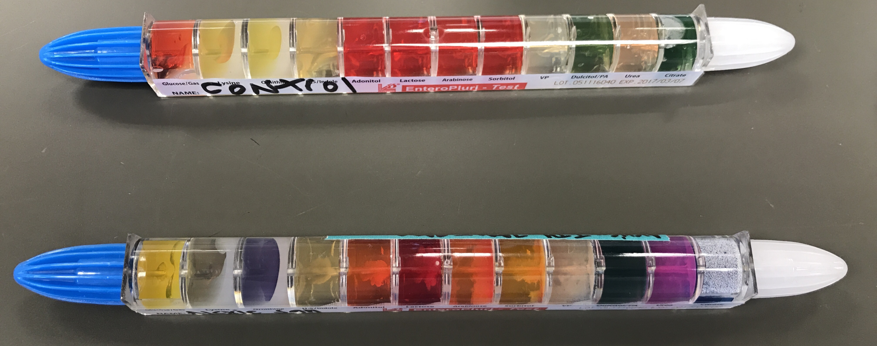
Top: Control Enterotube
Bottom: Inoculated Enterotube

Picture 2:
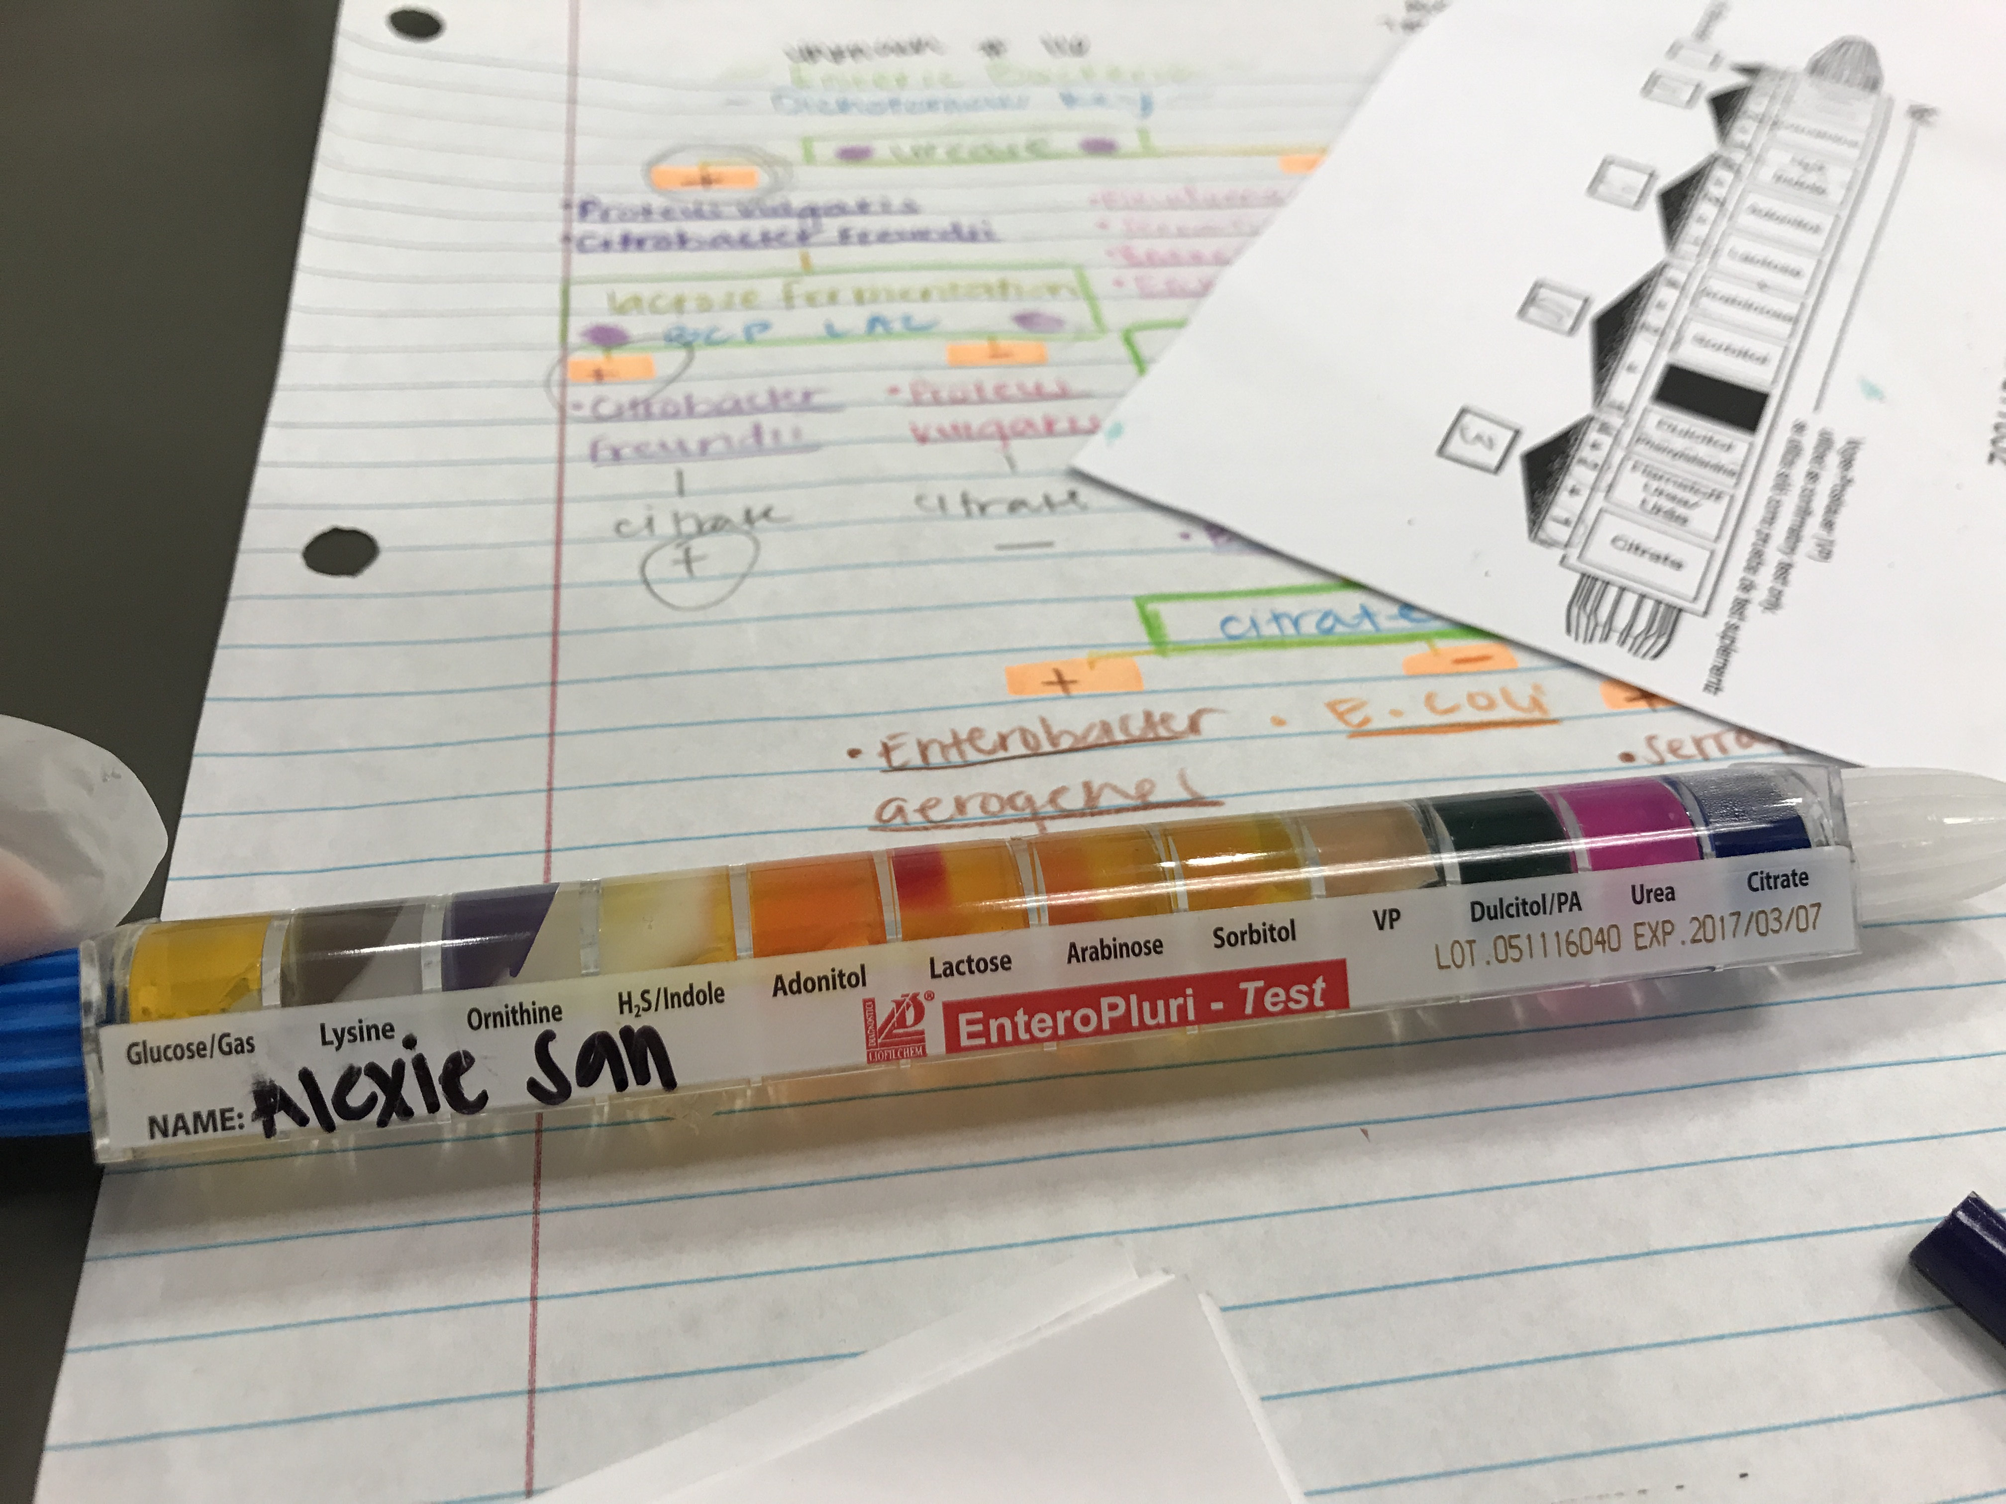

Each compartment has a designated biochemical test labeled directly underneath.

Discussion
The urease and citrate tests were the key tests in this lab execution to recognize unknown 16, which was resolved to be Citrobacter freundii. This is due to out of the six potential enteric microorganisms, just one is appeared to test positive for both urease and citrate. The first directed BCP lactose test brought about a false negative since it was seen to have no response. Lactose aging was then retested through the Enterotube and brought about a positive test. The agar in the compartment for the lactose test abandoned splendid red to bright yellow. Albeit a few pieces of the agar were red, it was coordinated that any hint of bright yellow be treated as a positive outcome. The Entertotube was reliable with different outcomes for citrate and urease since the citrate agar turned blue and the urease agar turned maroon.
The Enterotube in general was not resolved to be reliable to Citrobacter freundii. This may be due to interpretations that were slightly off destroyed the entire identification code. Labs working in microbiological analysis have indicated that Citrobacter freundii is extremely adaptable in its province morphology, just as in its biochemical, antigenic and pathogenic practices. This phenotypic adaptability has made Citrobacter freundii hard to distinguish. A shortcoming in this test configuration was that more tests ought to have been directed, for example, the SIM profound test to help the end made. The more tests done, the better. As expressed already, since there were six potential microorganisms that the obscure could be, it was anything but difficult to recognize that it was indeedCitrobacter freundii. This was demonstrated to be valid through the positive BCP lactose, urease, and citrate tests.

Microorganism
Citrobacter freundii is a facultative anaerobic gram negative bacteria. It is a common commensal of gut microbiome of humans, but it act as oppurchunstic pathogen. Citrobacter freundii cause oppurchunstic nosocomial infections of respiratory tract, urinary and blood. Some Citrobacter freundii cause food poisoning and diarrhea. The main virulence factors of Citrobacter freundii that cause diarrhea are toxins including
Shiga like toxins, heat stable toxins and a cholera toxin B homolog.
The toxins released by bacteria helps to manipulate host cell functions and to withstand host immune response. These toxins increase the virulence of bacteria. To forestall these sorts of diseases in the hospital, it is urgent that staff appropriately wash their hands regularly, wear defensive, wear when required, deal with and discard sullied fomites appropriately, just as altogether disinfect and keep up medical clinic hardware, for example, respirators.

Question Discussion:

- If your organism is a bacillus shaped bacterium, would the PR Glucose test be a logical test to run? Why or why not? Answer: Yes, since it has positive results.

- If your organism is a coccus shaped bacterium, would the PR Glucose test be a logical test to run? Why or why not? Answer: The PR Glucose test be a logical test to run if organism is a coccus shaped bacterium since Glucose is fermented.

- If your organism is a coccus shaped bacterium that is negative for lactose fermentation, what test should you run to determine the identity of your organism?
Answer: I can use the BCP lactose test.

References
[1] ImAshish. Citrobacter Freundii: Definition, Characteristics And Symptoms. 2018; 70, 7153-7155.
[2] Karasawa, T.; Ito, H.; Tsukamoto, T.; Yamasaki, S.; Kurazono, H.; and Faruque, S.M. Cloning and characterization of genes encoding homologues of the B subunit of cholera toxin and the Escherichia coli heat-labile enterotoxin from clinical isolates Citrobacter Freundii andE.coli.2012.
[3]Johnson, E, Microbiology Lab slides, Transfer of Bacteria: Aseptic Technique. 2014; 10-2.

Johnson, E, Microbiology Lab slides, Transfer of Bacteria: Aseptic Technique. 2014; 10-2. Karasawa, T.; Ito, H.; Tsukamoto, T.; Yamasaki, S.; Kurazono, H.; and Faruque, S.M. Cloning
Karasawa, T.; Ito, H.; Tsukamoto, T.; Yamasaki, S.; Kurazono, H.; and Faruque, S.M. Cloning and characterization of genes encoding homologues of the B subunit of cholera toxin and the Escherichia coli heat-labile enterotoxin from clinical isolates Citrobacter Freundii andE.coli.2012.
Johnson, E, Microbiology Lab slides, Transfer of Bacteria: Aseptic Technique. 2014; 10-2.

