1)
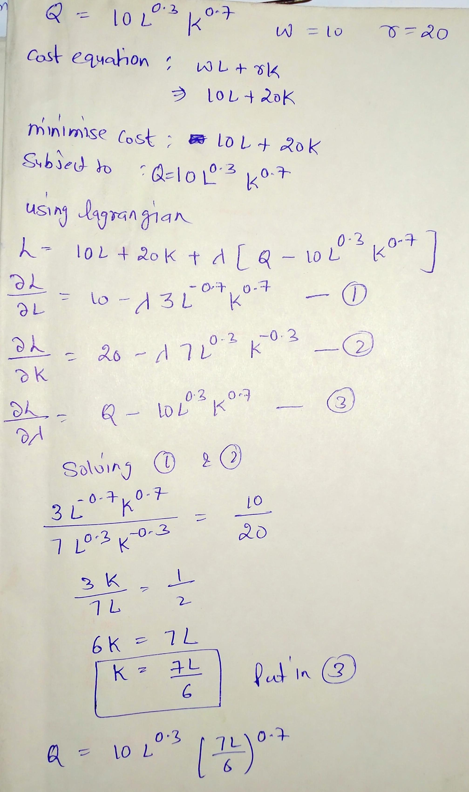

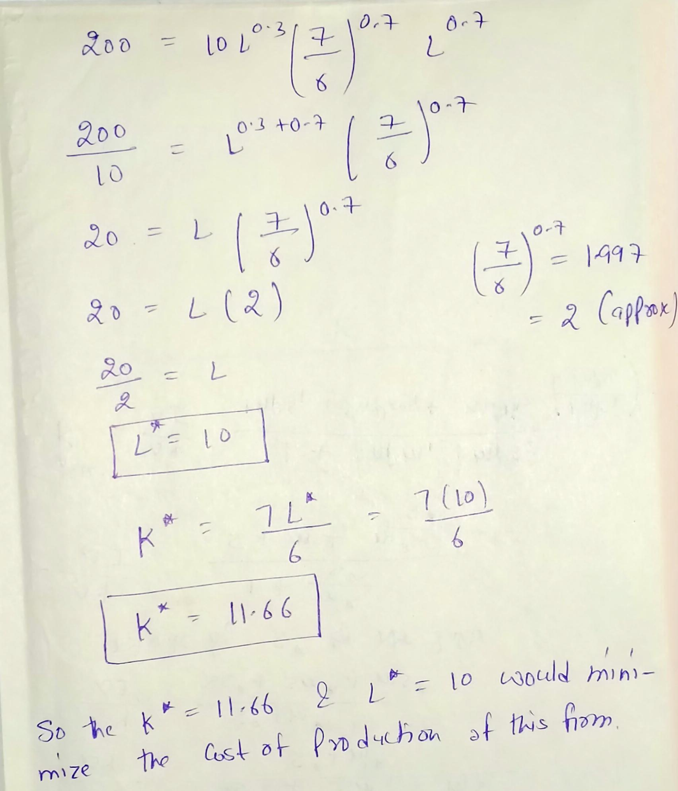

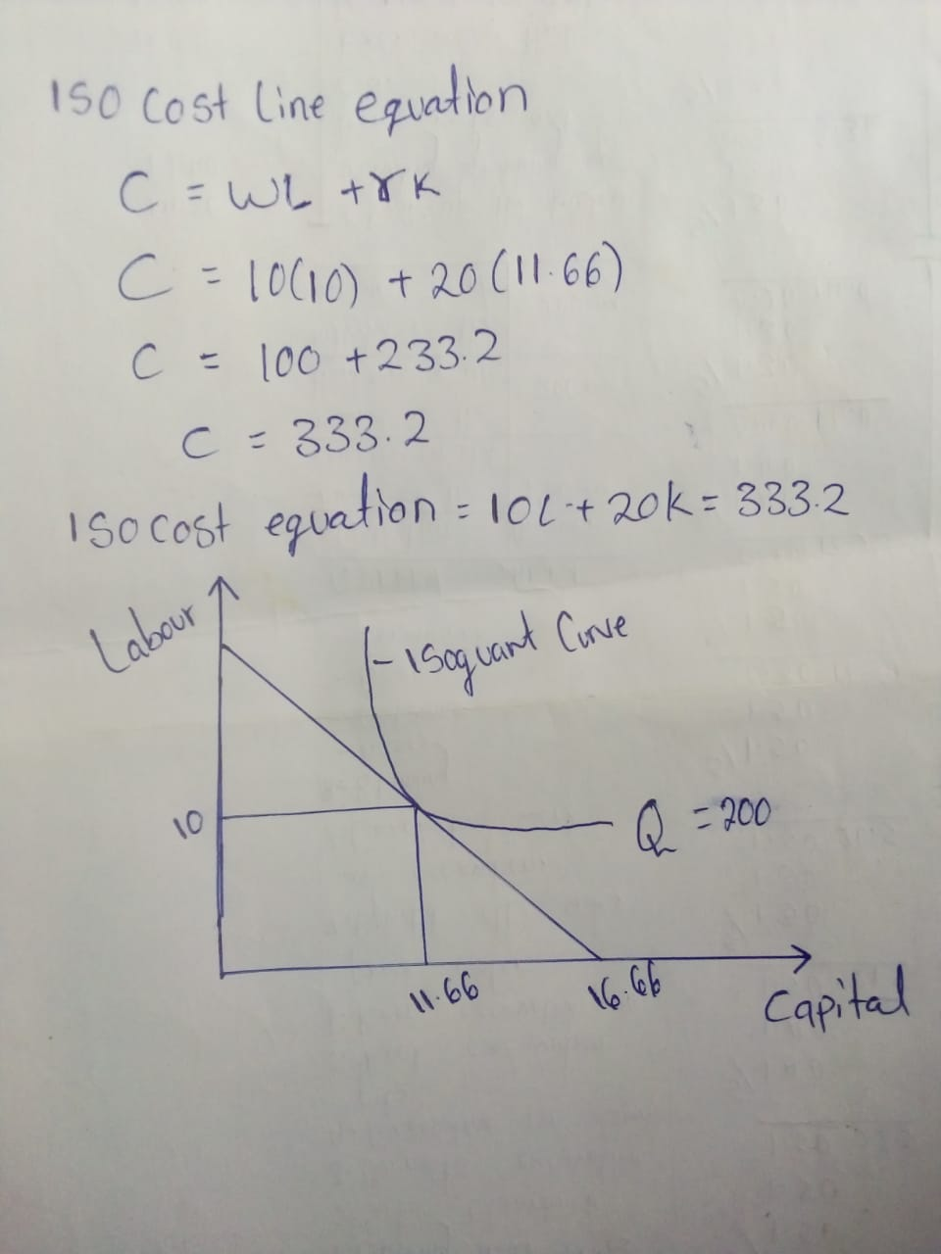
2)
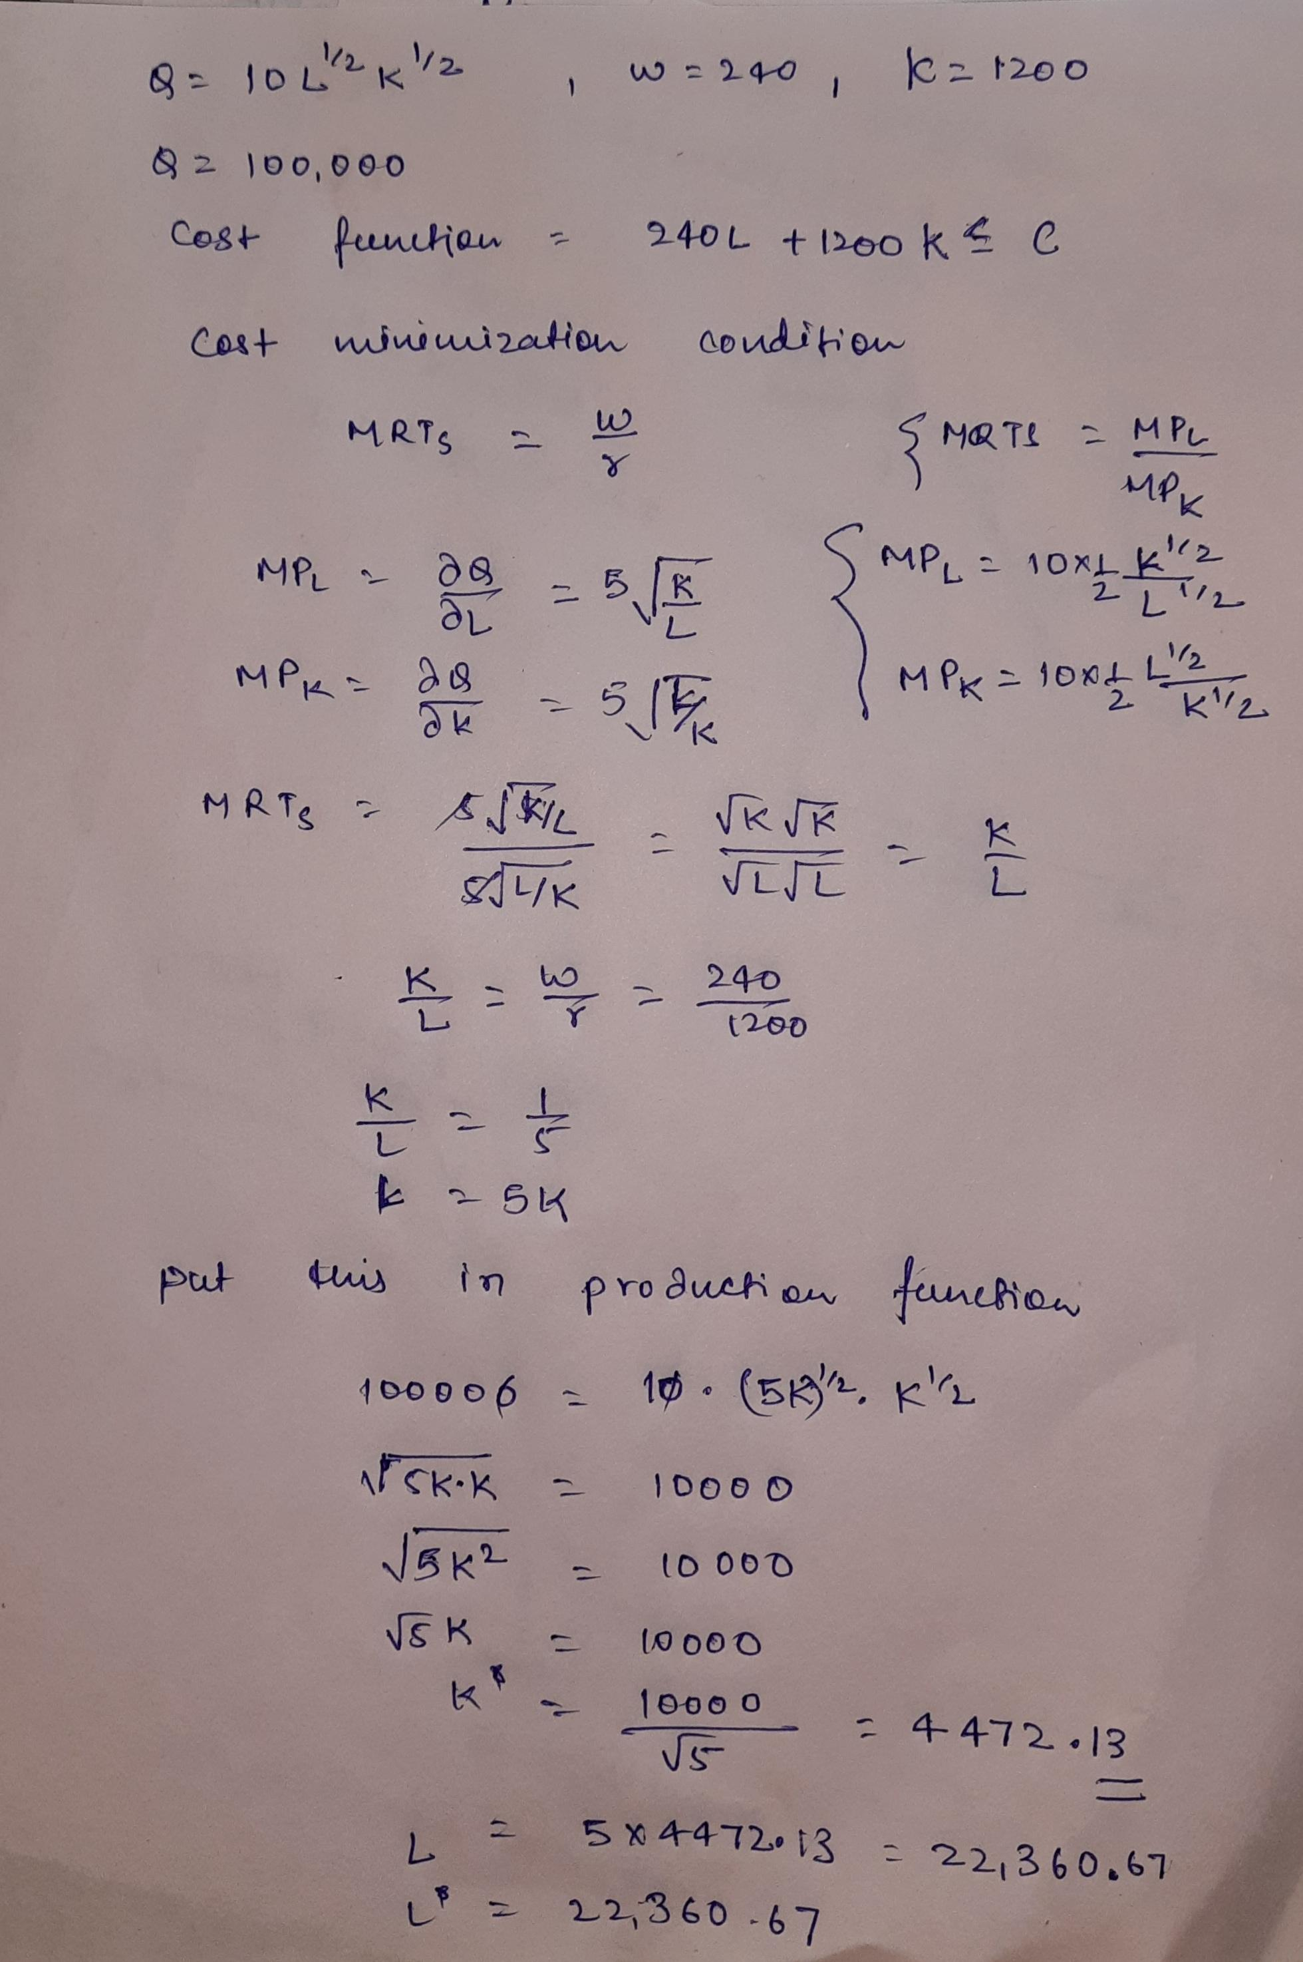
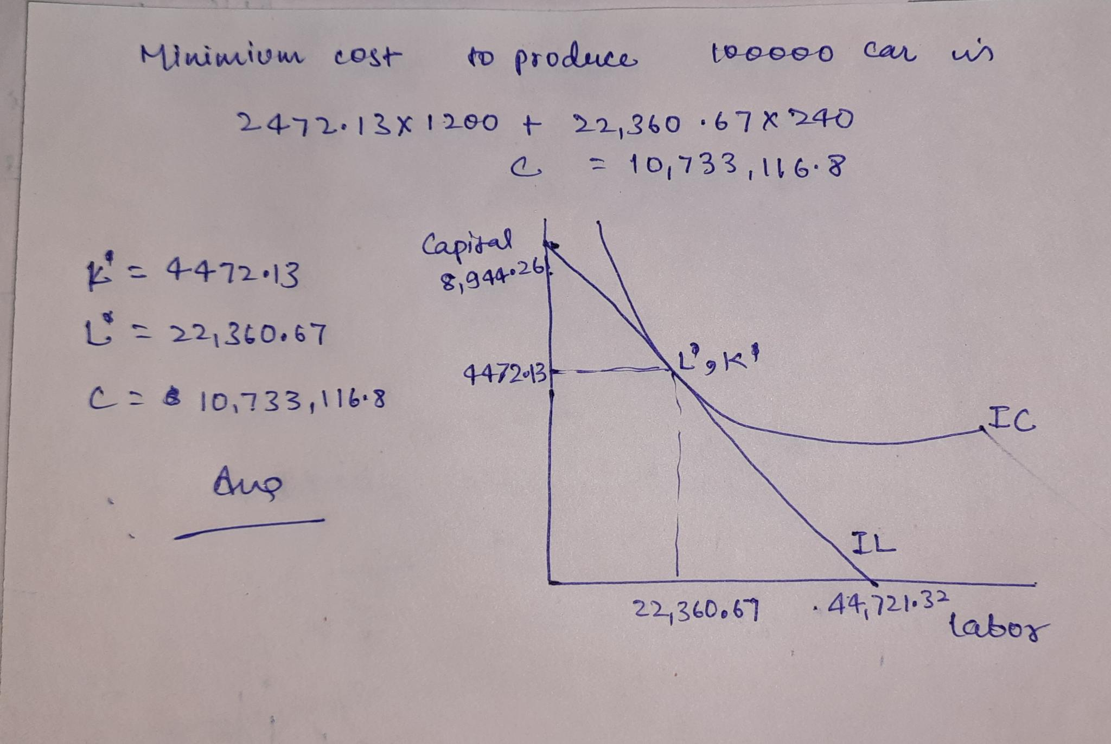

3) U(S, T) =0.4S^{0.}4T^{.6}
S-amount of sandwich
T- Amount of tacos eaten
Price of tacos (pt) =$5
Price of sandwiches (ps) =$10
Income=$100
Budget constraint
Pt.T+ps.S=I
10S+5T=100
At optimal MRS=ps/pt
U(S, T) =0.4S^{0.}4T^{.6}
Dv/ds=MVs=0.4(0.4)5^{-0.6}T^{0.6}
Dv/dt=MVt=0.4(0.6)5^{0.4}T^{-0.4}
MRS=MVs/MVt
MRS=2/3.t/s
At optimal MRS=ps/pt
2/3.t/s=10/5*2/3
.t/s=3
t=3s
Substituting t in the budget constraint
10s+5t=100
10s+5(3s) =100
10s+15s=100
25s=100
S=4
T=12
Optimal bundle= (4, 12)
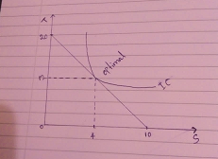

4) For the give data we'll first calculate
Mean= Sum of observation/No of observation = 19.55/10 = 1.955
Standard Deviation (s)
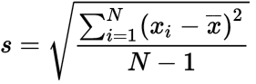
S | = | sample standard deviation
N | = | the number of observations
X_{i} | = | the observed values of a sample item
X | = | the mean value of the observations

Using formula =stdev.s you can calculate standard deviation in excel, which we get s=0.103
Based on the stated problem
Null Hypothesis: H0: μ ≠ 2
Alternate Hypothesis: H1: μ =2
As the sample size is small we'll use t statistic
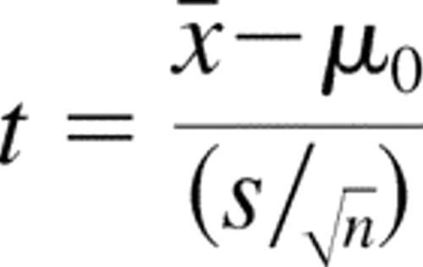
t= (1.955-2)/ (0.103/3.162) = t statistic= 1.385
Now t critical at significance level 98% and degree of freedom 9
Therefore t critical= 2.821
Decision Rule
If t statistics> t critical, we'll reject the null hypothesis
1.385<2.821, therefore we'll not reject the null hypothesis
Therefore the average heat capacity of the new composite material is not equal to 2 joules/ Kelvin.
5)
A) Given that Y = $100, pm = $30 and pc = $30:
Qd= 130-4p+2(100) +3(30)-2(30)
Qd= 130-4p+200+90-60
Qd= 360-4p
p | Qd
10 | 320
15 | 300
20 | 280
25 | 260
30 | 240
35 | 220
40 | 200
45 | 180
50 | 160
55 | 140
60 | 120
65 | 100
70 | 80
75 | 60
80 | 40
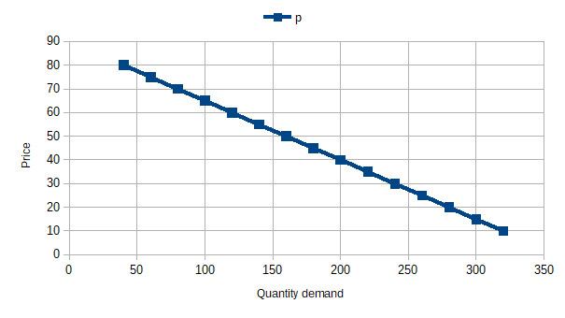
B) Given that Y = $120, pm = $30 and pc = $30:
Qd= 130-4p+2(120) +3(30)-2(30)
Qd= 130-4p+240+90-60
Qd= 400-4p
p | Qd
10 | 360
15 | 340
20 | 320
25 | 300
30 | 280
35 | 260
40 | 240
45 | 220
50 | 200
55 | 180
60 | 160
65 | 140
70 | 120
75 | 100
80 | 80

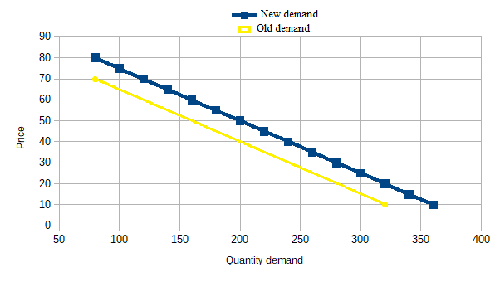
C) Let Y = $100 and pc = $30 again, but let pm increase to $40:
Qd= 130-4p+2(100) +3(40)-2(30)
Qd= 130-4p+200+120-60
Qd= 390-4p
p | Qd
10 | 350
15 | 330
20 | 310
25 | 290
30 | 270
35 | 250
40 | 230
45 | 210
50 | 190
55 | 170
60 | 150
65 | 130
70 | 110
75 | 90
80 | 70

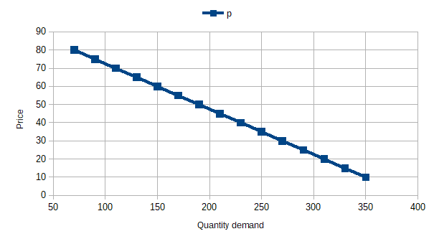
D) Let Y = $100, pm = $30, and pc increases to $40:
Qd = 130 - 4p + 2Y + 3pm - 2pc
Qd= 130-4p+2(100) +3(30)-2(40)
Qd= 130-4p+200+90-80
Qd= 340-4p
p | Qd
10 | 300
15 | 280
20 | 260
25 | 240
30 | 220
35 | 200
40 | 180
45 | 160
50 | 140
55 | 120
60 | 100
65 | 80
70 | 60
75 | 40
80 | 20
