MILK MOVIE
Institution
Date of submission

Meaning in the movie is created by the theme which is based on the storyline. In the movie, the theme talks about equality. The movie majors more on gay rights. The first person who majored in this was an American activist and politician Harvey Milk. Meaning in the movie is created by the characters who are participants in the movie. the characters have props that they use to create meaning and costumes that suggest supporting gay rights. There are camera movements and shots that indicate the ability of the actors in the movie which are either eve level that shows the subjects in the real-life and high level that shows the effects of diminishing the subjects.
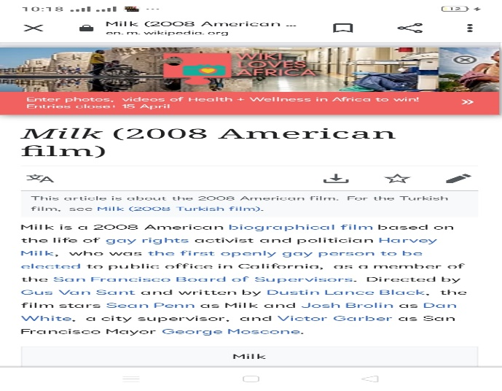
Some of the cinematic terms are seen when the adults in the movie are seen taking milk there is a symbolism of the innocence in the person in the movie this indicates a pure and bright soul behind the outer shell. In the milk movie, negative souls are taking the milk which demonstrates their malicious power. This kind of person tends to demonstrate a frightening atmosphere to the audience.
The film does not create suspense because it gives details about the predominant rights the actors are fighting to achieve. The irony in the movies is created by the suspicion that the character is an odd bird that makes him identifiable whereas Harvey's milk genitals make the person different where some people argue that he is a gay soul while they have not shared the souls to determine the truth. Conflict is evident where people have already made a decision from the on the intentions of the movie without giving a chance to interact with the souls to determine their goal. His expectations in the movie are fulfilled and we can see him as a rich guy and who influenced the culture of the Americans.

