Title:
Name:
Course name:
Course code:
Professor:
Date:

Model of buyer behavior for the Coke product
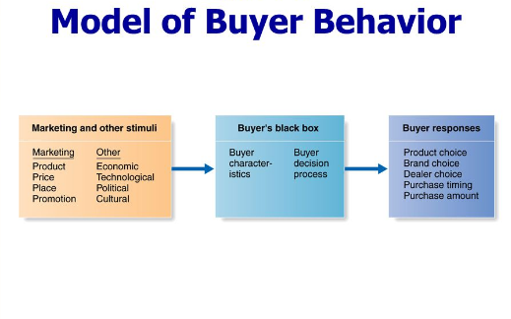
The first step of the model is to define the consumer market. The market that enjoys the product has a number of characteristics that could be very important in realizing the approach that the company ought to take in order to achieve its market goals or objectives. It is the first step to understand the influences of consumer buyer behavior. In this particular case, the market is key. The Coca Cola company ought to understand the stimuli in the market which include the culture, technology, politics, economic and the different activities that the competitors are doing in the market in order to influence it which include promotions, discounts, price, place and what a few (Bonoma , & Harvard University, 2016).
The second step is to realize the buyers characteristics. What exactly does the buyer want and what decisions does he/she make before buying a Coke brand. For example, is the customer interested in consumption of Coke bottle for purposes of gaining energy or refreshment. These are important decisions that the Coca Cola company ought to understand clearly before taking the product to the customer (Moriarty, 2015).
Finally, the buyer’s response is very important. After the customer has taken the product, he/she will have a feeling of how the product worked out his/her needs. For example, did the brand choice fulfill the need? Was there value for money? Is the product choice worth? What else should be added into the product to make it more fulfilling? These are some of the responses that the customer will give and which the company can use to make good out of it (Moriarty, 2015).
Model for an organizational buyer vs. individual consumer
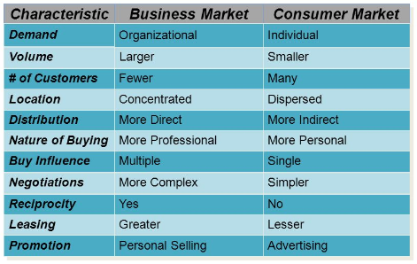
Looking at this model, it seems the organizational buying behavior is complex than the consumer market. Other behaviors that are notable in this model include the fewer customers in the organizational buyers as compared to the consumer buyers. The organizational buyers are concentrated while on the other hand the consumer market is dispersed (Moriarty, 2015).

References
Bonoma, T. V., & Harvard University. (2016). Major Sales: Who really does the buying?. Boston, MA: Harvard Business Review.
Moriarty, R. T. (2015). Industrial buying behavior: Concepts, issues, and applications. Lexington, Mass: Lexington books.

