Module 5 overview and summary
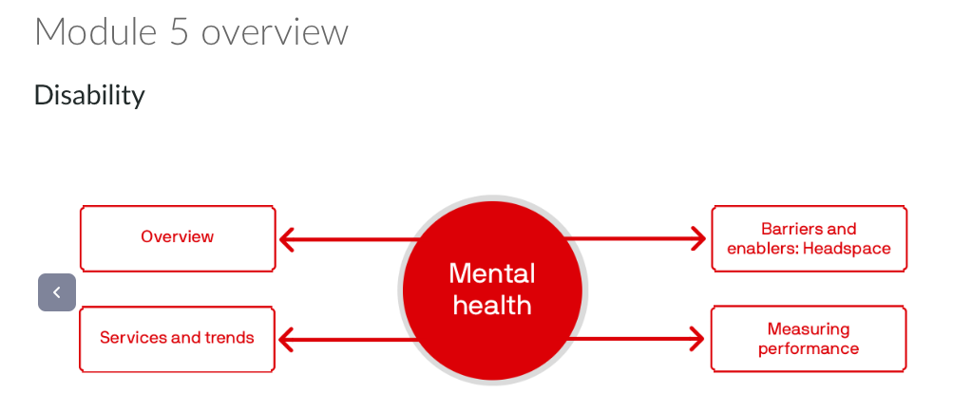

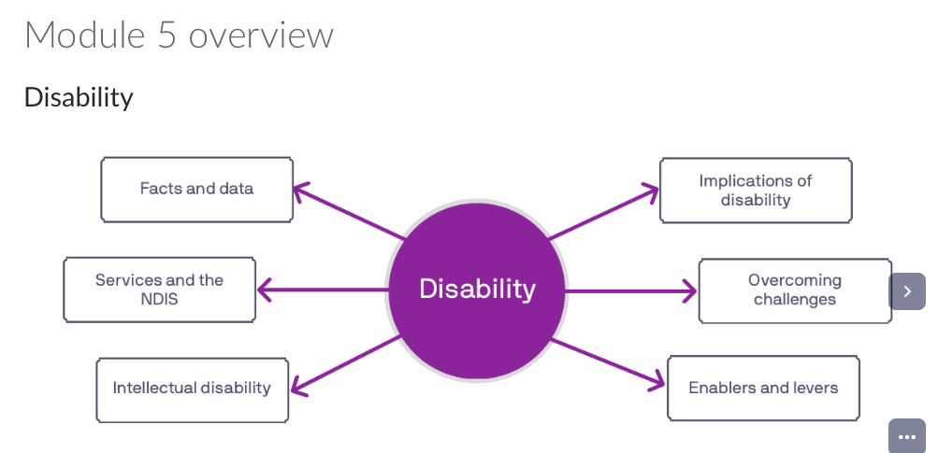

Focus on
focuses on health service delivery in Australia for people with disability and mental illness. We will explore the service demand and drivers for change in the delivery of these services, along with barriers and enablers to the delivery of integrated person-centred care. Finally, we consider whether and how the performance of these services is measured

By the end of this topic you will be able to:
- Describe how disability is defined in Australia
- Analyse the implications of industrialisation on attitudes toward disability today and health service provision for people with disability
- Describe service provision in Australia for people with disabilities
- Evaluate barriers to providing integrated person-centred care in Australia for people with disability
- Evaluate whether and how the performance of disability services is measured

Definition
“Disability is an umbrella term for any or all of the following components, all of which may also be influenced by environmental and personal factors:
- impairment—problems in body function or structure
- activity limitation—difficulties in executing activities
- participation restriction—problems an individual may experience in involvement in life situations.” (AIHW, 2019)

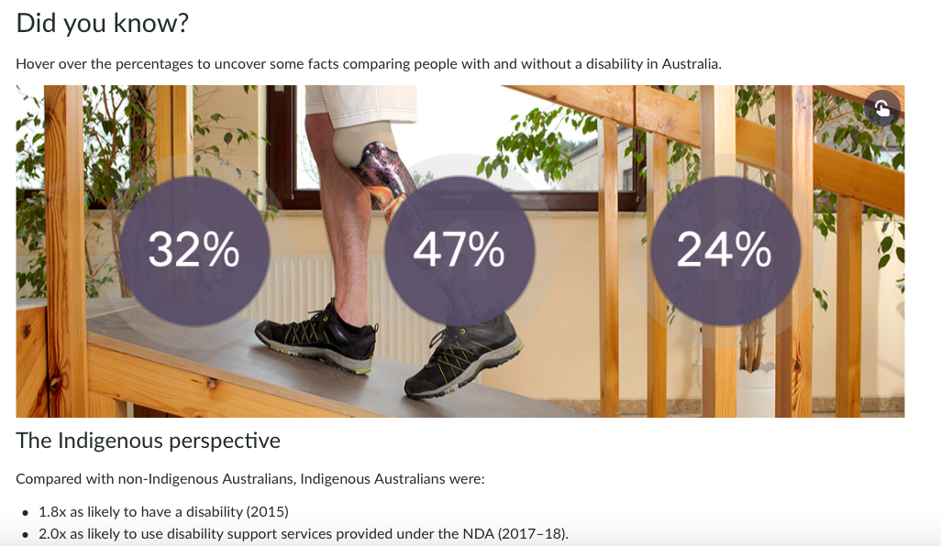

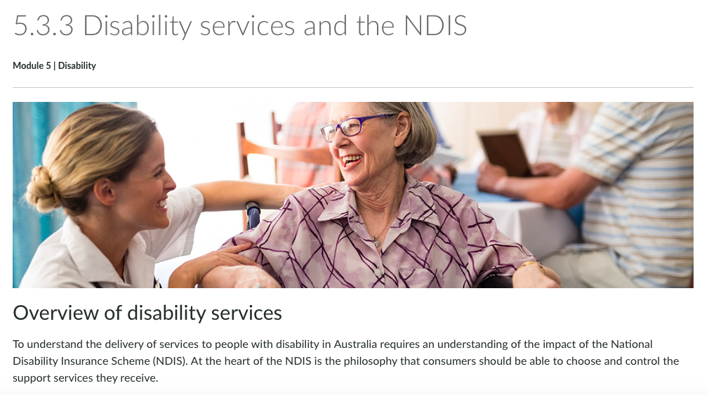

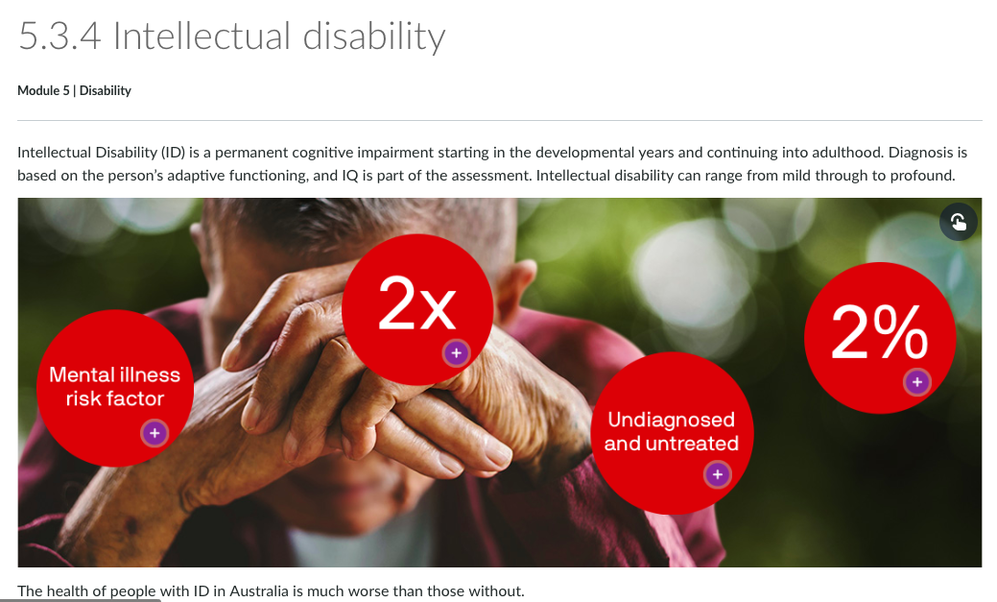

Read

Cause of death and potentially avoidable deaths in Australian adults with intellectual disability using retrospective linked data
This research, published in 2017, was a landmark study, as it shone a light on the overrepresentation of people with ID in premature and potentially avoidable deaths.
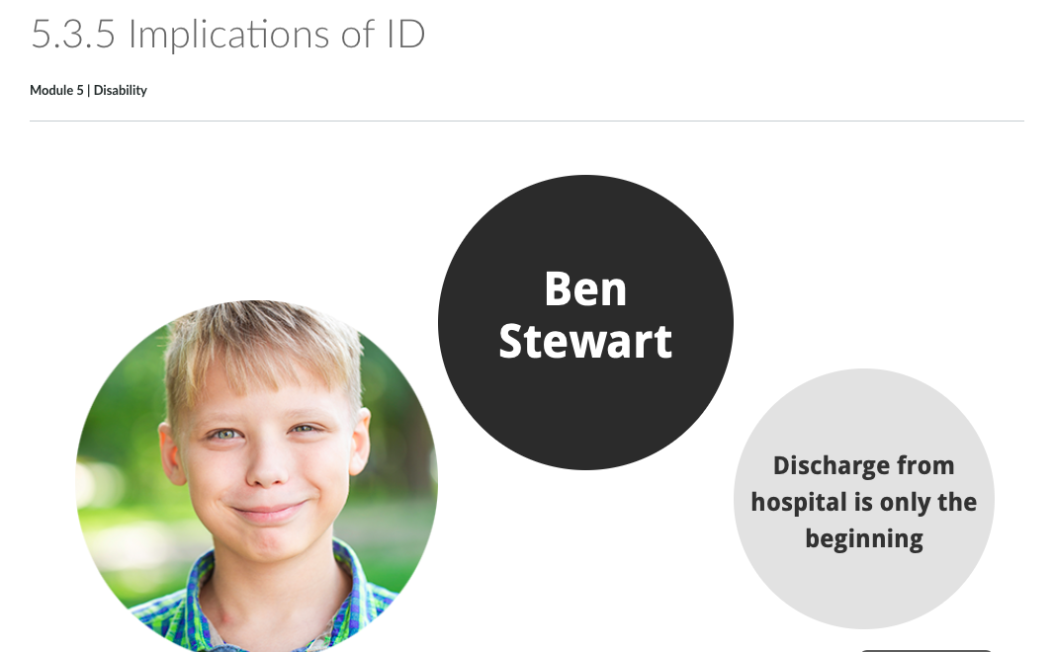

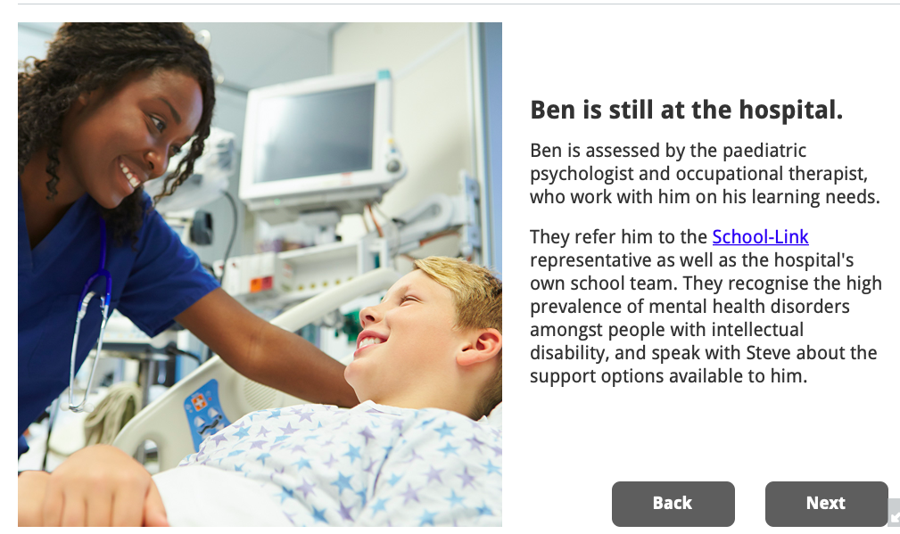

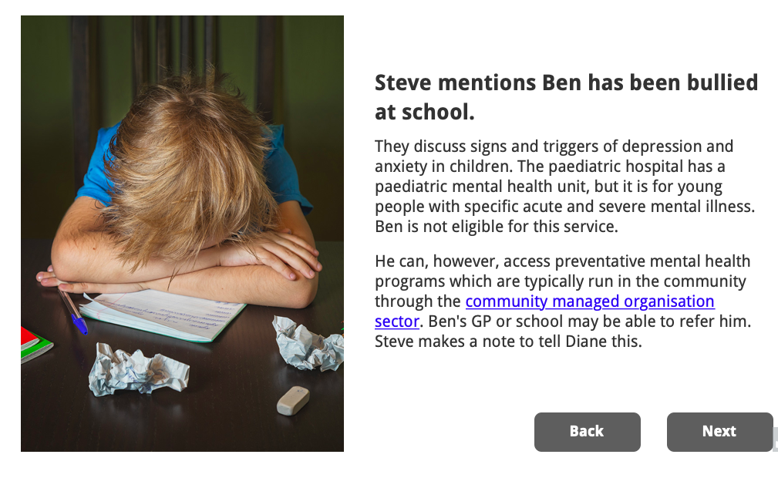



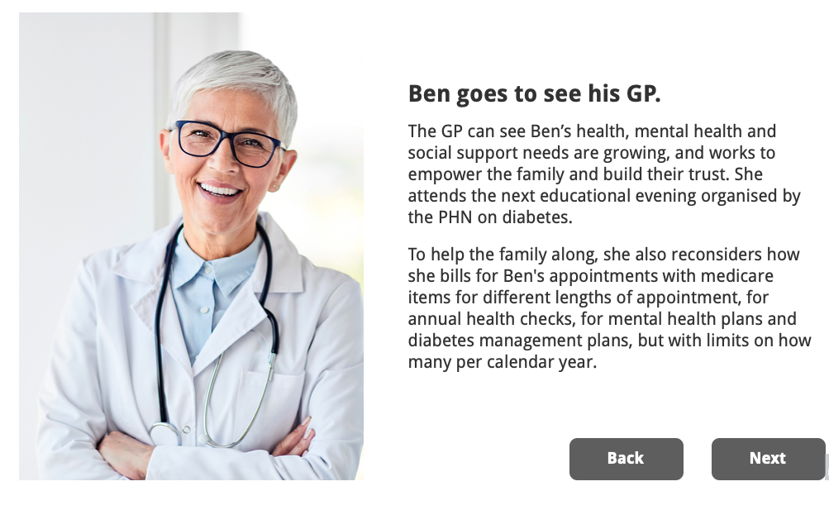

People with a long-term disability are among the most disadvantaged and invisible groups in our community, with comparatively poor health status and a healthcare system that often fails to meet their needs. This includes people with an intellectual disability, as well as people with other long-term physical and mental conditions, whether present at birth or acquired later in life.
These poorer health outcomes include aspects of health that are unrelated to the specific health conditions associated with their disability. At least one-third of Aboriginal and Torres Strait Islander people aged over 15 years report having a disability or a long-term health condition.


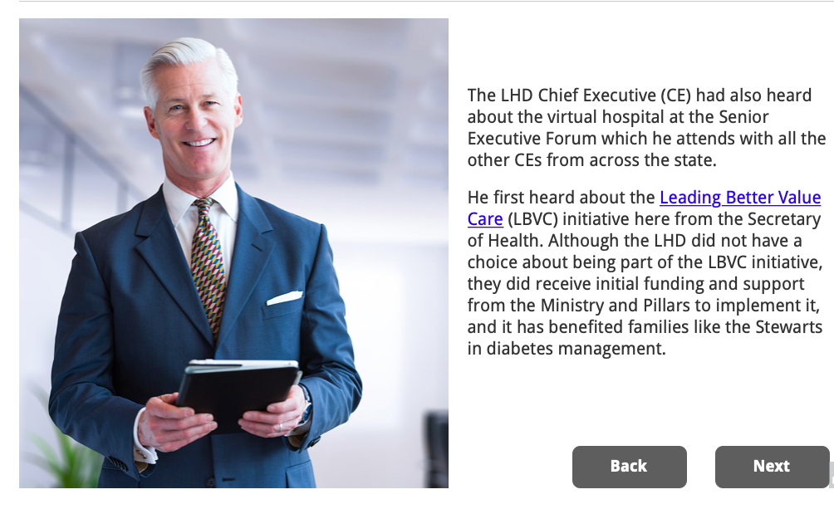

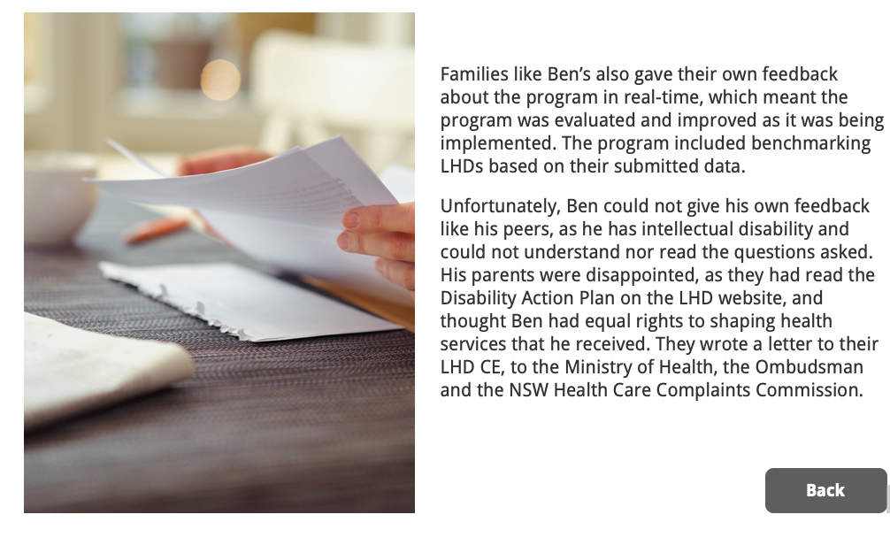

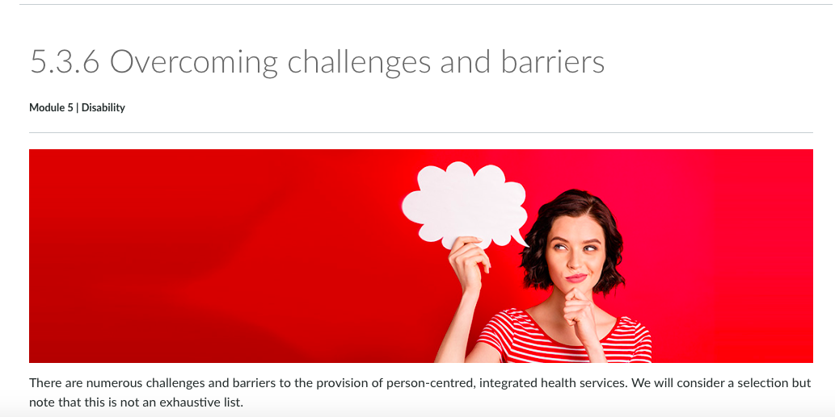

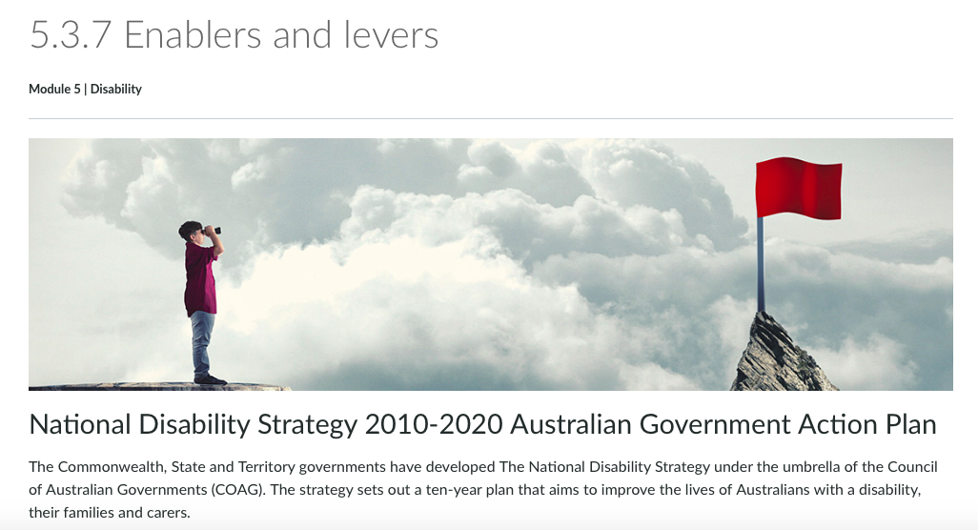

Summary module 5
People with a long-term disability are among the most disadvantaged and invisible groups in our community, with comparatively poor health status and a healthcare system that often fails to meet their needs. This includes people with an intellectual disability, as well as people with other long-term physical and mental conditions, whether present at birth or acquired later in life.
These poorer health outcomes include aspects of health that are unrelated to the specific health conditions associated with their disability. At least one-third of Aboriginal and Torres Strait Islander people aged over 15 years report having a disability or a long-term health condition.
Dr Avery spoke about the embodiment of cultural values in the design of health and social systems, which act to perpetuate dominant ways of thinking and power imbalances. Dr Avery challenges us to get beyond “system responses”.
When people are “othered,” they are socially excluded and looked down on. There becomes an unspoken tacit understanding that they are not deserving of the same standard of care.
Health services are customised for the mainstream – those who can contribute to society in a way determined useful as part of the industrial revolution. The design of health and social systems which act to perpetuate dominant ways of thinking and power imbalances.
As a result, challenges and barriers exist to the provision of person-centred integrated health services for people with a disability and mental illness including diagnostic overshadowing, policies that do not work together, services that are siloed and healthcare set up for people who do not have a disability. Navigation of health services is difficult even for those who have resources and time. How much more difficult is it for those who are disadvantaged and the most vulnerable

