Module 3
Your name
Institution

Q1
For a certain company, the cost for producing x items is 50x+300 and the revenue for selling x items is 90x−0.5x2.
The profit that the company makes is how much it takes in (revenue) minus how much it spends (cost). In economic models, one typically assumes that a company wants to maximize its profit, or at least wants to make a profit!
Part a: Set up an expression for the profit from producing and selling x items. We assume that the company sells all of the items that it produces. (Hint: it is a quadratic polynomial.)
Answer
Cost function C(x) = 50x+300
Revenue function, r(x) = 90x – 0.5x²
So, profit function P(x) = r(x) – C(x)
P(x) = 90x-0.5x² – (50x+300)
P(x) = 40x-0.5x²-300
Part b: Find two values of x that will create a profit of $50.
If profit = $50, then:
40x-0.5x²-300 = 50
40x-0.5x²-350 = 0
80x-x²-700 = 0
x²-80x+700 = 0
x²-70x-10x+700 = 0
n(x-70)-10(x-70) = 0
(x-10) (x-70) = 0
So, x = 10 and x = 70
So the two values are x = 10, 70

Part c: Is it possible for the company to make a profit of $2,500?
Answer
When P(x) = 2500 = 40x-0.5x²-300
0.5x²-40x+2500 = 0
x²-2x+5600 = 0
b² – 4ac = (-2)² – 4*1*(500) = 64 < - 22100 < 0
So, this is not possible.

Q2. Solve the inequality
$$5x-15≤10$$
Solution
$$5x-15≤10$$
$$5x≤10+15$$
$$5x≤25$$
$$5x≤25$$
$$x≤5$$

Q3. Solve the compound inequality
$$3x+2>2x-4>x-12$$

Solution
$$3x+2>2x-4$$
$$3x-2x>-4-2$$
$$x>-6$$

$$2x-4>x-12$$
$$2x-x>-12+4$$
$$x>-8$$
So, the interval notation is [-8, -6].

Q4.
A basic cellular package costs $30/month for 60 minutes of calling with an additional charge of $0.50/minute beyond that time. The cost function C(x) for using x minutes would be
• If you used 60 minutes or less, i.e. if if x≤60, then C(x)=30 (the base charge).
• If you used more than 60 minutes, i.e. (x−60) minutes more than the plan came with, you would pay an additional $0.50 for each of those (x−60) minutes. Your total bill would be C(x)=30+0.50(x−60).
If you want to keep your bill at $50 or lower for the month, what is the maximum number of calling minutes you can use?
Answer

Cost formula C = 30 + 0.50(x-60)

Given bill cannot be greater than $50

C ≤ 50

30 + 0.50(x-60) ≤ 50

0.50(x-60) ≤ 50-30

0.50(x-60) ≤ 20

(x-60) ≤ 20/0.50

x-60 ≤ 40

x ≤ 40+60

x ≤ 100

Therefore Maximum 100 minutes can be used.

Q5 5. Answer the functions questions below.
a. Determine whether the relation represents y as a function of x.
y=x²
Answer
For each value of x results to an exact one y output.
Hence, yes, the relation represents a function.

Part b) Determine whether the relation represents y as a function of x.

$$x^{2}+y^{2}=9$$
Answer
$$x^{2}+y^{2}=9$$
$$y^{2}=9-x^{2}$$
$$\sqrt{y^{2}}=\sqrt{9-x^{2}}$$
$$y=±\sqrt{9-x^{2}}$$
By using any of x input between -3 and 3 gives two different output of y. Therefore, the relation does not represent a function.

Q6 Answer the vertical line test questions below.
a. Use the vertical line test to determine if the relation shown in the graph below is a function.
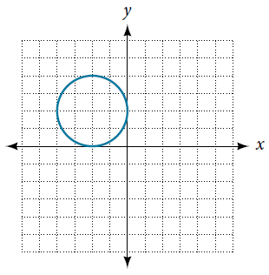
Answer
a) No, it is not a function

b
a
Here the vertical line n = -2 intersects the graph at two points ‘a’ and ‘b’.
Therefore, the graph is not a function

Part b) Use the vertical line test to determine if the relation shown in the graph below is a function.
Answer: Yes, it is a function

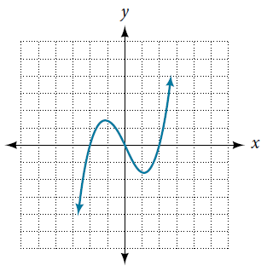
N=1
Here vertical line intercepts the graph at one point only. Therefore, the graph is a function.

Q8 Consider the relationship 7r+4t=14.

Part a). Write the relationship as a function r=f(t).

Answer
The function, 7r+4t=14 can be rewritten in the r=f(t) as:

$$r=\frac{14-4t}{7}$$

Therefore,
$$ft=\frac{14-4t}{7}$$

Part b). Evaluate f(−7).

Answer

Since,
$$ft=\frac{14-4t}{7}$$
So,
$$f\left(-3\right)=\frac{14-4\left(-7\right)}{7}=\frac{-14}{7}=-2$$

Therefore,

f(−7) = -2

Part c). Solve f(t)=22.

Answer:
Given that f(t)=22 and $ft=\frac{14-4t}{7}$,
Then
$$\frac{14-4t}{7}=22$$
$$14-4t=154$$
$$-4t=140$$
$$t=-35$$
Therefore,
t = -35

Q10 Given the following graph
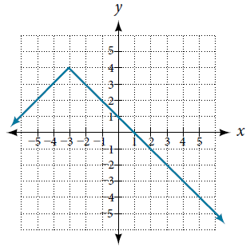
- Evaluate f(3).
f(3) = value of ‘y’ coordinate when x = 3.
So,
f(3) = -2.

- Evaluate f(2).
Find the value of ‘x’ when y = f(x) = 2
X = (-1, -5)

Q11
The amount of garbage, G, produced by a city with population p is given by G=f(p). G is measured in tons per week, and p is measured in thousands of people.
- The town of Tola has a population of 45,000 and produces 11 tons of garbage each week. Express this information in terms of the function f.
Answer
11=f(45)
- Explain the meaning of the statement f(5)=2.
Answer
The amount of garbage produced per week by a city with population 5 is 2 tons.
The amount of garbage produced per week by a city with population 2,000 is 5 tons.
The amount of garbage produced per week by a city with population 50,000 is 2 tons.
The amount of garbage produced per week by a city with population 5,000 is 2 tons.
The amount of garbage produced per week by a city with population 2 is 5 tons.

Q12
- Find the domain of the function using interval notation
f(x)=−2x(x−1)(x−8)

The f(x)=−2x(x−1)(x−8) does not have the variable in the denominator. Therefore, the domain is all real numbers.
$$Domain Interval=(-∞,∞)$$

- Write the domain and range of the function using interval notation.
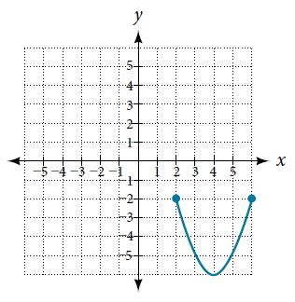
Range
Domain
By projections, we are able to obtain the domain and range as:
Domain: [2, 6]
Range: [-2, -6]

Q13. The cost in dollars of making x items is given by the function C(x)=10x+900.
Part a)
The fixed cost is determined when zero items are produced. Find the fixed cost for this item.
Solution:
C(x)=10x+900
For zero items, then x = 0
C(0) = 900

Part b)
What is the cost of making 25 items?
Solution
C(x)=10x+900
C(25)=10(25)+900
C(x)=250+900
C(x)=1,150

Part c)
Suppose the maximum cost allowed is $2400. What are the domain and range of the cost function, C(x)?
Solution:
Given the maximum cost = 2400
The domain would be:
2400 = 10x + 900
$x=\frac{1500}{10}$
$x=150$
Domain:[0,150]
Range:[900,2400]

______________________________________________________________

Consider the graph of f shown in the figure below.
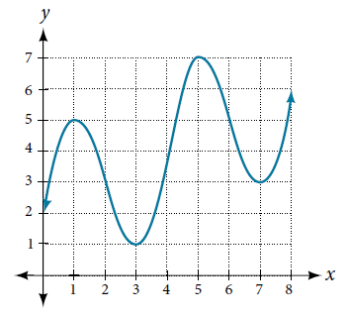
Estimate the average rate of change from x=2 to x=6

Answer
$$Average rate of change=\frac{f\left(6\right)-f(2)}{6-2}$$
$$=\frac{5-3}{4}$$

$$=\frac{1}{2}$$

$$=0.5$$

_______________________________________________________________________
Consider the graph of f shown in the figure below.
Estimate the average rate of change from x=2 to x=6.
Answer
$$Average rate of change=\frac{f\left(6\right)-f(2)}{6-2}$$
$$=\frac{5-3}{4}$$

$$=\frac{1}{2}$$

$$=0.5$$

_______________________________________________________________________
Use the graph of the function to estimate the interval on which the function is decreasing.
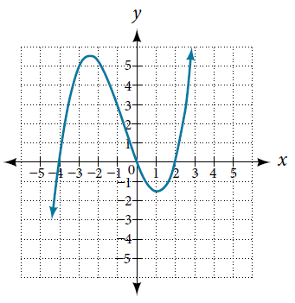
Enter your answer in interval notation.

Answer

Decreasing
The function is decreasing from (-2.5, 1).

A driver of a car stopped at a gas station to fill up his gas tank. He looked at his watch, and the time read exactly 3:40 p.m. At this time, he started pumping gas into the tank. At exactly 3:44, the tank was full and he noticed that he had pumped 11.8 gallons. What is the average rate of flow of the gasoline into the gas tank?

Answer:
The average rate of flow, A = $\frac{gallons}{change in time}$
$$change in time=3:44-3:40=4 minutes$$
So,
$$A=\frac{11.8}{4}$$
$$A=2.95 \frac{gallons}{minute}$$

The average rate of flow of the gasoline is $2.95 \frac{gallons}{minute}$ gallons per minute.

