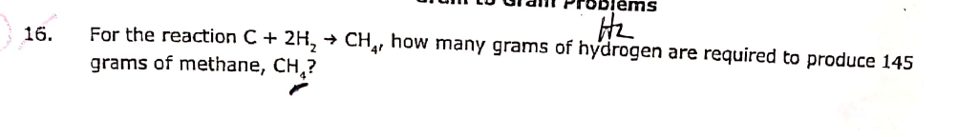
$$145 g CH4 x \frac{1 mol CH4}{16 g CH4}x\frac{2 mol H2}{1 mol CH4}x\frac{2 g H2}{1 mol H2}=36.25 g H2$$

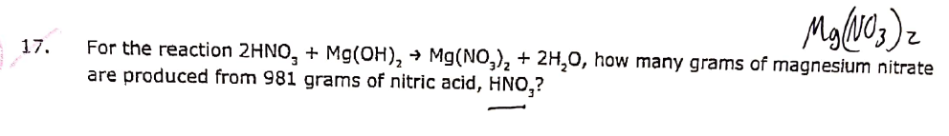
$$981 g HNO3x\frac{1 mol HNO3}{63 g HNO3}x\frac{1 mol Mg\left(NO3\right)2}{2 mol HNO3}x\frac{148.3 g Mg\left(NO3\right)2}{1 mol Mg\left(NO3\right)2}=1154.62 g Mg\left(NO3\right)2$$

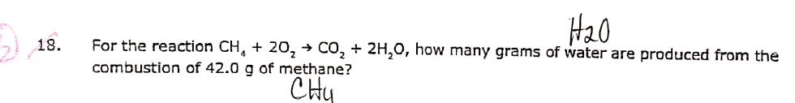
$$42.0 g CH4 x \frac{1 mol CH4}{16 g CH4}x\frac{2 mol H2O}{1 mol CH4}x\frac{18 g H2O}{1 mol H2O}=94.5 g H2O$$

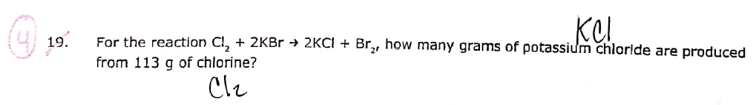
$$113 g Cl2 x\frac{1 mol Cl2}{70.9 g Cl2}x\frac{2 mol KCl}{1 mol Cl2}x\frac{74.5 g KCl}{1 mol KCl}=237.48 g KCl$$

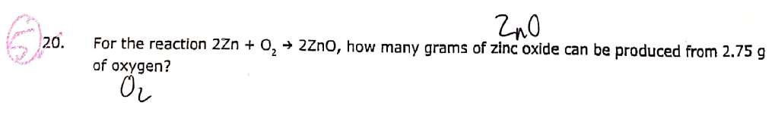
$$2.75 g O2 x \frac{1 mol O2}{32 g O2}x\frac{2 mol ZnO}{1 mol O2}x \frac{81.4 g ZnO}{1 mol ZnO}=13.99 g ZnO$$

