Mole to mole conversions
Molar Map:

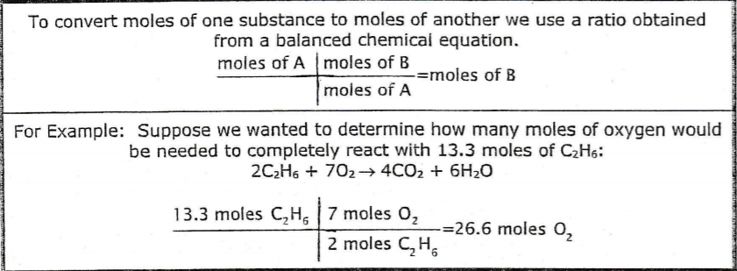

2 C₂H₆ + 7 O₂ -> 4 CO₂ + 6 H₂O

- What is the mole ratio between C₂H₆ and H₂O? _____2:6_____________

Since C2H6 has 2 moles and H2O has 6 moles, simply their ratio is 2:6

- How many moles of water (H₂O) are produced from 20.3 moles of C₂H₆?
20.3 moles of C2H6 ( 6 mole of H2O / 2 mol of C2H6)
= 60.9 moles H2O are needed.

C + 2 H_{2 ->} CH₄

- What is the mole ratio between H₂ and CH₄? ______2:1___________

- How many moles of H₂ are required to produce 10 moles of methane, CH₄?
10 moles of CH4 ( 2 moles of H2 / 1 mole of CH4)
= 20 moles of H2 are needed.

2 HNO₃ + Mg(OH)₂ -> Mg(NO₃)₂ + 2 H₂O

- What is the mole ratio between HNO₃ and H₂O? ____2:2_________

- How many moles of H₂O are produced from 8.21 moles of HNO₃?
8.21 moles of HNO3 ( 2 moles of H2O / 2 moles of HNO3)
= 8.21 moles of H2O are needed.

CH₄ + 2 O₂ -> CO₂ + 2 H₂O

- How many moles of H₂O are produced from combustion of 12.5 moles of CH₄?
12.5 moles of CH4 ( 2 moles of H2O / 1 mole of CH4)
= 25 moles of H2O are needed.

Cl₂ + 2 KBr -> 2 KCl + Br₂

- How many moles of KCl are produced from 4.3 moles of Cl₂?

4.3 moles of Cl2 ( 2 moles of KCl / 1 mole of Cl2)
= 8.6 moles of KCl are needed.

