Chemical reactions facilitation by enzymes and factors which affect enzymes

Student’s Name
Institutional Affiliation
Course Name and Number
Instructor’s Name
Submission Date

Introduction
A living organism's body harbors many reactions which occur at any time. Most of the reactions occurring in a living organism's body are enzyme controlled reactions. An enzyme is a protein molecule that acts as a catalyst in regulating the rate at which a chemical reaction takes place. A catalyst is a chemical substance that increases a chemical reaction rate without taking part in the reaction. In any enzymatic reaction, the enzyme's active sites are attached to the substrate leading to the chemical reaction (Aebi, 2014). The process of the combination of the enzymes and the substrate is referred to as the enzyme-substrate complex. If an enzyme leads to a single substrate's breakdown, the type of reaction which occurs in such a reaction is called a catabolic reaction. In case an enzymatic reaction leads to a combination of two or more substrates forming a product, the type of the reaction occurring is referred to as anabolic reaction. In the study, enzyme catalase and enzyme catechol oxidase are used. The enzyme catalase is commonly found in most living organisms. Enzyme catechol oxidase is mainly found in the plants chloroplast (Eicken, 2019). Therefore investigation of chemical reactions facilitated by enzymes Catalase and catechol oxidase and temperature and pH on enzymatic reactions.
Experiment 1
Investigation of the presence of enzyme Catalase
Materials and requirements
Five small clean and dry test tubes were labeled 1 to 5, labels, a marker, dropper, 3 % hydrogen peroxide, distilled water, a piece of squash, banana, mushroom, and some sand.
Procedure
Five clean test tubes were marked at around 1 inch from the bottom. Each tube was filled with a 3 % hydrogen peroxide solution up to the mark using a dropper. A pea-sized pinch of mushroom was added to the contents in tube 1, a pea-sized pinch of squash was added in the tube 2, a small piece of banana to tube three, to tube four, a pinch of sand was added, and finally, in tube five about five drops of water were added. Observations were then made after 5 minutes for any changes in the tubes' solutions after the addition of the various sources of the enzyme. The set up was set, as shown in figure 1.0 below.
Figure 1.0 (Aebi, 2014)
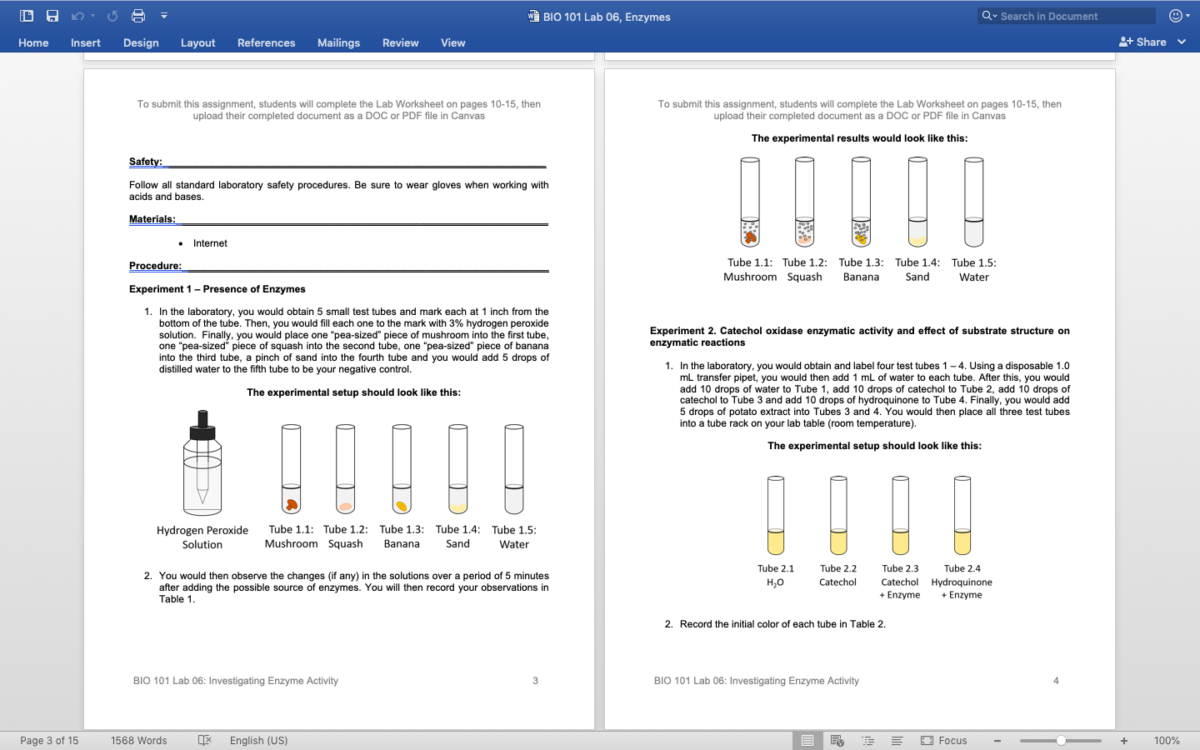
Experiment 2
Catechol Oxidase activity and the effect of substrate structure on enzymatic reaction
Materials and requirements
4 clean test tubes, 1.0 mL disposable transfer pipette, distilled water, Catechol Oxidase, hydroquinone, Tube rack, and potato extract.

Procedure
Four clean test tubes were labeled tube one up to tube four. Using a disposable 1.0 mL transfer pipette, 1.0mL of distilled water was placed in each of the four tubes. Ten drops of distilled water were added to tube one, 10 drops of catechol were added to tube 2 and 3, and then 10 drops of hydroquinone were added to tube 4. Five drops of a potato extract were added to the tube 3 and tube 4. All the tubes and their contents were then placed in a test tube rack placed on the lab table. Observations for any color change in the tubes were made after every 5 minutes for 15 minutes. The set up was, as shown in figure 2.0 below.

Figure 2.0

Experiment 3
Effect of Heat on Enzymatic reaction
Materials and Requirements
4 test tubes labeled 1-4, disposable 1.0 mL transfer pipette, water, potato extract, ice, lab table, thermometer, labels, mark pen, water baths at 40 ⁰C, and 80⁰C. Incubator and catechol.
Procedure
Four test tubes were labeled tube 1 to 4. Using a disposable 1.0 mL transfer pipette, 1.0 mL of water was transferred into each of the four tubes. Five drops of potato extract were then added to the contents in the four tubes. Tube one was placed in ice at 0 ⁰C, tube two was placed in the lab table at room temperature, tube three was placed on a water bath at 40 ⁰C, and tube four was placed on a water bath at 80 ⁰C. The four tubes were then incubated at their respective temperatures for five minutes. After incubation, 10 drops of catechol were added to each tube and the initial color in each tube was also noted. The set up was, as shown in figure 3.0 below.

Figure 3.0 (Eicken, 2019)
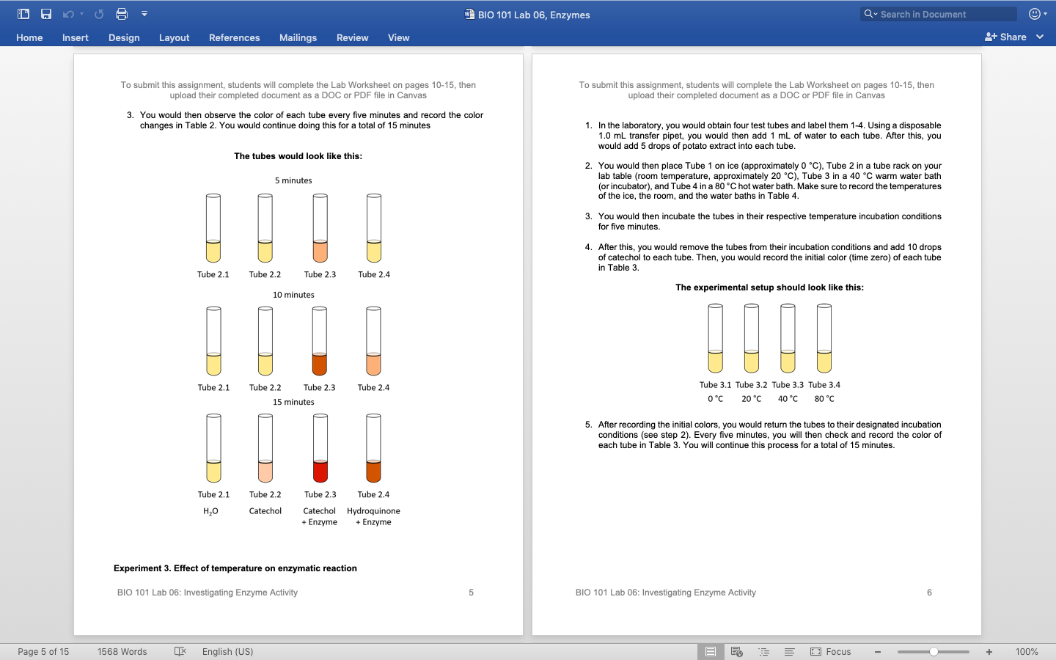
Experiment 4
The effect of pH on enzymatic reactions
Materials and requirements
5 test tubes labeled 1-5, disposable 1.0 mL transfer pipette, water, potato extract, Hydrochloric acid (HCl) solution, potassium hydroxide (KOH) solution, test tube rack, and catechol.
Procedure
Five test tubes were labeled tube 1 to 5. Using a disposable 1.0 mL transfer pipette, 1.0 mL of water was transferred into each of the five tubes. Five drops of potato extract were then added to the contents in the five tubes. In tube 1, 3 drops of HCl and 7 drops of water were added. In tube 2, 1 drop of HCl solution and 9 drops of water were added. In the tube 3, 10 drops of water were added. In tube 4, 1 drop of KOH solution and 9 drops of water were added. In the tube 5, 3 drops of KOH solution and 7 drops of water were added. 10 drops of catechol were then added in all the five tubes. The tubes were then placed in a test tube rack and placed on the lab bench.observations were made and recorded in the lab datasheet. Observations were recorded every 5 minutes for 15 minutes. The set up was, as shown in figure 4.0 below.

Figure 4.0
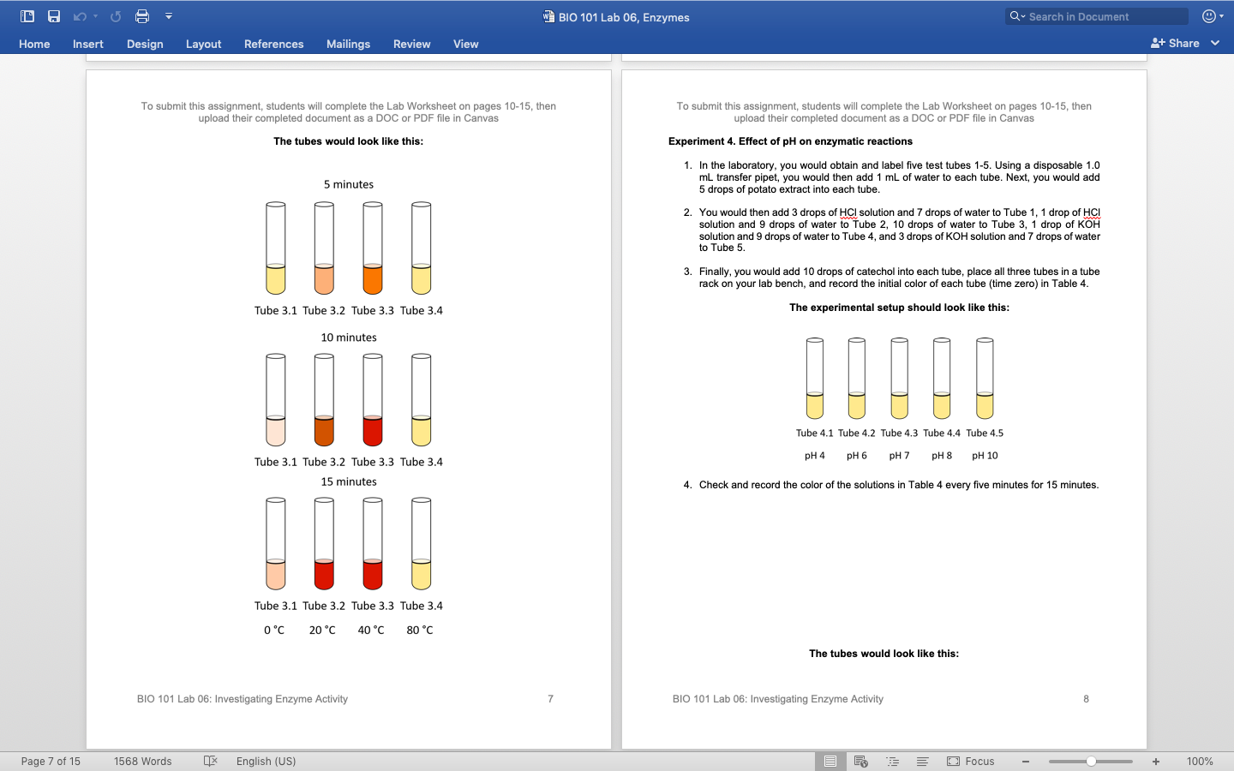

Results and Discussion
Experiment 1
Investigation of the presence of enzyme Catalase
Results Figure 1.0 (Aebi, 2014)
In tubes 1, 2, and 3, which contained pinches of Mushroom, Squash, and Banana, bubbles of a colorless odorless gas were formed. The colorless and odorless gas formed was oxygen gas. The observation confirmed that Mushroom, Squash, and Banana pieces contained the enzyme catalase (Aebi, 2014). The enzyme catalase decomposed the 3% hydrogen peroxide forming water and oxygen gas.
The reaction for the decomposition of hydrogen peroxide can be summarized, as shown by the equation below


.
There were no bubbles in tubes 4 and 5, which indicated that sand and water contained no enzyme catalase.
Experiment 2
Catechol Oxidase activity and the effect of substrate structure on enzymatic reaction
Results Figure 2.0 (Eicken, 2019)
The amount of red color change was recorded based on the red coloration from the chart below.
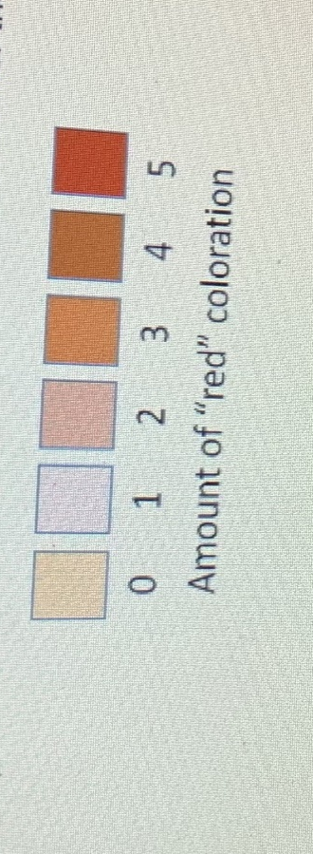

After 5 minutes in tube 3, the amount of red color was level 3 from the chart. And an indication that the catechol oxidase enzyme played an enzymatic role by catalyzing catechol oxidation to o-Quinone in the presence of oxygen; thus, the color became brown—color number 3 from the color chart. As time increase, the color concentration increased, and at the 15th minute, the color observed in tube three was color number 5, an indication that more enzyme action occurred (Eicken, 2019). Tube 4, after the 15th minute, the color-matched with color number 4 in the chat. An indication that some enzymatic action occurred as well. Tube one color matched the color for level zero of coloration. An indication that no enzymatic activity occurred in tube 1.

Experiment 3
Effect of Heat on Enzymatic reaction
Results Figure 3.0 (Cloughley, 2010)
The initial color indicated zero red coloration, an indication that no enzymatic reaction. After 15 minutes in tube 1, red coloration number 2 was observed. An indication that slight enzymatic action occurred before the enzymes were inactivated by the low ice temperatures (Cloughley, 2010). In tubes 2 and 3, red coloration was at its maximum number five since enzymatic actions took place fully since the temperatures were within the optimum where enzymes work at their best. At tube 4, red coloration was zero, indicating that there was no enzyme activity at all. The enzymes were denatured by the high temperatures in the 80 ⁰C water bath.

Experiment 4
The effect of pH on enzymatic reactions
Results Figure 4.0 (Neely, 2018)

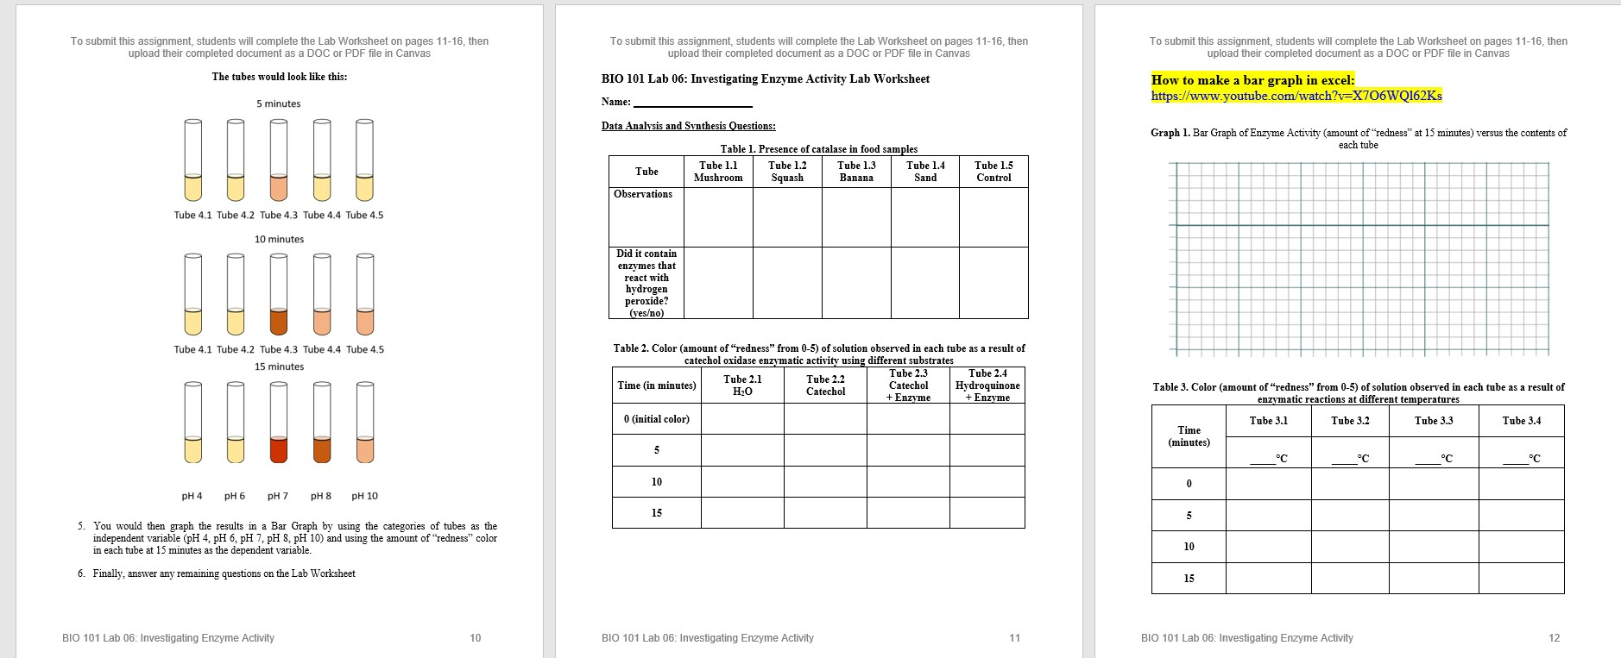

Coloration in tubes 1 and 2 was zero reddened because the pH was more acidic, and the enzyme was inactivated by acidic pH (Neely, 2018). Coloration in tubes 3 and 4 were at maximum level 5 since the pH was at the optimum range where the enzyme worked at its best. In tube 5, the color red was less at level 2, indicating that the pH was more basic, thus inactivated the enzymes.

Conclusion
Enzymes control chemical reactions in living organisms, and the temperature and pH influence the enzymes in their activity. For instance, hydrogen peroxide in organisms is broken down by enzyme catalase to form both water and oxygen. Enzymes are denatured by high temperatures and inactivated by low temperatures. Enzymes are denatured by both very high and very low ph. They work best at their optimum temperature and pH.

References
Aebi, H. (2014). Catalase. Methods of enzymatic analysis (pp. 673-684). Academic Press.
Cloughley, J. B. (2010). The effect of temperature on enzyme activity during the fermentation phase of black tea manufacture. Journal of the Science of Food and Agriculture, 31(9), 920-923.
Eicken, C., Krebs, B., & Sacchettini, J. C. (2019). Catechol oxidase—structure and activity. Current opinion in structural biology, 9(6), 677-683.
Neely, W. B. (2018). Studies on the enzyme dextransucrase. I. The effect of pH on enzyme activity. Journal of the American Chemical Society, 80(8), 2010-2013.

