Reasons and Effects of Fail in School

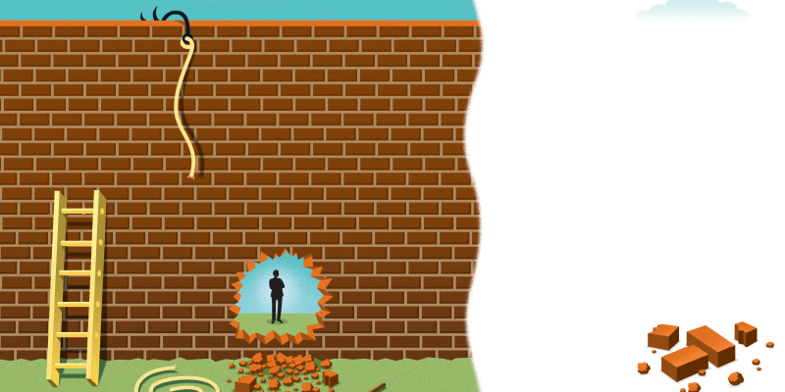
Figure 1. Learn from Failure. Reprinted from Learn from Failure, by Laurie. Burruss, 2010, Retrieved from https://www.td.org/magazines/td-magazine/learn-from-failure

Supervised by Ms. Arzoo Wasim Muhamm

Name: Najla Faleh Al Dossari
ID: 371200289
Department of English Language
Major: Interior Design
Date: 26 March 2018

Table of Contents

1 Introduction……………………………………………..………………………….. 1
2 Reasons for Fail in School…..……………………………………….……..……. 2-4
2.1 Health Problems…….……………………………………….………………...…. 4-5
3 Effects of Fail in School..……..………………………...………………………… 5
4 The Strategies for Learning from Failure ……………….……..……………….… 5-6
5 Famous People Who Fail in School…………………………………………….… 6-8
6 Conclusions……………………………………….…………………………….… 8-9
7 References ……………………….……………….………………………………. 10
8 Appendix …………………………………………………………………………. 11

- Introduction

Fail in school can have many effects on the students. These effects may make them stop trying to achieve their goals. The reasons for failure in school may be the way to teach the students, and there is nowhere to get an answer wrong, so students afraid to ask and participate with the teachers. This failure can decrease the opportunities for student’s job, income, and it may cause health problems. Also, not effects on the students, the unemployment will increase, health problems, and there will be an inactive community. Failure can produce success if the student knows it is okay to fail in life. Learning from failure is something good to learn more and to be successful in life career and actual life. For addition, people who failed in part of their lives, they are the most successful in the worldwide. They try to success for their projects, and they failed in the beginning, middle or even in the end, but they did not stop at that point, they tried to learn from that failure, and this is what makes them successful people among the world.

This research has been created to know what the causes and consequences are of failing in school, how to overcome the fear of failure, the strategies of learning from failure, and real stories about famous people who fail or did not complete their path in school or university, but they succeeded at the end.

2 Reasons for Fail in School

Many reasons can be the cause of students fail (Parents, teachers, and academic quality of learning). However, who will take this responsibility? Wade and Moore (1993) inquired some teachers this question, "Who is to blame for students' failure to learn?" 65% of them said that the child characteristics are the responsibility for it, and 32% of them said parents' position who view the school as the main factor of learning. Just 3% of them blamed the academic teaching quality as the responsibility for this issue.

OECD project description (2010) states that the school system can be responsible for the school failure because it failed to offer assistance to driving the students to the unbeaten path. According to Psacharopoulos (2007), the cause of this phenomenon may be influenced by many factors: one is student-based, like difficulties of how the student can learn. The other is school-based, like unsuitable teaching methods. Besides, the school systems have to realize that students are not in the same level of thinking and learning, studies show that students from poorest houses are not good at school unlike students from better houses (OECD project, 2010). According to (American Council on Education, 2001; Cameron and Hekman, 1993) students who have the least performing, are probably cannot graduate from high school and from college than other students.

Many factors can be the reasons to fail in school, Alessi (1988) has surveyed many reports about it, and he suggested five possible factors about the reasons for learning failure, and they were:
1. The curriculum.
2. Ineffective teaching and behavior management practices.
3. Ineffective school management practices.
4. Lack of home-based support by parents.
5. Physical and psychological problems affecting the child.
The school psychologists produced 5000 reports on learning problems in that school. The causes of failure to learn in their reports were:
1. Curriculum factors: None.
2. Inappropriate teaching and behavior management practices: None.
3. School administrate factors: None.
4. Parent and home factors: 10-20%
5. Factors within the child: 100%
“Perhaps the responses above are simply an understandably defensive response to a situation in which those in the education system come to terms with their inability to achieve all the community’s goals.”. (Hempenstall, 2013, p. 5).

(OECD, 2007) Performed research about how many students did not take out an upper secondary education and the proportion is of 25-34 years-old.
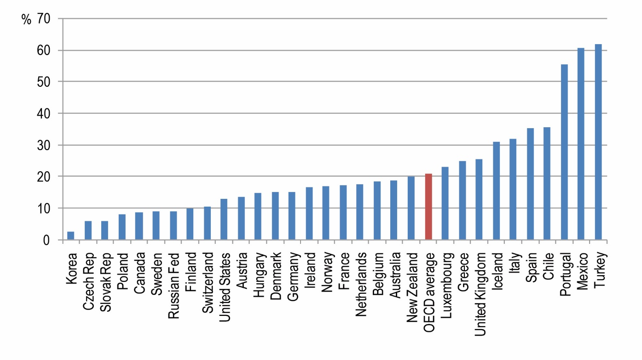
Figure 2. How many students did not obtain an upper secondary education?. Reprinted from Overcoming School Failure, by OECD Project Description. OECD Project Description, 2010, Retrieved from http://www.oecd.org/education/school/45171670.pdf

2.1 Health Problems

Another reason for this failure is the students' mental and physical health problems. (Needham, Croshoe, & Miller, 2004) explained that physical health and nutrition have some effects and failure may result in a student suffering from lack of understanding and absorption of serious mental disorders, because of his sense that he has a shortage also the student failure can cause the family to feel frustrated and shame, it is the basic pillar of society, which affects the psychology of the student. And students who suffer from academic failure and have difficulties in the study, they always complain of headaches is the means used by the body to show the extent of intellectual and mental difficulties experienced by them. They may get vomiting and pain in the stomach and loss of appetite and sleep disorder and may be plagued by nightmares and irritation and anger and anger for reasons and come back Difficulties faced by students in the study to emotional and social reasons such as separation of parents or bad relations with teachers and teachers or that the relations between the family members are tense and emotional and break the friendliness and lack of love affect the Student behavior and achievement.

3 Effects of Fail in School

Failure to study leads to the shallow level of cultural student and the inability to think and planning the right life in the right and sound in the future also may feel the student as a burden on his community, and kill the sense of guilt in terms of the family that seeks to meet all the demands, also become a student more violent and aggressive Against his successful peers, because he felt they had surpassed him. A sense of failure can lead to a weakness or loss of self-confidence. The student may result in disruption of communication and lack of harmony with family members because of feelings of guilt, shame and failure. According to scientific studies, most of those who go astray, and bullying are in fact individuals who have failed to study, because of the sense of inferiority, to break their hatred through their unethical actions on society.

4 The Strategies for Learning from Failure

Failure can be the first step to be a successful person, to have this way it must be in some strategies to turn failure to success.

Burruss (2018) argued that it is okay to fail then repeat this failure again and again, this will help to improve the abilities of the learners to search for a new way of learning. Besides, there are some strategies to learn from failure. First, take the failure as a lesson for you it will help to complete the process. Second, do not be frustrated, focus on your way and let your emotional back. The last one, is to fail forward to learn from the previous failure and make some modifications.

According to David (2010) failure and success are related to each other; this relationship has to be known to understand how they work. The first failure after successful way gives an unexpected situation; this will interrupt the "Comfort Success Zone” a place where you feel comfortable with unless you have failed.

5 Famous People Who Fail in School

Success in school not always a success in real life, maybe some people fail in school and have worse grades or cannot even complete the school, but in the end, they succeeded in their way. Many successful people did not complete the school or the college. (Thomson, 2016) stated some famous successful people, and they are:

1. Bill Gates

He is a businessman, investor, and author, and is the founder of Microsoft Corporation. Also, Gates did not finish university. In 13 age, Gates started doing personal software programming.

2. Steve Jobs

He is the founder of Apple Corporation. Jobes said in his legendary Stanford commencement speech: “I had no idea what I wanted to do with my life and no idea how college was going to help me figure it out. And here I was spending all of the money my parents had saved their entire life. So I decided to drop out and trust that it would all work out OK. It was pretty scary at that time, but looking back it was one of the best decisions I ever made.”

3. Richard Branson

Mr. Branson's wealth is about $ 4.9 billion, and he is the founder of the famous Virgin Group, which includes companies such as Virgin Atlantic Airways, Virgin Records, Virgin Mobile and many companies (about 200 companies). Branson could not complete high school and left the school at the age of 16. Not only that, but he was suffering from dyslexic, and his academic performance was weak, but all this did not prevent him from making a name for himself, and today is one of the strongest supporters and advocates of the importance of education and strongly believes that Schools should play a greater role in helping entrepreneurs and providing them with funding.

4. Mark Zuckerberg

Zuckerberg has left the college in his sophomore year to work in his project. He is the founder of Facebook. One of his famous statements is: “The biggest risk is not taking any risk.”.

5. Rachael Ray

Star of the famous cooking program, is also a writer and a businesswoman, has not entered any university at all, and did not get any formal education in the field of cooking and cooking arts! Her fortune is $ 60 million, a good figure for those who do not have a degree in business. After launching her program in 2006, she promoted him through appearances several times in the famous Oprah Winfrey program. It has also appeared in many other famous programs.

6 Conclusion

To sum up, according to the writers, failure is a tool for learning, and anyone must fail in life. Besides, the reason for failure in school is the academic system, and physical health problems, and it has some effects on students’ performing in school. Also, some strategies may convert this failure to success, how to overcome failure, and how to be a successful failure.

To conclude, teachers and parents must know it is okay if the students fail; it is their turn to learn from it and be successful.

7 Reference List
- Burruss, L. (2018). Learn From Failure. Retrieved April, 2018, from https://www.td.org/magazines/td-magazine/learn-from-failure
- Hempenstall, K. (n.d.). Failure to learn: Causes and consequence. Retrieved from https://www.nifdi.org/news-latest-2/blog-hempenstall/397-failure-to-learn-causes-and-consequences-dr-kerry-hempenstall
- Hillson, D. (2010). How to be a Successful Failure. Retrieved May 12, 2010, from https://www.pmi.org/learning/library/successful-failure-6813
- Needham, B. L., Crosnoe, R., & Muller, C. (2004). Academic Failure in Secondary School: The Inter-Related Role of Health Problems and Educational Context. Retrieved March 29, 2010, from https://www.ncbi.nlm.nih.gov/pmc/articles/PMC2846654/
- OECD Project Description (2010). Overcoming School Failure: Policies that Work. Retrieved April, 2010, from http://www.oecd.org/education/school/45171670.pdf
- Thomson, S. (2016). 6 highly successful people who didn't finish university. Retrieved Jan 08, 2016, from https://www.weforum.org/agenda/2016/01/6-highly-successful-people-who-didnt-finish-university/

8 Appendix A:
Figure A-1. Learn from Failure.

Figure A-2. How many students did not obtain secondary school?

