NEUROSCIENCE
students name
Institution
Date of submission

Question 1
sketch of action potential versus time
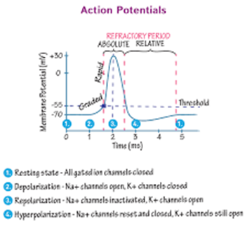
Question 2
What is the action potential that might result if the neuron is bathed in toxin tetrodotoxin TTX is known to block voltage-gated sodium channels
Tetrodotoxin (TTX) is a powerful poison that explicitly ties to voltage-gated sodium channels. TTX restricting truly impedes the progression of sodium particles through the channel, along these lines forestalling activity potential (AP) age and spread.
Question 3
Explain your rationale
TTX has diverse restricting affinities for various sodium channel isoforms. These distinctions are granted by amino corrosive replacements. Such replacements present TTX protection from an assortment of animal categories. Tetrodotoxin opposition, in any case, may include some significant pitfalls to execution brought about by changes in the biophysical properties as well as particle selectivity of the TTX safe sodium channels. We here audit the properties of sodium channels and their association with TTX and take a gander at some extraordinary instances of TTX safe channels wherein the advantage of poison obstruction might be counterbalanced by other social expenses.
Question 4
Superimpose the action potential that might result if the neuron had instead been bathed in toxin TEA is known to block voltage-gated K channels
TEA will increase the time needed for the inactivation of constant transient potassium ions in the suprachiasmatic nucleus of the neurons.
Question 5
Explain the rationale
Potassium ions have a critical role in neuron action potential firing that may lead to a frequency in circadian firing. TEA is mostly used to inhibit potassium ions in the electrophysiological recordings. TEA has a modulating effect on potassium ions that happens when there is contact with the membranes.
Question 6
Effect of acetylcholine on potassium and sodium ions as a result of opening neurotransmitter
Hyperpolarization will take place leading to some potassium channels opening and sodium channels reset.

Question 7
How do you know the terminals are presynaptic?
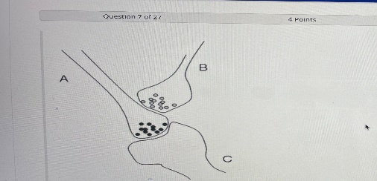
When the presynaptic terminals are observed through a microscope they are seen as small knobs that have many organelles. Most synaptic vesicles have neurotransmitters that are positioned on the terminal membrane which appear to be thick.
Question 8
Effects of gamma-aminobutyric acid on chloride ions
The enactment of GABAA receptors builds the intraneuronal convergence of chloride particles, prompting hyperpolarization, an activity shared by anxiolytic, entrancing, narcotic, and anticonvulsant drugs. Therefore, GABAA receptors are viewed as the primary objective for clinically compelling anxiolytic medications and some neurosteroids with possible anxiolytic properties.
Question 9
Suppose B is activated before neuron A. what do you think will happen to the probability that the glutamate vesicles containing neuron
A will be increased because of the collision and transitions that are taking place in the membranes.
Question 10
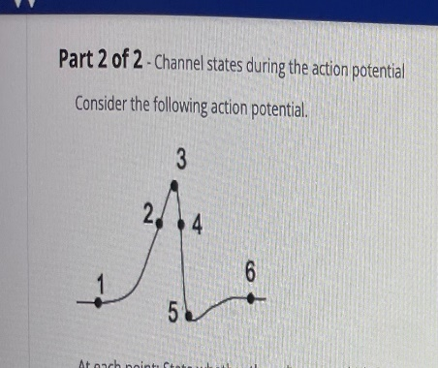
State at each point whether voltage-gated potassium ions are closed or open, state whether sodium ions are closed or open, state whether sodium ions are inactivated or deactivated
At point 2 potassium ions open and start leaving the cell and at point 5 potassium ions will be closed. Where potassium ions are activated and sodium ions deactivated.
At point 1 sodium ions open and enter the cell while at point 4 they close.
At location 1 potassium ions are closed
Question 11
At location 1 sodium gates are open
At location 1 the channel of sodium ions open.
Question 12
At location 1 sodium ions are inactivated
Question 13
At location 2 potassium ions are open
Question 14
At location 2 sodium ions are closed.
Question 15
At location 2 sodium ions channel is open
Question 16
At point 3 potassium ions channel gates are beginning to close.
Question 17
At location 3 sodium ion channel gates are closed.
Question 18
At location 3 sodium ions channels are becoming deinactivated.
Question 19
At location 4 potassium ion channel gates are open.
Question 20
At location 4 sodium ion channel gates become closed.
Question 21
At location 4 sodium channels are de-inactivated.
Questions 22
At point 5 potassium gates are closed.
Question 23
At location 5 sodium ion channels gates are open.
Question 24
At location 5 sodium ions channels are de-inactivated.
Question 25
At location 6 the potassium ion channels are open.
Question 26
At location 6 sodium channel gates are closed.
Question 27
At location 6 sodium ion channels are beginning to inactivate.

