Health and Nutrition
Institution:
Instructor:

Name:
Course code/name:
2018

Part I: Analyze diet
Three macronutrients in excess/deficit of CHO, PRO and fats and examples
The main categories of macronutrients that are necessary for the maintenance of the body include; proteins, fats and carbohydrates. The body can’t survive without these macronutrients and any deficit or excess of the same could result to health problem. For example, a deficit in calories could result to weight loss. Too much of calories or an excess will result to obesity. The body needs to regulate the amount of calories by burning the excess which can be achieved through exercises or eating less calories. Calorie is defined as the amount of food energy potential the body needs from the food. A calorie is a unit of energy (Myers, 2013).
Carbohydrates is the starch and sugars present for the body to use. These sugars and starch are needed by the body to use as a source of energy and to empower different body activities such as metabolism, muscular contraction, and brain function. Examples of carbohydrate foods include; potatoes, corn, seafood, seeds, herbs, dairy products such as ice cream and yogurt, sugary sweets legumes such as beans (Myers, 2013).
Protein contains amino acids, which are needed by the body for repair of the tissues as well as the proper functioning of the body’s immune system. It is important that 9 out of the 20 amino acids can be obtained from the animal and the vegetable sources of protein. Excess protein can be converted into energy. The deficiency of amino acids can result to a weak immune system and response. Examples of protein foods include; eggs, fish, shellfish, cheese, roasted pumpkin seeds, beef etc (Brock, & Diggs, 2013).
Foods have a combination of both unsaturated and saturated fats. Saturated fats are contained in eggs, dairy products, and vegetable oils while unsaturated fats are found in nuts, seed oils, and canola/olive oils. Fats are critical for formation and growth of cell membranes, which act as signaling molecules. They include omega-6 fatty acids and omega-3 fatty acid (Brock, & Diggs, 2013).
Five or more micronutrients that meet RDA approval and provides detailed explanations
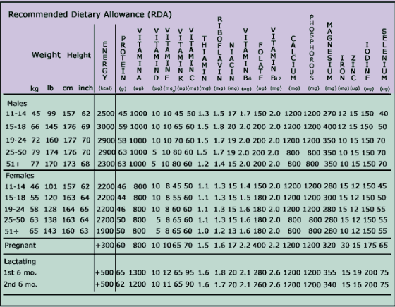
Energy RDA
Every person’s food energy intake should equal energy expended so that weight in maintained. For example, energy consumption of an individual determines the calories needed.
Protein RDA
Proteins needed in the body are mainly based on the body weight. 0.6 grams of protein/body kilogram is the average requirement.
Water recommendation
The average body needs at least six to eight ounce glasses of water or liquid daily. The larger the body, more water is needed.
Fiber
No recommendations for fiber however, they can be gotten from legumes, fruits, minerals, and water
Carbohydrate and fat
No RDA for carbohydrate and fat however, for carbohydrates, small amounts are needed since the same can be obtained from excess proteins and fats too (Groot, Et. al., 2016).
Part II: Evaluate how the patient’s diet affects: The person’s health (anatomy) The progression of the illness (pathophysiology) Common medications associated with the disease
Patient 2: S.W
The RDI of protein for men and women living with HIV is 100–150 g and 80–100 g, respectively [105]. The patient needs high intake of protein foods e.g. fish and eggs and beef to provide enough nutrients for body tissue development. Proteins added with ARVs will be a nice boost for the body to remain healthy. The patient also ought to take a balanced diet all through and do exercises regularly. She needs to take foods with high contents of iron such as eggs, beans, leaf vegetable, cashews, milk, whole grain and enriched breads, baked potatoes. The rich iron foods will give her bones calcium and make them strong. The foods will also work well with the calcium medication.
Part III: Create patient SMART goals and an evidence-based plan of care (patient education) Begin by selecting one of the patient profiles.
Calculations
CHO
For patient 2 and 3, they need a calorie intake of roughly 1527Kcal. The BMI plus activity and food intake is the calculation documented below. 112 X 10 = 1120 X 0.20 (activity) = 224 + 1120 = 1344 X 0.1(food) = 134 + 1344 = 1478 calories/day.
1478 X 0.65 = 960 calories then/by 4 calories/gram = 240 grams/day,
1478 X 0.45 = 665 calories then/by 4calories/gram = 166 grams/day
Daily range 665-960 calories/day from CHO, 166 - 240 grams/day,
PRO
Patient needs 1.5 to 2.0 times the normal intake of protein; at a minimum, a cystic fibrosis patient would need 57.3 grams to 76.4 grams of protein per day.
112 lb. / 2.2 kg/lb. = 50.9 kg. X 0.8 gm/kg = 40.7 grams protein daily
FAT
There is no restriction on fat intake
2839 X 0.35 = 568 calories then/by 9 calories/gram = 63 grams/day
SMART Goals
Patient 2
SMART goal 1- Due to the low immune system because of AIDS, the patient will need to eat regularly a well-balanced diet. For example, high in protein and fat. SMART goal 2- physical exercise is important to boost the body’s strength as well as adhering to medication requirements. The patient will develop a dietary program that ensures a balanced diet and at the same time maintaining of body weight by exercising regularly. The patient can consume 2 meals in a day. 100% of breakfast and 70% of lunch (Krešić, Et. al, 2018).

References
Brock, K. G., & Diggs, G. M. (2013). The hunter-gatherer within: Health and the natural human diet.
De Groot, C. P., Van Den Broek, T., & Van Staveren, W. (2016). Energy intake and micronutrient intake in elderly Europeans: seeking the minimum requirement in the SENECA study. Age and ageing, 28(5), 469-474.
Krešić, G., Šimundić, B., Mandić, M. L., Kenđel, G., & Žeželj, S. P. (2018). Daily menus can result in suboptimal nutrient intakes, especially calcium, of adolescents living in dormitories. Nutrition research, 28(3), 156-165.
Myers, L. (2013). No Excuses: The Fit Mind - Fit Body Strategy Book. Cork: BookBaby.
Nelson, A. (2012). Unequal treatment: confronting racial and ethnic disparities in health care. Journal of the National Medical Association, 94(8), 666

