Health and Nutrition
Institution:
Instructor:

Name:
Course code/name:
2018

Part I: Analyze diet (Patient 2)
Criterion 1: Three macronutrients in excess/deficit of CHO, PRO and fats and examples
The main categories of macronutrients that are necessary for the maintenance of the body include; proteins, fats and carbohydrates. The body can’t survive without these macronutrients and any deficit or excess of the same could result to health problem. For example, a deficit in calories could result to weight loss and the patient needs to be strong in order to fight opportunistic diseases. Too much of calories or an excess will result to obesity. The body needs to regulate the amount of calories by burning the excess which can be achieved through exercises or eating less calories. Calorie is defined as the amount of food energy potential the body needs from the food. A calorie is a unit of energy (Myers, 2013).
Carbohydrates is the starch and sugars present for the body to use. These sugars and starch are needed by the body to use as a source of energy and to empower different body activities such as metabolism, muscular contraction, and brain function. Examples of carbohydrate foods include; potatoes, corn, seafood, seeds, herbs, dairy products such as ice cream and yogurt, sugary sweets legumes such as beans (Myers, 2013).
Protein contains amino acids, which are needed by the body for repair of the tissues as well as the proper functioning of the body’s immune system. It is important that 9 out of the 20 amino acids can be obtained from the animal and the vegetable sources of protein. Excess protein can be converted into energy. The deficiency of amino acids can result to a weak immune system and response. Examples of protein foods include; eggs, fish, shellfish, cheese, roasted pumpkin seeds, beef etc (Brock, & Diggs, 2013).
Foods have a combination of both unsaturated and saturated fats. Saturated fats are contained in eggs, dairy products, and vegetable oils while unsaturated fats are found in nuts, seed oils, and canola/olive oils. Fats are critical for formation and growth of cell membranes, which act as signaling molecules. They include omega-6 fatty acids and omega-3 fatty acid (Brock, & Diggs, 2013). After the evaluation of the patient’s diet, the diet is balanced with CHO, PRO and fat contents.
Criterion 2: Five or more micronutrients that meet RDA approval and provides detailed explanations
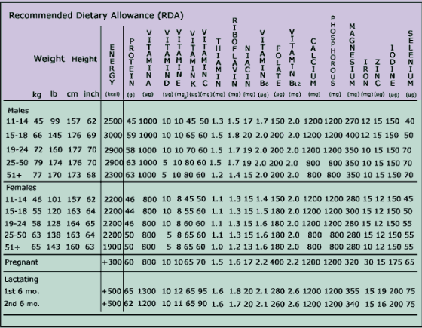
Energy RDA
Every person’s food energy intake should equal energy expended so that weight in maintained. For example, energy consumption of an individual determines the calories needed.
Protein RDA
Proteins needed in the body are mainly based on the body weight. 0.6 grams of protein/body kilogram is the average requirement.
Water recommendation
The average body needs at least six to eight ounce glasses of water or liquid daily. The larger the body, more water is needed.
Fiber
No recommendations for fiber however, they can be gotten from legumes, fruits, minerals, and water
Carbohydrate and fat
No RDA for carbohydrate and fat however, for carbohydrates, small amounts are needed since the same can be obtained from excess proteins and fats too (Groot, Et. al., 2016).
The following is MyFitnessPal screenshot of patient 2’s breakfast, lunch, dinner, and snacks.
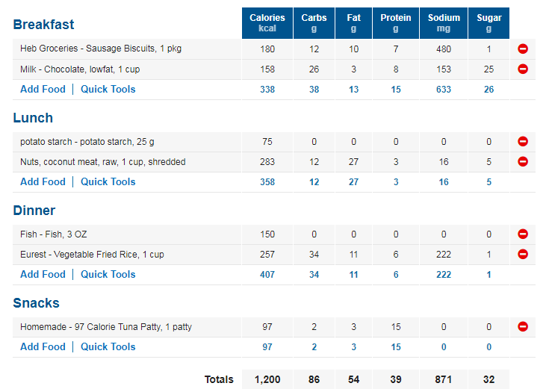
Part II:
Criterion1: Person’s diet
HIV/AIDS has a devastating impact towards the patient’s health and nutrition. It is important that the patient to look at personal health at a different angle. The patient need to understand that HIV related infections are common and she needs to improve on her dietary quality and increase the dietary intake in order to keep the body strong and able to fight with diseases. Severe nutritional intake could result to loss of weight and appetite and cause the body to be more prone to opportunistic diseases. Maintaining physical activity is a major milestone towards muscle strength. The patient also need to increase energy intake. Research shows that increased energy demands are usual to HIV infected persons thus it demands high-energy intake for any HIV/AIDS patient. The patient ought to consume more of vegetables, proteins and food containing high contents of iron. It is important for the patient to avoid high fat foods and snacks.
Criterion 2: Food interaction with medication
The RDI of protein for men and women living with HIV is 100–150 g and 80–100 g, respectively [105]. The patient needs high intake of protein foods e.g. fish and eggs and beef to provide enough nutrients for body tissue development. Proteins added with ARVs will be a nice boost for the body to remain healthy. The patient also ought to take a balanced diet all through and do exercises regularly. She needs to take foods with high contents of iron such as eggs, beans, leaf vegetable, cashews, milk, whole grain and enriched breads, baked potatoes. The rich iron foods will give her bones calcium and make them strong. The foods will also work well with the calcium medication.
Part III:
Criterion 1:
Calculations for patient 2
BMI
Weight/height
Height (m)
(95 X 0.45)/(62 X 0.025)
42.75/1.55 =17.79BMI
1.55
BMR
BMR = 655 + (4.35 x 42.75) + (4.7 x 62) - (4.7 x 35)
655+ 185.9625+ 291.4-164.5
967.8625BMR
CHO
1200 X 0.45=540 divided by 4 calories per gram= 135grams/day
1200 X 0.65= 780 divided by 4 calories/gram= 195 grams/day
Daily range 540-960 calories/day from 166-135-195 grams/day
PRO
The recommended is 1.5 to 2.0 per day and a minimum cystic fibrosis of 57.3grams- 76.4grams/day.
FAT
There is no restriction on fat intake
1200 X 0.35 = 420 calories then/by 9 calories/gram = 46.7 grams/day
1200X 0.40= 480 Cal/9 calories/gram= 53.3grams/day
Daily range 420-480 Cal/day or 46.7-53.3 grams/day
Criterion 2: SMART Goals
Over time, HIV kills the defense system of the body against diseases and the patient needs to develop a number of strategies or goals that need to be followed in order to maintain a healthy life. The patient need to better assess her nutritional needs and this can be perfectly done with the help of a registered dietician or a primary health care professional. It is therefore wise to consult health advice from a dietitian before making several changes towards a healthy eating.
In order to decrease the amount of sodium she consumes, the client can follow the following strategies to attain the goal.
- Individual dietary counselling in order to understand the kind of food to eat that has little and adequate sodium
- Food labelling. Food cooked should be well labelled and amount of sodium contained labeled
- Use sodium’s that are generally regarded as safe (GRAS)
Three nursing strategies to achieve SMART goals
- Align the goals with the health values. Setting goals that bring value to the body is key. It is important to seek medical, nutritional guidance in the goal alignment
- Assembling all the health needs before embarking on the SMART goals. e.g. collecting the needed menu and medications
- Consulting the health educator, instructor for guidance towards the accomplishment of the SMART goals.
SMART goal 1- Due to the low immune system because of AIDS, the patient will need to eat regularly a well-balanced diet. For example, high in protein and fat. The patient will develop a dietary program that ensures a balanced diet and at the same time maintaining of body weight by exercising regularly. The patient can consume 2 meals in a day. 100% of breakfast and 70% of lunch (Krešić, Et. al, 2018).
SMART goal 2- physical exercise is important to boost the body’s strength as well as adhering to medication requirements. It is important to educate the patient on the importance of physical exercise and how it could help her to remain strong and healthy. In teaching the patient how to do it, it is important to understand what she is willing to do during the physical exercise time and demonstrate the right techniques that will effectively enhance muscle growth and keep the body fit. Aerobics exercises will also do well for the patient.
SMART goal 3 is to take diet and medication all together seriously. The patient needs to maintain healthy eating habits with a balanced diet and high-energy intake. This should be taken seriously in line with the medication. The antiretroviral therapy should also be taken seriously as prescribed by the health specialist. The current diet of 1200 is good for the patient and if well maintained, it is right for the health of the patient. This strategy will help in building a strong immune system and keep the patient safe from opportunistic diseases.
References
Brock, K. G., & Diggs, G. M. (2013). The hunter-gatherer within: Health and the natural human diet.
De Groot, C. P., Van Den Broek, T., & Van Staveren, W. (2016). Energy intake and micronutrient intake in elderly Europeans: seeking the minimum requirement in the SENECA study. Age and ageing, 28(5), 469-474.
Krešić, G., Šimundić, B., Mandić, M. L., Kenđel, G., & Žeželj, S. P. (2018). Daily menus can result in suboptimal nutrient intakes, especially calcium, of adolescents living in dormitories. Nutrition research, 28(3), 156-165.
Myers, L. (2013). No Excuses: The Fit Mind - Fit Body Strategy Book. Cork: BookBaby.
Nelson, A. (2012). Unequal treatment: confronting racial and ethnic disparities in health care. Journal of the National Medical Association, 94(8), 666

