Observation of Sociability Behavior in Famous Las Vegas Sign

Name
Institution
Course
Instructor
Date

Observation of Sociability Behavior in Famous Las Vegas Sign
Observation Background
Famous Las Vegas Sign is among the well-recognized historical landmarks developed in 1959. The Park has a sign with the words “Welcome to Fabulous Las Vegas sign” and is established in the median at 5100 Las Vegas Boulevard South. Individuals can easily visit the Park because of its fascinating location, which is outside the city restrictions. Therefore, I observed the Park for thirty minutes from 22:00 to 22:30 on 11th October 2021.
The behavior selected to observe is sociability because of the coronavirus pandemic; the behavior was essential in understanding how individual social status is affected. Operation definition: sociability is the tendency of individuals to be cooperative with others, go out with friends and have fun. Individuals behave socially through involvement in certain activities and events that make them happy and feel concerned and empathetic. The reason for selecting sociability behavior is because the majority of the individuals that come to the Park always come to have fun by taking photographs and enjoying with their friends. This is through creating memories together.
Coronavirus pandemic increased tremendously in early 2020. Therefore, Zuo et al. (2020) performed a study to understand the effects of the pandemic on the mobility and sociability of individuals. The authors analyzed data from cities like New York City and Seattle because the coronavirus had already hit them. The data indicates that the transport industry and individuals’ socialization is highly affected because of the restrictions set, such as social distancing to reduce the spread of the virus (Zuo et al., 2020). I quantified the behavior based on how individuals take photos and how different groups interact and communicate while in the Park. For example, four groups of people interacted closely and took a picture together during the thirty minutes. Only one woman was carried by a man when taking a shot during the thirty minutes. Different groups that came separately interacted alone without other groups. The study hypothesis is the virus has significant effects on individuals’ sociability behavior.
Observation Field Notes
The webcam begins with a group of individuals taking photos in the Park. The group of four individuals takes pictures together, with the lady being at the center. After several shots, they show each other at 22:01 while two groups enter the Park (EarthCam, n.d). The first group is a couple who converse together take a picture together. They can be viewed to be couples. The next group comprises two men, three women a child. They are close to each other and take a selfie while standing close at 22:15 (EarthCam, n.d). Nevertheless, the group does not interact very closely but is seen chatting in various ways and seeing each other photos at 22:20. Another group comes in with three individuals comprising of two men and a woman. The two individuals go close to the sign, and the man carries the woman while the other man takes a photo at 22:28.
Observational Results
Based on the observation, I found out that individuals increased their interaction among themselves. The group that knew each other and came out together socialized and had fun together. Some even raised their hands and jumped up to get a better picture. Also, the couples had a good experience in Park. However, the different groups did not interact efficiently. I concluded that people are still afraid of the virus and fear interacting with other groups they do not know. However, I believe the vaccines have allowed people to socialize because they can slightly come out to the sign together. I have confirmed the hypothesis that the virus affects individuals’ socialization; as the webcam shows, the majority of the individuals seem to have limitations in their interaction. The observation went well because I had a good internet connection, and the webcam was well visible and indicating the timestamp. I was able to pause the video and record my observation effectively and continue with the video again.

References
EarthCam. (n.d). Welcome to Fabulous Las Vegas. https://www.earthcam.com/usa/nevada/lasvegas/?cam=sign_hd
Zuo, F., Wang, J., Gao, J., Ozbay, K., Ban, X. J., Shen, Y., ... & Iyer, S. (2020). An interactive data visualization and analytics tool to evaluate mobility and sociability trends during covid-19. arXiv preprint arXiv:2006.14882.

Appendix
- Individuals interact together while taking pictures.
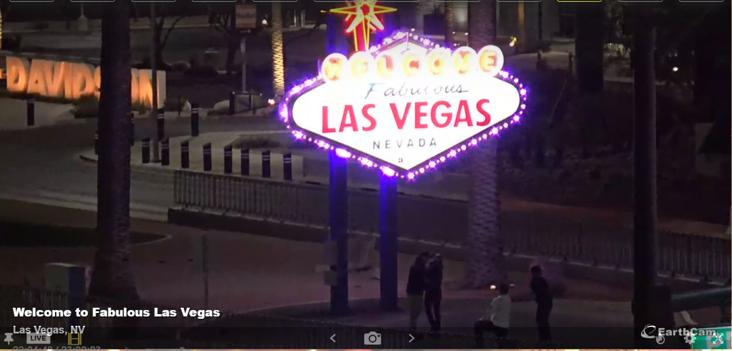
- More groups come in and interact
