Name
Instructor
Course
Date
Opium War
The Opium War (Anglo-Chinese War) refers to the armed conflict between the Qing Dynasty of China and the United Kingdom. This war was due to the different perception on trade imbalance between the two countries and justice system China meted on opium traders. During 17th and 18th century China enjoyed a balance of trade between her and United Kingdom. It exported tea, silk, and tea which had significant demand in the UK. Consequently, Great Britain devised a method to shift the deficit by shipping opium to China through the British East India Company through the Canton city’s port.
The increasing presence of opium in China caused both social and economic effect. Firstly, it altered the trade balance in favor of Great Britain. Secondly, it led to the rise in the number of drug addicts which threatened Chinese social fabric. It is worth noting that opium and its products were already banned in the country since 1729. Great Britain thus promoted the violation of the country's laws by hiring middlemen, mostly Chinese, to ferry the products into Qing Dynasty. The Daoguang Emperor introduced drastic measures in 1839 to reverse the situation. Some of the measures included banning opium trade and blocking external trade at Canton. The British government retaliated by military invasion to the Chinese Empire.
In 1842, the Chinese Emperor involuntarily signed the Treaty of Nanking. This treaty granted Britain indemnity and extraterritoriality leading to the annexing of Hong Kong. The conflict over Hong Kong is still ongoing with Chinese government insisting it is under its administration.
The Opium War is critical as it depicts the nature of intercontinental trade that existed in the 16th and 20th century. It is interesting to note that countries were using unorthodox means to shift the trade balance to their favor. For instance, the British government adopted crude methods of supplying opium to China to gain an advantage. Secondly, it shows the changing trading policy during these centuries that would later influence economic ideology. For example, the British and Europe adopted capitalist approach whereas China employed Confucian-Modernist model.
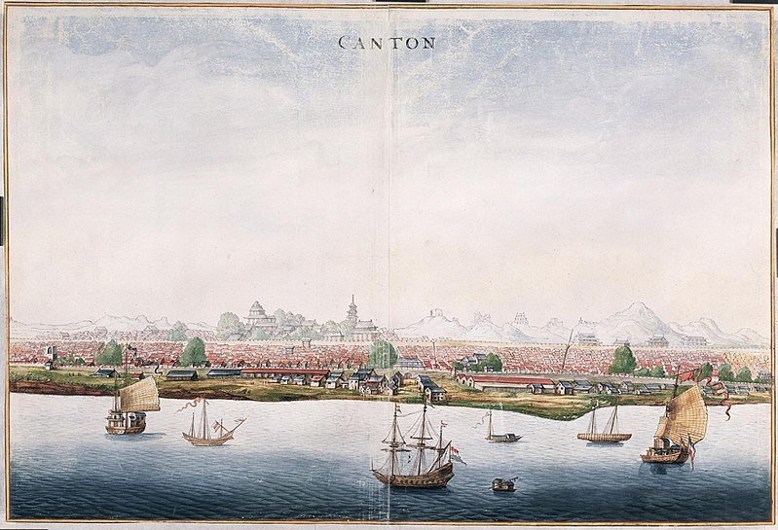
Canton City with ships from Dutch East India Company in 1665. Source: Atlas of Mutual Heritage.
The picture above the Southern Port city of Canton which was the primary gateway into China by European traders. Similarly, it was used by Great Britain to supply opium into Chine Empire to tilt trade in their favor. It would later fall into the hands of the British government after the first opium war.

