Overview of The Play Othello
Student’s Name
Institution

Overview of The Play Othello
In the play Othello, I would dress the main character in black and white. The protagonist, Othello wears a black leather jacket, a smooth soft-fabric white shirt and a black soft-jeans trouser. The Character also puts on black, quality, leather boots giving them a serious and fearful look. The whole fabric for the character remains of high quality to symbolize the societal status of Othello as an energetic man (Jain et al., 2018). The look displays a serious military man that as a Venetian Army captain. The color symbolizes the evil and deceitful mood of the play. Lago, the antagonist displays most of his evil plans and behavior during the night. The play itself introduces in a night setting. Darkness translates to wickedness and the play harbors scenes of evil and darkness. Othello, the protagonist closes the play with chills as he murders his innocent wife and later commits suicide.
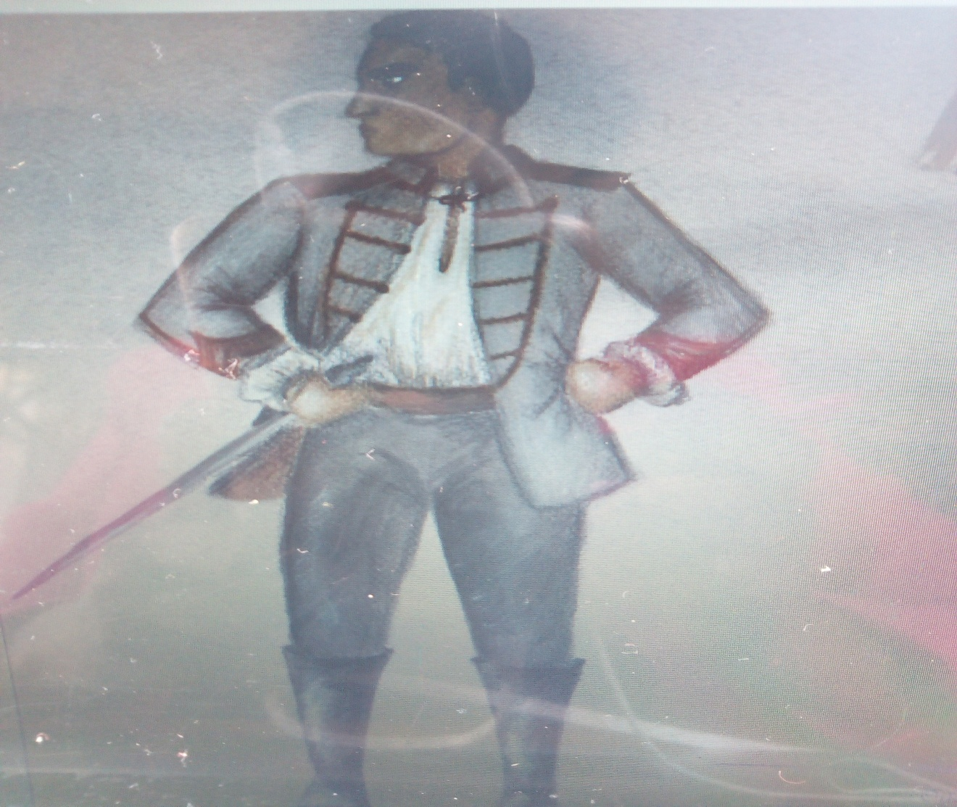
Figure 1: OTHELLO’S Sketch from Othello by Shakespeare

References
Jain, S., Verma, S., Kumar, S., & Aggarwal, S. (2018, July). An evolutionary learning approach to play Othello using XCS. In 2018 IEEE Congress on Evolutionary Computation (CEC) (pp. 1-8). IEEE.

