Word Choice: A Look into the American Media Attack on Saudi Arabia over Khashoggi's Death

2019

Introduction

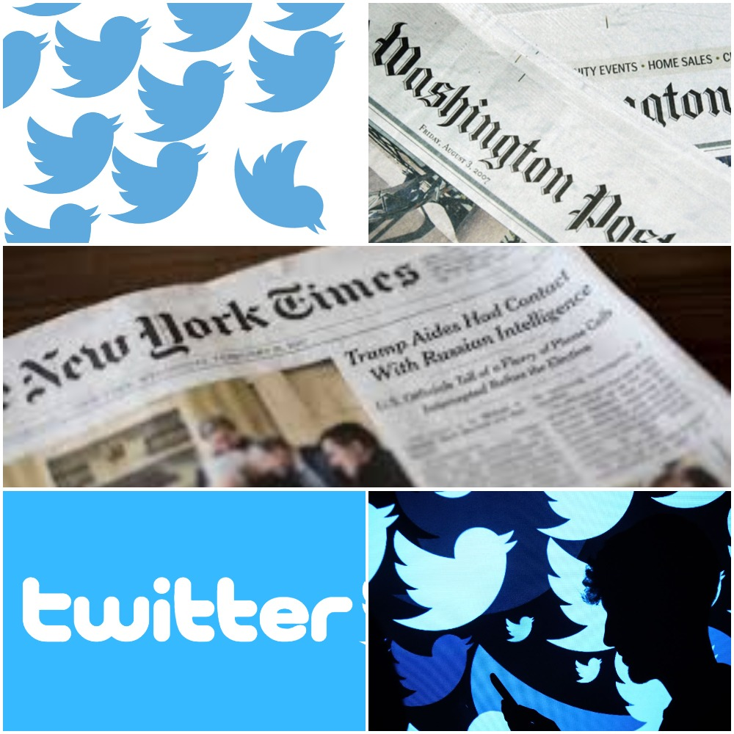 | Abstract

In the last couple of months, Saudi Arabia has been subjected to a wave of fierce attack from major western media outlets, especially the American ones such as The Washington Post and The New York Times newspapers and many others. This attack, which is still ongoing in the time of writing this paper, comes after news of the killing of the Saudi journalist Jamal Khashoggi inside the Saudi consulate in Istanbul, Turkey, have swept all over the world. Given how bizarre the incident was, as well as its timeliness and massive impact on the image and reputation of the Saudi government and people, the paper produces a brief analysis of the phenomenon in the sense of both its extent and depth; the analysis is critical to realize the broad context of this state of affairs as well as its function and results. Indeed, and from the beginning, there was a set of linguist practices that helped shape popular, informative false ideas which are very well imbued with pure political acts even when, and especially if, ‘the political’ conceals itself (Schmitt, 1932).
But what is also of paramount importance is the arena in which such acts have taken place with unprecedented manner, namely, social media platforms; for ever since these new media platforms were considered as alternative spaces of expression and as more democratic than the traditional institutions of media, their importance has been intensifying especially for those concerned with discourse analysis. We can, for instance, observe that although the incident under investigation has been viewed in no small degree in light of a case of extrajudicial killing, it has nevertheless provoked a particular type of discourse that is characterized by political pragmatism and concealment.
The absence of statistical and empirical material in the paper will be noticed, since only descriptive and theoretical approaches were used, along with real samples of texts, forming a methodology that best suits the nature of the topic. The content analysis proceeds from examining discourse elements critically with a focus on wording, direct and indirect implications, and the historical, lexical load of meaning. A commentary type of organization is applied, where a text is followed by a comment of analysis; thus the whole issue is going to be tackled in the following lines by mainly examining four selected textual excerpts which are actual tweets that attracted much attention and have been extensively circulated in -and even out of- Twitter network, all written by Karen Attiah. As mentioned, this examination aims to reveal the language-games within texts, which according to Wittgenstein, reflect that language is not somehow separate from and corresponding to reality (Wittgenstein, 1953). This paper attempts to do just that, in a way that, hopefully, enhance the understanding of journalistic techniques, which aside from being hugely related to funding partners and other ideological details, are in essence of linguistic nature.

Excerpt1
"It’s easy to get lost in the grief and outrage over Trump siding Saudi regime that thinks nothing of butchering peaceful journalists in consulates. But hope is not all lost. Congress must act, and the American people can still help."

In this tweet, Karen Attiah uses a way of discourse known for creating a specific image of an entity, whether that entity is a person, a group, an establishment, a government or even a country. That image-making is, in essence, a reproduction of some reality but with the involvement of specific ideological or political agenda that create particular versions of the world (Fairclough, 2000). The result can sometimes be, especially for widely uncritical audiences, an easily grasped idea (and equally false), which is precisely represented here in the tweet.
Technically speaking, and from highly linguistic point of view, Attiah's use of words like 'journalists' and 'consulates' in the plural form instead of the singular, does not simply reflect a purely stylistic choice of words, it rather comes in the context of deforming Saudi Arabia's reputation in the international scene by carefully conveying the implication that what has happened to Khashoggi is something usual and practiced regularly on behalf of the Saudi government. Of course, the audience does not necessarily have to absorb this implication literally, but the implication nonetheless stands still and conveys the aimed message with linguistic efficiency.
The last part of the tweet, in which Attiah urges the Congress and encourages the American people to act according to her objectives, uncovers the ultimate goal behind this tweet, but at the same time, makes it legitimate and morally unquestionable; and, interestingly enough, depoliticizes what is political. This concealment of 'the political' as Carl Schmitt defines it, is one distinguished feature that finds its roots in the modern liberal state, where the political is thought of and exhibited as something at the contrary to the cultural, the economic, the religious, the jurisdictional and the scientific. Although the interrelation between these concepts is self-evident, there has been a historical tendency within liberal democracies to distinguish them with each other not in the sense of clarifying their hidden meanings and functional boundaries, but in the sense of contrasting the political concept with the other ones (Schmitt, 1932). Of course, this goes beyond Attiah's tweet or even Khashoggi's death, and it applies to one degree or another to all media discourses. However, it reflects some form of persistent delusion that an event like, say, human rights abuse, can be tackled and condemned in itself without engaging with the political thinking, making the latter appear -falsely- less relevant or temporary suspended.

Excerpt 2
"Congress must investigate Trump’s and Jared Kushner's financial dealings with Saudi Arabia and Mohammed bin Salman and resulting conflicts of interest. MbS once reportedly bragged about having Kushner “in his pocket”"

The political goal that drives Attiah becomes even more present within this tweet. In order for this to be clear, it is of grave importance to understand the political scene in democratic societies in general and in the United States in particular. Political players invest in all what could be of benefit to gain public sympathy and better political position; media is one excellent example (Nguyen, 2011; Gurevitch, Coleman & Blumler, 2009). In the case of the United States, the long historical feud between the Democratic party on the one hand and the Republican party on the other finds its way through almost all the news that make the local headlines, let alone an incident that provoked global media turmoil and international interest. Attiah, being a prominent journalist in a newspaper that has historically been identified with the democratic party, and being herself at the opposite side of the American president Donald Trump, a Republican, and his entire administration and party, will surely have all the reasons to use the incident rather politically.
When we view this tweet in its specific social and political context, we see that Attiah almost uses His Royal Highness the Crown Prince's name only as a secondary element in the tweet, or as mere catalyst. She directs the attention to both Trump and his senior advisor Kushner to reassert what The Washington Post, along with other high-profile Democratic newspapers have been asserting for more than a year, that Trump and Kushner have personal financial relations in Saudi Arabia, Russia and other countries that may be at odds with the national interest of the United States and the American people.

Excerpt 3
"There is talk that the Saudis may choose a woman ambassador (Princess Reema) to come to Washington. Women shouldn’t be used to whitewash brutality Especially as long as Saudi Arabia is jailing, torturing, + sexually abusing women’s rights activists."

This tweet is better understood in light of contemporary Western culture, in which feminism and women's rights movements are prospering and, at least in the United States, are relying on massive acknowledgment and support by various institutions as well as liberal celebrities and intellectuals including those who are members of or voters for the Democratic party. While the struggle to improve women's conditions even in Western societies is real, it has, however, always been a ground for pure political conflict as well as discourse exchange.
The extent to which this conflict has reached may be described as "language wars" if we are to borrow Jeff Lewis's concept. In the modern age, language wars are conducted through the mass media which involves constantly changing signs and signifiers that are adapted and sometimes revived to serve as tools of meaning (Lewis, 2005). Attiah, who is engaged in these circumstances, neglects the recently-made efforts by the Saudi government regarding women's rights. Some of those efforts and decisions were so significant to the point that they were described as "historical" by many news outlets, including American ones; most notably was the decision to allow women to issue driving licenses and drive their vehicles by themselves.
However, this negligence is not a matter of ignorance towards the Middle East complexities, given Attiah's position as senior editor and journalist, as well as her professional focus on the region; but it is instead a matter of deliberate linguistic choice (Cruse, 2011). By starting the tweet with mere rumors, she jumps to virtual defending of women to portray the Saudi government as brutal one which is in favor of using women to its own ends, the thing that, ironically, she is doing. While it is true that media has always been imbued with 'the political' as Schmidt defines it, we can still find that there is as much share for cultural imagining and inspirations as for political goals.

Excerpt 4
"As a black woman, I am tired of seeing black, brown and Arab bodies treated as disposable by violent state agents. We shouldn't be choked to death on New York sidewalks. Or strangled and dismembered in consulates."

This tweet is by far the most outstanding example in which social and racial tensions of the American history are deployed without any regard to their right context. Attiah here refers to the death of Eric Garner, black American man killed by policemen in New York City in 2014 in a case of police brutality that caused many protests all across the country. Of course, the case of Khashoggi has no relevance to this particular case nor does it relate to the historical atrocities and discrimination practiced since the times of American settlers before the independence and up to at least the seventh decade of the twentieth century (and let us not forget the current 'Black Lives Matter' movement), but it portrays a complete case of mixing domestic issues to international ones, a common practice by American policy and media makers usually results in a kind of factual misrepresentation that ultimately constitutes misleading and falsely described events (Chomsky, 2017).
This linguistic maneuver, however, builds feelings of sympathy with what Attiah is saying among marginalized racial groups inside American society. This text seeks to establish a sort of social solidarity using a specific view that may be labeled progressive within contemporary American culture. This progressiveness is deeply related to what has been known in American media as 'political correctness', a well-known characteristic of the current social and political life in the United States that is historically associated with the liberal left (and the democratic party), against which the president now in office, Donald Trump, expressed hostility and contempt since the early stages of his political campaign for the presidency. However, the progressive creed is not something constrained to the political life, rather, it has been forcing itself into all sorts of cultural activity (journalism, books, film, theater, etc.) so much so that this tweet loses its heavy load of meaning if viewed in isolation to the cultural setting in today's America. Once again, towards the end of the text, we see the use of the word 'consulates' in the plural, to reassert the deforming factor mentioned earlier in the analysis of excerpt 1.

Conclusion
It is evident that modern western culture celebrates new technology and align itself with cyber patterns of discourse as in social media platforms. However, before jumping to cultural reasoning regarding the case, it is worth mentioning that this attractiveness of social media is experienced throughout the whole world, even in developed and underdeveloped countries (although with some limitations due to infrastructural incompetence), and not just in western societies. However, it is in the West that we observe its ultimate realization since it was originated in the same western capitalist society. It was an essential objective of this paper to notify that social media is not to be understood as new outlets of expression and discourse exchange only, instead, it is more accurate to view them firstly as commercial products with entities that produce, improve, maintain and making revenue out of them.
With that put into consideration, we can understand how and why in all shapes, traditional and new, media has been so effective in cultural transformations to the point that Heidegger pessimistically referred to it as ‘world as picture’ (Lewis, 2005), indicating that humanity has lost its ability to view the world as it is, since the world became only presented through non-neutral mediums. This lack of neutrality is not a mere product of ill intentions, but it is an inevitable result of the intersecting with the political, which Schmitt says cannot be neutralized since it seeks, in principle, to achieve an ideological goal. In this light, Twitter is of significant influence in the political sphere, without regard to whether or not it serves just causes and legitimate public demands.
It has been shown throughout the paper that Twitter virtually enables all sorts of discourses to broaden their reception range, as seen in the case of Attiah's tweets, which not only caused unmeasurable damage but rather attracted more sympathizers over time. The paper has portrayed how Twitter, being fashionable and easy-to-access space of discourse interaction, has been -and remains to be- a virtual political tool to affect people's opinions, feelings and attitudes. Indeed, it should always be taken into consideration that the lack of and the need for professional and organized media counter-attack effort on the global level has contributed dramatically in placing Saudi Arabia in a compromising position. Such professionalism was, unfortunately, missing from the scene, allowing the whole situation to be that of a single-sided offense.

References
Attiah, Karen, (2018, November 21), [tweet]. Retrieved from: https://twitter.com/karenattiah/status/1065242625421262853?s=21
Attiah, Karen (2018, November 21), [tweet]. Retrieved from: https://twitter.com/karenattiah/status/1065246780206563329?s=21
Attiah, Karen (2018, November 21), [tweet]. Retrieved from: https://twitter.com/karenattiah/status/1065254726525161472?s=21
Attiah, Karen (2018, December 5), [tweet]. Retrieved from:
https://twitter.com/KarenAttiah/status/1072614272545497090
Chomsky, Noam (2017), Global Discontents, Penguin Random House.
Cruse, Alan (2011), Meaning in Language: An Introduction to Semantics and Pragmatics, Oxford University Press.
Fairclough, Norman (2000), New Labour, New Language? Routledge.
Gurevitch, Michael, Coleman, Stephen & Blumler, Jay G. (2009), Political communication: Old and New Media Relationships, Sage Journals.
Kramsch, Claire (1998), Language and Culture, Oxford University Press.
Lewis, Jeff (2005), Language Wars: The Role of Media and Culture in Global Terror and Political Violence, Pluto Press.
Schmitt, Carl (1932), Der Begriff des Politischen [The Concept of the Political], The University of Chicago Press.
Wittgenstein, Ludwig (1953), Philosophical Investigations. Blackwell.

A tweet is a short message composed and shared by users of the social media service Twitter. It can hold up to 280 letters maximumly.
Some analysts believe that Trump's refusal of political correctness was significant to his success, marking the split and polarization of contemporary America.

