
t1
t₂
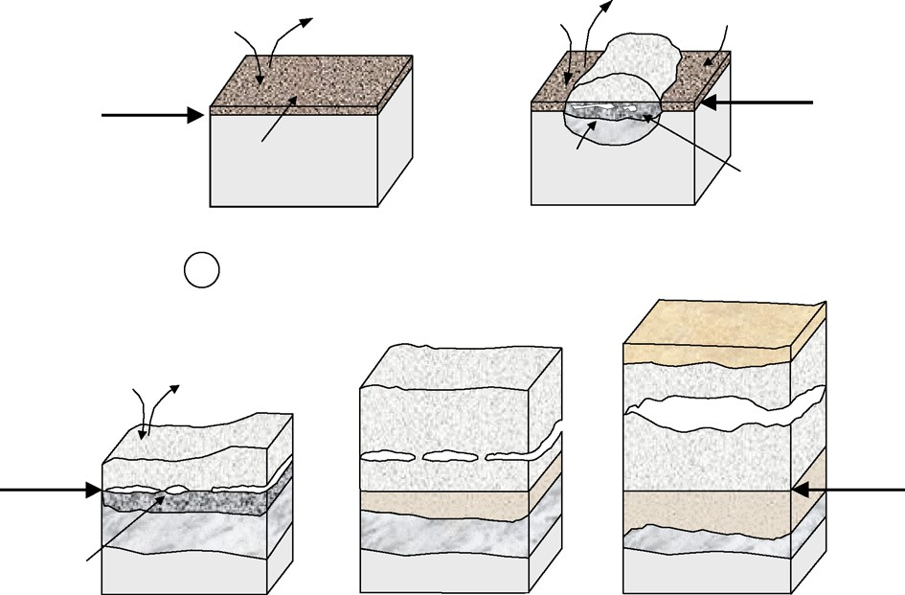
H2
H2O
H2
H2O
protective spinel
alloy surface
Fe3O4
alloy surface
protective spinel
Alloy
FeO + Cr O
2 3
Alloy
Fe3O4 +
Cr2O3
t3
t4
t5

Fe2O3
H2O
H
2
orginal alloy surface
Fe O
Fe3O4
3 4
Fe O
3 4
orginal alloy surface
Fe3O4 + (Fe, Cr)3O4 FeO + Cr2O3
Alloy
Fe3O4 + (Fe, Cr)3O4
Fe3O4 +
Cr2O3
FeO + Cr2O3
Alloy
FeO + Cr O
2 3
Alloy
Fig. 7. Schematic illustration showing scale formation of 9–12%Cr steels in Ar–H₂O mixtures in the temperature range 550–650 °C. Exact mechanisms and times depend on steel composition and exposure temperature. In case of 10Cr–Mo–W steel at 650 °C the time t₅ is approximately 2–5 h, after Ref.

0.30
P(H2O) = 101325 Pa
P(H2O) = 32500 Pa
P(H2O) = 15000 Pa
T = 1000oC

0.25

0.20
-2
⊗m / S (mg cm )

0.15

0.10

0.05

0.00
0 10 20 30 40 50
t / h
Fig. 1. Weight gain vs. time. water vapour-ratio eﬀect on Kanthal-A1 oxidation at 1000 °C, after Ref. [4].

The presence of water vapor where industries use metallic materials under high pressure correlates with power generation petrochemical, and aerospace sectors. Power station boilers and heat recovery steam generators are extreme cases where the moisture content is 100%. The combustion of biofuels and fossil fuels produces an atmosphere very rich in water vapor. Critical attention to the impact of water vapor on high-temperature oxidation is a consequential effect of the development of solid oxide fuel cells. The interconnect material must demonstrate resistance to reducing and oxidizing atmosphere, which is both rich in water vapor. Steam is also presented in numerous petrochemical processes within reducing environments. The presence of water vapor is also relevant in the fabrication of vessels of tubes from metallic materials, through the oxide protective layer. Dry oxygen or a mixture of oxygen and steam provides the oxidizing environment of silica to from the oxidation of silicon. Previous historical records show no meaning in addressing the influence of water vapor on the rate of reaction and resultant microstructure for experiments with 3% moisture content. Additional research found a basis of influence by H2/H2O mixtures on oxide compounds. The paper studies the kinetics involved in the growth of oxide compounds within an environment with vapor. Te focus will be on alumina, chromia, silica and influence of water vapor on titanium and its alloys, and oxides of iron and nickel.
Kinetic effects
Alumina
The reports on the influence of water vapor on alumina forming alloys are contradictory. A wide-ranging review in 1994 found less than significant influence in oxidation. However, the results also indicated magnesium dopes aluminas had hydrogen defects and water vapor reduced scale adhesion. Vapor encourages the formation of hexagonal oxides, with a similar structure to α-Al2O3 which eventually forms. Dry oxygen, on the other hand initially forms cubic ϒ-Al2O3. The hexagonal alumina has traces of Fe and Cr, which demonstrated lower protection than α-alumina developed in the environments free from the vapor. Water vapor encouraged enhanced gaseous support, therefore leading to the early formation of a stable protective layer. The formation eliminated any differences in composition and oxide microstructure, with Al depletion leading to breakaway. Hydrated alumina may have formed in the early stages of growth in the wet atmosphere which was more susceptible to cracking, and this led to the increase in nodule formation.
The influence of water vapor in oxidation at temperatures of 900⁰C is insignificant but reduces scale adhesion. At 700⁰C, vapor promoted internal oxidation and inhibited selective oxidation of alumina. The water molecules present affected the interfacial toughness of the α-Al2O3/ alloy. When cracking and spalling of alumina scales in dry air, water molecules doubled the degradation rate. However, lack of any cracking or spalling limited the influence f water vapor in the oxidation process. During cyclic oxidation, water vapor causes stress corrosion cracking to the Al2O3 alloy. Moisture also reduced interfacial toughness for alumina/alloy interface and the presence of impurities exacerbated the effect. With an increase in temperature from the range of 680 to 980⁰Crequired higher critical levels of Al for good oxidation.
α-alumina is believed to form in conditions with Fe 14% and 19% Al, with 2% and 5% Cr additions at 500⁰C in 2% O2, 15% CO2 balance N2, with or without the addition of 6% water molecules. The materials with alloy content recorded a significant increase by a factor of 7 from water vapor influence in the oxidation. The presence of water influenced all alloys in the presence of sulphidizing environments. A thin CVD-aluminide coating applied to a 304 stainless steel for short term cyclic tests at 700 and 800⁰C made the alloys more resistant to attacks. The presence of water vapor presented the more severe chance of attack for NiCrAlY plasma sprayed coating in cyclic oxidation tests at 1050⁰C in O2 and O2 + 5% H20. Dry atmosphere led to the formation of α-alumina, while the presence of water vapor formed a mixture of chromia, spinel and nickel oxides.
The rate of oxidation for alumina-forming MCr AlY coating was greater in hydrogen and steam gaseous mixes by 25% compared to the dry air at 1080 and 1100 ⁰C. Water vapor at 30% did not affect the oxidation rate of alumina forming TiAl (CrAg) alloys containing more than 1% Ag in the air at 900⁰C. However, protective α-alumina formed in both cases. For the oxidation of Fe 20% Cr 10% Al at 920⁰C the presence of only water vapor in the environment provided oxides richer in aluminum than compounds with oxygen or oxygen water vapor mixtures.
The kinetics of the formation of alumina is thus not significantly affected, though the presence of water vapor reduces scale adhesion. The presence of water vapor led to the failed development of alumina layer and increased the rate of oxidation significantly for MCrAlY. The presence of steam has paramount significance in the initial stages of oxidation and influences the stability of the transitioning alumina, as opposed to influencing transport processes for protective α-alumina post establishment of a layer. The procedures, however, did not present any effect of increasing the water vapor concentration in any setup. It is crucial to forming protective α-alumina scales in dry conditions, then assessing the alteration of water vapor on reaction rate and scale adhesion.
Chromia
Chromium metal
Water vapor only slightly increases the growth rate of pure chromium metal. Under characteristics of 800 to 1000 ⁰C, the oxidation rate was 15% higher with 1000Pa addition of water vapor to argon/oxygen mixtures. However, the rate reduced by 60% when water vapor was present in nitrogen/oxygen mixtures. The observations illustrate the reduced influence of water vapor in competitive adsorption when the carrier gas was nitrogen. Though presents ion small amounts, water vapor was the source of the oxidants, but their lack of influence in the oxidation rates signify an insignificant effect on the transportation process. The absence of water vapor brought about cracking for N2/O2 gaseous mixtures since steam made the scale more plastic. The adhesion scale also improved if formed in atmospheres containing water vapor. The results are attributed to the greater fraction scale growing at the metal/oxide interface. Higher hydrogen content is metals also results in increased rates in the presence of water vapor, due to the smaller ionic radius of the OH- (95pm) compared with the 02- (140pm). Water vapor presence also significantly improved scale adhesion in reducing environments. Oxide growth is sustained by the diffusion of chromium and adsorption of water molecules on oxide exposed to low oxygen activity gas, which led to the formation of hydroxyl species. At high oxygen activities, molecular oxygen adsorbs preferentially on the entire surface, overwhelming any local variation due to its catalysis of water dissociation. The context explains the absence of whiskers in the high oxygen atmospheres.
Chromia forming alloys
Water vapor has a major eﬀect on the oxidation rate of chromia-forming alloys and is most evident for the iron-based alloys. Oxidation for the iron chromium-containing allows are increased with the addition of water vapor into the atmosphere. The failure of the protective chromia layer brings about an increased rate by more than a magnitude after observing an initial period of protection, and a base layer offers subsequent protection. High oxygen partial pressures led to the formation of volatile hydroxides which caused the failure of the chromia layer. Fe(OH)2 forms at low metal oxide in the inner layers of the scale, which is then converted to haematite and magnetite in the outer layers, which contributes to the higher rates of oxidation. The first stage of breakaway corresponds to the separation of chromia scale from the alloy and consequent scale equilibration allowing the formation of haematite at the metal-oxide interface. The condition is favorable since haematite is more acidic as compared to chromia, and thus encourages rapid dissociation of water. In the absence of water vapor, chromia formation would continue, and protection maintained.
Hydrogen/water dissociation also increases the rate of oxidation in the pores of the wu stite layer, which is not stable at 1% presence of steam. Increased oxidation could also be a consequence of nickel particles found in the thick scale formed on 316L stainless steel during breakaway oxidation in an air 10% water vapor gas mixture at 1030 °C catalyzed the decomposition of water. Different oxidation processes for iron and chromium alloys reflects their use in the interconnect material for SOFC or in power stations as boiler tube material. hydrogen generated on one side of the alloy diffuses to the side with a higher pO2 and in doing so changes the transport processes of the protective chromia to promote more rapid diﬀusion of iron and thus accelerate attack. By applying a coating of the same material with a columnar grain structure with a diameter of about 12 nm no breakaway was observed after 25 h at 900 °C. The rapid supply of chromium by grain boundary diﬀusion is responsible for the improved behavior, although eventually this would become depleted. Thicker coatings are necessary. Long-term stability of the nanostructured coating is claimed due to pinning the columnar grains to the substrate alloy, and they have an outer layer.
The failure of protective chromia for iron with 15% and 20% chromium at 900-1000⁰C in the atmosphere containing up to 20% water vapor is as a result of cracking. The process admits the water vapor into the alloy/scale interface prompting a reaction with the ally forming iron oxide and hydrogen. The H2 reduces the chromia, and chromite is the result of reaction with haematite. The presence of layered ceria surface prevented breakaway in the air/water vapor gaseous mixtures, which disregards volatilization as the mechanism. increasing amounts of water vapor in the atmosphere the time to the onset of breakaway oxidation was reduced but that the rate of oxidation in the breakaway phase was approximately independent of the water vapor content of the atmosphere. Transport processes for chromia-forming alloys within the scale are altered by water vapor causing relatively small changes in the oxidation rate. Pure chromium metal increase in oxidation emanates from the presence of water vapor reducing the ability of the alloy to form a protective scale, and since the base alloy controls the oxidation.
Silica
Oxidation of silicon is widely acknowledged to provide a solid basis for understanding the formation of silica in dry and wet atmospheres. At small thicknesses, the rate is approximately linear and at high thickness it is parabolic. The linear rate results from the interfacial reaction, Si–Si bond breaking, and the parabolic rate is due to diﬀusion controlled processes. Both parabolic and linear rate constants are more than an order of magnitude greater in wet than dry oxygen in the range 920–1200 °C. The main diﬀusing species in dry conditions is molecular oxygen, whereas in wet conditions it is molecular water. For very thin oxides the oxidation rate at 800 °C increases with increasing water vapor content the initial model can be improved by consideration of the presence of micropores. In wet gas, the constant rate is proportional to the equilibrium concentration of molecular water which is three orders of magnitude greater than oxygen
Deviations from Deal–Grove are found for the first tens of atomic layers of oxide which are critical for the ultra-thin oxide layers now demanded. The nature of the oxide closest to the Si substrate is different both in defects and structure from the amorphous stoichiometric oxide further out. Finally, the charge states of both fixed and mobile species are not the same as in thicker oxides films. Under these conditions, the reaction of silica with water vapor to form the volatile hydroxide plays an important role in the acceleration of the oxidation process. Silicon was most eﬀective in reducing the oxidation rate at the highest temperature tested and at the highest silicon content, where rates were reduced to 50% of that observed with the low Si alloy
Typically, for SiC, oxidation rates were about an order of magnitude higher in O2/90% H2O at 1400 °C than those found under dry conditions, and the rate constant shows a power-law dependence both species are involved in the growth of amorphous and crystalline silica at 1200 °C and 1400 °C, respectively. At lower temperatures (600 °C and 700 °C) for MoSi2 in oxygen 10% water vapor mixtures, the presence of Mo was found to be beneﬁcial in establishing a protective layer of silica. Differences in the volatility of (MoO2(OH)2) and (MoO3)3 allowed the establishment of a compact protective silica layer sooner in the water vapor containing atmosphere than on dry oxygen. The formation of an amorphous silica inner layer was eﬀective in reducing the oxidation rate of an Fe 9%Cr alloy to about half that of essentially Si-free steel, but the eﬀect of silicon is less beneficial at lower temperatures. Silica does not contain insulating properties, and therefore not able to prohibit transport through scale.
Titania
In the temperature range, 650–850 °C, the rate of oxidation was directly proportional to the water vapor content and parabolic kinetics were observed. Hydrogen was found in the metal after exposure and there was no change in the conductivity of the oxide which remained n-type. The increased rate of oxidation result from the incorporation of OH— in the lattice and the more rapid diﬀusion associated with the smaller ionic radius than the oxide ion is the intermetallic titanium aluminide, although in this case for optimum protection alloys are usually designed to form alumina by additions of Cr and Ag. The oxidation rate of titanium aluminides is increased in moist atmospheres compared with dry conditions for alloys where alumina does not form. The rate of oxidation of Ti 47% Al 1% Cr 1% Si doubled at 700 °C when 10% H2O was present in the air compared with the rate under dry conditions. Exclusive formation of alumina did not occur for this alloy under either set of conditions, but instead, a mixed alumina titania scale formed. The eﬀect of water vapor was to alter the morphology and microstructure of the titania. Upon changing conditions from wet to dry air there was an immediate decrease in oxidation rate. Changes in defect chemistry of the rutile resulted in preferential crystal growth and altered morphology of the rutile phase. Hydrogen dissolving in the rutile changed the defect structure and thus, accelerated oxidation. The eﬀect of water vapor was directly related to the composition of the phase(s) present at the metal/scale interface and thus the ability to form a protective alumina scale.
Iron oxides
At 750 °C, there was no eﬀect of water vapor on the oxidation rate, but that at 950 °C and with the highest concentration of water vapor the rate was increased by a factor of 1.6. The scale had an outer compact layer and an inner porous layer and hydrogen also dissolved in the metal. Increased oxidation in the presence of water vapor was due to a dissociation reaction in the pores of the oxide which contained H2O and H2. The reduction of the oxide occurs at the outer edge of the pore and oxidation of iron ions or metal at the inner surface, thereby transporting oxygen inwards to accelerate the reaction. For this mechanism to operate either hydrogen or water must penetrate the scale and enter the pore. Water penetrated the scale due to the formation of micro-channels. Faster diﬀusion of cations in the grain boundary compared with lattice will cause the grain boundary region to open up. Gas access down the open channel would allow oxidation to occur there and thus close the grain boundary channel. The presence of channels is the result of creep and plastic deformation of the scale. Either proton dissolve in the outer scale and diﬀuse inward to interact with the pore or water is transported through micro-cracks in the scale. Both compact and porous inner layer scales were formed in the oxygen 12% water vapor mixture, whereas oxygen spallation occurred. The compact layers were only found on ﬂat specimens of pure iron whereas porous scales were formed on all specimen shapes of mild steel. Plasticity had been increased by the presence of steam. Hydrogen dissolved in the scale and enhanced plasticity by providing additional sources and sinks for dislocation movement and by increasing the volume of the distorted zone around the dislocation thus permitting easier movement.
Scales formed on dilute iron alloys

