Abstract
Showing that motions and directions of the motions can be independent based on the study of time dependence of displacement, velocity, acceleration and one and two dimensions was the main aim of this experiment using an air table, spark timer, sheet of paper, puck, and wooden block. The puck’s acceleration in experiment 1 and 2 was obtained and equalled to 0.597±0.0120$\frac{m}{s2}$ and 0.484±0.0112$\frac{m}{s2}$. Though OY direction motion has a free fall acceleration, motion in OX direction was discovered to be uniform.

Introduction
Proving that motion in one direction can be independent from motion of the other direction and studying dependence of velocity, displacement and acceleration using a large sheet of paper, wooden block, ruler, spark timer and an air table was the main aim of this experiment.
Experiment 1
Analysing the motion in one direction was the goal of this experiment. For this experiment, a paper was placed on the air table, in line pucks were put and the air table air switch turned on. Opposite two legs of the air table was a third leg put on the first step of the wooden block thus tilting the table. We drew x and y axes used for finding out the distance between various points.
With the spark timer frequency at 10 Hz, we placed on the tilted table a free puck on top and where by when the puck on the table was freely released and sliding, the timer switch was turned on. However, when it hit on the edge of the air table, the timer switch turned off. We observed eight straight line of dots with different spaces in between on the paper starting from the second mark of the paper.
We measured the distances in between and recorded them in a table. However, some relative errors and errors were also recorded whereby δΔy error was recorded to be 0.0005mm and $\frac{δΔy}{Δy}$ as 0.0093, 0.0077, 0.0065, 0.0057, 0.0051, and 0.0042.
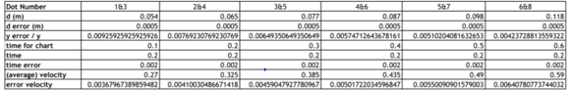
According to this experiment, velocity is constant and be obtained using the formula x = U_{0x}t = U_{x}t. After measurements, the distance in between the points skipped one point thus other than t, we used 2t, U = $\frac{ΔX}{2Δt}$
Average velocities were 0.270$\frac{m}{s}$ , 0.325$\frac{m}{s}$, 0.385$\frac{m}{s}$, 0.435$\frac{m}{s}$, and 0.590$\frac{m}{s}$. Relative error was realised to be 0.002 seconds (0.2%) leading to the interpretation that it can be neglected. We used the formula δɀ = ɀ * √($\frac{δx}{x}$)² ⁺ √($\frac{δy}{y}$)² to calculate relative velocity as dy was known to be 0.0005. The relative error of velocity was computed to equal 0.00368, 0.00410, 0.00459, 0.00502,0.00550, and 0.00640.
The time interval in between the points was 0.1 second. With this information therefore, we created a plot of U vs t including the error bars as below;
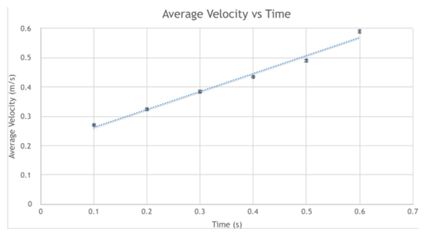
We calculated the slope and the error of the slope using a tool found in the IPL’s website and it equalled 0.59683 with an error of 0.0119808.The slope of the function showed acceleration equal to 0.59683±0.01198$\frac{m}{s2}$. The error is due to air resistance, random error and imperfect measuring.

Experiment 2
Examination of the motion of an object in two dimensions was the basis of the experiment. On top-left corner of the tilted air table, we put a puck with another on the right-bottom corner. A puck on top was pushed in x direction although it experienced a portion of gravity force in the opposite direction y. When the puck hit the top-left corner of the paper, the spark timer switch was pressed and released when it hit the second puck at the right-bottom corner.
We numbered eight dots on the paper starting from the third point. My partner and I noticed vertical and horizontal separations between the dots 1 and 3, 2 and 4, 3 and 5, et al. Errors were also discovered and included in the table. We used the formulas U = $\frac{ΔX}{2Δt}$ and δɀ = ɀ * √($\frac{δx}{x}$)² ⁺ √($\frac{δy}{y}$)² to calculate velocity and propagated error as used in experiment 1.
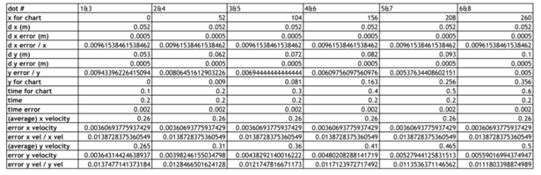
Creation of x vs. t and y vs. t graphs was possible using x and y coordinates collected. The x vs. t graph shows data on a straight line as a result of displacement of the object in x coordinate which is uniform and has no acceleration; x = U_{0x}t = U_{x}t where U_{x} is constant.
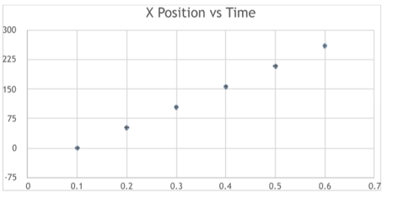
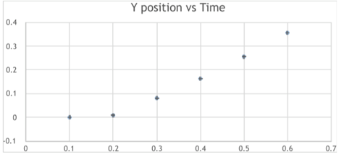
Graph y vs. t appeared to look like an exponential set of data rather than a straight line. This was due to the free fall acceleration experienced by the object accelerating towards the air table’s bottom. To explain the relationship of y displacement with regards to time, initial velocity and free fall acceleration, we used the formula thus arriving at 9.81$\frac{m}{s2}$. Δy = U₀t + $\frac{gt2}{2}$
We had to compute the average time for each of the three points and the error in the two velocities. The formulas U_{x =} $\frac{ΔX}{2Δt}$ U_{y} = $\frac{Δy}{2Δt}$ were used to calculate the average velocities.
For each interval, the average velocity with error equalled to 0.260±0.0036$\frac{m}{s2}$ and the time interval between single points was 0.1 seconds thus enabling us to create a graph U_{x} vs. t and U_{y} vs. t.
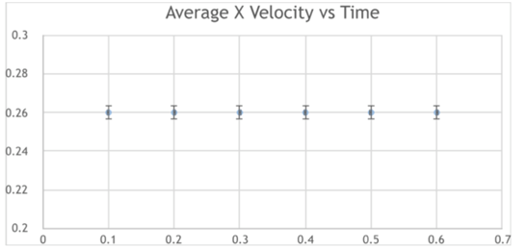
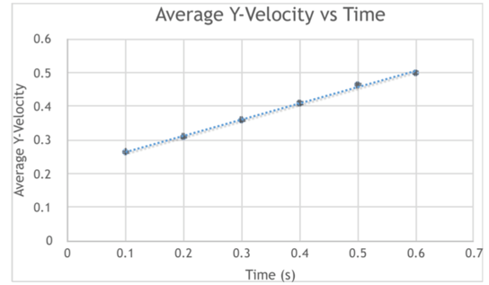
As clearly evident on the graph, it was observed that the graph U_{x} vs. t had a slope which is the object’s acceleration in y axis and it equalled to 0.483876±0.0111725$\frac{m}{s2}.$ The acceleration of the object in experiment 1 equalled 0.597±0.0120$\frac{m}{s2}$ while acceleration of the object in experiment 2 is 0.484±0.0112$\frac{m}{s2}$. However the set of data on the graph U_{x} vs. t does not have a slope indicating that acceleration is equal to zero and the velocity is constant which is 0.26±0.0036$\frac{m}{s2}$.

Experiment 3
In this experiment, we calculated the free fall acceleration g in each experiment based on the results obtained in experiment 1 and 2 using the formula sinɵ = $\frac{gy}{g}$ found from the right triangle. The free fall acceleration will be vertical catheter if the known acceleration in the triangle is hypotenuse. Therefore, the fall acceleration could be computed with sinus of the adverse angle.
After measuring the air table and the wooden block that titled it, we found out that the air table and the wooden block are 0.58±0.0005m and 0.35±0.0005m wide respectively. Theta was calculated to equal arcs in ($\frac{0.0035}{0.58})$ degrees.
We then divided known acceleration by sin(ɵ) to find a free fall acceleration in experiment 1. Free fall acceleration in experiment 1 equalled 9.89± 0.244$\frac{m}{s2}$ and 8.02±0.218$\frac{m}{s2}$ in experiment 2. The average free fall acceleration was computed to 8.96±0.327$\frac{m}{s2}$ while the formula δɀ = √(δx)² + (δy)² was used to compute the error for average free fall acceleration.

Conclusion
The objective of this experiment was studying the dependence of acceleration, velocity and displacement in one and two dimensions and showing that displacement OX coordinates does not dependent on OY displacement in two dimensional motion. An air table, wooden block, sheet of paper, spark timer and a ruler were used to conduct the experiment. In order to calculate the velocity of an object in a uniform motion, the formula U = $\frac{ΔX}{2Δt}$was used in experiment 1 and 2. To find the propagated error, the equation δɀ = ɀ * √($\frac{δx}{x}$)² ⁺ √($\frac{δy}{y}$)² was used when two variables are multiplied.
In experiment 1 using the collected measurements of the points the average velocities of the dots was 0.270±0.00368$\frac{m}{s}$ , 0.325±0.00410$\frac{m}{s}$ , 0.385±0.00459$\frac{m}{s}$ , 0.435±0.00502$\frac{m}{s}$ , 0.490±0.00550$\frac{m}{s}$ , 0.590±0.00640$\frac{m}{s}$. After plotting a graph of the data created, a slope was observed which can also be referred to as the acceleration which equalled to 596.83±11.98$\frac{m}{s2}$.
In experiment 2, two graphs were plotted based on the measurements collected whereby when the object was moving uniformly the horizontal motion graph appeared to be a line from a certain angle. On the other hand, when the object was moving vertically, it had an acceleration and ergo thus its graph looked like an exponent with its velocity equal to 0.26±0.0036$\frac{m}{s2}$.The velocity of the puck was then found through plotting two graphs of x and y components of velocity by time. The velocity was 0.483876±0.0111725$\frac{m}{s2}$.
Experiment 3 required finding out the free fall accelerations for experiment 1 and 2 through the data in the table. Then we computed the average free fall acceleration with error. The free fall was 9.89±0.244$\frac{m}{s2}$ and 8.02±0.218$\frac{m}{s2}$ for experiments 1 and 2 respectively. Their average velocity was computed to be 8.96±0.327$\frac{m}{s2}$.
Using an electric ruler instead of a regular one increases the accuracy of the experiments conducted.

