Part one responses.

- X-axis show the time the allele takes to disappears while Y-axis shows the number of times an allele appears in a generation.

- Each line represents different population which exhibit different path over time because drift process is random and happens by chances.

A line going to the top shows that the number of alleles appearing increases with generation while a line going to bottom shows that the number of alleles appearing decreases with generation.

When a line reaches 1 mark or zero mark it does not come back as the allele is either lost or fixed on the population.

- The difference in the simulations is as a result of using population with different number of individuals as genetic drift has more adverse effect on smaller population than on a larger one.

- Y-values flactuates because drift process is random, it does not follow a regular pattern.

- A-25 times

a-35 times

- It exhibit the founder effect as far as number of individuals in a population is concern. The effect is exhibited when a small group of individuals break off from a large population to form a colony. This result in new colony which do not represent full genetic diversity of the original population.

- Flactuation on the y-axis is low because alleles are known and therefore it does not happen by chance.

- It takes sometimes before genetic drifts occurs. The allele frequencies do not flactuate and the two graph are fairly the same.

Part two.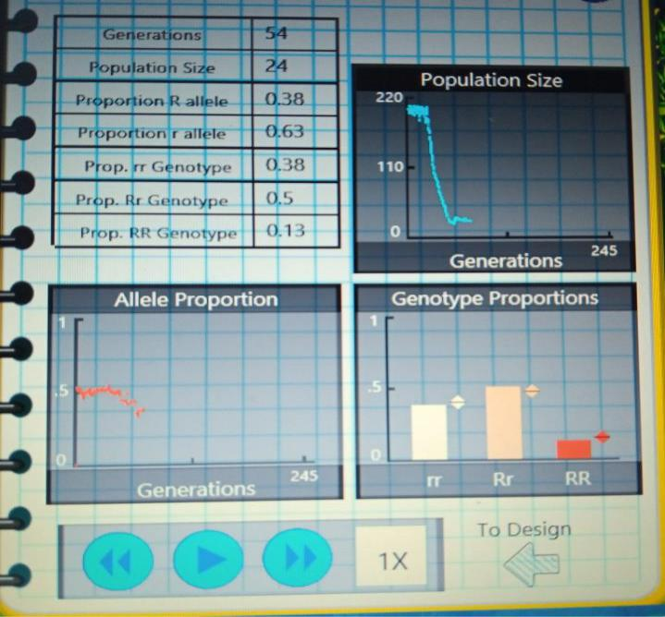



Apart from the above graph analysis it is clear that genetic drift occurs largely on population with smaller number of individuals. As drift is a random process each population shows a different path over time.

Having 30% R, does not affect much the results as the genetic drift is by chance and therefore the graph in part one and part two are almost the same.

Allele benefit or harm does not affect the genetic drift unlike natural selection.

The population size of 25 individuals decreases with time due to factors such as mortality and the allele proportions decreases also. While the population with 500 individuals the size fairly remains the same. As more alliele are passed to the next generation and also the mortality rate is low. (127 words)

