The situation
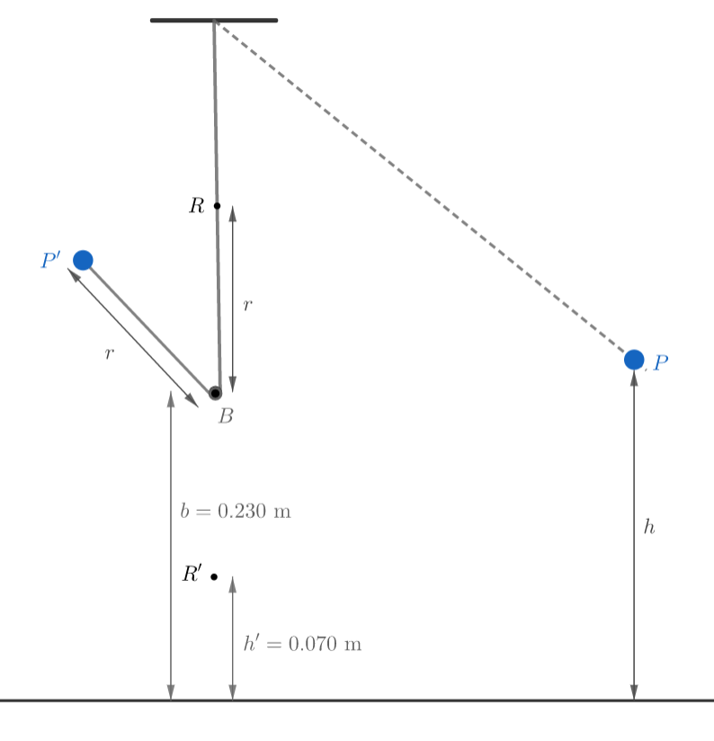
The dotted line represents the initial position P of the pendulum (and string), where the pendulum is held at a height h above the ground with the string taut. The pendulum is then released; it swings left, but when crossing the mean position R’ at h’ m above the ground, the string is caught by the horizontal bar B (into the page – cross-section shown) – which is b m above ground – and the trailing part of the string of length r = b – h’ with the pendulum continues onwards to position P’, which is shown in a solid line.

The problem
The objective is (1) to determine the minimum speed v for which the pendulum reaches the point directly above the bar B with the string taut, i.e. crosses the point R exactly r m above the bar, and (2) to determine the minimum height h required to achieve this speed v.

The solution
(1) For this part, we assume that the string is light and inextensible.
For the pendulum to pass through point R, it must be undergoing circular motion in a circle of radius $r$. This means that the centripetal acceleration is:
$$a_{c}=\frac{v^{2}}{r}$$
where v is the velocity of the pendulum.
The centripetal force necessary is:
$$F=ma_{c}=\frac{mv^{2}}{r}$$
There are only two forces acting on the pendulum at point R: weight of the pendulum, which is vertically downwards, and tension in the string, which is also vertically downwards, so the resultant force (which provides the necessary centripetal force) is:
$$F=T+W$$
We have:
$$\frac{mv^{2}}{r}=T+W$$
As velocity increases, the resultant force must increase as well. Therefore, the minimum velocity is at the minimum resultant force, which is when the string is just barely taut, i.e. $T=0$:
$$\frac{mv^{2}}{r}=0+W$$
$$\frac{mv^{2}}{r}=mg$$
Canceling out mass:
$$v=\sqrt{gr}$$
$$v=\sqrt{g\left(b-h'\right)}$$
For the given values:
$$v=\sqrt{9.81⋅(0.230-0.70)}≈1.253 m s^{-1}$$
(2) Assuming negligible air resistance and friction, i.e. no energy lost, the total energy at points P and R must be the same:
$$K.E_{P}+G.P.E_{P}=K.E_{R}+G.P.E_{R}$$
At point P, the pendulum is released from rest, i.e. with 0 kinetic energy. Considering 0 gravitational potential at the ground:
$$0+mgh=\frac{1}{2}mv^{2}+mg\left(b+r\right)$$
Canceling out mass, and substituting the final formula from part (a):
$$h=\frac{1}{2g}v^{2}+b+r$$
$$h=\frac{1}{2g}\left(gr\right)+b+r$$
$$h=\frac{r}{2}+b+r$$
$$h=1.5r+b$$
$$h=1.5\left(b-h^{'}\right)+b$$
$$h=2.5b-1.5h'$$
For the given values (using the result of part (a)):
$$h=2.5⋅0.230-1.5⋅0.070=0.47 m$$

