War Photography
Name
Institution

Introduction
Photography has long been used as a way of promoting visual journalism. Photographs also serve to inform the public on the life events taking place each day making each and every individual part of the world we live in. War events are also documented through photography. War highly affects people’s lives. Below is a discussion of two photographs taken from different wars and timing. The photographs demonstrate the different war aspects apart from some few crucial features.
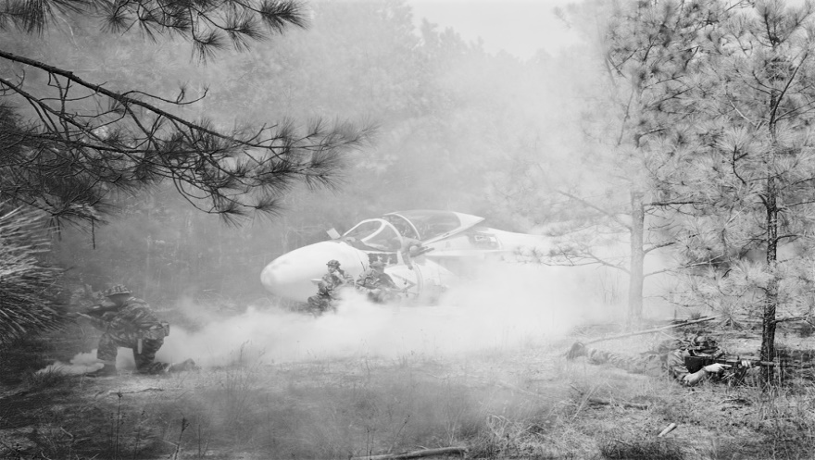
Small Wars, (rescue), 1999-2002, by An-My Lê
The above photo was taken by An-My Lê a Vietnamese-American who has experienced life in a war zone. The photographer was born in Saigon in 1960. She vividly remembers how her parents would protect her from night war attacks by placing sandbags in her bedroom. This war experience is what motivated her to venture into war photography. Her photography captures more of the US military operations from her homeland and all over the world. Most of her photography evaluates armed conflict while a few of them demonstrates the real actual military engagement.
The above photo is one of the few that depict actual military engagement. In the photo, we can see soldiers on the battlefield being rescued. The soldiers are getting into the plane in turns as they cover each other. The photo demonstrates the techniques applied in the battlefield. One soldier is lying on the ground shooting while the other one is squatting. The war appears to be taking place in a forest which is a good defensive area. Although the image is black and white the features are really clear and easy to spot.
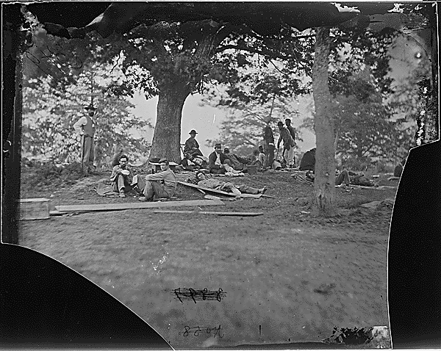
Wounded soldiers under trees 1864 by Mathew Brady
The photo above captures several wounded soldiers who had participated in the Spotsylvania battle in 1864. The soldiers are nursing their wounds under the tree as they also try to rest. Some soldiers are standing while others are lying and sitting on the ground.
Similarities
The two photos demonstrate the events of a war that took place during different errors. Their main strength is that they are able to capture the real action in place and inform the public of what happens in the battlefield. Additionally, the photos are both black and white which makes it easier to focus on the actual object as compared to colored images. Too much color makes it hard to concentrate on the main subject but the application of black and white photography ensures maintenance of focus on the real photo composition and texture. It gives a chance to concentrate on perspective, lights, lines, and shadows. Due to the black and white color, the photos can remain clear even in insufficient light. Nonetheless, the black and white color makes it impossible to tell the actual skin tone of the involved soldiers as well as the actual color of the objects sounding them.
Differences
The first image is quite clear that the second one. This can be attributed to the different timing when the photos were taken. The first photo was taken more recently than the second one. Unlike 1864 technology had massively evolved between 1999-2002 hence camera lenses were clearer and could vividly to capture the real events. We also see a plane in the first image which is absent in the second image. This, therefore, shows that the different errors when the photos were taken can highly affect audiences understanding of what is captured in the photos. It is easier to tell what is happening in image one than in image two. In the second photo it is hard to tell who is in the photo and what they are doing but in the first image, you can clearly see that that is a war zone with armed soldiers being rescued.
Conclusion
Photography serves an important role of documenting events as they happen especially during war. However, the timing and the mode at which the photo is taken greatly affects its understanding. As time erupts technology continues to advance with its effects being felt in the photographic fields.

