Art by Gordon Parks

Name:

Institution affiliation:

Date:

Gordon Parks was born on 30th November 1912 and lived until 7th March 2006. He was born as the fifteenth child in his family. He grew up in poverty and had to struggle to make ends meet. Park was a black American writer, musician, photographer and also film director. According to (Flynn, 2017) he pioneered the entry of the blacks into the art industry in the US. Park was a humanitarian, an activist and an advocate of civil rights in America. At the age of 25, he bought his first Camera which he referred to as "weapon of choice." Using his camera and his works of art, he was able to expose his social injustices as well as the marginalization of the non-Americans. Park proved how images and photographs had the power to transform society.
Gordon participated in the struggle for equality in the United States using art. This was unlike the trend then where the oppressed participated in demonstrations and brutality to fight for their social justice. He presented the injustices he saw in photographs. He aimed at creating empathy of these injustices among the white Americans. In doing this however, park established a close relationship with the blacks such that they allowed him to take photographs of the injustices they were facing. However, Park had a number of hindrances to overcome. Being a non-white, most of his photographs were not published initially thus making it hard for him to pass his message. Below are some of the photographs that Gordon took.

The American Gothic

The American gothic was an image created in 1942. The image was created by Gordon Parks who at this time had gone to work for the Farm security Administrator, Washington DC. In the photo, there was a black woman called Emma Watson. The black woman can be seen holding a floor mop. At the back of the woman, is an American flag which was meant to make people feel how Washington DC was in 1942. The photo is influenced by the discriminations of the whites against the non-whites. In the picture, Park aimed at explaining the struggles that black women went through under the whites. In his explanation of the photo, Park stated that while working at the company, he saw black people were given a raw deal. For instance, he explains that Ella Watson earned as little as $1080 annually. With this meager earnings, Ella had three grandchildren and an adopted child who all depended on her. Also, she would be made to clean the offices of a white woman whom she help similar qualifications with (Parks, 1942). Park presented this photo to Roy Stryker, his boss at FSA. Roy viewed the photo as an indictment of America and therefore fired Park. Later, the photo was published by the Washington Post. The photo would then be referred the American Gothic, a 1930 painting by Grant Wood.
The American gothic was the name given to the painting by Grant woods. The painting was done in in the American Gothic House in Eldon, Iowa. In the painting by Grant, there is woman standing next to a farmer. The farmer is holding a three prong garden fork. This is unlike the case in the American gothic by Gordon Park where the photo only had a single person, a lady who is holding a floor mop. The American gothic art works by Grant and Gordon also differ in that the art by Grant involved two whites while that of Gordon involved a black American lady. Another difference between the two art works is that in the art by Gordon, Emma Watson is holding a mop while in the art work by Grant, the gent is holding a pitchfork. The two art works were however motivated by the societal factors that were taking place in the United States. In the case of Gordon, he was motivated to take photograph of Emma by the racial injustices met on black Americans by the whites. Below are the two American gothic art works.
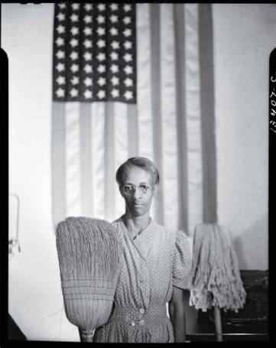
Figure 1American gothic by Gordon Park in 1942
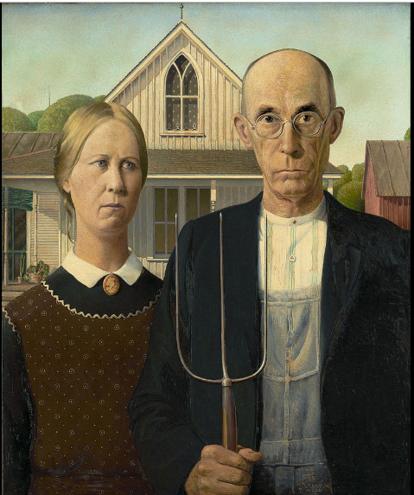
Figure 2American gothic painting by Grant wood in 1930

Department Store, Mobile, Alabama

In 1956, Gordon Parks took a photo from the Life Magazine essay. The essay was on the life of the Thornton family under apartheid of Alabama. (Google Arts and Culture, 1956) Explains that in the photo, Park aimed at challenging the racial inequalities. In presenting the image, Park chose to use a colored picture in an era where photographs were exhibited in black and white. In the picture, a lady appears to be standing next to a young girl outside a store. They are both wearing khaki dresses. At the entrance of the department is a colored signboard written "colored entrance." The colors in the images were meant to represent the white Americans. Only the whites were allowed inside the department. The lady and the girl outside the department could not be allowed into the store due to their skin color. By using a colored photograph, Park aimed at eliciting empathy of the racial injustices. Unlike other activists who used brutality, boycotts, and demonstrations to air their discontentment of the racial discrimination, he opted to use images. The image by Park shared the experiences of the non-whites under the whites.
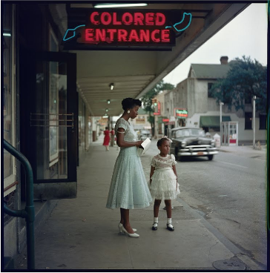

Outside Looking

According to (High Museum of Art, 1956), this photo was taken in 1956. The photo was published in the article the Restraints: Open and Hidden. The photo was published together with other 26 colored photos. The photo has six black children standing outside a park. Inside the park, there are whites and whites’ children who are recreating inside the park. The black children are not allowed inside the park. The photo by Gordon Parks shows how the whites discriminated against the whites. Like the department store image, the outside looking photo was published colored unlike the norms then when the photos were published in black and white. This photo was motivated by the discrimination of non-whites by the white American. At the time of taking this photo, the society was focusing on demonstrations and brutality to fight against racism. On his part, Park opted to use the picture of the Thornton family to create empathy and emphasis on the racial injustices that were being done by the whites on the non-whites. By this, Park was able to draw the human aspect of the society towards the racial injustices.
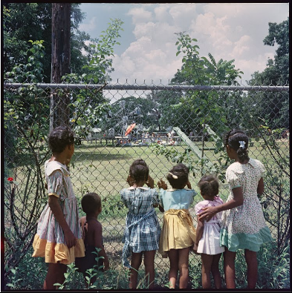

Conclusion
In conclusion, art is a very powerful tool in society today as it was in the past. The art works by Gordon Parks demonstrates how art can be used to address the vices that are affecting the society. The images, for instance, can be used to create empathy on issues such as racial injustices. The works of art by Gordon Park draws the attention of the society towards the challenges a society or part of the society is facing. Gordon showcases the different ways that the white Americans were discriminating against the black Americans.

References
Flynn, N. (2017, June 16). How Gordon Parks broke new ground for Black American artists. Retrieved from dazeddigital.com: http://www.dazeddigital.com/art-photography/article/36376/1/how-gordon-parks-broke-new-ground-for-black-american-artists
Google Arts and Culture. (1956). Department Store, Mobile, Alabama. Retrieved from artsandculture.google.com: https://artsandculture.google.com/asset/department-store-mobile-alabama/sQFKGbsYoOhaWQ
Gordon Parks. (1942). American Gothic. Retrieved from 100photos.time.com: http://100photos.time.com/photos/gordon-parks-american-gothic
High Museum of Art. (1956). Outside Looking In, Mobile, Alabama. Retrieved from artsandculture.google.com: https://artsandculture.google.com/asset/outside-looking-in-mobile-alabama/PAG8WXXibce3hA

