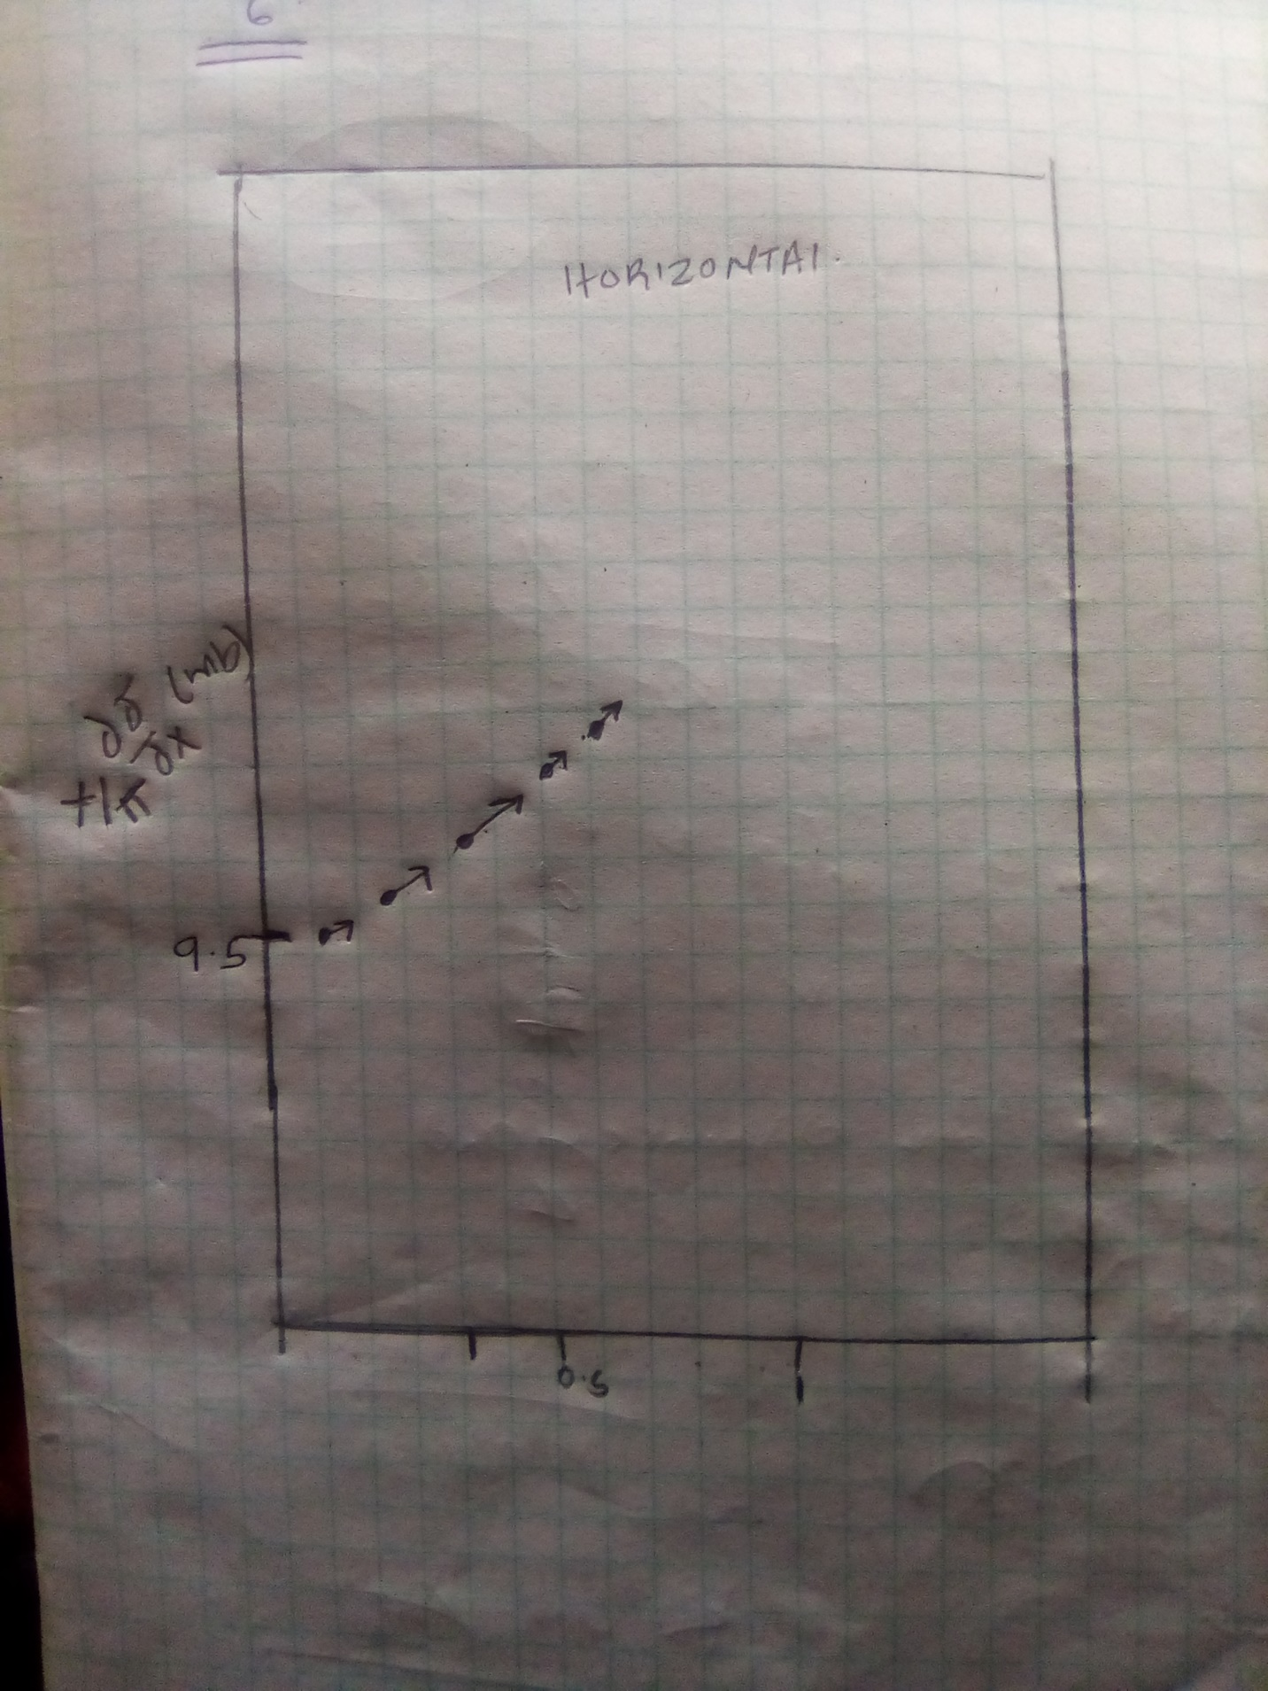

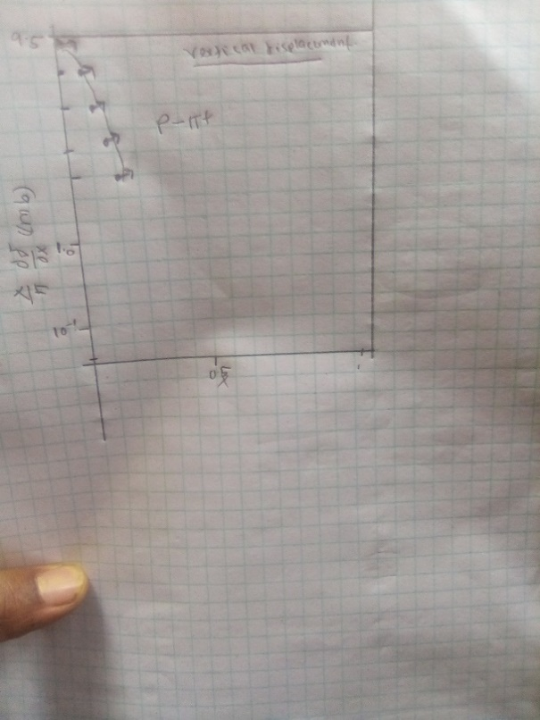

MAGNITUDE  MM | 95.5 | 94.5 | 92.5 | 91.4 | 89.0 | Total  (mm) | Total  (GeV/c)
HORIZONTAL  MM | -94 | -93 | -92.3 | -90.3 | -88.5 | -458.1 | -458.1
VERTICAL  MM | -14 | -13 | -11 | -10 | -9 | -57 | -57

Q3
From the conservation of momentum final momentum + initial momentum should give a zero
In our case adding the two they are not going to give a zero. Meaning some energy is not conserved and is turned to something else.
Final +initial=0
-94+-14=-108
0—108=108GeV/c
93+-13=-106
0—106=106GeV/c
-92.3-11=-103.3
0—103=103GeV/c
-90.3+-10=-100.3
0—100.3=100.3GeV/c
-88.5-9=-97.5
0—97.5=97.5GeV/c

Q4
From einsten equation of energy we know that
Total energy is equal to
E2=(pc)2+(mc)2
Where p is relativistic momentum but the momenta being too big we can ignore the MC2 factor

-94+-14+95=-13GeV/c
-11-92.3+92.5=-10.5GeV/c
-90.3-10+91.4=-8.9GeV/c
-9-88.5+89.0=-8.5Gev/C
Q5
SHOWING MASS OF A TOP QUARCK
From the einsten equation of energies
E2 =(PC)2+(mc)2
But now we are told this particle is in rest meaning it has zero momentum
The energy produce by the collision is 95GeV
SINCE WE ARE INTERSTED IN FINDING THE MASS THE EQUATION BECOMES
ENERGY/SPEED OF LIGHT
IF ENERGY IS 95 THEN
95/(3*10^8)= 3.1*10^-10

Q6
This collision is not dissection since the collision will lead to collision which will make the proton and antiproton to produce energy and a quack particles
This quack particle contain double the energy of the original particles since they contain both kinetic energy and potential energy
The energy of the quacks can even be 10 times that of proton. That it is not dissection it is more splitting of protons and antiprotons when the collide producing quacks of high energy compared to the protons.

