ME/CEE 2140
MECHANICS OF MATERIALS LABORATORY
Lab: Torsional Test of Rectangular Cross-Section bars
STUDENT NAME:
GROUP:
GROUP MEMBERS:
DATE SUBMITTED:

Abstract
In the field of mechanics, torsion is looked at because the twisting of a good due to the applied moment as a move to produce movement alongside the longitudinal axis of a good. On the other hand applied torque is acted on deformation broaden, shear stress and member. Another term is Torsion is an issue that arises within the designing level of shaft which mainly comes up in power generation as well as long run transmission. To get your goal the applied torque is calculated with appreciate to its angle of twist as well as using torsion formulation, shear modulus, modulus of rupture as well as limit of proportionality will be determined. The down fall moments were achieved through the test and comparisons was as well made between the effectiveness among the whole and solid round shaft respectively.

Introduction
A prismatic cross-section bar is clean bar that has a cross-section in the shape of prism for example triangular, hexagonal, square, rectangular and circular sections. The process is done on top of torsion of square cross-section bars. In the process a bar that has rectangular cross section is used. The Torque is drawn as a function of the angle of twist.
For a rectangular cross-section bar subjected to torque t, the highest shearing stress T_{max} is given by,
$$τ_{max}=\frac{T}{c_{1} a b^{2}}$$
Incase a is the bigger dimension, b is the smaller dimension and coefficient c₁ relies on the ratio a/b as stated in the table 1(a>b).
The angle of twist as achieved through,
$$ϕ=\frac{TL}{c_{2} a b^{3}G}$$
Incase the coefficient c₂ relies on the ratio a/b and is given in the Table 1 (a>b). The difference among torsion in circular and non circular cross-section bars is that every cross section of a circular bar is clean and not tampered with, while on the other hand non circular bars have out of plane deformation. As shown in Figure 1.

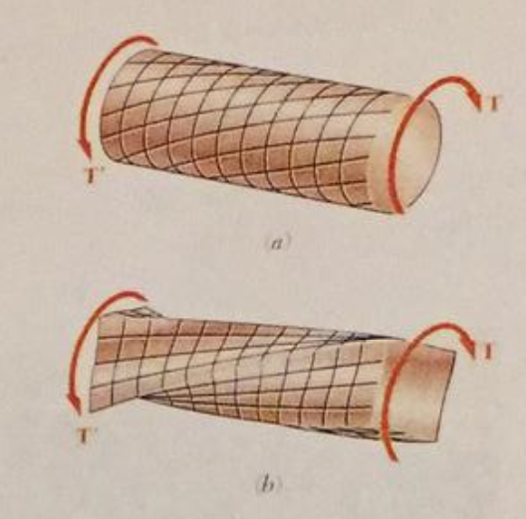

- Circular Bar subjected to Torsion b) Rectangular bar subjected to Torsion.
Torsional stiffness K_{t} for a rectangular cross-section bar is,

$$K_{t}=\frac{c_{2} a b^{3}G}{L}$$

a/b | C₁ | C₂
1 | 0.208 | 0.1406
1.2 | 0.219 | 0.1661
1.5 | 0.231 | 0.1958
2.0 | 0.246 | 0.2290
2.5 | 0.258 | 0.2490
3.0 | 0.267 | 0.2630
4.0 | 0.282 | 0.2810
5.0 | 0.291 | 0.2910
10.0 | 0.312 | 0.3120
∞ | 0.333 | 0.3330

We can calculate shear modulus G from torsional stiffness K_{t}. Once shear modulus G is calculated, the modulus of elasticity E is determined from the following equation:
$$G=\frac{E}{[2\left(1+v\right)]}$$
Where v is the Poisson’s ratio.

EXPERIMENTAL SETUP
Objective:
To obtain the torque-angle of twist diagram for non circular cross section bars and as well as get the materials qualities such as the torsional stiffness K_{t}, the shear modulus G and the ultimate shearing stress$τ_{u }$.
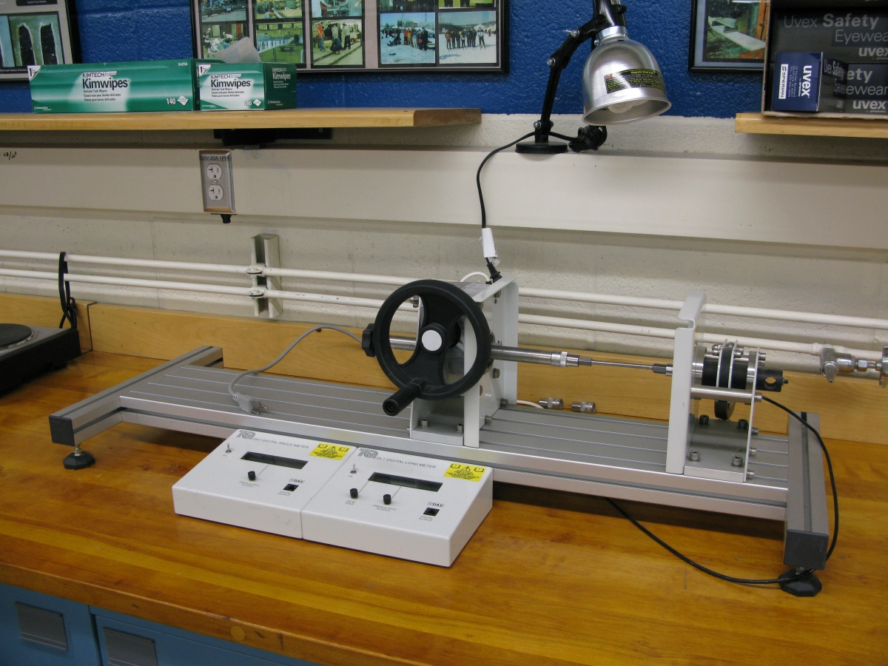
Figure 2: Torsional Test System

Procedure of the Experiment:
- Put the work piece slowly in the Torsion Test machine
- Measure the gage length as well the dimensions and b as shown in figure 3 for the rectangular cross section bar. Choose the value of C1 and C2 from table 1
- Start applying twisting load systematically by turning the handle at the appropriate selected intervals. Also measure the angle of twist as well as the applied twisting force P. Change angle degrees to radians. Obtain torque by multiplying the load time its lever arm.
- Value the linear slope of the torque-angle of twist diagram, torsional stiffness and use the digitals obtain to get the modulus of rigidity.
- Calculate the ultimate shearing stress for the specimen from the shearing stress-strain diagram.
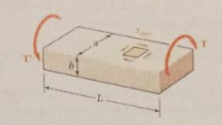

Figure 3: rectangular specimen subjected to torsion.
Observation Table 1:

For Large Work piece:

C2 = 0.1406
L=41.5mm
Poisson’s ratio=0.36
a=10.04mm
b=9.99mm

θ (degree) | T (N∙m) | τ_(max ) | G(GPa) | K | E(GPa)
90 | 0.4 | 1.92 | 131.05 | 4444.44 | 356.47
180 | 0.9 | 4.32 | 147.44 | 5000.00 | 401.03
270 | 1.35 | 6.48 | 147.44 | 5000.00 | 401.03
360 | 1.75 | 8.40 | 143.34 | 4861.11 | 389.89
450 | 2.1 | 10.08 | 137.61 | 4666.67 | 374.29
540 | 2.4 | 11.52 | 131.05 | 4444.44 | 356.47

Observation Table 2:

For Small Work piece:

C2 = 0.1406
L=38.07 mm
Poisson’s ratio=0.36
a=8.13 mm
b=8.07 mm

θ (degree) | T (N∙m) | τ_(max ) | G(GPa) | K | E(GPa)
90 | 0.2 | 1.82 | 140.82 | 2222.22 | 383.04
180 | 0.4 | 3.63 | 140.82 | 2222.22 | 383.04
270 | 0.62 | 5.63 | 145.52 | 2296.30 | 395.81
360 | 0.95 | 8.63 | 167.23 | 2638.89 | 454.86
450 | 1.15 | 10.44 | 161.95 | 2555.56 | 440.49
540 | 1.3 | 11.80 | 152.56 | 2407.41 | 414.96

RESULTS AND DISCUSSION

Graph 1: T- φ curve for Large Material

Graph 2: T- φ curve for Small Material

SAMPLE CALCULATIONS:
As shown from the Table 1 for the larger material we can evaluate the properties of the items as shown below:
Begin from the value of Torque and angle of twist we can obtain the highest shearing stress T_{max}
$$τ_{max}=\frac{T}{c_{1} a b^{2}}$$

$$τ_{max}=\frac{0.4}{0.208 x 0.01004 x {0.099}^{2}}$$

$$τ_{max}=1.92 Mpa$$

Now for value of Shear Modulus G,

$$ϕ=\frac{TL}{c_{2} a b^{3}G}$$

$$G=\frac{TL}{c_{2} a b^{3}ϕ}$$

$$=\frac{0.4 x 0.01004}{0.1426 x 0.01004 x {0.099}^{3} x 90}=131.05 GPa$$

Torsional stiffness K_{t},

$$K_{t}=\frac{0.1426 x 0.01004 x {0.099}^{3} x 131.05}{0.04105}=6575\frac{N m}{rad}$$

Modulus of elasticity (E),
$$G [2\left(1+v\right)]=E$$

$$E=131.05 \left[2\left(1+0.36\right)\right]= 356.47 GPa$$
- From the graph for Torque VS Angle of Twist we can highlight that as the angle of twist raises the value of torque also raises.
- Therefore, Torque and Angle of Twist have linear relation.
CONCLUSION
In the lab experiment we have carried out the Torsion test on the material using Torsional test system. It’s clear that there are three different material properties 1. Torsional K, 2. Shear modulus 3. Modulus of elasticity G. From our findings we can select the material according to its application.
Torsional stiffness K is clear that the load withstands the capability of material. On the other hand Shear modulus G, it is clear that the material ability to withstand shearing load. And lastly the Modulus of Elasticity G we have realized that the material ability to regain shape from the applied load.

References

Beer F. P, Johnston E.R., DeWolf J.T. (2002). Mechanics of Materials, 3rd edition, McGraw-Hill, Inc.

