Activity 1.
Situation | Rate the Difficulty
Situation | Prediction | Actual
With a 200g mass at 90cm mark | 1 | 2
With a 400g mass at 90cm mark | 2 | 3
With a 200g mass at 50cm mark | 1 | 1
With a 400g mass at 50cm mark | 1 | 2

- (already given).
- The factors which torque depends on are: Mass (force of the subject) and R (distance from your force to subject’s Mass).
Situation  With the 100g mass at 90cm mark | Rate the Difficulty
Situation  With the 100g mass at 90cm mark | Prediction | Actual
The meter stick is horizontal | 1 | 3
30º above | 2 | 2
60 above | 2 | 1
30 below | 1 | 2
60 below | 1 | 1

- When angle changes, R doesn’t change but the perpendicular distance from pivot point changes.
- Follow the equations given.
- First situation:
Pivot
Meter stick
Lever arm
- Lever arm = Cos30.0,8 = 0,693m.
- Torque = Leverarm.F = 0,693.2 = 1,4 Nm.
Second situation:
- Lever arm = Cos30.0,8 = 0,693,.
- Torque = Leverarm.F = 1,4 Nm.

Situation  The meter stick horizontal | Rate the Difficulty
Situation  The meter stick horizontal | Calculated torque | Rank
With a 200g mass at 50cm mark | 0,8 | 1
With a 200g mass at 90cm mark | 1,6 | 2
With a 400g mass at 90cm mark | 3,2 | 3
Situation  With the 200g mass at 90cm | Rate the Difficulty
Situation  With the 200g mass at 90cm | Calculated torque | Rank
Horizontal | 1,6 | 3
Above 30 | 1,4 | 2
Above 60 | 0,8 | 1
Below 30 | 1,4 | 2

Activity 2.
- M1 reprensents the boy, m2 represents the girl and the middle represents Pivot point.
- In order for the meter stick remains in balance so the torque from 2 sides must be equal. However the mass of the metal clip and mass hanger are equal so the distance must also be equal
- We should put other at 70cm mark ( 70 – 50 = 50 – 30 ).
Pull force of force meter - F
Mass force of the meter stick - F_{M}
Mass of the mass hanger and metal clip – F₂
Mass of the mass hanger and metal clip – F₁
a. F = F₁ + F₂ + F_{M}.
b. F_{M} = F – F₁ – F₂ = 3,8 – 0,5 – 0,5 = 2,8 N
Mass of the stick is F_{M}/10 = 0,28 kg = 280g.
c. Scale for mass of the stick: M_{scale} = 300g.
%diff = (300 – 280)/280.100 = 7,14%
- a) F₂ – and F₁ +.
b) F₁ – F₂ = 0.
c) Because it doesn’t effect on the pivot point (vertical) then its effection = 0.
Part B.
- The parent sits near the pavot point. And the child sits far from the pavot point.

8. 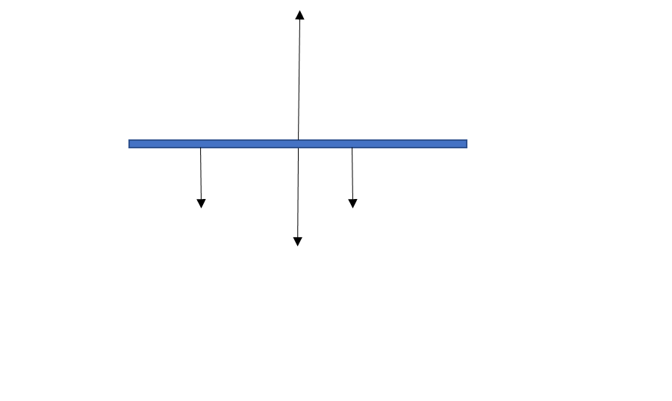
M1 : CW (-)
M2 : CCW (+)
L1
L2
9.
 | Mass | Distance from pivot |  | %difference
 | Mass | Prediction/Calcutalion | Experimental | %difference
Parent | M1 = 210g | L1 ~ 0,1524m | L1 = 0,15m | 1,6%
Child | M2 = 80g | L2 = 0,4m | L2 = 0,4m | N/A

Part C. 11.
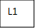
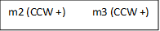
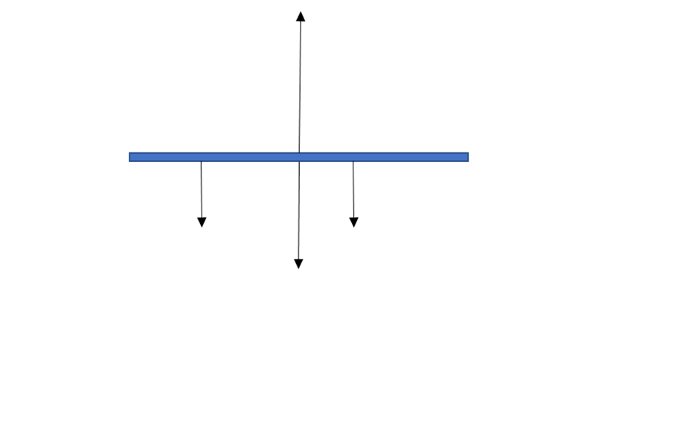
m1 (CW -)
L2 L3
12.
 | Mass | Distance from pivot |  | %difference
 | Mass | Prediction/Calcutalion | Experimental | %difference
Parent | M1 = 210g | L1 = 0,3m | L1 = 0,3m | N/A
Child 1 | M2 = 80g | L2 = 0,4m | L2 = 0,4m | N/A
Child 2 | M3 = 110g | L3 ~ 0,2818 | L3 = 0,3m | 6,46%

Part D.
 | Distance from pavot | Mass
 | Distance from pavot | Calculation
Parent | L1 = 0,5m | m1 = 70kg
Child | L2 = 0,9m | m2 ~ 39kg

