Lab Report
Name
Institutional Affiliation
Course
Date

Summary
This report primarily discusses two experiments to study the index of refraction through an optical or transparent medium. The objectives of the two experiments are to
- To study the dependence of the angle of refraction angle on the incidence angle
- To study the dependence of the angle of refraction on the angle of incidence
Criticism

Experiment One
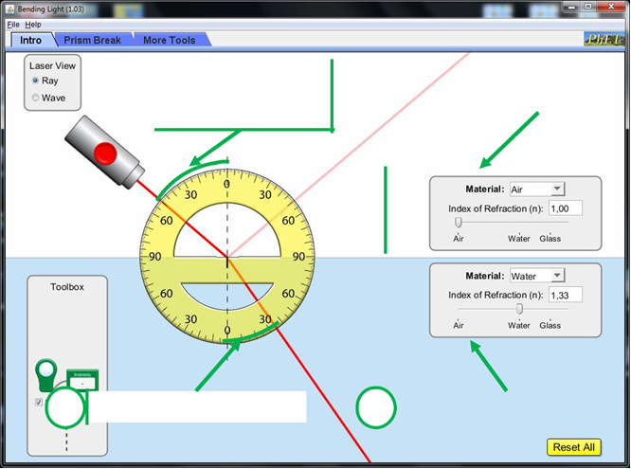
When the laser light falls from the air to an optical or a transparent medium, the refraction index will increase, thus decreasing the angle of refraction. This is on account that as the refraction index increases, the entire phenomenon turns out to be increasingly pronounced and thus the ray will bend more. Therefore, when the refractive index increases, then the refraction angle will decrease. And therefore, in this case, we predict that if the refraction angle decreases then the index of refraction will also increase.
In this experiment, a laser was placed so that the incidence angle was equivalent to ${50}^{°}$. The refraction angle was then measured for several n to obtain the table (1) below.
Measurement | Refraction Index (n) | Refraction Angle
1 | 1.0 | ${49}^{°}$
2 | 1.1 | ${43}^{°}$
3 | 1.2 | ${37}^{°}$
4 | 1.3 | ${35}^{°}$
5 | 1.4 | ${31}^{°}$
7 | 1.5 | ${30}^{°}$
8 | 1.6 | ${27}^{°}$
Table 1: Refraction index (n) versus refraction angle
After recording the measurements takes in the above table, we used to excel sheet to plot a graph of the refraction angle versus the refraction index. The graph is indicated in the figure (1) below.
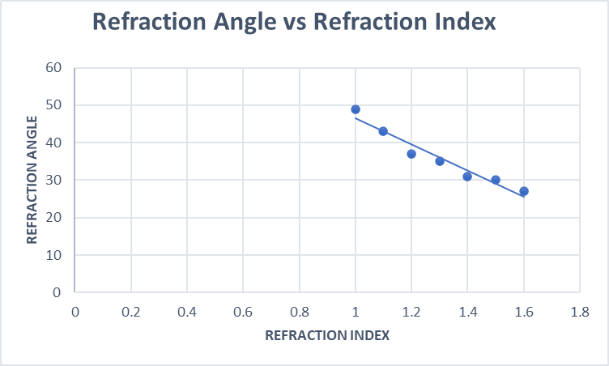
Figure 1: Refraction Angle vs Refraction Index:
N/B: Compared to our prediction, the refraction angle decreases with increase in the refraction index.
Experiment Two
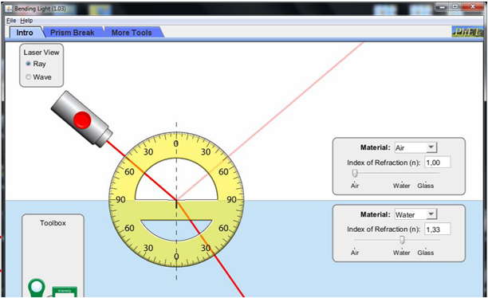

In this experiment, the refraction angle, or the refraction angle increases proportionally as the incidence angle increases. This is because Snell’s Law ascertains the refraction angle dependent on the incidence angle, and the refraction index of the two mediums. Both the angle of refraction angle and the incidence angle share the linear relationship depicted by the formulae$Sin \left(θ_{1}\right).n_{1}=Sin \left(θ_{2}\right).n_{2}$ whereby $θ_{1}$ represents the incidence angle, $n_{1}$ represent the original medium’s refraction index, $n_{1}$ represents the refraction angle, and $n_{2}$ signifies the refraction index.
During this lab experiment, we measured the refraction angle for several incidence angles and obtained the values recorded in the table (2) below
No. of Measurement | Incidence angle | Refraction Angle
1 | 11 | 9
2 | 20 | 15
3 | 30 | 22
4 | 40 | 30
5 | 50 | 36
6 | 60 | 40
7 | 70 | 45
8 | 80 | 48

When the plotted a graph refraction angle versus the incidence angle using the excel sheet.
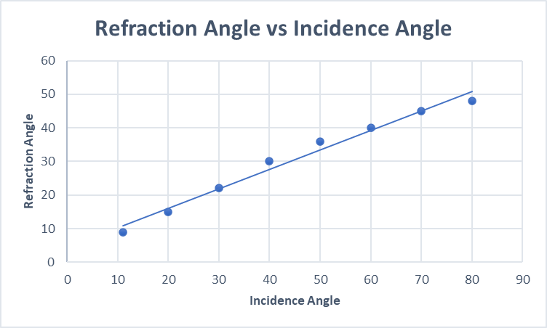
Figure 2: Refraction Angle vs Incidence Angle
Therefore, comparing to our prediction, as the incidence angle augments, the refraction angle also increases.
Conclusion
Generally, the two simulated experiments results discussed in the paper are known to be compatible with the formulae
$$\sin{i=}\frac{\sin{r}}{n}$$
This is on account that in the first experiment, we noted that sin(i) is inversely proportional to the refraction index. Thus, from this relation, we could state that the refraction varies inversely with the refraction index. From the second experiment, we noted that sin (i) is directly proportionate to sin (r). Hence, we could deduce that as there is increase in the incidence angle increases with increase in the refraction angle.

References
Aieta, F., Genevet, P., Yu, N., Kats, M. A., Gaburro, Z., & Capasso, F. (2012). Out-of-plane reflection and refraction of light by anisotropic optical antenna metasurfaces with phase discontinuities. Nano letters, 12(3), 1702-1706..

