POETRY
Students Name
Institution Affiliation

Living in Sin by Adrienne Rich
Living in sin is a poem written by one of the most famous American poets, Adrienne Rich. The title of the poem makes a reader believe that the poem is all about an exciting relationship but it turns out to be an ordinary description of house chores and a loveless relationship. The woman had imagined how charming and perfect her studio would look but the studio actually needs a lot of cleaning. The man in the poem acts bored and leaves for boring errands. The woman in the poem realizes that living with her partner out of wedlock is not as dreamy as she thought, the real sin is staying in a loveless relationship. Later that night, the woman feels better but the thought of what tomorrow will bring keeps her awake.
Theme of dissatisfaction; in the poem, the woman had thought the relationship would be perfect but what it actually turned out to be shows a lot of dissatisfaction. She however puts more effort than her partner to “clean things up” and make the situation better. In the end, the question is, was the way things turned out the only dissatisfaction she had or she was also dissatisfied with her choice in partners.
b) We agree with the authors message because life does not always turn out to be exactly as we expected.
To the Virgins, to Make Much of Time by Robert Herrick
Part 1
- Spent- can be defined as something is used up or gone
Coy- refers to being inactive, shy or reserved
Prime- refers to youth or beauty
Tarry- it means to delay or prolong something
- The speaker is seemingly addressing a group of virgins encouraging them to make most of their time before its too late (before they are too old).
- In line 2, time is personified because time doesn’t actually fly.
- The flower in the poem represents youth and beauty that is blooming and the author warns the young people that just like the flower, soon their youth and beauty will fade.
- The speaker uses time as a literary device for the sun. A lifetime is compared to a day. A human life is born, just like the sun rises, and when the sun sets, refers to death.
- The second stanza the author talks about the journey of the sun across the sky and it refers to life. The sun is compared to lamp that illuminates a room.
- Stanza two reinforces stanza one in that stanza two has the same ideas as stanza one but they are expressed in a different way. The author further explains about time moving really fast and comparing life to a day, from sunrise to sunset.

Part 2
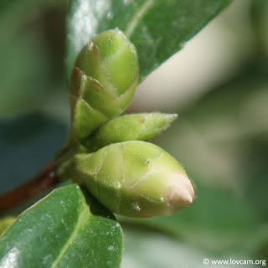http://2.bp.blogspot.com/-x-KdrLjiIGs/UNiF0NyIymI/AAAAAAAAABg/k4ayVkSTMNo/s1600/cathie-bouton-3-big.jpg
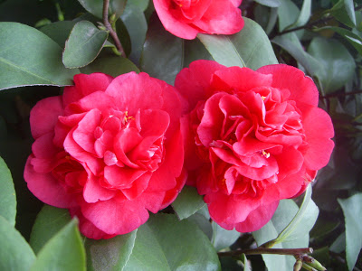http://1.bp.blogspot.com/-AsyaoC7UxAc/UNiFy2uehcI/AAAAAAAAABY/yXAlhD9lJeY/s1600/Beautiful-red-Camellia-flowers.jpg
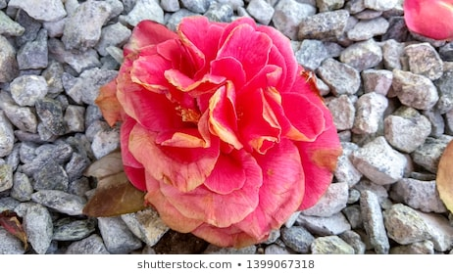https://www.google.com/url?sa=i&source=images&cd=&ved=2ahUKEwi30tfGtN7iAhUE2BoKHRIaDwAQjRx6BAgBEAU&url=https%3A%2F%2Fwww.shutterstock.com%2Fsearch%2Fwithered%2Bcamellia&psig=AOvVaw1I5cviEWYniktzaNz3bTIn&ust=1560238780311001
The idea in this poem is life, from the time life starts until the end. The above images are the best illustration for the ideas in the poem. The first image shows how the life of a flower starts and how it blossoms and its beauty finally fades. Just like in the poem, human life starts at birth, the child becomes a youth and is beautiful and he finally grows old. The author in the poems urges the young and beautiful to make most of their time while they are still young before old age catches up with them.
Part 3
Song; Good Old Days by Macklemore ft Kesha
The song is about making the most of the life at the moment so that you wont live to regret in the future. The message in the poem is to value what one is experiencing right now, live life to the fullest to avoid regrets and wishing you had done things differently. Make choices and take advantage of the better situations.
Link; https://www.google.com/search?q=Macklemore+feat+Kesha+%E2%80%93+Good+Old+Days&oq=Macklemore+feat+Kesha+%E2%80%93+Good+Old+Days&aqs=chrome..69i57j0l5.1033j0j7&sourceid=chrome&ie=UTF-8

