YOUR NAME: _______________
Postmodern Resistance
This worksheet is based on the reading from the book, “Graphic Design: A New History” pages 347 - 355.
There are 4 questions. Please fill this worksheet out. If you do not write full sentences then bullet point your answers. If it is a direct quote from the chapter, then include quote marks.

1. | Explain the meaning behind the term “postmodernism resistance.”
Postmodernism Resistance as defined in the passage is “is where the message presented in the works resists or attempts to undermine aspects of the society that the artist wants to change “
It emerged when the revival of the protest poster came out of the politicization of Europeans and Americans young people in the 1960s especially university students who were outraged by what they saw as racist ,sexist and class-based discrimination in their societies

2. | Explain Emory Douglas’ role as a young graphic artists and the movement surrounding the Black Panthers.
Emory Douglas worked on various media projects his artwork for the weekly paper was most significant because the paper proved to be the panthers most successful and influential enterprise (fig.9.55)
He was an important figure in the creation of the Black panther visual identity

3. | How does the graphic messages against the Vietnam War compare to the messages of Dadaist during WWI?
In the Dadaist war ,one of the most shocking protests posters to come out of the anti-war movement was Peter Brandt’s1970 Q. and babies ? a member of the Arts workers’ coalition while in the Vietnam war the revival of the protest poster came out of Europeans and Americans young people in the 1960s especially university students who were outraged by what they saw as racist ,sexist and class-based discrimination in their societies

4. | Provide some additional information about the artists and messages around social activism, feminism, and AIDS epidemic. Look for information beyond the text. Share visual examples of some of the messages being displayed. (Do not share the ones from the text).
in 1971, Judy Chicago, one of the most prominent early activists in the New York group Women Artists of Revolution, established the Feminist Art program at Cal State Fresno. In 1972, Judy Chicago created Woman house with Miriam Schapiro at the California Institute of the Arts (Cal Arts), which also had a Feminist Art program.

Nicholas Nixon became well known as a photographer; in 1988 he had an exhibition at the Museum of Modern Art in New York City entitled "Pictures of People." Some photographs were of people with AIDS, documenting their physical deterioration in intervals of weeks or months. Nixon claimed that his goal was to visually capture the dire consequences of the AIDS epidemic. His depiction of people with AIDS was very controversial as some claimed his images were of hopeless, lonely individuals.

Diego Rivera was one of the leaders of the Mexican Mural Movement of the 1920s. He created popular political murals throughout Mexico that included attacks on the ruling class, the church and capitalism. Instead, he promoted communism and socialism, and wanted to protect workers’ rights.
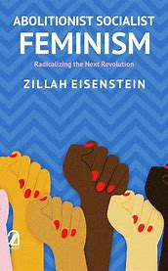 figure 1(shows a message about feminism) 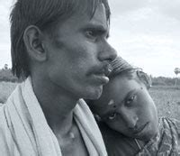figure 2(a picture of people living with Aids)
Figure 3(a message of change in the society)

