Supply Chain Resilience vs. COVID-19 Disruptions

Dr Sheraz Alam Malik

Agenda

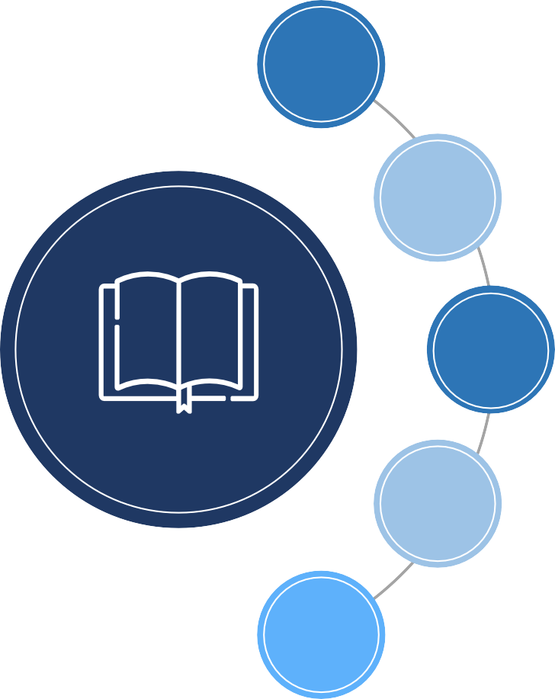
01 Introduction & Objective

02 The Process

03 Data Analysis

04 Conclusion & recommendations

05 Issues & challenges

01
Introduction & Objective

What is Supply Chain?

The flow of material, information, money, goods and services, from raw material suppliers through factories, offices, warehouses, to end consumers. (Lambert, et al 2000)

What is Resilience?

The ability of a supply chain system to reduce the probabilities of disruptions, to reduce the consequences of those disruptions, and to reduce the time to recover normal performance. (Falasca, et al 2008)

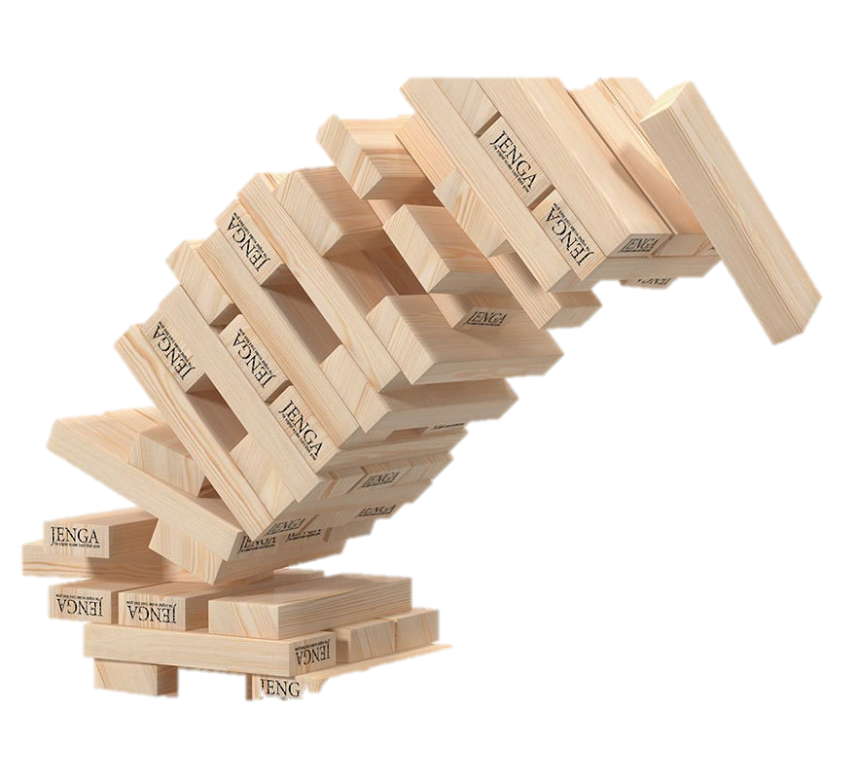

Why do supply chains have to be resilient?

The less resilient, the more vulnerable firms will be, where it is proposed that firms will be the most profitable in the long term the more resilient they are. (Pettit, et al 2010)

How to measure Supply Chain Resilience?

It is a multidimensional problem; it spans across multiple tiers. It is difficult to quantify. (Munoz, et al 2015).

There is not one single model to measure SCR

Objective

Show how resilient are supply chains against the disruptions caused by COVID-19.

02

The process

What did we do?

09

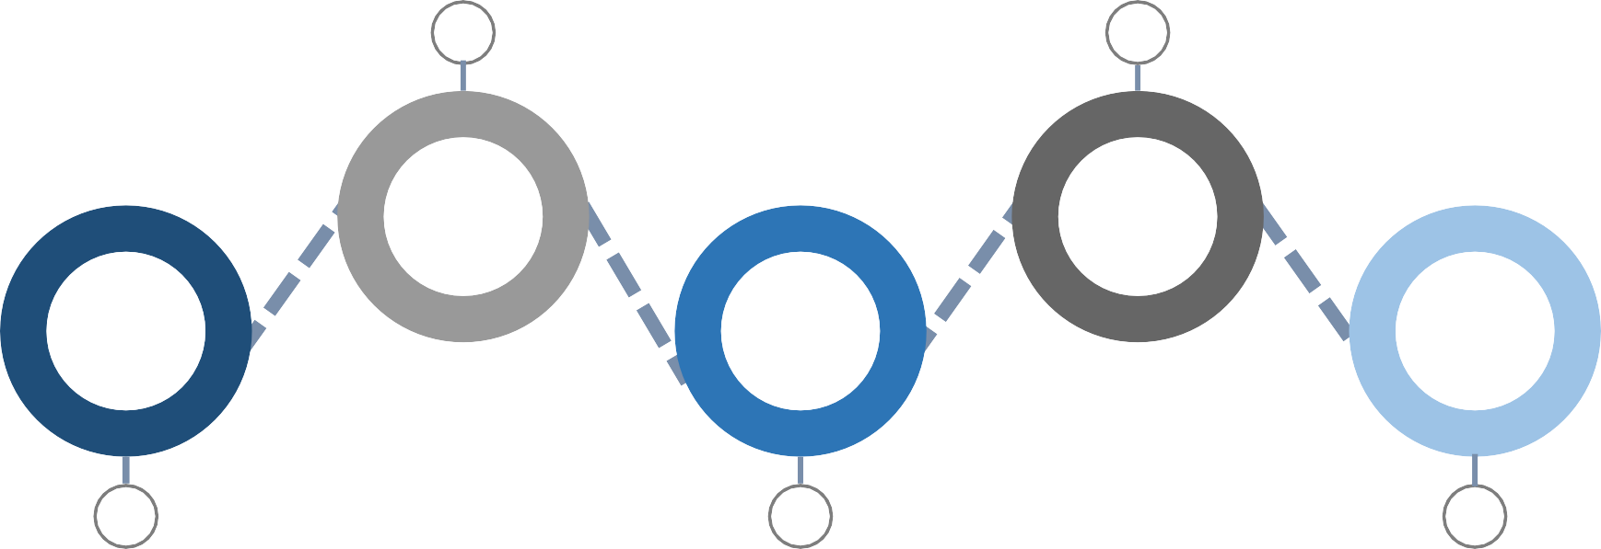Collected Data Analyzed it
02
04

01 | 03 | 05
Understood questions & built survey | Organized it | Reported it

Understood Questions – Survey Clarity

10

To ensure the clarity of some questions, we added descriptions to the ones we felt were ambiguous.

Examples:
Please identify the major source(s) of the COVID-19 disruption.
- Own company – you affected the supply chain of other firms
- Upstream supply chain – e.g., from suppliers to you
- Downstream supply chain – e.g., from you to your customers
Please identify the major impact of the COVID-19 disruption.
- Postponed shipping orders to customers - your decision
- Customers postponed receiving orders - their decision

Proceeded to online surveys for the remainder of the data collection process.

Built Survey – Tool Used

11
Online surveys were conducted through Google Forms.

Data Collection - Sampling & Criteria

12

Only those who understand what a supply chain is should take the survey The only exception was if the respondent was a C-suite level
Requests to participate were shared with potential respondents

Targeted only companies working in the Kingdom – Some ended up giving the location of their global headquarters

Data Collection – Stages

13
Number of respondents contacted vs. those who answered vs. those who qualified (n = 25)
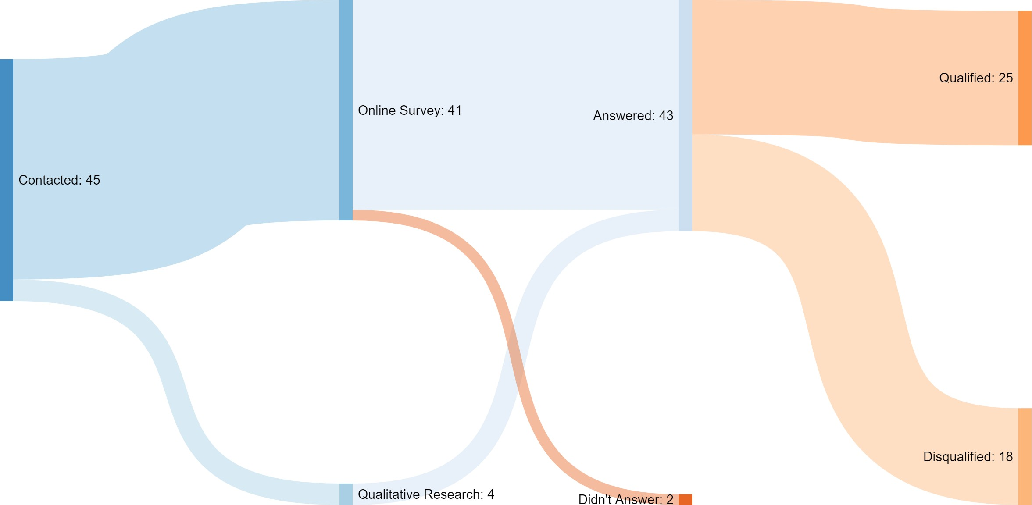

Data Organizing

14
Took us 5 rounds to reach a final dataset we can happily work with
Data cleaning &
format unifying
Removed
corrupt, nonmeaningful, duplicated & incomplete data

Final Dataset

Data Analysis & Visualization

15
We used SPSS & Tableau and some other extensions

03

Data Analysis

So much to cover, so we will focus on THREE

17
areas:

The Sample
1

Disruptions & Impact (Descriptive Analysis) Resilience (Correlation Analysis)
2
3

The Sample

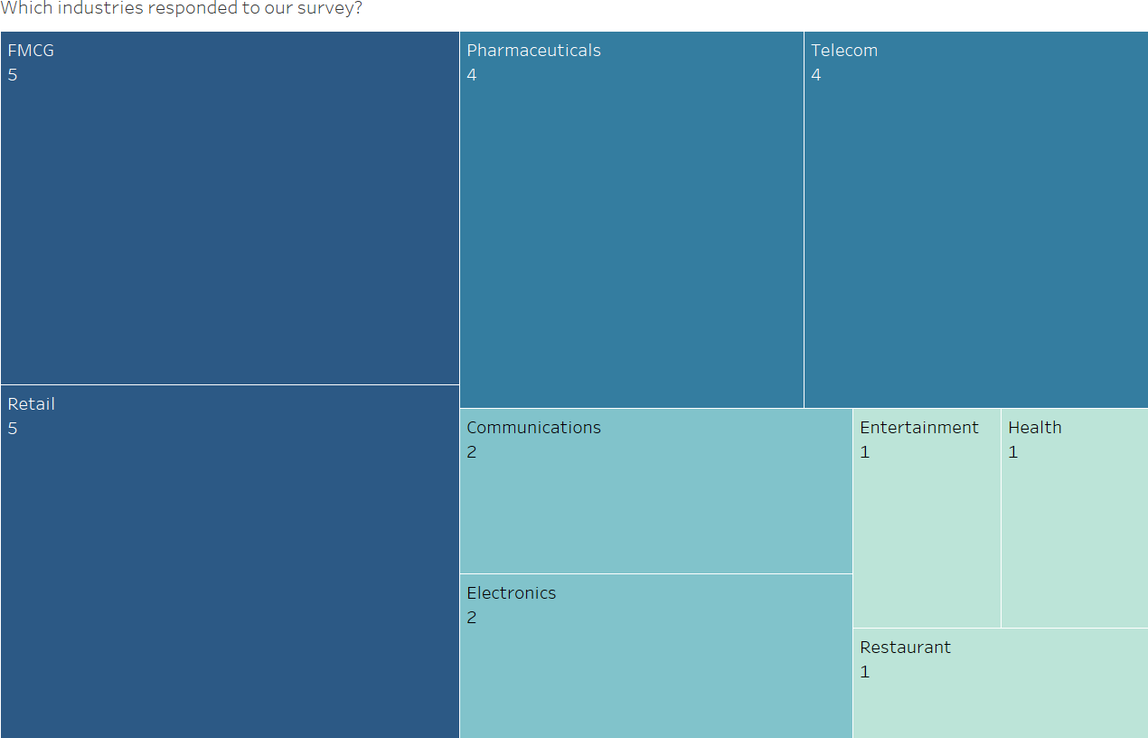

19

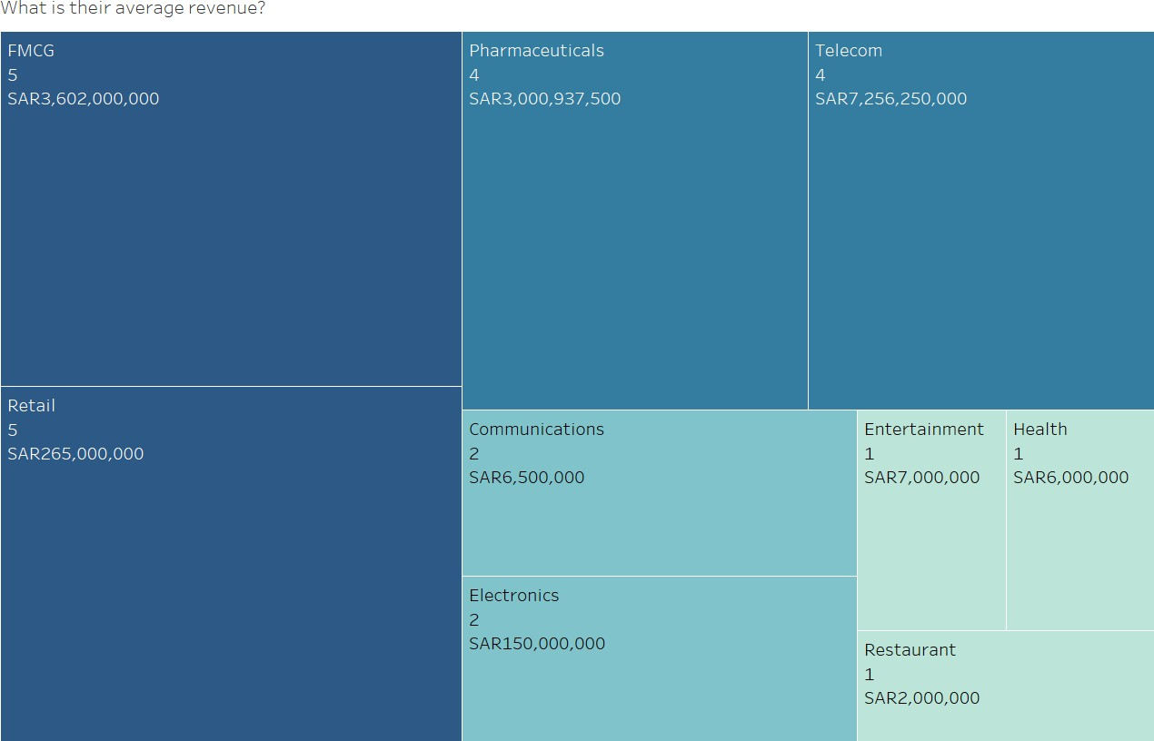

20

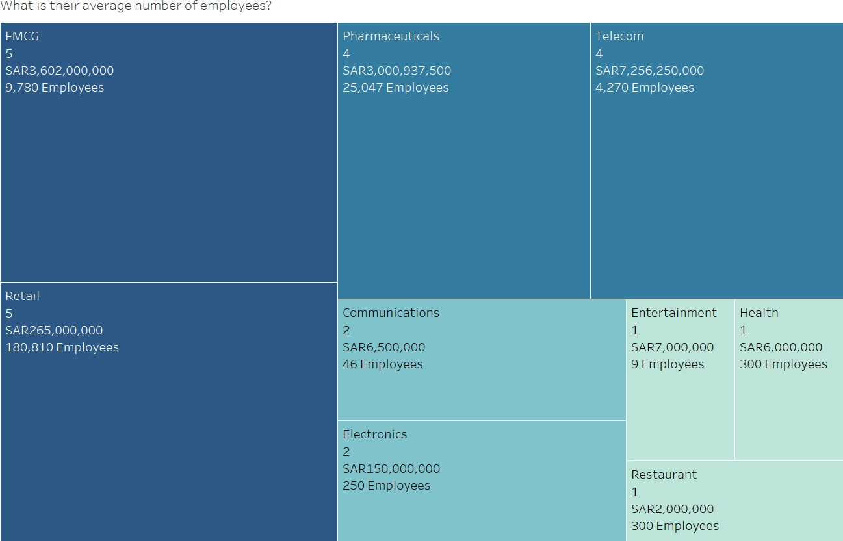

21

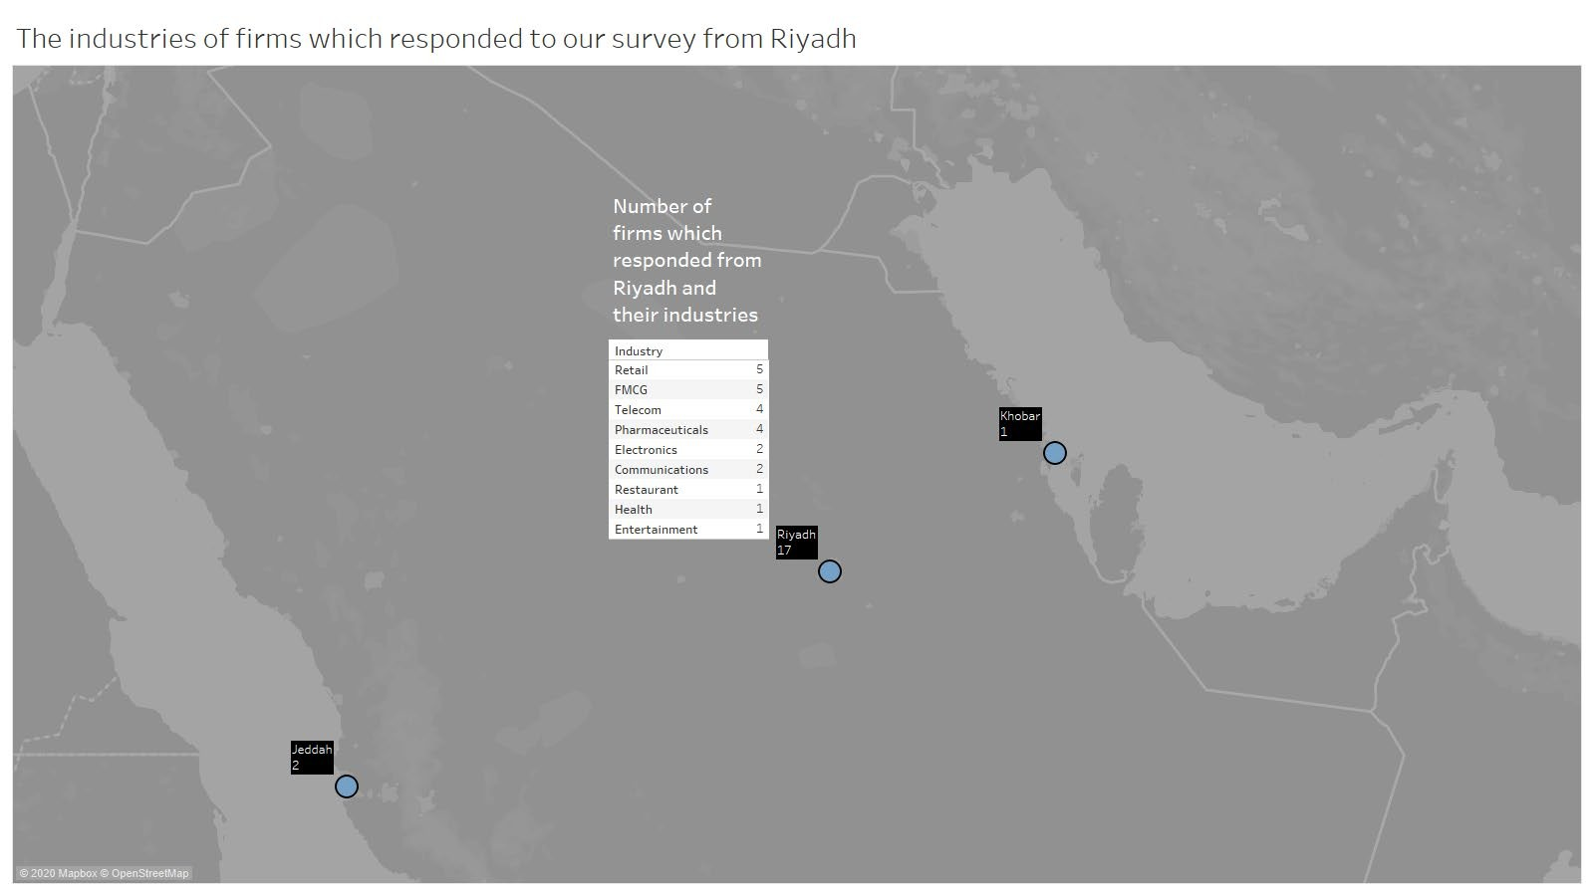

23

23

Disruptions & Impact (Descriptive Analysis)

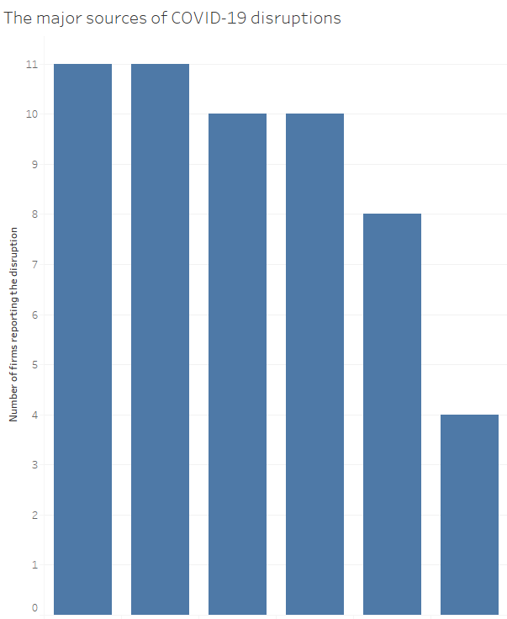
Source of Disruption

Immediate customers

Immediate Suppliers
Upstream SC
Downstream Multiple entities in the SC

Downstre am SC
Own Company

Source of Disruption: |  | Upstream supply chain | Immediate suppliers | Own company | Immediate customers | Downstream supply chain | Multiple entities in the supply chain
N | Valid | 25 | 25 | 25 | 25 | 25 | 25
 | Missing | 1 | 1 | 1 | 1 | 1 | 1
Mean |  | 0.44 | 0.48 | 0.16 | 0.40 | 0.32 | 0.40
Median |  | 0.00 | 0.00 | 0.00 | 0.00 | 0.00 | 0.00
Mode |  | 0 | 0 | 0 | 0 | 0 | 0
Std. Deviation |  | 0.507 | 0.510 | 0.374 | 0.500 | 0.476 | 0.500
Variance |  | 0.257 | 0.260 | 0.140 | 0.250 | 0.227 | 0.250
Skewness |  | 0.257 | 0.085 | 1.975 | 0.435 | 0.822 | 0.435
Std. Error of Skewness |  | 0.464 | 0.464 | 0.464 | 0.464 | 0.464 | 0.464
Kurtosis |  | -2.110 | -2.174 | 2.061 | -1.976 | -1.447 | -1.976
Std. Error of Kurtosis |  | 0.902 | 0.902 | 0.902 | 0.902 | 0.902 | 0.902
Range |  | 1 | 1 | 1 | 1 | 1 | 1
Minimum |  | 0 | 0 | 0 | 0 | 0 | 0
Maximum |  | 1 | 1 | 1 | 1 | 1 | 1

Positive-skewed under Own Company tells us majority said they were not the source of disruption.

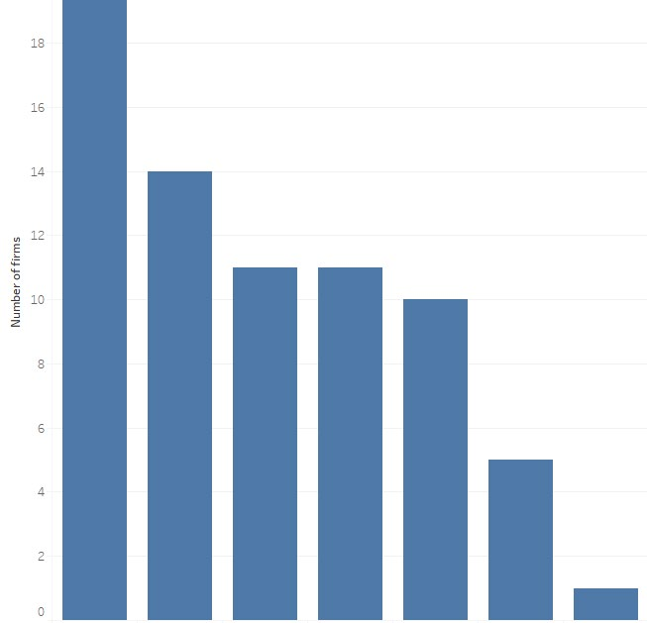

Disruption Impacted

Delays in Shipment from Suppliers

Unavailability of Transportation Capacity
Postponed Shipping Orders to Customers
Unavailability of Human Resources
Customers Postponing Receiving Orders
Production Interruptions in Own Company
Postponing Sending Orders to Suppliers

Disruption Impact |  | Delays in shipments from suppliers | Postponing sending orders to suppliers | Production interruptions in own company | Postponed shipping orders to customers | Customers postponing receiving orders | Unavailability of transportation capacity | Unavailability of human resources
N | Valid | 25 | 25 | 25 | 25 | 25 | 25 | 25
 | Missing | 1 | 1 | 1 | 1 | 1 | 1 | 1
Mean |  | 0.84 | 0.04 | 0.20 | 0.48 | 0.40 | 0.56 | 0.44
Median |  | 1.00 | 0.00 | 0.00 | 0.00 | 0.00 | 1.00 | 0.00
Mode |  | 1 | 0 | 0 | 0 | 0 | 1 | 0
Std. Deviation |  | 0.374 | 0.200 | 0.408 | 0.510 | 0.500 | 0.507 | 0.507
Variance |  | 0.140 | 0.040 | 0.167 | 0.260 | 0.250 | 0.257 | 0.257
Skewness |  | -1.975 | 5.000 | 1.597 | 0.085 | 0.435 | -0.257 | 0.257
Std. Error of Skewness |  | 0.464 | 0.464 | 0.464 | 0.464 | 0.464 | 0.464 | 0.464
Kurtosis |  | 2.061 | 25.000 | 0.593 | -2.174 | -1.976 | -2.110 | -2.110
Std. Error of Kurtosis |  | 0.902 | 0.902 | 0.902 | 0.902 | 0.902 | 0.902 | 0.902
Range |  | 1 | 1 | 1 | 1 | 1 | 1 | 1
Minimum |  | 0 | 0 | 0 | 0 | 0 | 0 | 0
Maximum |  | 1 | 1 | 1 | 1 | 1 | 1 | 1

Positive-skewed under Production interruptions in own company tells us majority said they faced no issues at their own firms.

Company’s Size.. Does it Matter?

28

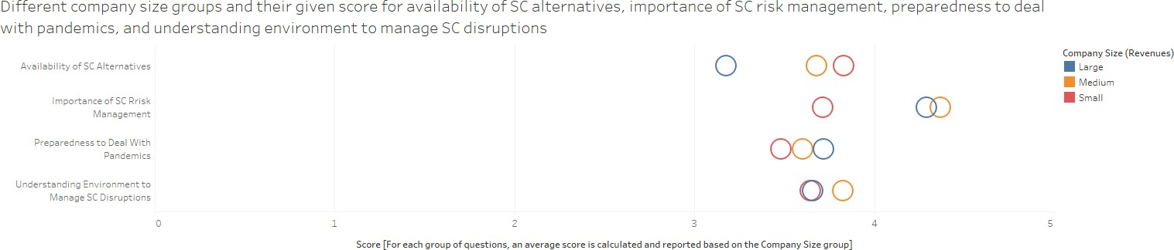

The larger the company:
- The less available alternative to its suppl chain it has
- The more prepared it is against COVID-19 disruptions
- Medium and Large companies place higher importance on supply chai risk management Would that mean they will be disrupted less than small companies?

29

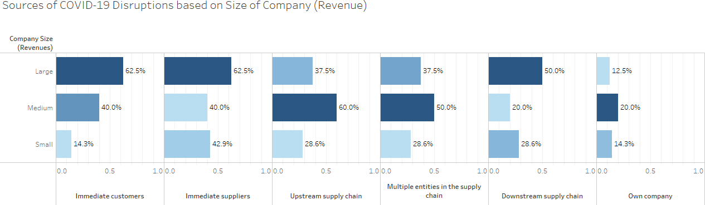

30

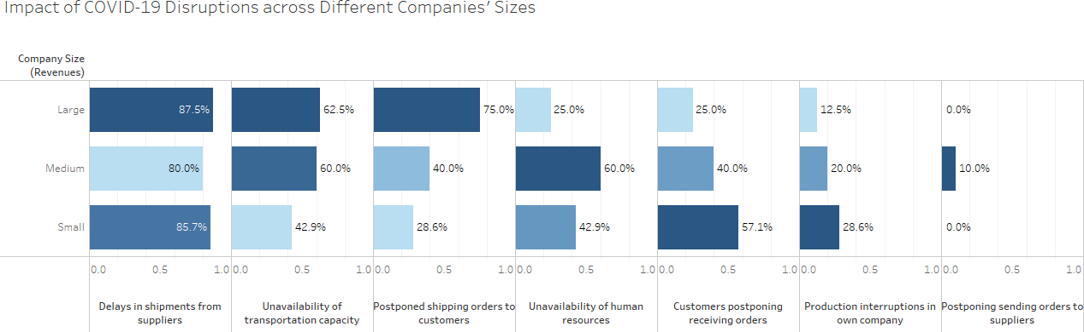

How well are they doing now ?

31

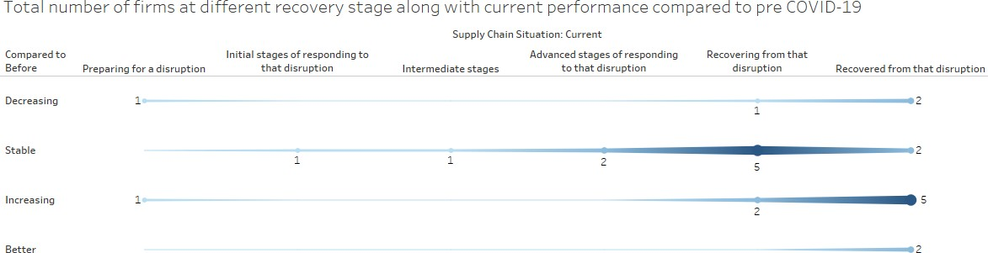

Resilience
(Correlation Analysis)

What caused resilience? What helps firms
recover?

Prepatdenss to deal with pandamics

Understanding Environment to manage SC disruptions

Importance to SC Risk management

Recovery Level
Resilience

Availability of SC alternatives

How are they correlated?

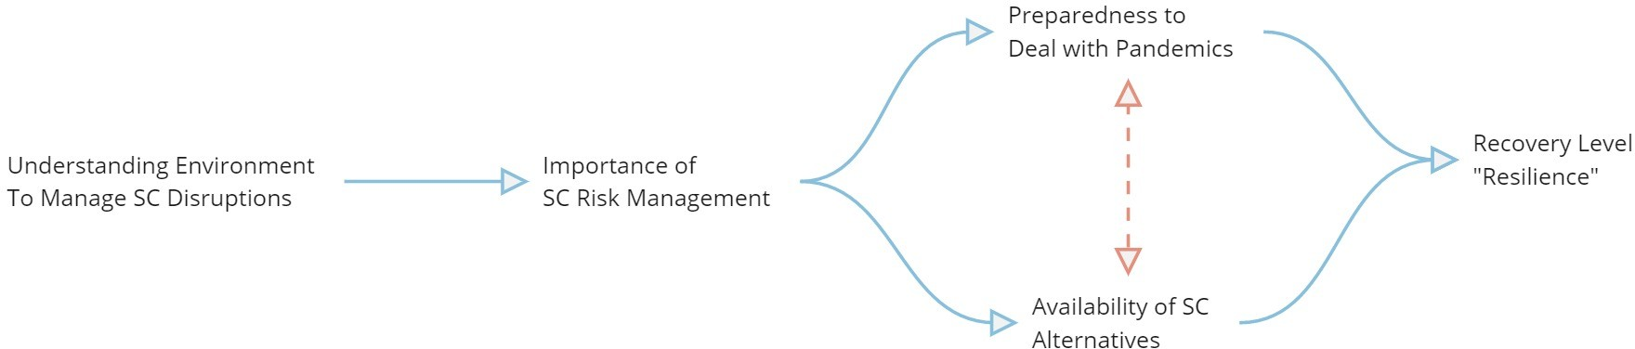

How are they correlated? |  |  |  |  | Importance: Supply chain risk management for supplier selection for raw materials and parts | Importance: Supply chain risk management for site selection
Spearman's rho | Understanding of environment: Perceive the | Correlation Coefficient |  |  | .617**
 |  | Sig. (2-tailed) |  |  | 0.001
 |  | N |  |  | 25
 | events in external environment that are likely to cause disruptions |  | Bias |  | -0.003
 |  | Bootstrap^{c} | Std. Error |  | 0.119
 |  |  | 95% Confidence Interval | Lower | 0.359
 |  |  |  | Upper | 0.838
 | Understanding of environment: Interpret the perceived events in the internal environment for their impact on our supply chain | Correlation Coefficient |  |  | .591** | .567**
 |  | Sig. (2-tailed) |  |  | 0.002 | 0.003
 |  | N |  |  | 25 | 25
 |  | Bootstrap^{c} | Bias |  | -.002^{d} | -.009^{d}
 |  |  | Std. Error |  | .115^{d} | .125^{d}
 |  |  | 95% Confidence Interval | Lower | .343^{d} | .293^{d}
 |  |  |  | Upper | .808^{d} | .790^{d}
**. Correlation is significant at the 0.01 level (2-tailed).
c. Unless otherwise noted, bootstrap results are based on 1000 bootstrap samples
d. Based on 999 samples

Strong positive correlations:
- More importance is given to supply chain risk management for supplier selection for raw materials and parts, the higher a firm perceives the events in external environment that are likely to cause disruptions (understanding)
- More importance is given to supply chain risk management for site selection, the higher a firm interpret the perceived events in the internal environment for their impact on their supply chain (understanding)

Preparedness: We had Preparedness: We had
Preparedness: We had procedures to protect

How are they correlated?
Correlation Coefficient
supply chain partner alternatives

.417*
supply chain flexibility
our goods from criminal activity and contamination
.512**

Spearman's rho
Importance: Supply chain risk management for supplier selection for raw materials and parts

Importance: Supply chain risk management for site selection

Importance: Supply chain risk management for transportation decisions
Sig. (2-tailed) N

Bootstrap^{c}

Correlation Coefficient Sig. (2-tailed)
N

Bootstrap^{c}

Correlation Coefficient Sig. (2-tailed)
N

Bootstrap^{c}

Bias
Std. Error
95% Confidence Interval

Bias
Std. Error
95% Confidence Interval

Bias
Std. Error
95% Confidence Interval

Lower Upper

Lower Upper

Lower Upper
0.038
25
0.001
0.163
0.073
0.701

.512** 0.009
25
-0.010
0.125
0.233
0.712

.448* 0.025
25
-0.005
0.152
0.081
0.709
0.009
25

36
0.000
0.136
0.208
0.748
.472* 0.017
25
-0.004
0.119
0.228
0.682

**. Correlation is significant at the 0.01 level (2-tailed).
*. Correlation is significant at the 0.05 level (2-tailed).
c. Unless otherwise noted, bootstrap results are based on 1000 bootstrap samples
Moderate positive and negative correlations between:
- Strong positive: Firms strongly agree that they are more prepared and do have procedures to protect their goods from criminal activity and contamination, the higher the importance reported towards Supply chain risk management for supplier selection for raw materials and parts
- Strong positive: Firms strongly agree that they are more prepared by having supply chain alternatives, the higher the importance
reported towards risk management for transportation decision

How are they correlated?
Correlation Coefficient Sig. (2-tailed)
Preparedness: We N

Availability of Alternatives: We have alternative sourcing options for critical parts

.430* 0.032
25

Availability of Alternatives: We have alternative markets for our finished products

Availability of Alternatives: We have alternative options to produce our goods

.408* 0.043
25

Availability of Alternatives: We have alternative distribution channel options to deliver the goods to our customers
.478* 0.016
25
Availability of 37
Alternatives: We
have alternative transportation options to deliver the goods to our customers

had supply chain partner alternatives
Bootstrap^{c}
Bias
Std. Error
95% Confidence Interval

Lower Upper
0.000
0.160
0.085
0.723
0.001
0.177
0.029
0.711
-0.003
0.159
0.131
0.743

Correlation Coefficient
.630**
.438*

Spearman's rho
 | Sig. (2-tailed) |  |  | 0.001 | 0.029
Preparedness: Our | N |  |  | 25 | 25
employees had the  skills to deal with |  | Bias |  | 0.002 | 0.003
the disruption | Bootstrap^{c} | Std. Error |  | 0.184 | 0.197
 |  | 95% Confidence | Lower | 0.225 | -0.012
 |  | Interval | Upper | 0.908 | 0.764
 | Correlation Coefficient |  |  | .458*
 | Sig. (2-tailed) |  |  | 0.021
Preparedness: We | N |  |  | 25
had procedures |  | Bias |  | -0.002
and plans in place | Bootstrap^{c} | Std. Error |  | 0.187
 |  | 95% Confidence | Lower | 0.066
 |  | Interval | Upper | 0.784
Preparedness: We | Correlation Coefficient Sig. (2-tailed)  N |  |  | .442* 0.027  25

had supply chain
Bias
0.006

visibility  Bootstrap^{c} | Std. Error |  | 0.210
 | 95% Confidence | Lower | 0.022
 | Interval | Upper | 0.815
**. Correlation is significant at the 0.01 level (2-tailed).
*. Correlation is significant at the 0.05 level (2-tailed).
c. Unless otherwise noted, bootstrap results are based on 1000 bootstrap samples

How are they correlated?

38
 |  |  |  |  | Preparedness: Supply chain partners were willing to collaborate with us | Availability of Alternatives: We have alternative markets for our finished products
 |  | Correlation Coefficient |  |  | .504* | -.452*
 |  | Sig. (2-tailed) |  |  | 0.012 | 0.027
 |  | N |  |  | 24 | 24
Spearman's rho | Supply Chain Situation: Current | Bootstrap^{c} | Bias |  | -0.013 | 0.007
 |  |  | Std. Error |  | 0.129 | 0.166
 |  |  | 95% Confidence Interval | Lower | 0.185 | -0.724
 |  |  |  | Upper | 0.702 | -0.086

*. Correlation is significant at the 0.05 level (2-tailed).

c. Unless otherwise noted, bootstrap results are based on 1000 bootstrap samples

Strong & Moderate positive correlations between:
- Strong: The more preparedness firms shown in terms of collaborations with their supply chain partners, the better the current
supply chain situation
- Moderate: The less markets for finish products available to a firm, the better the current supply chain situation is

04

Conclusion & Recommendations

Reminder

40

Resilience: The ability of a supply chain system to:
  - REDUCE the probabilities of disruptions
  - REDUCE the consequences of those disruptions
  - and to REDUCE the time to recover normal performance.

Falasca, et al (2008, May).

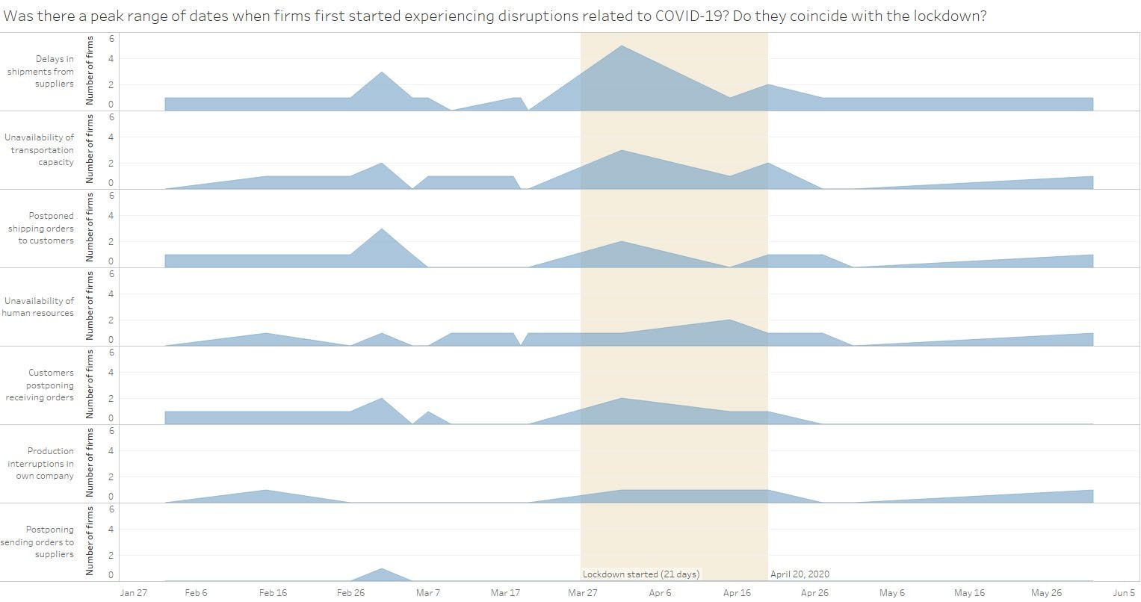

42

If each disruption was reported at a specific date, we wouldn’t see the first spike (pre-lockdown)

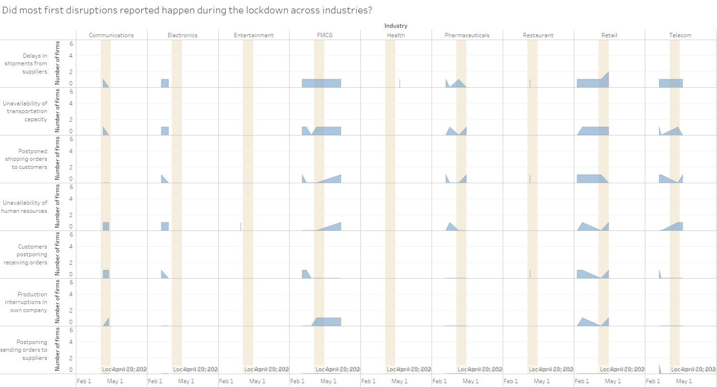

42

Six weeks of overlapping phases – Learning Window (first when thought of implications vs. when disruptions first happened) – A Learning Window would help in REDUCING the probabilities of disruptions

43

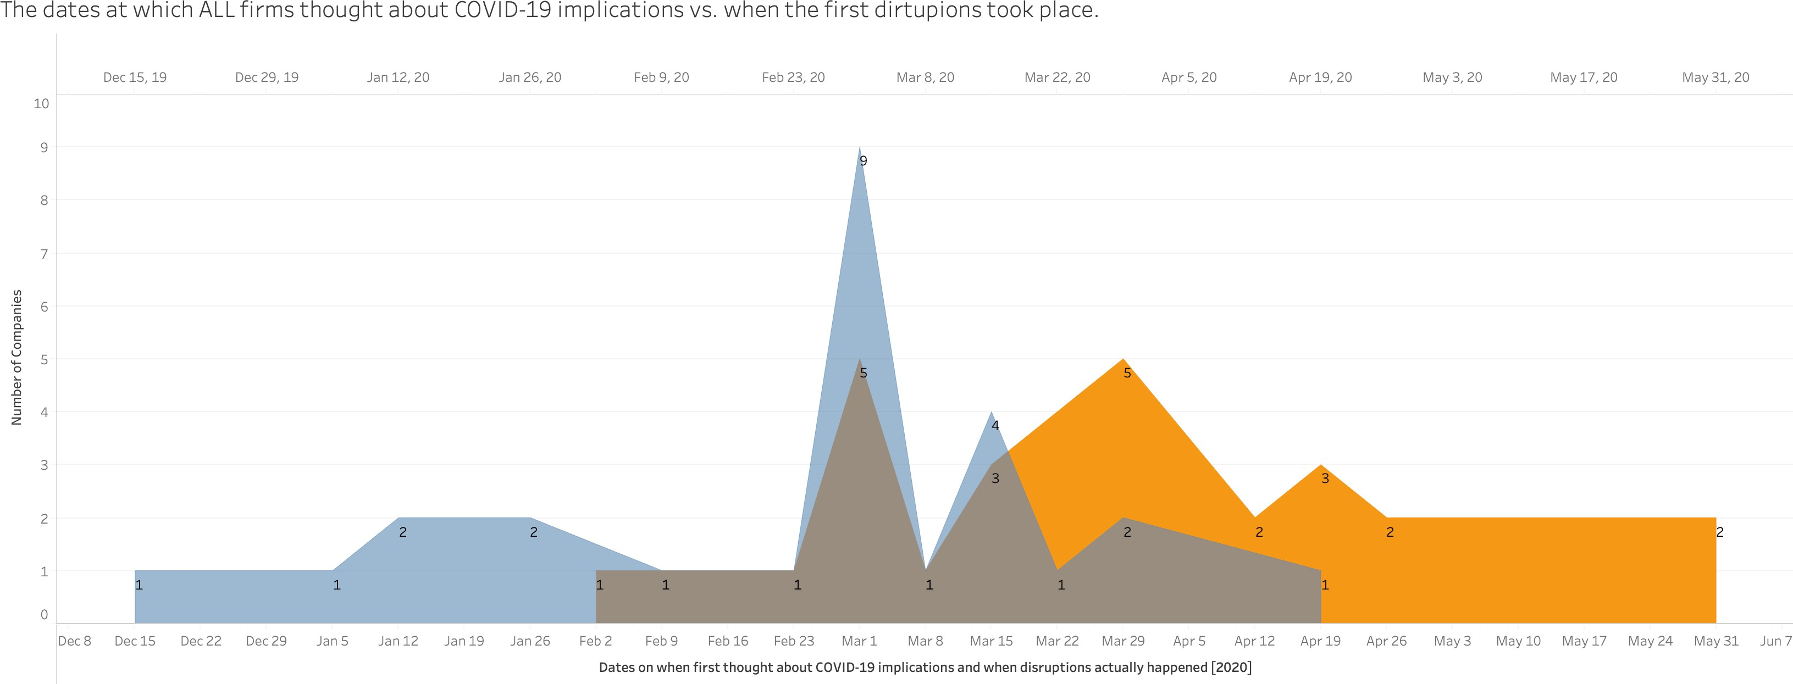Dates at which firms were thinking of COVID-19 implications
Dates at which firms witnessed COVID-19 disruptions
Learning Window

Companies dealing with products had longer lead time (Action Window) between when they first thought about implications to the day actual disruptions took place.

44
An Action Window would help in REDUCING the consequences of those disruptions. (for both products and services providers); the longer, the less impact.

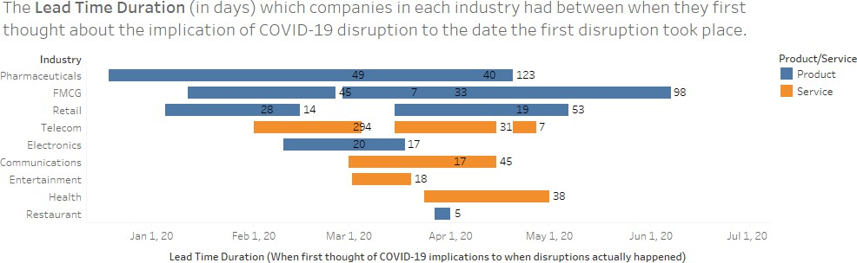

Calculated field = Lead Time Duration (in days)
Equation: First when thought about COVID-19 implications – Date when first disruption took place

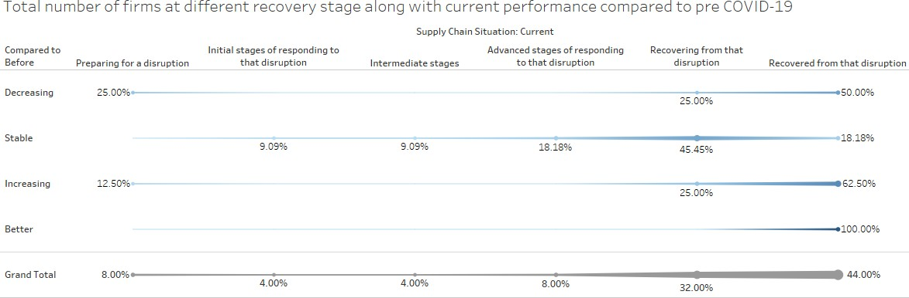
- 76% of sample are either recovering or have recovered from COVID-19 disruptions
- 80.7% of sample are either in a stable or increasing performance/situation compared to pre COVID-19 disruptions

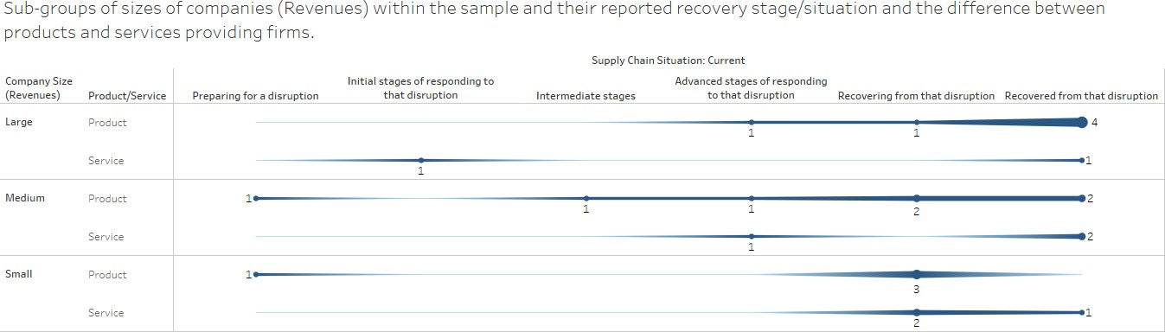

Product vs. Service:
  - 70.6% of firms selling products are either recovering or have recovered from the disruption, of these 75% are either medium or large companies
  - 75% of firms selling services are either recovering or have recovered from the disruption, of these 50% are either medium or large companies

Size:
  - 62.5% of large companies (products & services) have fully recovered
  - 33.33%% of medium companies (P&S) have fully recovered
  - 14.3% of small companies (P&S) have fully recovered

What could next studies focus on?

Measure resilience against the product/service production complexity

Level of firms’ liquidity during the disruptions and if this has any correlaJtAioNnUAwRith2 r1e9silience

Investigate the digital sales maturity level of firms during the time of disruptions to check if firms who are selling online had less disruptions than those which do not
Could add another question, which would allow us to further analyze; if we add day of recovery for each reported disruption, then we could show which industry/firm had a more SC resilience.

48

05

Issues & Challenges

Issues

Some respondents decided to not share their answers when giving the name of their firm was mandatory (even C-suite level)

Some – who are working with international firms – answered questions pertaining to revenues and number of employees considering the overall firm, not the local branch → caused outliers, some were fixed via callbacks, others were assumed, others were unchanged

Questions were too long, neither SPSS nor Tableau would show the full text, ended up shortening them but keeping the meaning; they were difficult to handle even on excel

It was easier to catch anomalies for earlier respondents, since the distribution of the survey was limited, fixing these was easy, the more the survey got circulated, the more difficult it was to know who is who

Challenges

We wish we did not start early; more understanding of SPSS would have enabled us to use better surveying techniques, example: A Likert scale could have been numerical instead of coding in SPSS

Some of the questions are not timely, which meant less accurate results

Sample size is small, we wished we focused on 2 industries to have specific and direct findings more worthy of reporting

References

51

    - Lambert, Douglas M., and Martha C. Cooper. "Issues in supply chain management." Industrial marketing management 29, no. 1 (2000)
    - Munoz, A., & Dunbar, M. (2015). On the quantification of operational supply chain resilience. International journal of production research
    - Falasca, M., Zobel, C. W., & Cook, D. (2008, May). A decision support framework to assess supply chain resilience. In Proceedings of the 5th International ISCRAM Conference
    - Pettit, Timothy J., Joseph Fiksel, and Keely L. Croxton. "Ensuring supply chain resilience: development of a conceptual framework." Journal of business logistics 31, no. 1 (2010)

Shukrn.

