EMR in Healthcare Technology
Student name
University name

EMR in Healthcare Technology
Project Description: For this paper on technological issues in Healthcare information field, I have chosen the Electronic Medical Records system or EMR system to focus and discuss about the uses, functions, and potential barriers of it. The advancement of technology has greatly impacted every big and small area of our daily dealings. It has also touched the healthcare with some major transformations in their service management and providing care. One of the significant technological developments is adoption and use of electronic medical records or EMR systems. It has been developed gradually and facilitated managing and keeping vast information of various medical records in a healthcare organization. Although the benefits and advantages of EMR facility has largely been acknowledged by medical professionals, academicians, government, and industries in recent decades, its proper implementation in healthcare field, especially in rural healthcare settings are not much advanced. Therefore, it is necessary to conduct study upon the use of EMR to improve its implementation in the less advanced areas. This study is conducted based on previous literature reviews in the field, and information obtained from the medical journals and websites. Therefore, it does address interviews, equipment, personnel needs, cost estimates, time requirements, and analysis, necessary for a quantitative research.
Objective: The objective of this study is to address the major functions and benefits of EMR system in delivering improved services both to medical professionals and patients to bring support for its implementation in rural healthcare settings.
Identification of the Problem: Healthcare is a crucial part of our life, and we spend a part of our expenditures to healthcare services almost at a monthly basis. But few of us know the difficulties of managing, providing, utilizing the vast medical records, necessary for delivering care services. Also, the benefits of EMR are not recognized by many rural healthcare organizations and their government, and continue with the traditional process of paper record keeping.
Value to Healthcare field: By addressing the overall benefits and functions of EMR systems, this study will help to create awareness about the EMR implementation in rural healthcare. It will improve their care delivery services as well as develop policies and guidelines to make further advancement in the field.
History: The EMR facility has been developed during two major time periods. One, during the 1960s and 70’s, when academic medical centers advantaged their own systems and another during 1980s, when political leaders acknowledged benefits of industry-wide standards and started forming organizations to manage the broader issues to facilitate the widespread use of electronic medical information (Atherton, 2011). At first, this system was known as clinical information systems. During the 1960s Lockheed developed one such service, which has since been handed down to the Vendor Technician, TDS healthcare, then Eclipsys, and now a part of Allscripts. During the 1970s, the federal government started using EHR with the Department of Veteran Affairs’ Implementation, or VistA, which is originally known as Decentralized Hospital Computer Program or DHCP. Since 1980s, more organized efforts have been provided to increase the use of EMR in medical profession. In the mid-1980s, the Institute of Medicine (IOM), recognizing the needs for serious analysis of paper health records undertook such a study, the result of which was published in 1991 and its revision in 1997. This report first argued the case for EMR facility, identifying it as one of the seven key recommendations to improve the patient records and proposing a means of converting paper to electronic records. While private industries became conscious of the IOM’s findings, the supporters formed the Computer-based Patient Record Institute or CPRI. This helped to break down barriers to EMR development. The IOM has also collaborated in developing an electronic standards organization, HL7, which is an international, non-profit standard organization or SDO in 1987. HL7 expands electronic standards to improve the components of the EMR to make the communication easier, resulting in a working electronic health record system. Since 2006, the Certification Commission for Healthcare Information (CCHIT), which is an oversight organization, has been certifying vendors as HL7 compliant. More widespread concern about the recordkeeping’s benefits upon public healthcare services has been made possible by U.S presidents. While President Bush mentioned it in his State of the Union Address in 2004, President Obama has incorporated EMR into his American Recovery and Reinvestment Act of 2009 as part of the Health Information Technology for Economic and Clinical Health Act or HITECH that includes relevant purposes and meaningful use criteria of EMR (Atherton, 2011).
Background: Electronic Medical Records or EMR systems are defined as “an electronic record of health-related information on an individual that can be created, gathered, managed, and consulted by authorized clinicians and staff within one health care organization.” It provides substantial assistance to physicians, clinic practices, and healthcare organizations. It has been implemented within the healthcare network to facilitate workflow and improve the quality of patient-care and their safety. Considering these advantages, U.S non-federal acute care hospitals have gradually increased the adoption of EMR facility since HITECH act in 2009. In 2014, three out of four non-federal acute-care have adopted at least one basic EMR system with clinician notes. This represents almost an eight fold increase in EMR adoption since 2008 (Charles, Gabriel, and Searcy, 2015).
Applications & Functions of EMR: Different types of EMR systems have been developed by academic medical centers, governments and industries to help physicians, healthcare organizations or hospitals, other clinical professionals, patient and their families to obtain access over improved health-care records. The basic function of EMR facility is to help the physicians practice better medicine and improve the bottom line. These functions are, but not limited to- identifying and maintaining patients’ records, managing patients’ demographics, managing problem and medication lists, managing patients’ history, organizing clinical notes and documents, capturing external clinical documents, presenting care-plans, guidelines, and protocols and properly managing them, generating and recording patient-specific instructions. There are a large number of broad functions including presenting alerts for preventive services and wellness, clinical task assignment and routing, notification and reminders for preventive services and wellness, pharmacy communication, provider-patient or –family communication, patient/family-care-giver education etc. (AAFP, 2017).
Technological Aspect: Healthcare organizations all across the globe have adopted a variety of information technologies to improve the management of health-care records easily and quickly. Among these technologies, the Electronic Medical Record or EMR system has been developed, adopted, and considered as one core technology within the healthcare services. This technology combines several complex information technologies such as, computerized physician order entry (CPOE) system, picture archiving and communication system (PACS). Besides providing a large number of benefits, the EMR system has affected a wide selection of clinical settings among healthcare organizations (Park & Lee, 2014). The many components of a well-established EMR facility in an healthcare organization include software, coordination process between the transfer and reception of information by the various departments, organizational guidelines for personnel use, and established care-plans for continuing education and training by the medical staffs.
Benefits and Drawbacks: This study will help to outline many benefits of EMR within the field of healthcare both for the patients and the medical practices. For the patients and their families EMR helps to improve diagnosis and treatments; for the medical practices EMR helps to foster care and decision making processes from the assigned professionals, quickly transfer patients’ data from one department to another, save space, papers, and time, serve an increased number of patients daily thus enhancing workflow and productivity, decrease operational expenses such as transcription services and overtime labor costs, develop customizable and scalable electronic medical records according to the need of the practice, advance e-prescribing and clinical documentation capabilities, and add an improved bottom line to the healthcare practice by enhancing the process of patient billing more accurately and efficiently. Among the most significant drawbacks of EMR adoption are- high capital cost and inadequate return on investment for small practices and safety net providers, underestimation of the organizational capabilities and requirement of the management change, failure in redesigning the clinical procedures and workflows that would incorporate with the EMR technology systems, concern about the system becoming obsolete, lack of skilled resources for proper implementation and support, awareness that current market systems are potentially not meeting the needs of rural health centers or federally qualified health centers (FQHC), concern about negative unintentional consequences of technology etc. (AHRQ, n. d.).
Summary: The study suggests the large number of functions that EMR conducts in medical services and its advantages for medical practitioners, organizations, and patients. Although there are a number of barriers to EMR adoption in rural settings, they can be avoided with the help from local government aid, private industry support etc. to develop education, training, and infrastructure.
Conclusions: Healthcare management in the rural framework should acknowledge the benefits of EMR systems in improved care delivery as early as possible to implement it in their care facility to add to a global network. Following are some examples of how EMR system functions-
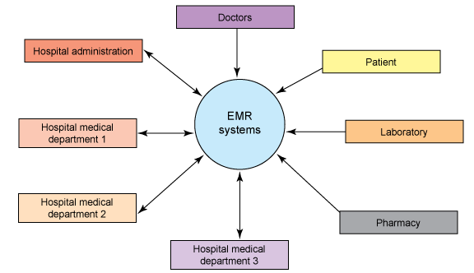
Fig:1 Functions of EMR systems to different stakeholders (Source: Krishna, 2010).

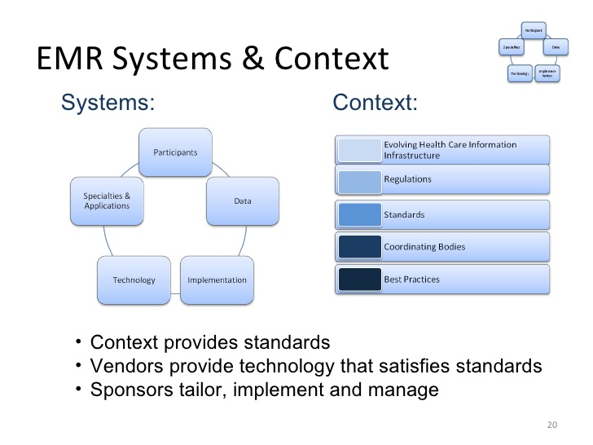
Fig 2: source: Lyon, Popanz, & Forester, (2009).

References:
Agency for Healthcare Research and Quality (2016). Electronic Medical Record Systems. Retrieved from: https://healthit.ahrq.gov/key-topics/electronic-medical-record-systems
American Academy of Family Physicians, (2017). Understanding Features & Functions of an HER. Retrieved from: http://www.aafp.org/practice-management/health-it/product/features-functions.html
Atherton, Jim (2011). Development of the Electronic Health Record. AMA journal of Ethics, Volume 13, Number 3: 186-189.
Charles, Dustin, Gabriel, Meghan, Searcy, Talisha, (2015). Adoption of Electronic Health Record Systems among U.S. Non-Federal Acute Care Hospitals: 2008-2014. The Office of the National Coordinator for Health Information Technology. No. 23.
Krishna, Sreevidya, (2010). Taking medical records into the digital age. Retrieved from: https://www.ibm.com/developerworks/websphere/library/techarticles/ind-openemr/index.html
Lyon, Popanz & Forester, (2009). Anatomy and Issues of Electronic Medical Records Systems. Retrieved from: https://www.slideshare.net/hal9007/anatomy-of-an-emr-system
Park, Young-Teak, Lee, Jinhyung (2014). Factors Affecting Electronic Medical Record System Adoption in Small Korean Hospitals. Healthcare Information Research, 20(3): 183–190. doi: 10.4258/hir.2014.20.3.183.

