Arts Project
Student name
University name

Arts Project
- Andy Goldsworthy’s Stone River across the road:
The British sculptor Andy Goldsworthy’s sandstone sculpture Stone River occupies a 320 ft. long volume of space, set in a 3 ½ ft. channel in front of the Cantor Center for Visual Arts of the University of Stanford.
The sculpture contains features of naturalism bringing the elements of nature and shaping them into work of art that perfectly fits the environment in where it is situated. The serpentine-like sculpture, created with 128 tons of sand stone at once echoes the form of a curved river, flowing back and forth in sinusoidal waves. The content of this work as reciprocated by the sculptor himself is about returning to the ground, “back into the earth, for a work that is about flow, movement, and change” (qtd. in Palmer, 2002). This ephemeral work, which conveys the notion of life and movement, expresses the aesthetic sense of the artist.
This artwork can be compared to the ancient megalith of Beltany Stone Circle, which is found in the North West of Ireland near the town of Raphoe and made of sixty-four stones of nearly 6 ft. spanning almost 45 meters in diameter forming a circle of mound, because of the volume of its size. The stones are thought to be raised around 1400 BC to 800 BC. Though much is not known about the purpose of its origin, it may relate to Pagan festival of Beltane that involves lighting fire on top of the hill in order to rejuvenate the Sun, again a link to the naturalism. According to some other theories, the stone circle resemblances to the circles at Carrowmore Cemetery, thus indicating a possible purpose during the burial process. Some others claim that the sculptor is built to make a burial cairn. Thus like the Stone River sculptor, it is also related to the idea of life (Batt, 2016).
- Block statue with cartouches of Ramses II c. 712 BCE-332 BCE
Major attributes of Egyptian royalty are visible on this statue of the King Ramses II (1279-1213 BC). The crown he wears symbolizes the King’s authority over the country. The gesture of his hands folded together represents his power over his subject. The Uraeus, the cobra snake, which is on his crown, protects the King against any attack. The curly beard is of a type only worn by the Kings.
The tone of the sculptor comes from its granite material. The texture of the artwork is mainly smooth with proper curves detailing the human features of eyes, noses, lips, eyebrows, hands, crown, snakes, and beards.
The statue of Ramses II expresses the Egyptian worldview most eloquently as it is the statue of an emperor, who is considered Ramses “the great”. Ramses II was the third King of the 19th dynasty of Egypt. With his contributory works in making temples, founding a new capital, conquering more states, he became one of the strongest Kings of Egyptian legacy.
The block statue essentially captures the control and power, the Ramses II enjoyed as well as of the Egyptian King over his citizens in general. It also shows the difference between a king and the common citizens. Moreover, what the citizens felt about the authorship of their kings has also been depicted by the powerful statue.
In Egyptian world, pharaoh’s effigies are always meant to be powerful, both as the functioning images and as the images of power. The images and architectural accomplishments of the Egyptian pharaohs assert the policy and authority of them both on Egypt’s territory and its beyond as well as the broader ideological discourse on monarchy in Egypt (Semat, 2016).
- The Gates of Hell:
The French sculptor Auguste Rodin’s massive bronze sculptor The Gates of Hell, created between 1880 and1917 has been kept alongside the main entrance to the Kunsthaus Zurich art museum since 1949. The sculptor is almost 7meters tall, 4 meters in width, and weighs 8 ton.
The artwork is representational of a vision of afterlife, which is inspired by Dante’s Inferno from the “Divina Commedia”. The art contains 180 figures grouped together a central figure “The Thinker”, which shows a contemplative man seated and resting his chin on his palm.
This composition is inspired by the long tradition of compartmentalized church doors, particularly the doors to the Baptistery in Florence. Rodin creating “a free-form environment in which tormented souls float and weave in a surging arrangement” (Iris & B. Gerald Cantor Foundation) presents the underworld as well as the suffering of the humankind. It expresses the poignant struggle, which is the basis of our existence.
The artwork is also figurative composed of powerful but graceful mythical creatures, people, and animal figures, which are depicted as rising up or falling into the hell. The sculptor, although is realistic, some of its parts are deliberately exaggerated to better demonstrate the fundamental emotions of desire, fear, and suffering. The sculptor conveys the expressionistic “feelings about man’s hopelessness, estrangement, and sense of lost in the vast universe” (Elsen, 1960).
Although the sculptor is a modern artwork, it emphasizes some of the ancient view of afterlife. The technique, the artist has employed in it shows his skill of making a modern sculptor and converting it into much like an ancient sculptor. This massive bronze sculptor reminds us of the classical Greek or Roman sculptors that also beautifully describe the theme of its subject with detailed description.
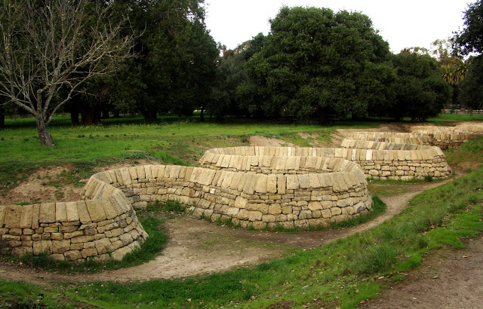

Photo: Andy Goldsworthy, Stone River, 2001. Sandstone

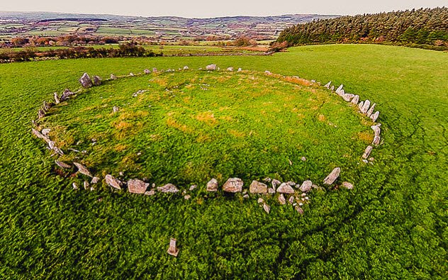

Photo: Beltany Stone Circle

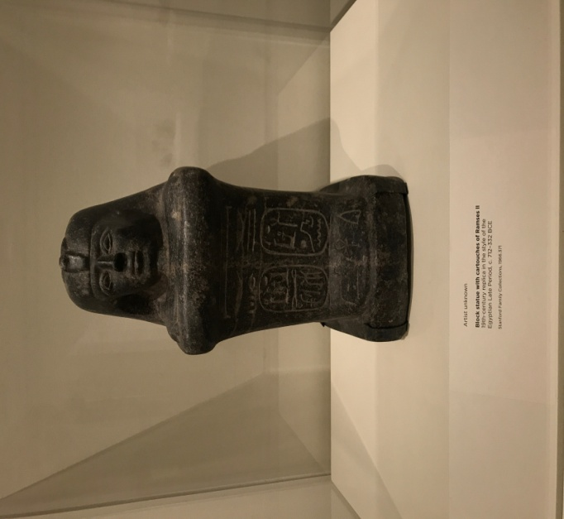
Photo: Block statue with cartouches of Ramses II

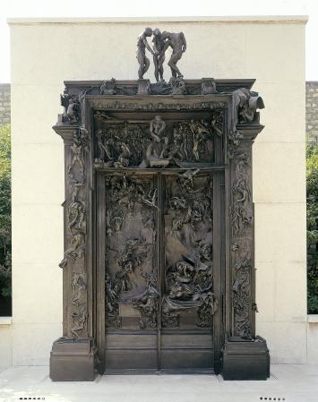
Photo: The Gates of Hell (1880-circa1890)

References:
Batt, S. E. (2016). 10 Ancient Megalith Monuments with Unsolved Purposes. Retrieved from: https://listverse.com/2016/07/01/10-ancient-megalith-monuments-with-unsolved-purposes/
Elsen, Albert (1960). Rodin’s Gates of Hell. Minneapolis, MN: University of Minnesota Press, p. 141.
Iris & B. Gerald Cantor Foundation, n.d. Selected Bronzes. Retrieved from: https://cantorfoundation.org/resources/selected-bronzes/
Palmer, Barbara (2002). Andy Goldsworthy's Stone River joins outdoor art collection. Stanford Report, Stanford University.
Semat, Aude (2016). Art and Power in Ancient Egypt. The Cleveland Museum of Art.

