

Revmpunt the MIS System for widget manufacturing company



Introduction
This project proposal evaluates end to end Information Technology overhaul of the Widget Manufacturing Company. The coverage includes evaluation of the existing processes and required technological solutions to implement automation of all the processes so that the business functions continue as they exist today. The proposal takes into consideration customization of the applications and solutions so that the employee training and impact is minimal.
Current Processes
Based on the information and input from the employees and the management professionals, the system requirements are gathered. The current processes are all manual and every piece of data that is generated is in the paper form. The documents that are generating this data are filed in archives and stored over years. The information required for reporting are generated on a monthly basis to support their strategies and these documents serve as a source for the data in generating those reports. Based on the current process, a change in their strategies take long time and often inaccurate as they reflect data that is error prone due to exclusions of vital data due to oversight caused by the laborious manual process.
The widget company has many departments and includes all aspects of business cycles and covers processes dealing with procurement, design, manufacturing, warehousing, sales and marketing, financial and HR functions. It is strongly recommended to implement an ERP solution that is responsible in collecting data and storing them in a centralized platform so that it is accessible to all the departments.

System Architecture
The system to be implemented will consist of a database to store all the data generated. The data will be served by ERP solutions, different solutions covering processes that are key to the success of the widget manufacturing company. A conceptual diagram indicating the different functions that the ERP system in place can help is shown below.
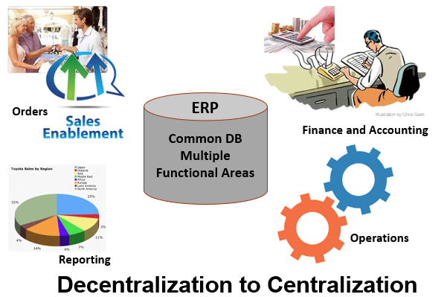
As can be seen, the purpose of the ERP system is to bring all the data that is in different places from disparate sources into a central location, the ERP common database and let it be used by various applications that can be layered over business functions, in using the data. The key operative word is to centralize the data that would enable the functions to be decentralized.
A SOA based system is recommended to be put in place as indicated in the following diagram.

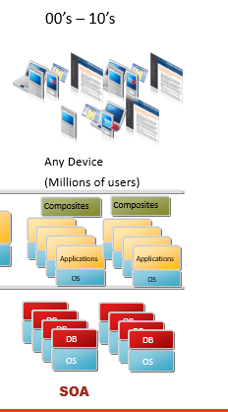

This recommendation enables the system to be scalable to any device anywhere concept. The presentation layer performs the function of the input and output to the users and is served by the applications using services. The services are generalized with contracts through APIs that ensures security and integrity of the data that is being handled. The applications provide the logic that is proprietary and specific to the widget manufacturing company’s existing processes in place. This is the place where the applications that are developed by the software vendors are customized to match the company’s process requirements. The project proposal will take into consideration time and effort required to provide these customizations to be in place. Based on this strategy of a centralized data server and decentralized application layer, an architectural diagram is presented as shown below.
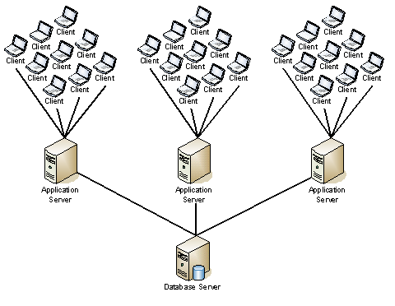
Software Vendor Recommendation
Putting an ERP solution is very expensive when off the shelf, existing solutions from top five vendors such as Oracle, SAP, IBM for a midsized company like widget manufacturing. The choice is to get software that do not have overloaded functions and implement only those that are required for the company here. A good strategy is to look for an open source package, that is tested out in the market and implement it. One such software is “ODOO” which has solutions for all aspects of businesses with a reliable ERP backbone. ODOO software support can be purchased at extra cost for customizations. Additional maintenance can be purchased as part of the ongoing operational cost and that is not included in this project proposal budget. They also offer an online solution but that is not considered here as it overrides the requirement that the data resides inside the network, controlled by widget manufacturing. ODOO solutions cover procurement (SCM), sales and marketing (CRM), inventory and warehousing (SCM), HR, design and development (PLM), sales orders processing and financial modules. This seems to be a good fit from the requirements as well as financial sides.
Project procurement and cost details
A synopsis of the breakdown of the hardware, software and installation costs are provided here. A detailed excel spreadsheet is also attached. The cost is within the budget proposed by the company when taken into consideration the variance allowed for the proposal.
Component | Units | Cost Per Unit | Total
Desktop Towers HP / Includes Win 8.1 Pro Keyboards and Mice | 125 | $689.00 | $86,125.00
HP DL380p Server with Xenserver for Virtualization | 1 | $17,449.00 | $17,449.00
Virtualized 2012 R2 Server with SQL 2014 50 Licenses | 1 | $7,965.00 | $7,965.00
Virtualized Server 2012 R2 DC 200 CAL | 1 | $5,880.00 | $5,880.00
Network BW Laser Printers | 50 | $199.00 | $9,950.00
Network Color Laser Printer | 3 | $359.00 | $1,077.00
Network Color MFP | 4 | $225.00 | $900.00
Hardware SubTotal |  |  | $129,346.00
Office 365 Premium 12.50 a month per user | 100 | $150.00 | $15,000.00
ODOOO ERP Solution for all aspects of Manufacturing | 1 | $0.00 | $0.00
Customization of the software (Professional Services) | 400 | $90.00 | $36,000.00
Software Subtotal |  |  | $51,000.00
Professional Web Design | 1 | $5,000.00 | $5,000.00
Yearly Hosting Fee (bandwidth considered) | 1 | $350.00 | $350.00
Web Design Subtotal |  |  | $5,350.00
Hardware Installation *187.5 Hours estimated | 320 | $95.00 | $30,400.00
Installation Sub Total |  |  | $30,400.00
Total Project Costs |  |  | $216,096.00

A snapshot of the project distribution is shown in the chart. The major portion of the budget is dedicated to the hardware, which can be depreciated over the years. Further the hardware is chosen from the high end which can help in keeping the downtime minimal. A short presentation explaining the systems covered is also included in addition to the spreadsheet. Considering the advantages and the benefits, this is a win-win proposal for widget manufacturing.

