Report on Centrifugal Pump
Student’s Name
Institution
Date

Letter of Transmittal
Sender’s Name
Recipient’s Name
Recipient’s Title
City/Sate

Dear Mr(s)…………………..,
I am hereby writing a report regarding centrifugal pumps. The report seeks to demystify the working principle of the centrifugal pump and examine the various components making it. I have provided detailed information regarding the operation of the centrifugal pumps.
The report utilized various methods to develop succinct information on centrifugal pumps. Foremost, it defined and identified centrifugal pumps' purpose, summarized its description, background information, and a list of significant parts of the tool. Also, it majored in the illustration and the function of substantial parts of the centrifugal pump. The report then ended with a vivid elaboration of the functional overview and the centrifugal pump's operating cycle.
If there are issues of concern you would like to address regarding the report, please feel free to contact me.
Sincerely,
(Student’s Name)
Research on Centrifugal Pump

Signed by the student Date

Contents
- Introduction…………………………………………………………………………………..4
1.1 Definition and Purpose…………………………………………………………………….....4
1.2 Summarized description………………………………………………………………….4
1.3 Background………………………………………………………………………………4
1.3.1 Working of a Centrifugal Pump…………………………………………………....5
1.3.2 Applications of centrifugal pumps…………………………………………………7
1.3.3 Types of Centrifugal Pumps……………………………………………………….8
1.4 List of major parts ………………………………………………………………………….9
2.0 Description and Function of major parts…………………………………………………...11
2.1 Impeller…………………………………………………………………………….11
2.2 Casing……………………………………………………………………………....12
2.3 Delivery Pipe………………………………………………………………………13
2.4 Suction pipe with foot valve and strainer………………………………………..…13
2.5 Volute……………………………………………………………………………….14
2.6 Inlet Flange…………………………………………………………………………14
2.7 Outlet Flange………………………………………………………………….……15.
2.8 Shaft Seal…………………………………………………………………………...16
2.9 Lantern rings………………………………………………………………….…….17
3.0 Packing……………………………………………………………………………..18
3.1 Coupling……………………………………………………………………….……18
3.2 Shaft-drive………………………………………………………………………….19
3.3 Pump housing……………………………………………………………………….19
4.0 Conclusion…………………………………………………………………………………..20
4.1 Functional Overview ……………………………………………………………….21
4.2 Operating Cycle ……………………………………………………………………21
5.0 References……......................................................................................................................24
Report on Centrifugal Pump
- Introduction
1.1 Definition and Purpose
A centrifugal pump refers to a mechanical instrument invented to move fluid through the transfer of rotational energy from a single or many driven motors known as impellers.
1.2 Summarized description
A centrifugal pump is a mechanical device used to move liquids such as solvents and oils from one region to the other, utilizing the rotational energy brought about by impellers. The principle behind the operation of the pump is etched on the application of centrifugal force. (Zhang et al., 2020). A centrifugal pump operates by imparting momentum to the liquid by high-speed rotation of the blades. This produces the required thrust capable of transferring the fluid. The centrifugal pump can be applied domestically and in industries. For instance, power plants and oil refineries use centrifugal pumps to deliver oil to the storage tank after refinery. In storey buildings, centrifugal pumps are used to convey water to floors higher above. In most cases, the body of the pump is made of cast iron as a result of more economical manufacturing expenses. However, it is made of other materials such as stainless steel, bronze, plastic, and many more.1.3 1.3 Background
Long before the discovery of centrifugal pumps, the ancient Egyptians utilized water wheels that had buckets used to deliver water for irrigation on farms. This was tedious work that compelled people to use a significant labor force. However, in the 1600s, a French-born inventor named Denis Papin introduced a true centrifugal pump that eased the labor force. He was accredited with the introduction of a pumping device with straight lines. Later, A British inventor, John G. Appold, introduced the curved vane in 1851. The pump was more efficient and ensured the pumping of fluids would be done quickly. Contemporarily, the use of centrifugal pumps has been embraced far and wide. They are applied in diverse areas such as water distribution systems, industrial processes, and machineries' lubrication.
1.3.1 Working of a Centrifugal Pump
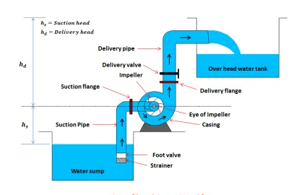
Before the centrifugal pump is started, it becomes primed. Priming is the operation of filling the pump casing with fluid before starting the centrifugal pump. Failure to do this, the centrifugal pump may not be able to function. The pump casing is filled with air, making the impeller gas-bound and incapable of pumping the liquid. Thus priming ensures that the air in the pump is driven out. After the centrifugal pump is primed, the electric motor is started to rotate the impeller while the delivery valve is closed (Tkachuk et al., 2019). The liquid enters the impeller at its axis known as the eye, and then exits between the vanes’ circumference. On the opposite side of the eye, the impeller is fixed through a drive shaft to a motor and rotates at high speed (500-5000rpm). The impeller's high rotational motion directs the fluid out through the vanes of the impeller into the pump casing. Typically, there are two basic designs of pump casing, namely volute, and diffuser. They both have the purpose of translating the fluid flow into an organized discharge at pressure.
The impeller is offset in a volute casing case, thereby forming a curved funnel with an expanding cross-sectional area towards the discharge or outlet. The design ensures that the fluid pressure increases towards the pump outlet.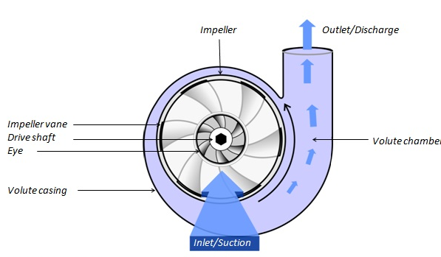
Likewise, in the case of the diffuser design, the same basic principle applies. As the fluid is expelled between a set of stationary vanes surrounding the impeller, the fluid pressures increases. Diffuser designs are usually custom-made for specific applications and are more efficient. On the other hand, volute designs are essential to applications consisting of entrained solids or high viscous fluids. However, the volute design's asymmetry can lead to significant wear of the impeller and the driveshaft.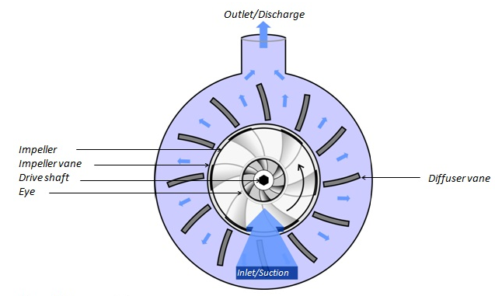
1.3.2 Applications of centrifugal pumps
Centrifugal pumps are mainly used for pumping fluid such as water, organics, acids, bases, oil as well as ‘thin’ liquids in industrial, agricultural and domestic settings. The table below shows the various types of centrifugal pumps, their application and features.
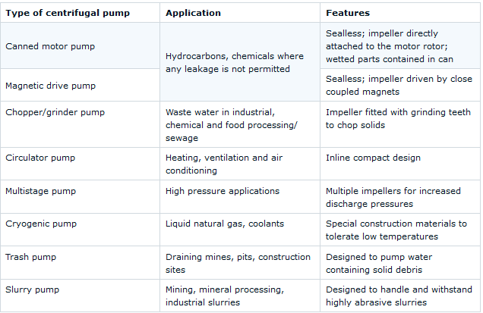
    - Types of Centrifugal Pumps
Since the invention of centrifugal pumps, there has been the introduction of new and sophisticated ones. Long before, the initially invented ones had straight lines. Currently, advanced technology has resulted in the creation of highly complex centrifugal pumps. Various types of centrifugal pumps exist. They include those with closed impellers, those with channel impellers, and those with vortex impellers.
- Centrifugal pumps with closed impeller
This centrifugal pump has 5 to 7 blades with a minimum size of 125mm and a maximum of 550mm. The blades are predominantly curved backward with a radial movement within the pump characterized by a low number – high heads and low volume flows (Dong. & Chu, 2018). The blades are fully closed between the hub disc as well as the crown disc. The pump's efficiency with such an impeller varies from 0.6 for the smallest impellers to 0.83 for the biggest impellers. They are essential for cleaning liquids or the ones having light impurities.
- Centrifugal pumps with channel impeller
These types of centrifugal pumps have reduced number of blades varying from 3 to 4 having the minimum size of 270mm and the maximum size of 450mm. The pumps have blades with a double backward curve and are fully closed between the hub disc and the crown disc. As compared to the centrifugal pumps with closed impellers, the hub is angled much further backwards. Since liquids are not guided in these impellers, they are less efficient as a result of the limited number of blades as well as the hub that is angled further backwards.
- Centrifugal pumps with spiral vane impeller
This impeller has two or four blades with varying sizes based on the viscosity of the fluid being pumped. It has no crown disc. Two of the blades are arranged symmetrically while the hub have an appendix stretching from the hub to the suction nozzle. Thus type of impeller is suited for pumping liquids that are dense and have high viscosity or solvents with large amounts of dry particles.

1.4 List of major parts
The main parts of a centrifugal pump
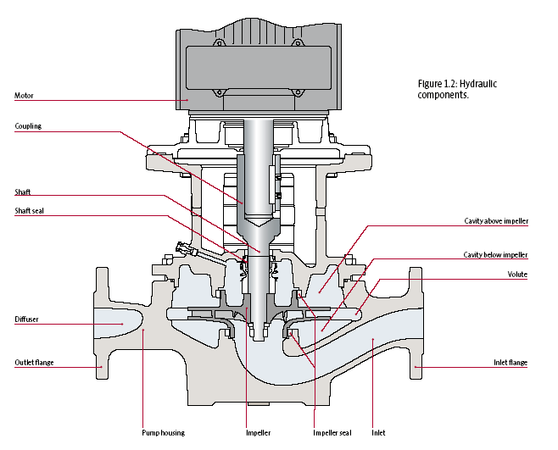
i. Impeller
ii. Casing
iii. Delivery pipe
iv. Suction pipe with foot valve and strainer
v. volute
vi. Lantern rings
vii. Packing
viii. Pump housing
ix. Inlet range
x. Outlet range
xi. Shaft seal
xii. Shaft-drive
xiii. Coupling
2.0 Description and Function of major parts
The major parts of Centrifugal Pump include:
  - Impeller
This is the wheel or rotor that is provided with various backward curved blades or vanes. It is mounted on the shaft that is attached to the external source of energy imparting the liquid energy to the impeller which makes it rotate. It has the function of producing a rotational energy directing the fluid to the discharge. Impellers are of various types. They include open impeller, semi-enclosed impeller and enclosed impeller.
A figure showing open, semi-enclosed and enclosed impeller
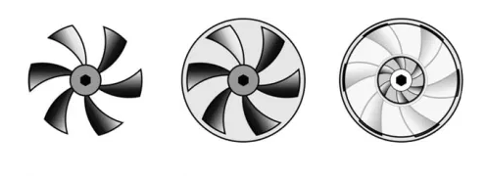
2.2 Casing
It is a pipe that is attached at the upper end to the pump’s inlet to impeller’s center referred to as the eye. The double end reaction pump comprises two suction pipe fixed to the eye on both sides. The lower end is connected to foot valve as well as the strainer. The lower end slopes into liquid to lift it. The three types of casing used in centrifugal pump include volute casing, vortex casing and casing with guide blades. It has the function of sealing off the inside of the pump from the atmosphere, thereby preventing leakage and retains pressure.
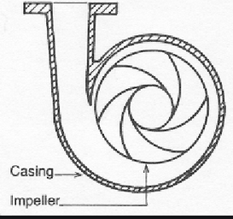
2.3 Delivery pipe
This is a pipe fixed at the lower end of the pump on its outlet and transfers the liquid to the intended height. It has a valve near the outlet of the pump that controls the flow of the liquid from the pump into the delivery pipe.
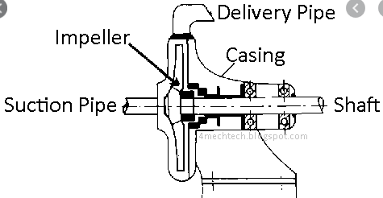
2.4. Suction pipe with foot valve and strainer
The suction pipe is fixed with impeller’s inlet while the other end is immersed into the pump water. It comprises foot valve and strainer at the water end. The foot valve opens in the upward direction sine it is a one-way valve. The strainer functions by filtering the unwanted particles in the water. This helps prevent the blockage of the centrifugal pump.
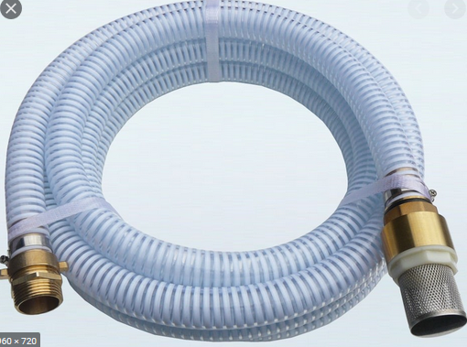
2.5. Volute
It is a curved funnel which expands in areas when it approaches the outlet port. In centrifugal pumps, it is the casing receiving the liquid that the impeller pumps and maintains the velocity of the liquid through to the diffuser (Huang et al., 2017). It functions by guiding the flow out of the impeller through converting the kinetic energy of the liquid’s flow into static pressure.
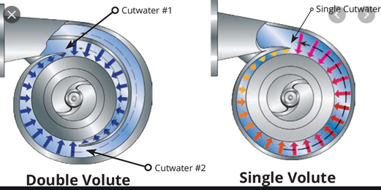
2.6. Inlet flange
It is the screw connecting the valves and has an opening to allow fluids move into the pump. When the electric motor has been started, it enables water to move into the pump. It has an inlet through which fluid enter the pump to be delivered to intended spot (Liu, Tan, & Cao, 2018). It is made of iron, asbestos or stainless steel which makes it appear shiny.
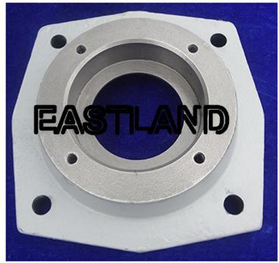
2.7. Outlet flange
This is the screw that attaching the pump to the pipes and valves. It enables the fluid to be delivered to the tanks for storage via pipes. It enables the water being pumped by the electric motor to pass and be delivered to the storage tanks. The outlet flange is attached to the diffuser. It is usually metallic as it is made of metals like iron, aluminum or steel.
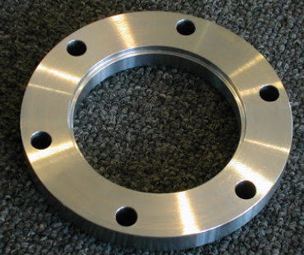
2.8. Shaft seal
It seals the centrifugal pump’s rotating shaft and passes through non-rotating pump casing, reducing fluid leakage thereby prevent the entry of air from the surrounding. Since it is the sealing element of the pump, it keeps low the wear of the sealing faces. It seals by a narrow radial gap or narrow axial gap in the pump. Shaft seal is made of stainless steel or asbestos. Impellers are anchored on it.
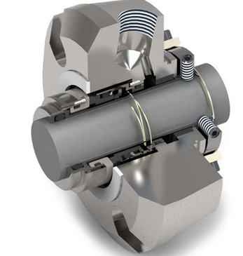
2.9. Lantern rings
These are perforated hollow rings positioned near the middle of the packing box which receives relatively clean liquid from the pump’s outlet or from an external source. It facilitates the uniform distribution of the fluid around the shaft to ensure lubrication and cooling of the pump.
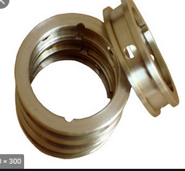
3.0 Packing
A centrifugal pump has packing boxes. The packing boxes have the function of packing to forestall the air or liquids from escaping the pump by supplementing the rotating. The packing boxes are black in color.
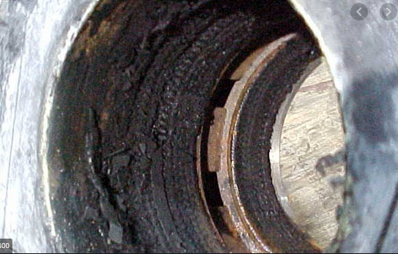
3.1 Coupling
Pump coupling refers to the element deployed to attach the rotating pump shaft to the motor’s drive shaft, thereby facilitating the motor to proficiently transmit power to the pump. Coupling emanates from the motor and radially in the middle of the pump. It is made of asbestos or aluminum.
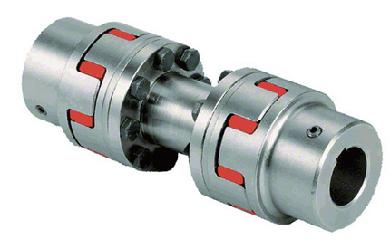
3.2. Shaft-drive
The shaft-drive is attached to the impeller and helps direct water to the intended destination by the exertion of the centrifugal force. It is embedded on the impeller. It transmits the driver torque to the impellers of the pump. Also, it carries various elements such as shaft sleeves and the bearings. It is made of stainless steel making it appear shiny.
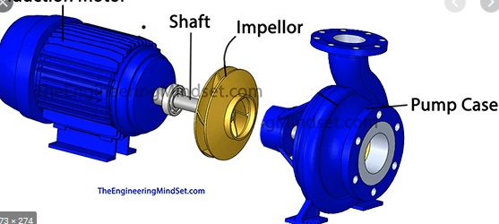
33. Pump housing
It is the casing enclosing every parts comprising the functioning of a pump. A sturdy pump housing is required to ensure that the elements of the centrifugal pump are safeguarded (Tahani et al., 2020). It is positioned next to diffuser and outlet flange. It is normally located on one side of the main source of the liquid to be pumped to pump it to the mains. A pump house is usually made of concrete where a centrifugal pump becomes stored.

4.0 Conclusion
4.1 Functional Overview
The centrifugal pump is used to direct the flow of liquid from the source to the intended place. It functions by producing fluid movement to deliver it to the required location. The efficient operation of the mechanical device depends on the constant high-speed rotation of the impeller. For the flow rate to be maintained, greater resistance, and higher pressure required. A centrifugal pump is well-matched to low pressure, high capacity, and pumping applications of liquids having viscosities between 0.1 and 200cP. High viscosity liquids like slurries – mud or oil – may cause wear as well as overheating resulting in damage and malfunctions. However, positive displacement pumps usually operate at substantially lower speeds and are less vulnerable to such problems. A centrifugal pump cannot produce suction when dry. It has to be primed with the pumped liquid to provide suction (Song et al., 2019). Thus centrifugal pumps are not suitable for applications where the supply is sporadic. Also, a centrifugal force produces a variable flow if the feed pressure is variable.
4.2 Operating Cycle
The working principle of centrifugal pumps entails imparting energy to the liquid using a centrifugal force created by the rotation of the impeller which has a series of blades. One complete operating cycle of the centrifugal pump consists of different stages. Foremost, the liquid goes through the pump casing via the impeller eye.
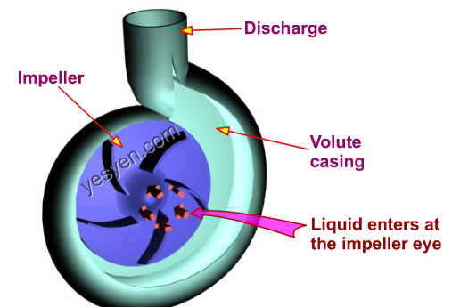
Then the velocity energy becomes imparted to the liquid as a result of the production of a centrifugal force developed by rotation of the impeller (Wei, Yang, & Xiao, 2019). The liquid is thus pushed radially to the impeller periphery.
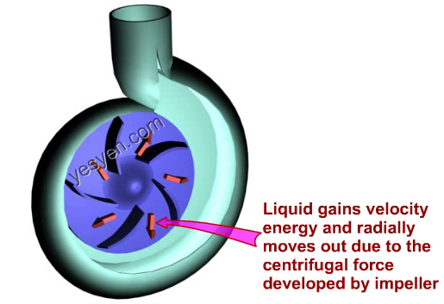
The velocity energy of the liquid becomes converted to pressure energy by leading it to an expanding volute design casing in a volute type centrifugal pump or diffuser within a turbine pump.
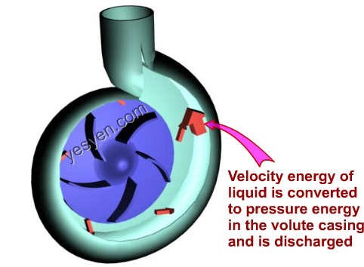

References
Dong, W., & Chu, W. L. (2018). Numerical Investigation of the Fluid Flow Characteristics in the Hub Plate Crown of a Centrifugal Pump. Chinese Journal of Mechanical Engineering, 31(1), 64.
Huang, S., Qiu, G., Su, X., Chen, J., & Zou, W. (2017). Performance prediction of a centrifugal pump as turbine using rotor-volute matching principle. Renewable Energy, 108, 64-71.
Liu, M., Tan, L., & Cao, S. (2018). Influence of geometry of inlet guide vanes on pressure fluctuations of a centrifugal pump. Journal of Fluids Engineering, 140(9).
Song, Y., Fan, H., Zhang, W., & Xie, Z. (2019). Flow characteristics in volute of a double-suction centrifugal pump with different impeller arrangements. Energies, 12(4), 669.
Tahani, M., Kandi, A., Moghimi, M., & Houreh, S. D. (2020). Rotational speed variation assessment of centrifugal pump-as-turbine as an energy utilization device under water distribution network condition. Energy, 213, 118502.
Tkachuk, V., Navas, H., Petrov, A., & Protopopov, A. (2019, August). Hydrodynamic modelling of the impact of viscosity on the characteristics of a centrifugal pump. In IOP Conference Series: Materials Science and Engineering (Vol. 589, No. 1, p. 012007). IOP Publishing.
Wei, Z., Yang, W., & Xiao, R. (2019). Pressure fluctuation and flow characteristics in a two-stage double-suction centrifugal pump. Symmetry, 11(1), 65.
Zhang, N., Jiang, J., Gao, B., Liu, X., & Ni, D. (2020). Numerical analysis of the vortical structure and its unsteady evolution of a centrifugal pump. Renewable Energy.

