Punnet Squares Certificate of Success
Name
Institution Affiliation

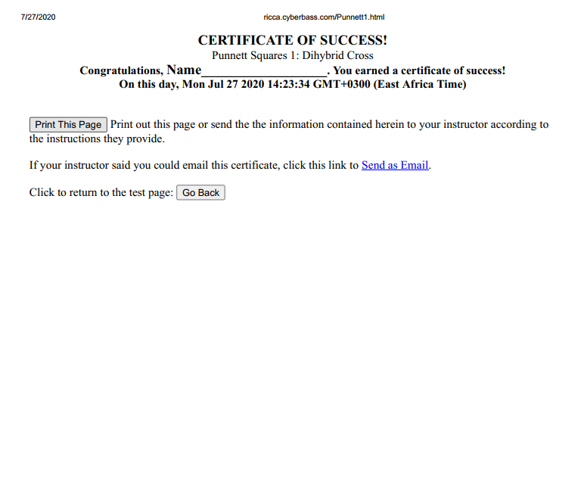
Image 1: Punnet Squares Certificate of Success

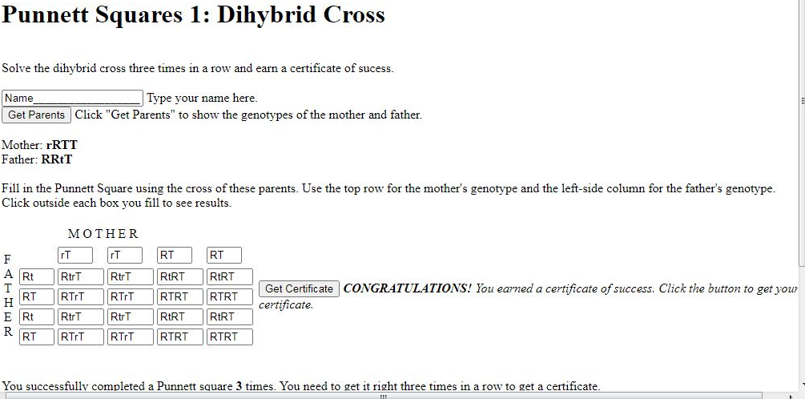
Image 2: “Get Certificate” Button

