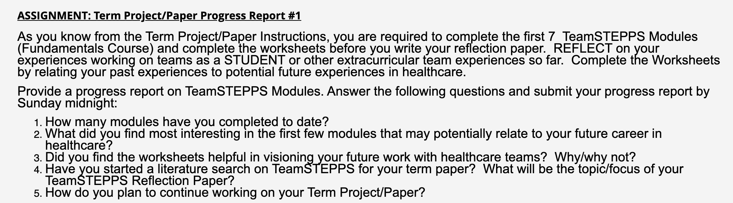
- You have to do this reflection report:

- In order to do this you have to follow 7 TeamSTEPPS Modules. To do that:

- Click at the link: https://www.ahrq.gov/teamstepps/instructor/fundamentals/index.html

- This link is going to send you to this page
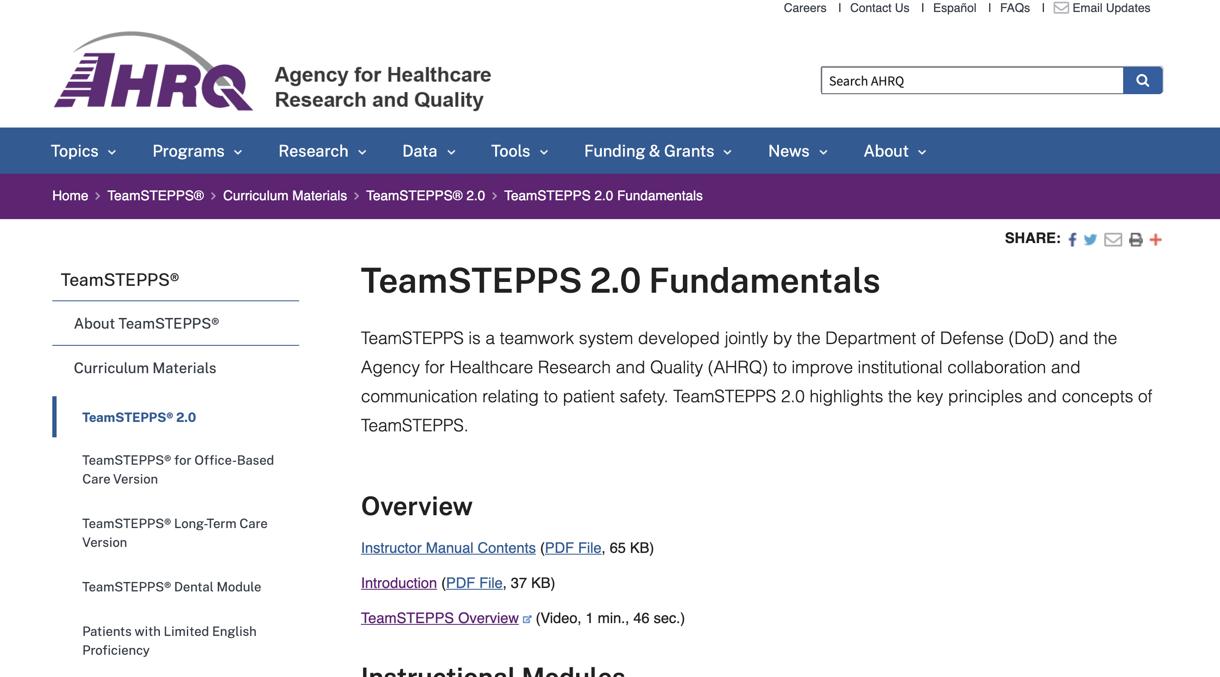

- You have to read modules 1-7 and later do the TeamSTEPPS overview: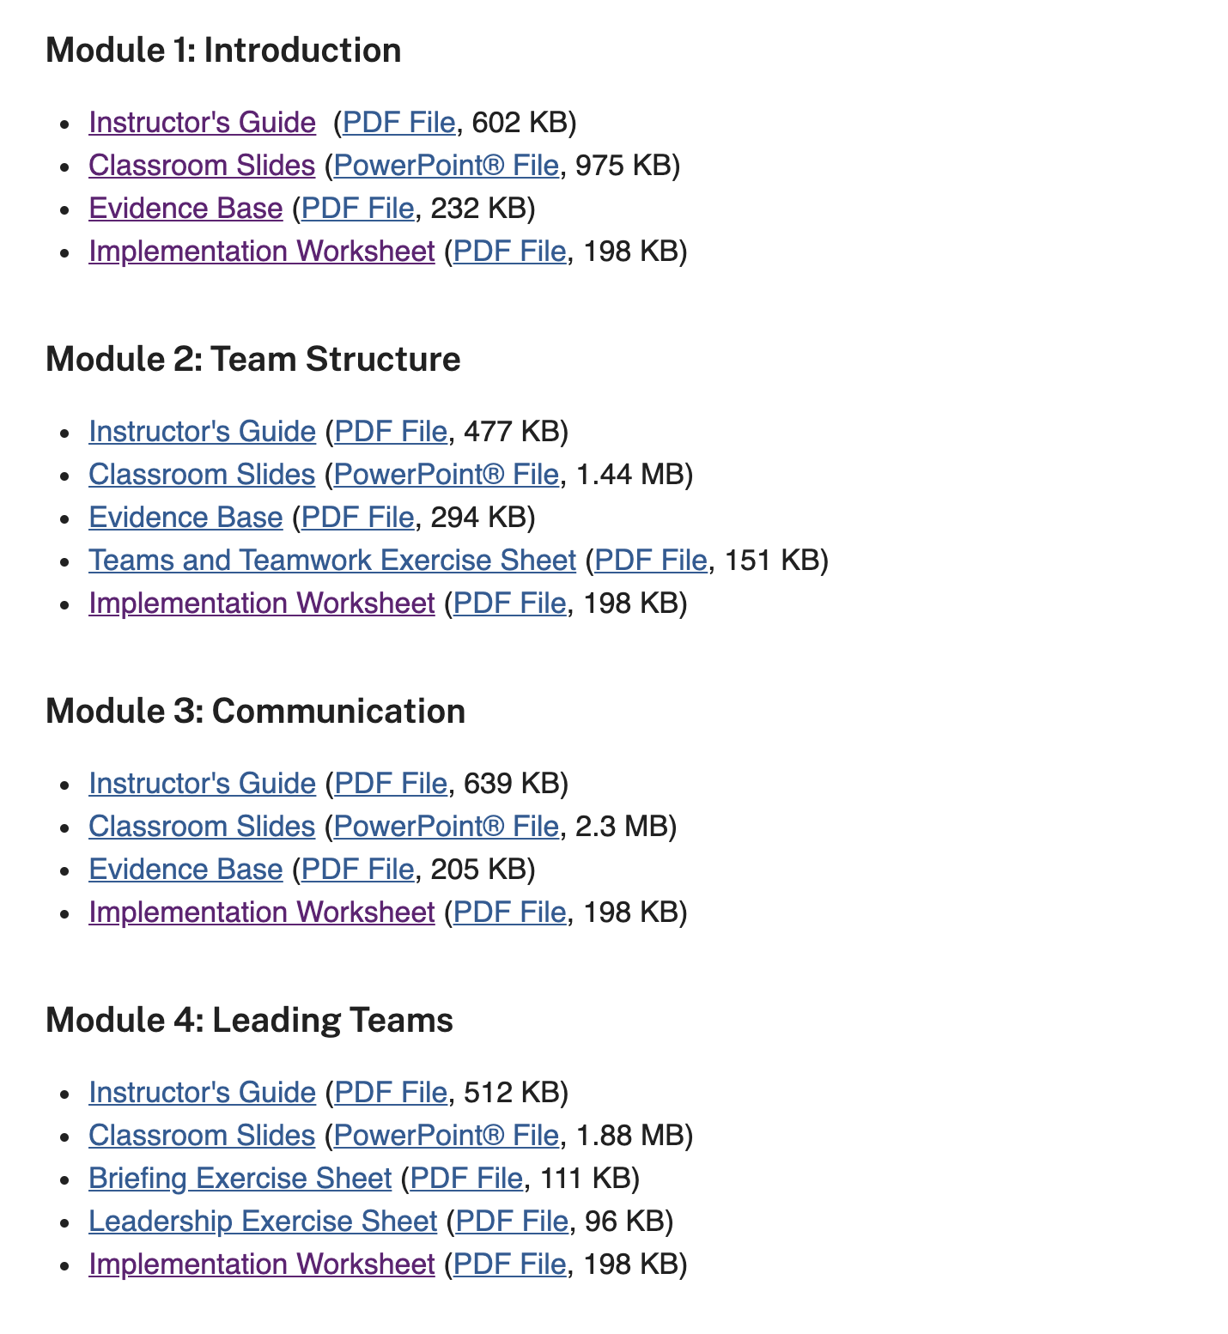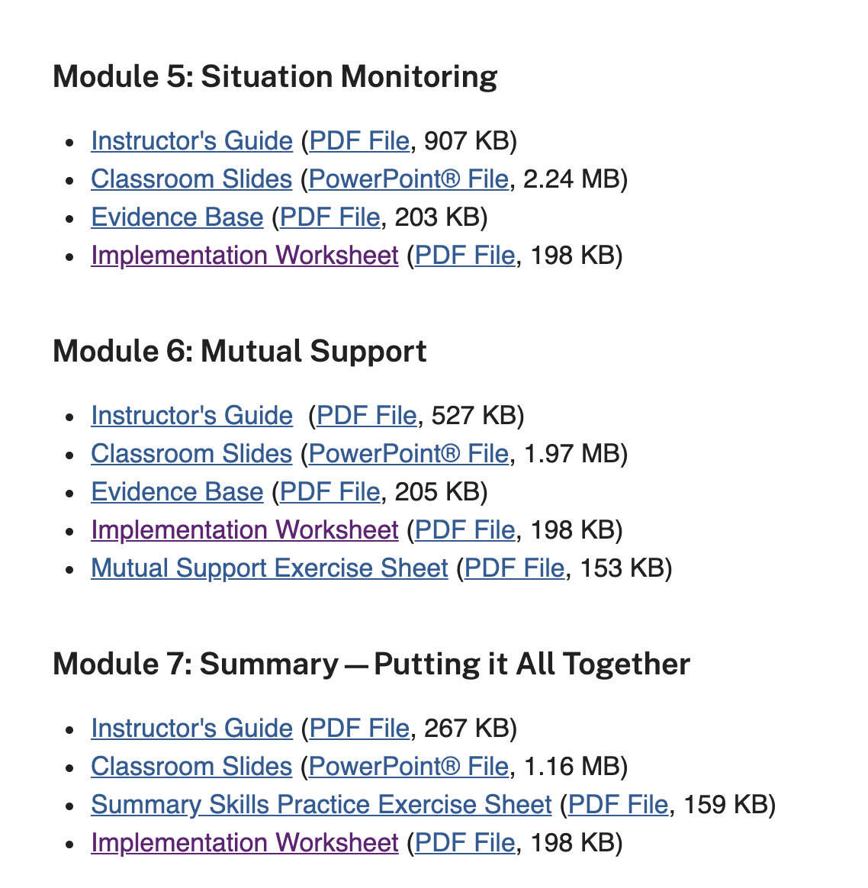

- Do the activities and later complete the worksheet
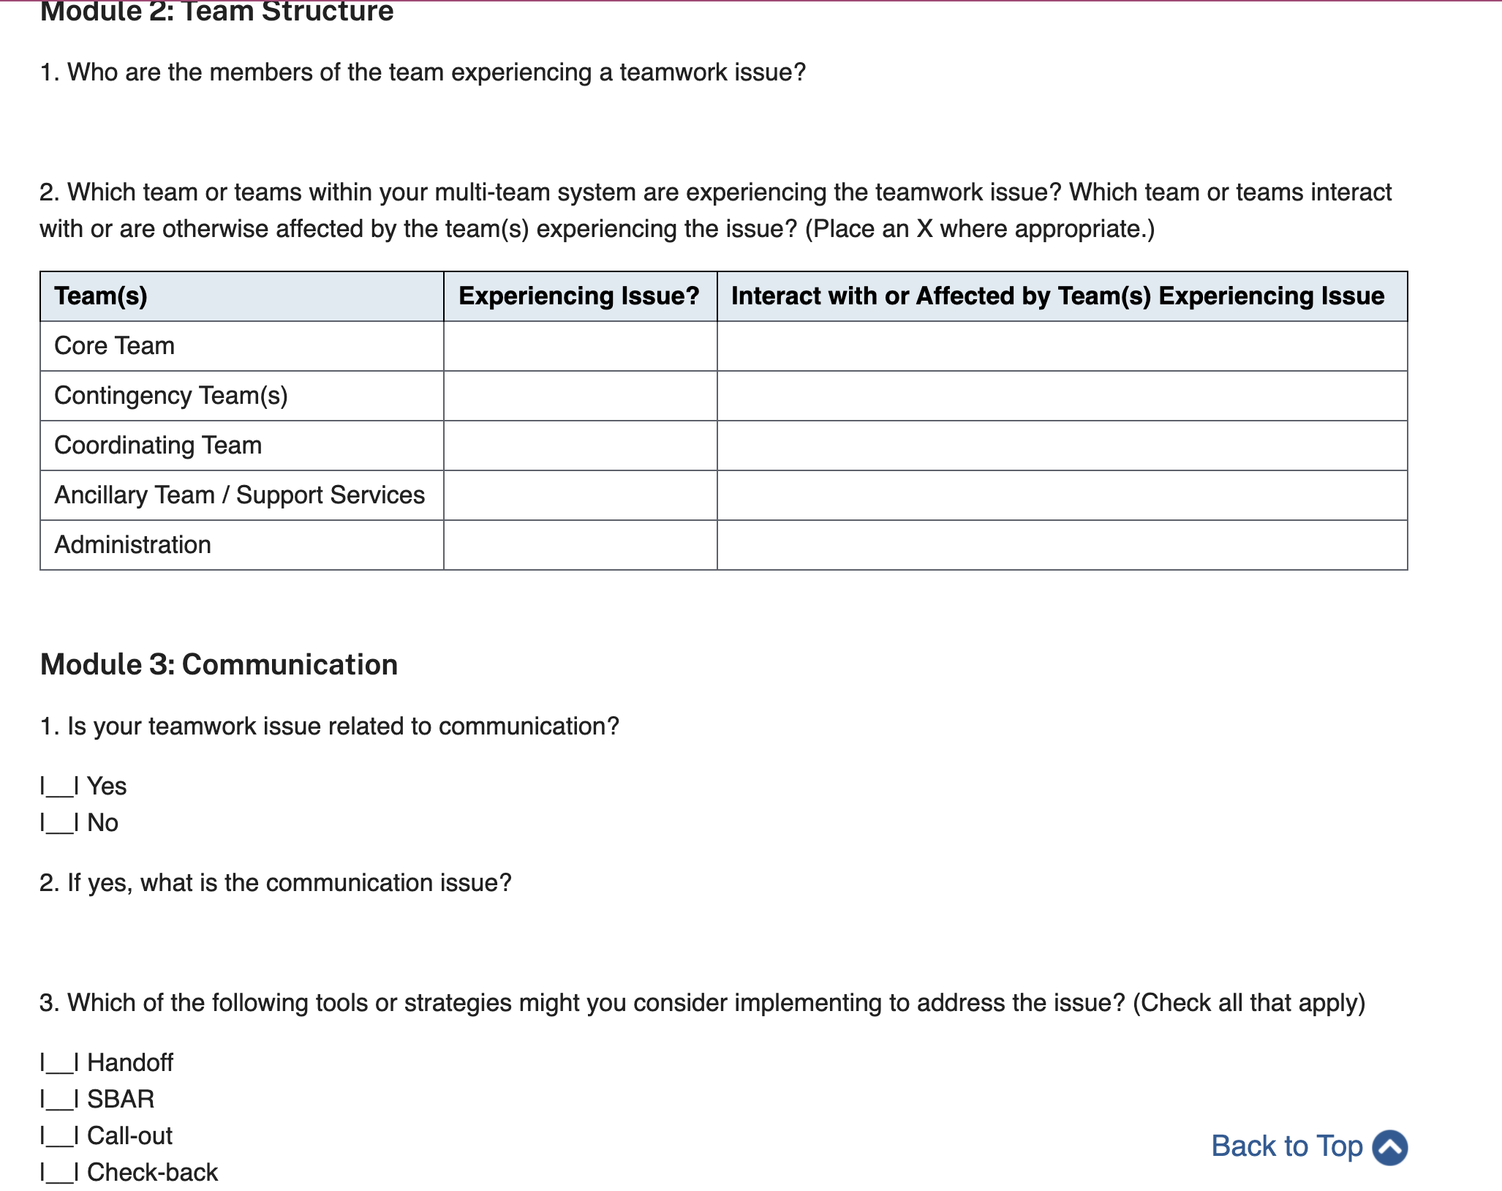
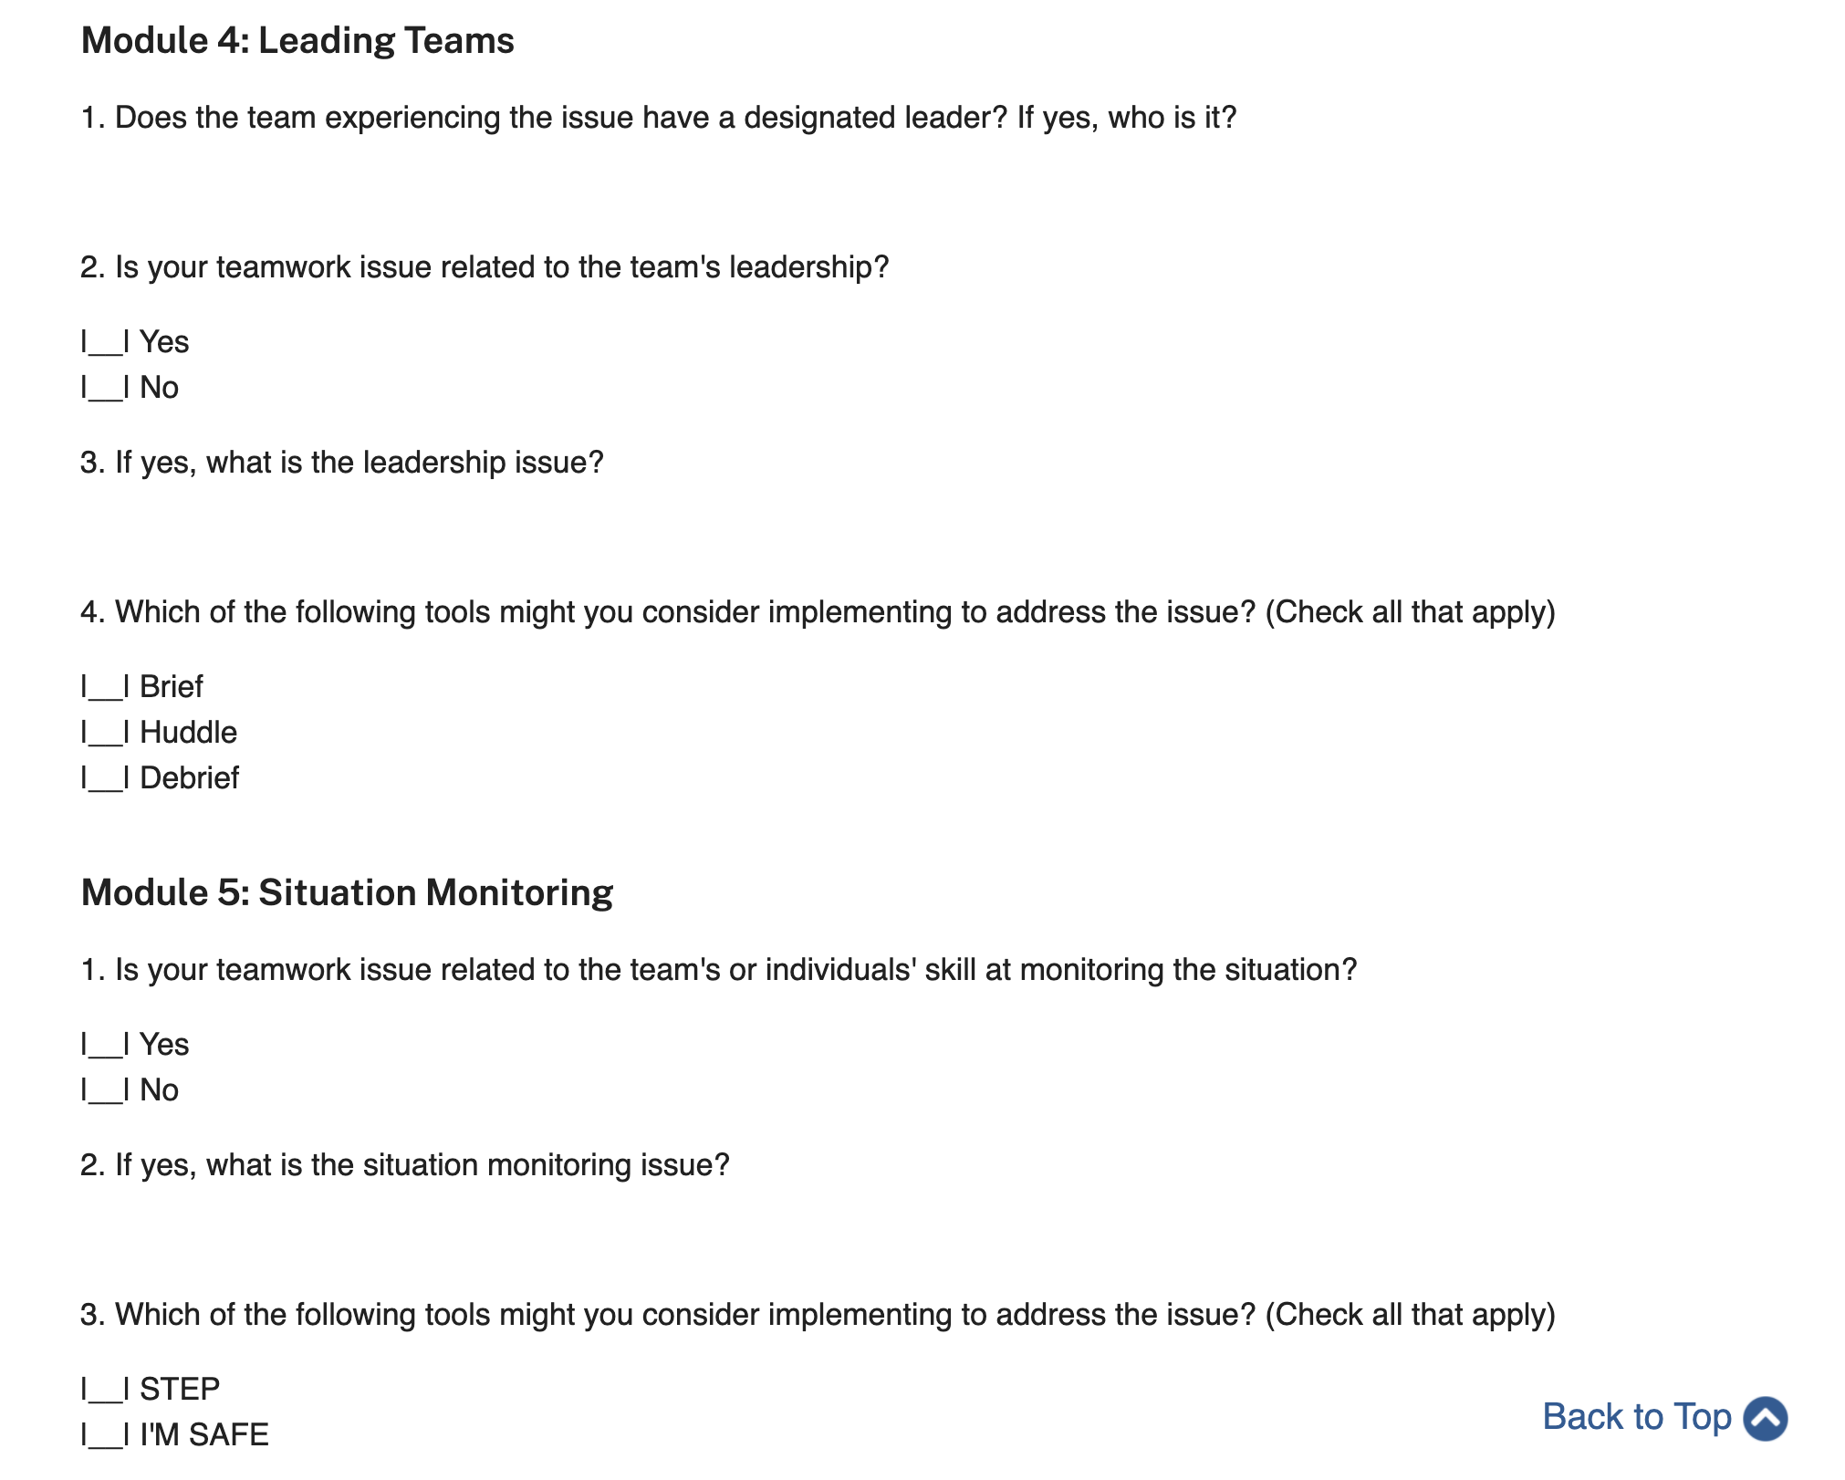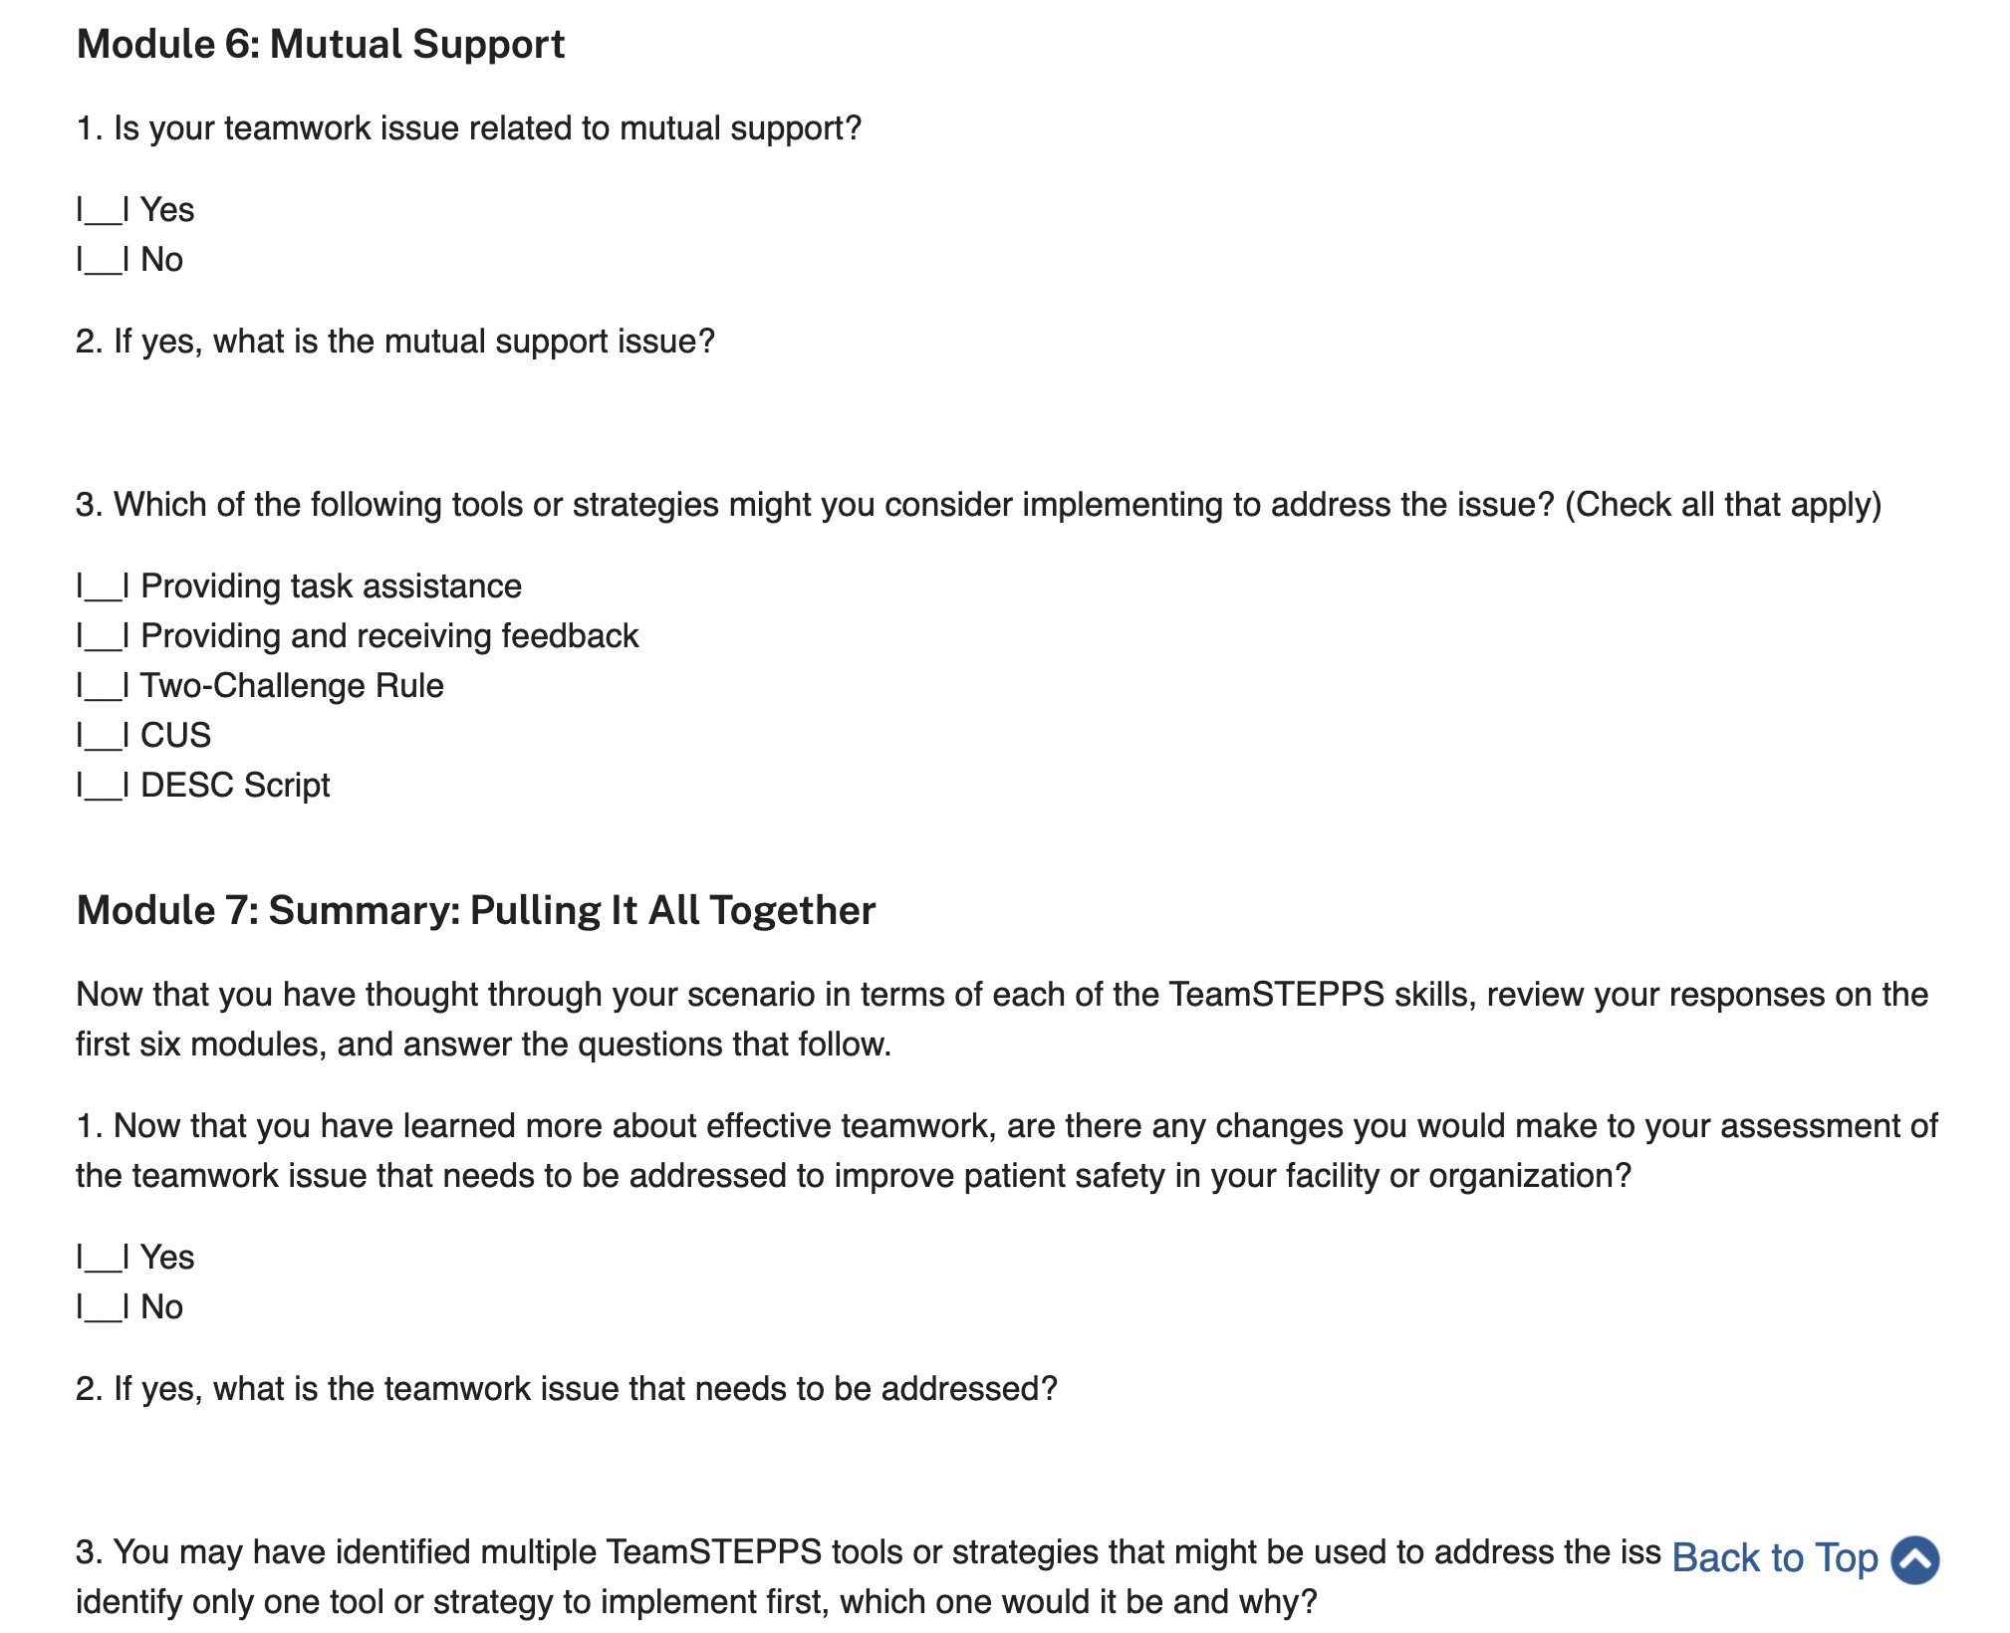
- I am going to provide the worksheet on a pdf too.

- After finishing the worksheet do the Team paper progress report

