Question 1 Linear regression takes correlation a step further, and allows predictions in one variable to be made based on values entered for the other. Remember the correlation analysis you conducted for snowfall and mood? A regression equation makes it possible to predict levels of negative affect based on snowfall.

Building on Correlation
For this assignment, you will use the dataset from last week's assignment (also provided here) to conduct a simple linear regression with SPSS. Then, you will use the regression equation you construct from the regression output to make predictions about negative affect levels.
Then, use this equation to predict Negative Affect Score for three different snowfall amounts not listed. Provide a 1-2 paragraph summary in which you address the following:
- Present the regression equation.
- Identify the three snowfall amounts you selected to predict Negative Affect Score for.
- Identify the Negative Affect Score predicted for each.
- Explain whether or not you agree with these predictions, and reflect on how appropriate regression is for these variables.
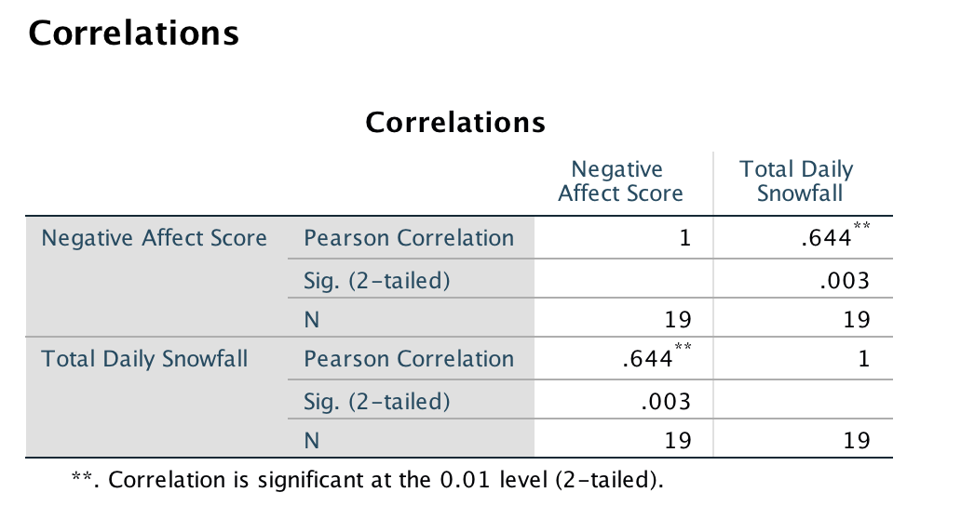
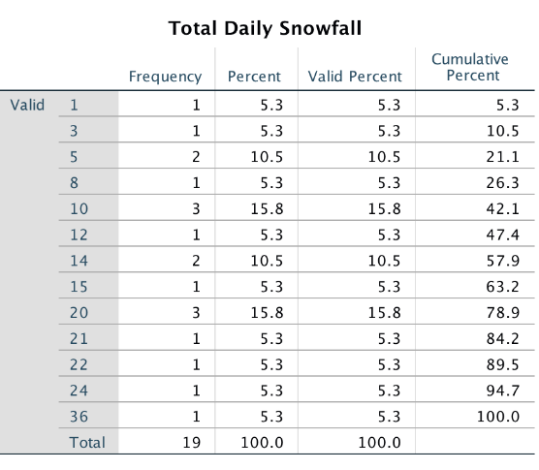

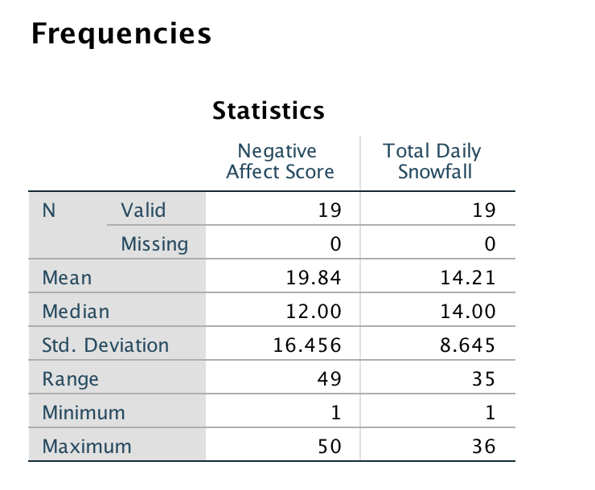
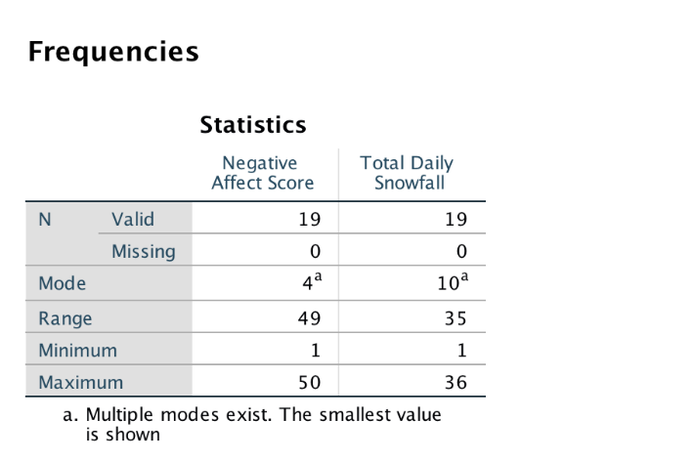

Question 2 Did you know there is an International Society for Microbial Ecology? Visit their site: ISME (Links to an external site.).
Summarize the page by explaining:
What is ecology?
How does it relate to microbes?
What are some of the subcategories that can be studied regarding this field?

Question 3 For your Final Project, review the DBs from the semester & select your favorite topic.
Topic I choose was. When Gregor Mendel was developing his ideas of inheritance of characteristics, molecular genetics was not yet discovered. Explain, in your own terms, why his two most important laws have stood the test of time. What assumptions about them were correct? Describe a scenario in which patterns of inheritance did NOT adhere to Mendelian genetics.
List what you knew (going in), what you learned & how your viewpoint changed/didn't change. Rubric (grading) is as follows:
25% Explanation of topic of DB (your sources (3 cited--even if only 2 DBs & the text book)).
25% Description of your knowledge of the topic at the outset.
25% What you learned/what others said that you agreed/disagreed with.
25% Your viewpoint changed/stayed the same--why?

This should be about 1 page (4 paragraphs).

