Biology

Student name

Institution affiliation.

Date

Question 1.
Answer.
Linear regression determines the relationship between dependent and independent variables in the form ŷ = b₀ + b₁x. the regression equation was therefore ŷ = 26.768 + 0.644x. A positive and negative affect measure is a scale utilized to assess the positive and negative effect o certain values in statistical data. Therefore, to determine the negative effect, one needs to consider the highest values. From the data, the amounts 10.5, 15.8, and 10.5. a person with an affectivity level of 15.8 has more extreme negative emotions than that person with 10.5. these emotions include Nervousness, anger, and distress. High results on negative affect, relate to mental stress, cause a varied list of emotional difficulties, People report more health difficulties and protest more than the symptoms necessary, and Results in challenges dealing with stress. I agree with the results shown by the frequency and correlation tables. This is because it assesses different kinds of relationships, controls the variables involved in the analysis, and it assists in making necessary predictions.

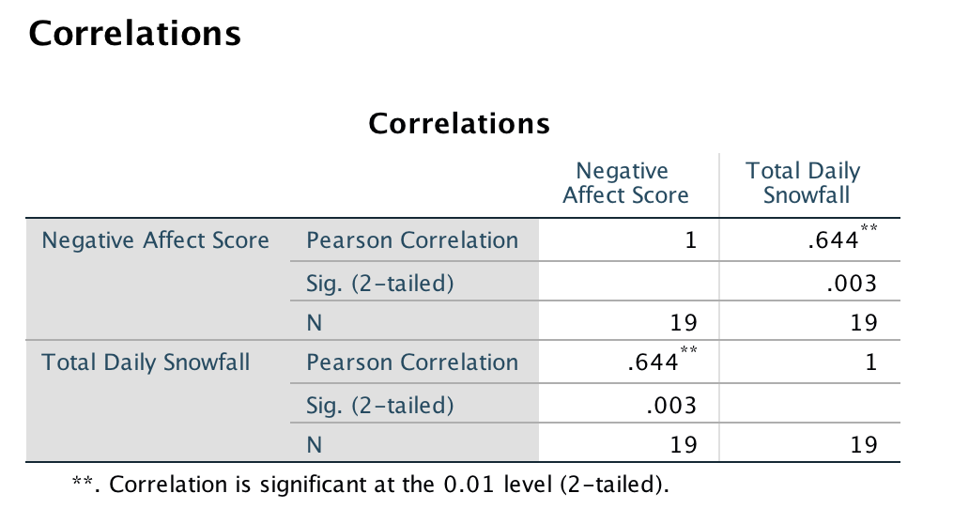
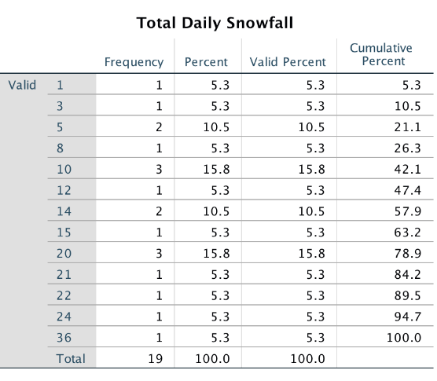

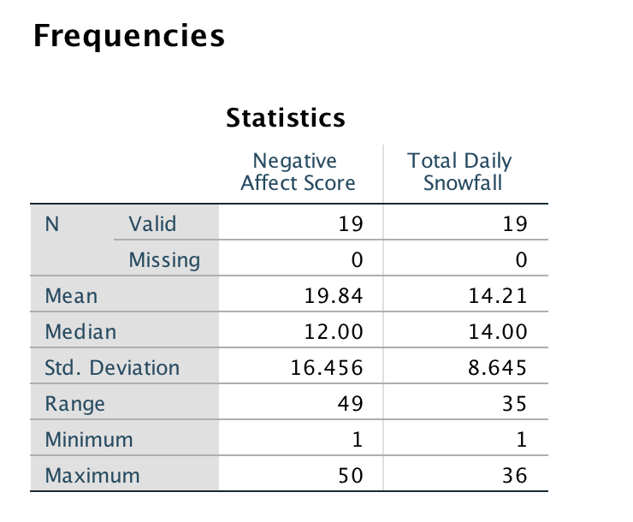
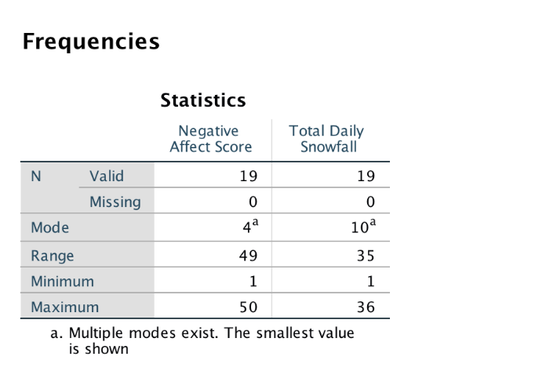

Question 2
Answer.
Microbial ecology refers to the study of interactions amongst microorganisms and their environments, which includes both biotic and abiotic factors. Ecology is related to microbes in a way that microbes have an important responsibility in a community of ecology since they act as both decomposers, and producers. Decomposers break down dead organisms and release the nutrients into the soil where they are reabsorbed back into the plant. The following subcategories can be studied; bacteria, archaea, fungi, protozoa, algae, and viruses.
Question 3
Answer.
Inheritance refers to the process where genetic material is passed from the maternal to the child, causing members of the same household to possess like characteristics (Bateson et al, 2013). When Gregor Mendel was creating his ideas concerning inheritance of features, he developed two major laws that stood over time. They are describing as follows.
The law of dominance argues that If the 2 alleles of passed down pair are different, then one allele will regulate the organism's physical features over the other, and is called the dominant allele, the other allele has no obvious effect on the organism's physical appearance and is called the recessive gene. The law of segregation argues that a pair of alleles of a gene detach when creating gametes, and gametes come back randomly informing offspring. The law of independent assortment argues that Alleles of genes found on separate chromosomes are inherited autonomously of one another (Binmore, 2021).
The laws of Dominance and the law of segregation have stood over time due to the following reasons. First, he showed how parents are able to pass on discrete heritable units and genes to their children while retaining their separate identities in offspring. Over the years it has been proven that those genetic factors come in pairs and are hereditary as distinct components, one from each parent. Mendel followed the segregation in the descendants as main or recessive traits. Out of the three assumptions known as the laws of heredity, the correct one involved the dominance law where the most dominant allele affects the appearance while the recessive allele is not visible (Muller-Wille, 2021).
The patterns of inheritance did not adhere to Mendelian genetics involves a situation with the presence of multiple alleles, incomplete dominance, Codominance, Lethal alleles, Pleiotropy, and Sex linkage. Therefore, I agree that the dominance allele will show appearance over the recessive alleles when inheritance occurs. However, it is also possible that different chromosomes are inherited independently of one another.

Reference.
Bateson, W., & Mendel, G. (2013). Mendel's principles of heredity. Courier Corporation.
Binmore, K. (2021). Charles Darwin versus Gregor Mendel. In Imaginary Philosophical Dialogues (pp. 107-113). Springer, Cham.
Müller-Wille, S. (2021). Gregor Mendel and the History of Heredity. Handbook of the Historiography of Biology, 105-126.

