In the Reading, Learning Activities, and videos related to the supply and demand analysis course outcome, you have learned how to calculate marginal opportunity costs in a simplified production possibility frontier curve to determine who has the comparative advantage as it relates to trade. You also learned how to calculate the equilibrium price and quantity in a perfectly competitive market and looked at how that equilibrium price and quantity changes when additional demand influences the market, as well as seeing how the original group of consumers are affected by these new consumers entering the market.

Directions:

In this Assessment, you will apply your understanding of comparative advantage as a foundation for trade, along with your understanding of the crucial concept of changes in supply and demand equilibrium. You will also provide a rational approach on how cultural differences and the downfalls of stereotyping people from foreign cultures and misunderstanding their cultural attitudes affect international trade. This Assessment requires a combination of short paragraph answers, computations, and completion of a 450–500-word expository research paper using this template.

Questions

1. Suppose that the supply schedule of Brazilian coffee beans is as follows:

Table 1
Price of Brazilian coffee beans  (per pound) | S  Quantity of Brazilian coffee beans supplied  (pounds)
$4.00 | 6,000
$3.50 | 5,000
$3.00 | 4,000
$2.50 | 3,000
$2.00 | 2,000

Suppose that Brazilian coffee beans can be sold only in Brazil. The domestic Brazilian demand schedule for Brazilian coffee beans is as follows:

Table 2
Price of Brazilian coffee beans  (per pound) | DB  Brazilian quantity of Brazilian coffee beans demanded  (pounds)
$4.00 | 1,000
$3.50 | 2,500
$3.00 | 4,000
$2.50 | 5,000
$2.00 | 7,000

- From the supply and demand schedules above, what are the equilibrium price and quantity of Brazilian coffee beans? The equilibrium price of Brazilian coffee beans supplied and demanded in the market is $3.00 while the equilibrium quantity 4,000 pounds respectively.

Now suppose that Brazilian coffee beans can also be sold in Canada. The Canadian demand schedule for Brazilian coffee beans is shown in Table 3.
Table 3
Price of Brazilian coffee beans  (per pound) | DC  Canadian quantity of Brazilian coffee beans demanded  (pounds)
$4.00 | 1,000
$3.50 | 2,500
$3.00 | 3,000
$2.50 | 5,000
$2.00 | 5,500

- Complete column DC+B total combined Canadian and Brazilian coffee beans demanded of Table 4, by inserting the correct values, computed from information contained in Tables 2 and 3, at each price.

Table 4
Price of Brazilian coffee beans | S  Quantity of Brazilian coffee beans  supplied | DB  Brazilian quantity of Brazilian coffee beans  demanded | DC+DB  Total combined Canadian and Brazilian coffee beans demanded
(per pound) | (pounds) | (pounds) | (pounds)
$4.00 | 6,000 | 1,000 | 2000
$3.50 | 5,000 | 2,500 | 5000
$3.00 | 4,000 | 4,000 | 7000
$2.50 | 3,000 | 5,000 | 10000
$2.00 | 2,000 | 7,000 | 12500

Below is the new supply and demand graph (Graph 2.b.) that illustrates the equilibrium price and quantity of Brazilian coffee beans.

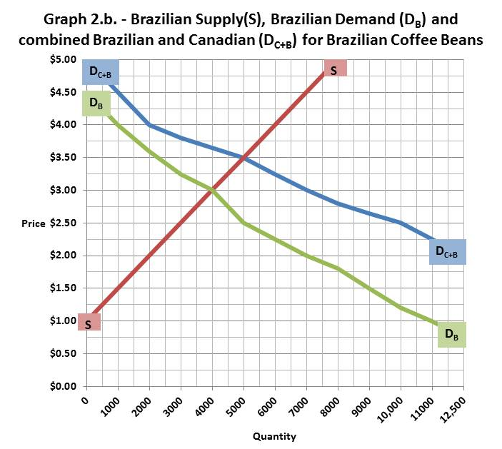

- From the completed Table 4, what will be the new price at which Brazilian coffee growers will sell Brazilian coffee beans? The Brazilian coffee growers will sell the coffee bean at the new equilibrium price of $3.50 and quantity of 5000 units of coffee beans to the Canadian customers.

- From the completed Table 4, what price will now be paid by Brazilian consumers?

- From the completed Table 4, what will be the quantity consumed by Brazilian consumers?

2. In ancient days, a tribe of natives on the mythical continent of Atlantis were able to produce two commodities to eat. They could harvest fish from the sea and they could grow a form of wild oats. Table 5 and Graph 1.a. both show the maximum annual output combinations of fish and wild oats that could be produced by the natives of Atlantis.

Table 5
Maximum annual output options | Kilograms of fish | Bushels of wild oats
1 | 7,000 | 0
2 | 6,000 | 300
3 | 5,000 | 500
4 | 4,000 | 625
5 | 3,000 | 710
6 | 2,000 | 775
7 | 1,000 | 825
8 | 0 | 850

Graph 1.a.
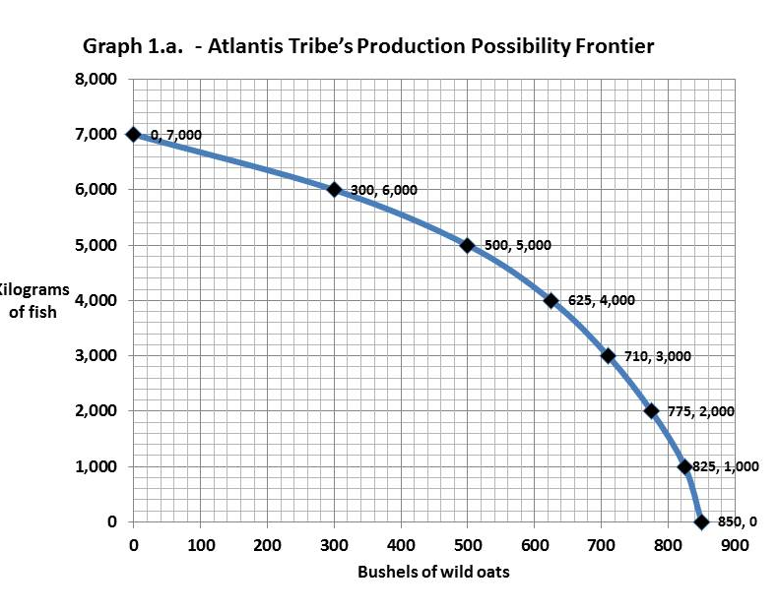

- Could the Atlantis tribe have produced 800 bushels of wild oats and 5,000 kilograms of fish at the same time? Explain your answer. Where would this point lie relative to the production possibility frontier? No, the Atlantis tribe could not have produced 800 bushels of wild oats and 5,000 kilograms of fish. The PPF shows optimal efficiency given the resources of the tribe and the point for 800 bushels and 5,000 kilograms lies beyond curve. Rather than being on the curve or under, it is beyond it as illustrated by the red dot above.

- Using Table 5, what would have been the marginal opportunity cost of increasing the annual output of wild oats by 200 bushels, from 300 bushels up to 500 bushels? The marginal opportunity cost for increasing the amount of bushels from 300 to 500 is 1000 kilograms of fish or for every 1 bushel of oats it costs 5 kilograms of fish.

- Using Table 5, what would have been the marginal opportunity cost of increasing the annual output of wild oats by 200 bushels, from 625 bushels up to 825 bushels? The marginal opportunity cost for increasing the amount of bushels from 625 to 825 is 3000 kilograms of fish or for every 1 bushel of oats it costs 15 kilograms of fish.

- Why are the marginal opportunity costs for two similar batches of 200 bushels of wild oats not the same? Explain. What does this difference imply about the shape of the Atlantis tribe’s production possibility frontier curve? The marginal opportunity cost to produce bushels is greater than that to produce fish. This causes the concave shape of the curve to become steeper as the production of oat bushels increases.

===== Question 3. Requires writing a 450–500-word expository research paper =====
An effective understanding of economics forms the foundation of every manager’s, entrepreneur’s, bureaucrats, and leader’s ability to analyze business situations and to develop an appropriate response. The globalization of business is a fact of life for all business professionals. One of the most contentious issues in today’s global business world is the issue of closing local manufacturing facilities, laying off those American workers, and re-opening the same manufacturing facility in an Asian, or other third world country.

Look in your own closet at the clothes you have purchased. Pick any 10 items of clothing and look at the labels in those clothes. Where were they manufactured? How many of the 10 items were manufactured here in America? If that same exercise had been done 50 years ago, (approximately the 1970s), all the clothes you owned would have been manufactured in textile mills in the Southeastern United States (Georgia, Alabama, Mississippi, North Carolina, South Carolina, etc.). All those Southeastern textile mills are now closed, and people buy foreign made clothes. If you were able to go further back in time to 150 years ago (1870s), the clothes you owned would have been manufactured in textile mills in the Northeast United States (Maine, New Hampshire, Vermont, Massachusetts, etc.). Yet, by the early to mid-1950s, those Northeastern textile mills were closed and their workers were out of a job. The mills had all relocated to the Southeast during the years following the Civil War.

Many people say that we should ban the import of these foreign made clothes, so that more workers in American clothing textile mills could have jobs. Others say that we should continue to import clothing because imported clothing is relatively less expensive and more people can afford to buy more clothes at these low prices. Still others say that we should put an import tariff (an extra tax that would be paid when we buy these imported clothes), making the price of imported clothing comparable to the price of clothing made in the U.S., and, therefore, encouraging American consumers to buy American-made clothing.

Compose a 450–500-word expository research paper, in APA formatting and citation style, including a references page. Insert your expository research below in the space indicated. Your writing and research should clearly respond to the following questions:

a. How much does international trade affect you personally? Look at any 10 items around your home that you have purchased in the last year. Where were they made? How many were made in America, compared to how many were foreign made? What things does America export to other countries? What things does America import from other countries? How does what you have learned about Comparative Advantage affect this trade?

b. Currently there is a lot of talk among politicians about imposing tariffs on foreign made products imported into the U.S. and retaliatory tariffs imposed by foreign countries on U.S. made goods. What is a tariff? Who ultimately pays the tariff? Who gets the proceeds from the tariffs? What is the money used for? Discuss the advantages and disadvantages to all involved parties (American workers, American consumers, foreign workers, and foreign consumers) of tariffs on imports to the U.S. and retaliatory tariffs imposed by foreign countries on U.S. made goods.

c. In considering the foreign trade issue, discuss how the background, education and cultures of the people in the U.S. and the cultures in each trading country affects their understanding of the importance of foreign trade. Discuss the importance of your ability to understand and accept multiple cultural differences in a global context. What recommendations would you suggest to increase American understanding and acceptance of foreign cultures?

Begin your essay below:

Question A
International trade affects every person in a particular way. I believe international trade affects the number of different items that end up as part of my personal belongings. For example, a good number of clothes in my wardrobe are not locally made. Many of the clothes in my cabinet were either made in Asian countries, more so in China and Turkey. A close comparison between those made in America to those manufactured in foreign countries reveals that only about a third of my total clothes are locally made. America is a significant exporter of food and beverages. Consequently, it also exports a substantial number of machines, such as industrial machines and cars (Rognlie, 2016). On the other hand, it imports textile products from countries such as China and Mexico since these countries produce clothes for a price far cheaper than the US (2016). This comparative advantage affects trade since it gives room for different economic blocks to mutually coexist by exchanging goods and services between each other

Question B
Recently, the Trump administration has threatened to put tariffs on foreign goods that are imported into the US. This development is in line with his campaign slogan that advocated for Americans to consider giving American products priority over foreign goods. A tariff is a tax or duty that a nation imposes on imported goods. The tariff, therefore, is supposed to be paid by the country that is exporting its goods into the US; hence, the money is paid to America (Laudon & Traver, 2016). Money from tariffs is then used by the government to increase its revenue collection thus improving service delivery to its citizens. This, however, will have a few pros and cons. For example, importers in most cases usually transfer the cost of tariffs to the consumers. This would then mean that the prices of goods would increase significantly (Laudon & Traver, 2016). The advantage of an increased in prices of imported goods to American is the fact that it gives more employment opportunities to American workers (2016).
Question C
The cultures of people, both from the US and other trading countries, have an impact on how the trade is carried out in the country. Doing international business requires a good understanding of the different cultures of the countries involved. Consequently, the education system in the US is a bit more advanced compared to the other countries it is involved in trade with. As a result, the levels of understanding of the countries in this economic block is also a bit different. The ability to understand the different cultural aspects of different countries is essential since it helps one make informed decisions (Draper, 2017). For example, it is common knowledge that the Chinese are generally industrious people. Therefore, setting companies in china would translate to reduced costs of production hence reduced the cost of goods (Draper, 2017). In order for America to have an increased understanding of foreign cultures, the country needs to take part in exchange programs with the countries. This way, America would be in a position to learn and understand the different cultures of other countries.
--------------------------------------------

References
Rognlie, M. (2016). What lower bound? Monetary policy with negative interest rates. Unpublished manuscript.
Draper, T. (2017). American business and public policy: The politics of foreign trade. Routledge.
Laudon, K. C., & Traver, C. G. (2016). E-commerce: business, technology, society.

