IMPROVEMENT COST REDUCTION PROCESS
Institutional affiliation.
Student name
Date.

Introduction
The task force for global health is an international organization found in American. The organization is driven by a commitment to attain health equality. It was started over 32 years along to deal with the health needs of the poor population in more than 151 countries (Mosley 1983). The organization work involves various programs that are focused on deals with tropical diseases such as area epidemiology, Vaccines, health workforce development, and public health informatics.
The company also collaborate with both governmental and non-governmental organizations such as pharmaceutical institution, the task force partners and ministry of public health to deliver services and required resources to deal with large scale health problems in international level. The recent report indicates that the task force has benefited millions of people in 151 countries (McInnis, & Merajver 2011).
The organization and its partners work to eliminate three NTDs, namely river blindness, lymphatics filariasis, and blinding trachoma by the end of 2030. The above diseases are a burden to the population and generation to come (Mosley 1983). The organization also donate millions of money each year in a different part of the world to eliminate these disease and save millions of lives (Rogers 1973).
The task force is all about collaboration, smart solution, and compassion that is focused on solving global health problems. The organization received more than $2 million in funding by a nonprofit organization and has been awarded a Humanitarian price in the last two decades (McInnis, & Merajver 2011). The fund received is used for a massive campaign to purchase resources that are used to help global health care activities.
The following are questions that I will answer throughout my paper: As technology changes global health care? What are the different aspects of healthcare that affect society? Give the main influential global health innovation that is happening in the modern world
Cost Reduction Process Improvement.
One of the strategies in the task force for global health care is cost reduction process improvement. The objective of the organization is to improve hospital productivity as a way to reduce operational costs. There is a lot of suggestion that the universal health core values needs must be improved. Taking, for example, many people are suffering from chronic disease are not treated that result optimally in avoidance health care cost (McInnis, & Merajver 2011).
In 2007 the spending cost increased up to 4 percent totalling $4 trillion of gross domestic product. It has also estimated that more than 25 percent can be attributed to wasteful spending that includes spending for things that are not necessary or unnecessary delivery services, fraud, excess administrative cost, missed prevention opportunity, and buying of equipment with high prices (Rogers 1973). Global health care cost increases faster than the GDP, imposing the budget of the federal state, individual, employers, and city government.

Graph showing time (years) against cumulative percentage change in healthcare.
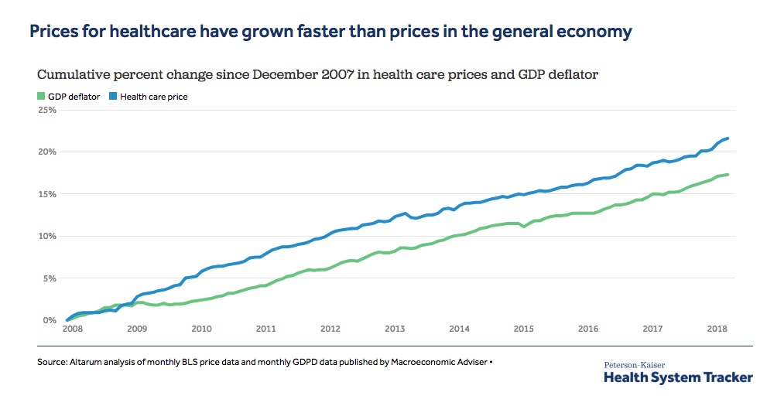
The organization has two ways to minimize the cost: increase productivity or use fewer services. The organization has mostly focused on using fewer services. This is the best strategy because the organization most overuse many services, while another function is not useful. The organization also reduces its cost problem by consuming less (McInnis, & Merajver 2011). To increase productivity within the organization, technology, and management department must be updated every time to maximize their production (Rogers 1973).
The health care organization in the recent past has experienced reduced productivity in spite of more spending on technology. Economic expert suggests that if health care industry productivity can grow by 5 percent, then the organizations would solve health care cost problem globally. It is tough to improve productivity in health care in personal preferences such as cancer options. The affordable care act helps in motivation gain to enhance productivity (Rogers 1973). The law aims at the centre for Medicare and medical services to minimize payment to a health facility that aims at increasing productivity.
A bar graph showing people affected with disease in US
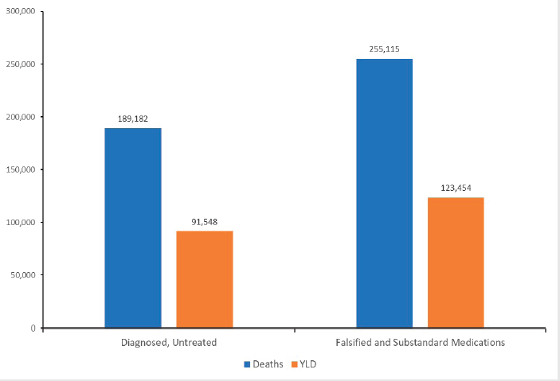
The organization has a lot of opportunities that improve Hospital labour productivity across all nations. Both the public and private sectors participate in a workshop that is aligned to increase the chance to improve productivity (McInnis, & Merajver 2011). Building a designed and intergraded health care facility in the private and public sector could highly improve productivity even if the productivity gain would take a long period to occur.
Recent research shows that building designed hospitals would increase the quality and minimize the operational cost, and a few work processes could be designed to increase productivity, especially for doctors and nurses (Rogers 1973). Other interventions can be taken to increase productivity in health care organizations such as the problem to be solved and solution certain and increasing communication among the clinicians and the people that need health care services (Rogers 1973).
Analysis
The list of the inefficiencies of the current condition includes Unnecessary Care, Waste of money and resources, perverse incentives in how we pay for care, Lack of transparency, and adding harm to patients, Racial and Gender Bias and Private Health Insurance and lack of insurance.
Unnecessary care is found in almost all healthcare organizations that increase health care costs, where hundreds of millions of dollars, are drained. As a result, the organization lost disability and productivity. Some services, such as early electives, delivers are not necessary that waste a lot of time and money. Organizations like the Association of women Health, Childbirth control, and the March of Dimes should plan well and avoid unnecessary care that costs the organization a lot of money (Rogers 1973).
Waste of billions of Money. Recent research by the institute of medicine health shows that more than a third of health costs go to waste (McInnis, & Merajver 2011). The cost of additional resources and services estimated in the American Journal of Gynecology and obstetrics to me more than $1 billion every year.
Avoidable harm to patients is one of the common problems in health care. The statistics show that some operation in the hospital generally harms patient such as surgery while others lead to death. Another example of early elective deliveries harm both the women and newborn (Schoonveld 2016). Statistics show that newborn born between 35-40 weeks gestation are at high risk of death. The new baby also has a high risk of harm, like having respiratory problems.
Lack of transparency. Excellent communication is essential in every organization because it provides more information to everyone. Transparency galvanizes being true to the whole health care organization. Early elective deliveries show that over the years from medical societies and other international organizations, the rate of premature births gas increased for the last decades. The price stopped after the non-governmental organization reported early deliveries by hospitals in 2014. It was a voluntary survey that analyses more than 1000 hospitals giving the date willingly to the public. In every institution, people need to be aware of these rates for every health centre delivering babies in the whole country (Mosley 1983).
Perverse incentives on how people pay for health care services. Traditionally, Medicare, healthcare plans, and Medicaid used to fund healthcare services regardless of whether the services benefit the patient or not. In any healthy organization, early payment motivates them to deliver services, and when the payment is delayed, services offered are also impeded (Mosley 1983). Research shows that the declining rate of early deliveries to regular numbers count could eliminate health care costs in the future. The case would force many healthcare institutions to take a massive financial hit. Once the hospital recognizes that they have early elective deliveries, they would take credit and not think twice.
Racial and Gender Bias in health care is another problem in the US medical department. Racial bias is also referred to as Racial and ethnic inequality where the African Americans are seen as less important than white people with the same health problem in receiving medical process. For example, where an African American has a blood disease, he/ she may be denied the proper medical procedures; hence, it leads to death (David, & James 2013). Gender bias usually affects the quality of healthcare where some county in a country is denied the right medical equipment.
Private Health insurance and the lack of insurance. Medicine is every country is a big business enterprise because it involves many people (David & James 2013). Healthcare requires a lot of money that are involved in health research and other services that have risen in the recent year ago. A country like the US has a system of private insurance which is very expensive, enhance making the patient pay a lot of money in acquiring medical attentions (David, & James 2013). Lack of proper health insurances in private health care has an adverse effect on the public because they are less likely to receive preventive healthcare for different illnesses and condition. Taking, for example, uninsured people are less likely to receive cancer screening with private insurances (McInnis, & Merajver 2011).

Proposed Improvement/Solution.
Develop a health improvement strategy. The task force organization should adapt health care improvement policies that decide how available resources are used effectively to address the health problem in the community. Some systems can achieve short term changes where they show improvements in health activities that can be seen over a long period. For example, if the community is fighting cancer, disease strategy must be formulated to eliminate smoking among youth and setting workplace smoking restrictions as the primary goal (Mosley 1983).
Another strategy is that priority should take action to ensure evidence of effectiveness is available in all health care organizations. Enough evidence is required so that an effort can be expected to have a good health effect. For example, immunization to prevent diseases like measles will act as a valid form of implementation that has been identified.
Inventory health resources. The community must access health care resources when they have a health problem. Inventory health resources in the organization include expertise, influence, and funding that are applied to the required work and also the people that are willing to volunteer effort and time(Schoonveld 2016). Another example of community resources will be the factors that operate as the protective influence that can induce the effect of adverse conditions. For example, immigrants usually overcome some diseases that are expected in the lower-income population. Financing, technical assistance is made available by the public and private sectors that support outside the community (Schoonveld 2016).
Analyzing the health problem. The community that is prepared to solve health issues must investigate the health problems through various departments such as health plan coalition or specific health agents such as the health department that will involve particular matters of concern in the community and also the aims for the health improvement activity — assessing the contributing factors of health problems in the community by analyzing health issues. When the factors that cause health problems are understood, disease protection provided by immunization. The analysis should also make community stakeholders understand the types of health improvement strategies that are beneficial to the community. Health issues advice help in participant coalition and the whole community to translate the evidence and suggest the best practices that will help to meet community need (Schoonveld 2016).
Focusing on microsystems. This is the one strategy that every healthcare must aim to implement. Microsystem may be referred to small units such as administrator, caregiver and workers who contribute to the delivery of healthcare services (David, & James 2013). The central concept of the microsystem in every healthcare institution is to maintain proper management of the institution. In every healthcare, organization microsystem should be the critical team of a health professional. The colleagues in the organization should work together to deliver healthcare to the subpopulation of patients. An excellent example of microsystem includes primary care provider, the staff of a call centre and lab technicians professionals (David, & James 2013).
The fundamental Principals of microsystem is to improve the measurement and provide live performances. Microsystems in healthcare deliver quality improvements in intervention for successful scalability. Healthcare centres should adopt the strategy to spread the word within their culture and structure (McInnis, & Merajver 2011).
Summary.
Health care is big business where it involves many people. As s big business it is faced with a lot of challenges such as wastage of money, unnecessary care, lack of transparency, Gender bias, private insurances and lack of insurances. Health care has to apply some strategy so that to minimize some of the problems they experience. The following are strategy and recommendation they should use for proper management, use of microsystems, analyzing health problem, Inventory health problem, and developing health strategies.
Conclusion.
In conclusion, the paper has analyzed the cost reduction process improvement in health care organizations. It has shown the current inefficient condition that is in help organization that includes: unnecessary care, wastage of money, Lack of transparency, and perverse incentives in how we pay for health care services. For instances, the provision of unnecessary care will spend a lot of money that can be used to provide critical services to the patient. The current inefficient conditions have harmful consequences on healthcare where they delay services provision, wastage of money and other resources. Wastage of money and resources also affect services delivery in medical centres as unnecessary are bought. Lack of transparency also affects services provision in healthcare organization where the communication process is challenging.
The paper has also given some recommendations to increase the current business conditions in a health organization, and it includes: Analyzing the health problem, Inventory health resources, and develop a health improvement strategy, and use of microsystem strategy. The healthcare institution should conduct proper analyses of the health problem that will help them come up with the best approach to use. Developing health program strategy will also help to increase services delivery in a medical practice where right procedures are used to deliver the services. The latter approach is the use of a microsystem strategy wherein a healthcare institution the management is divided into a small unit that helps to provide better services to the organization.
Great use of modern strategy will help to improve services in any healthcare institution. I would recommend that health organizations apply the above factors to reduce inefficiency service delivery.

References

David A. Collier & James R Evans (2013). OM⁴ or OM⁶ South Western Cengage: Boston, MA. ISBN- 13: 978- 1- 133- 37242- 4
McInnis, M. G., & Merajver, S. D. (2011). Global mental health: Global strengths and strategies: Task-shifting in a shifting health economy. Asian Journal of Psychiatry, 4(3), 165-171.
Mosley, W. H. (1983). Will primary health care reduce infant and child mortality? A critique of some current strategies with special reference to Africa and Asia [draft].
Rogers, E. M. (1973). Communication strategies for family planning.
Schoonveld, E. (2016). The price of global health: drug pricing strategies to balance patient access and the funding of innovation. Routledge.
Schreuder, B., & Kostermans, C. (2001). Global health strategies versus local primary health care priorities-a case study of national immunization days in Southern Africa. South African Medical Journal, 91(3), 249-254.

