Name
University Details
Date

1.0 Introduction
A satellite can be considered a space trash if it lacks a vigorous and effective antenna. For successful communication or mission between satellites, the transmission of information from ground to satellite or satellite to ground are paramount for any successful mission. To avoid wastage of man power, money and time, a satellite must be checked if it can operate fully before propelling it to the space.
Having this into consideration, during this experiment, the dish and dipole were both tested at varying heights, headings and pitches to measure the received signal strength (RSSI). Embry-Riddle Aeronautical University in partnership with National Aeronautics and Space Administration’s (NASA) and Earth Science Division (ESD) utilized their HubTM simulation software.
This research aims at determining the style (dipole or dish) antenna gives the best performance for the new GEOS-R geostationary weather satellite.
This lab report, procedures, reports and conclusions will be used to represent the NASA’s Earth Science Division findings.

2.0 Procedures and Data Visualizations
The experiments were carried out between June 4, 2020 and June 10, 2020. They were done using the Embry-Riddle Aeronautical University’s Hub™ Simulation Software, which is virtual software that allows testing of communications with different parameters
In the simulations, one geostationary satellite acted as the transmitting station that sent signals to the satellites with either dipole or dish receivers. Measurements for the headings and pitch were taken in degrees while the power was adjusted to 1 watt and recorded THE values for the Received Strength Signal Indicator (RSSI) ranging from 20 and 200 feet of unobstructed distance. Data processing was done using Microsoft Excel 2010 while the distances were measured in feet.
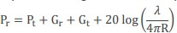
The main theory which was tested although the experiments is the Friis Transmission Equation (FTE). The theory predicts that the Received Strength depreciates as the distance between the transmitter and the receiver increases. With the theory assuming a power of one watt, a gain of one watt and a frequency of one GHz, the logarithmic equation is expressed as
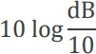
where Pt is the power fed into the transmitting antenna input terminals, Pr is the power available at receiving output terminals, Gr and Gt describe the gain of receiving and transmitting antennae, λ is the wavelength, and R symbolizes the distance between antennae. RSSI computations were reached at by converting dB to watts using the formula:
From the first experiment, the dish antenna RSSI was averaged for over 5 seconds, which were noted at 20-foot increments from 20 to 200 feet. The same experiment is repeated but this time, using the dipole antenna. In the third experiment, the RSSI for each antenna-type is measured at a distance of 200 feet with power transmission of 1 watt for different angles of heading. In the fourth experiment the antennae are tested from 200 feet using one-watt transmission source at various pitches which are measured in one-degree increments.
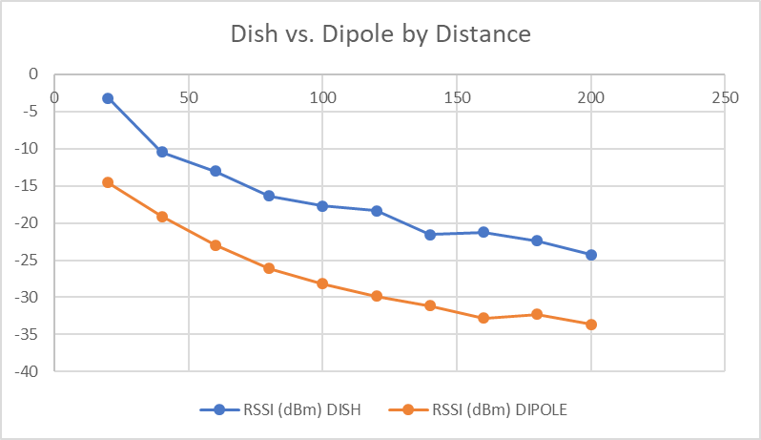
Figure 1: This is the data displaying dish and dipole RSSI’s by distance at intervals of 20 feet up to 200 feet.

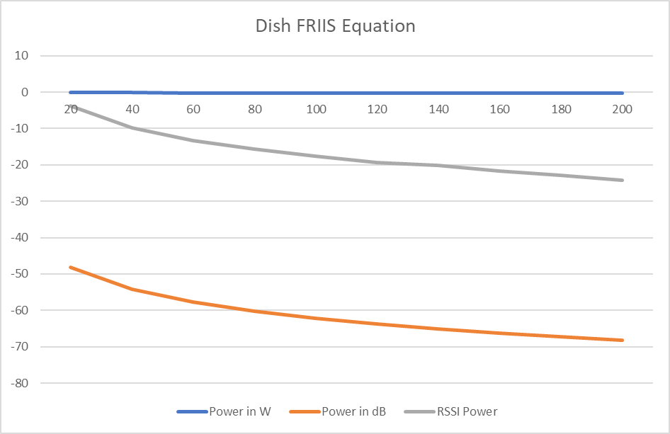
Figure 2: The FRIIS equation from the Dish antenna experiments.
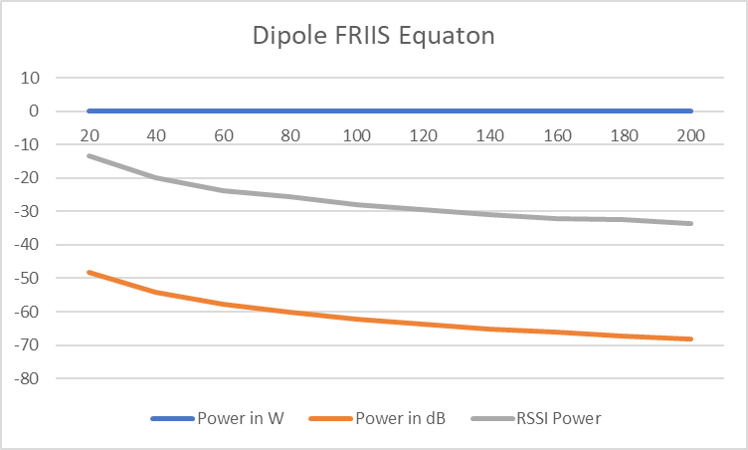

Figure 3: The FRIIS equation from the Dipole antenna experiments. The FRIIS equation assumes a power of one watt, a gain of one watt, and a frequency of 1 GHz.

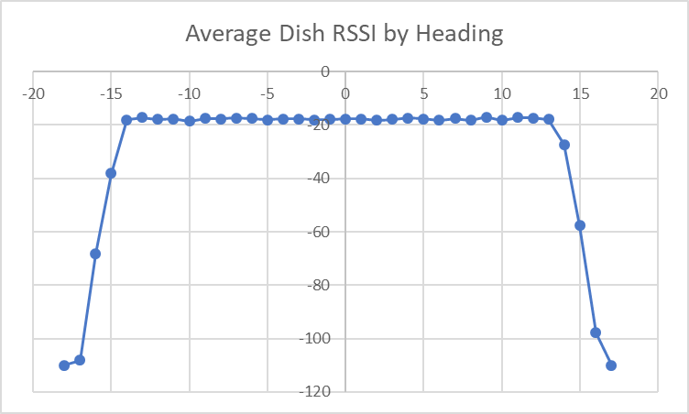
Figure 4: This scatter chart shows the average dish antenna RSSI based on the heading. The X- axis represents the RSSI value and the Y-axis represents the heading in degrees

3.0 Results
From the experiment, the results vividly shows that RSSI is inversely proportional to the distance between the receiver and the transmitter. As shown on the above figures, it’s evident that there is an optimal, overlapping zone of headings whereby no change in the RSSI. Away from that zone, as the communication drops, the RSSI values as well drop. This observation, clearly indicates the range of heading presenting the operational view for communication array.

4.0 Conclusions and Recommendations
With a lot of confidence, from these experiments, we can recommend dish type receivers. This experiment is vital since it assumes all that satellites go through during transmission of information in regard to the different pitches, headings, and the settings put on the power.

.

