Think About What You Think

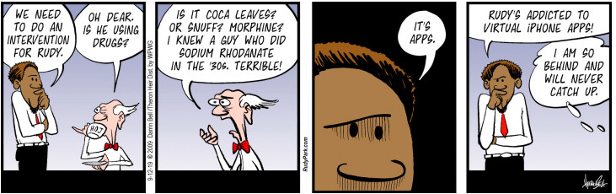
“Addiction begins with the hope that something “out there” can instantly fill up the emptiness inside.” ~ Jean Kilbourne
A Historical Perspective...
Treatment for opiate addiction was essentially unavailable until 1935 when a hospital called "The Farm" was started in Lexington, Ky.
Think about this historical fact as you watch the video and complete the rest of the assignment. Make sure you follow the assignment instructions.

The Prompt
America's rampant misuse of synthetic opioids has lead to a drastic increase in overdoses and deaths.Introduced in 1996, OxyContin, the most highly addictive synthetic opioid in the world, was aggressively marketed by Purdue Pharmaceuticals and the Sackler family.Others, although legally prescribed, (oxycodone, hydrocodone, codeine, and morphine), are addictive when misused also. Recently, illegal fentanyl has taken center stage in the illicit opioid trade. Opioids were originally believed to be safe when taken for a short time and as prescribed by a doctor. However, regular use, even as prescribed by a doctor, will lead to toleranceand, ultimately, dependence. Since 1999, over 760,000 deaths have resulted from the misuse of opioids, and there are no easy answers in sight.

The Assignment Instructions
- Watch the "The Whistle Blower" video here.(30min.)
- Referencing the video, your textbook, and other resources, discuss the escalating opioid crisis, and how the resulting trauma has impacted society.
- What should be done about those whose wealth and power, shields them from the consequences of their actions, both criminal and moral, of the opioid crisis they created?
- How can society intervene with millions of people who suffer from the disease of opioid addiction?
- Reference your sources in your response.

Note:
- Word count is 300-500 words
- You must submit a post BEFORE you can see your classmates posts.
- Ideally, your response to your classmates should consist of a complete thought that contributes to the dialogue and furthers the discussion.
- There are no right or wrong responses, so share your knowledge, insights and thoughts freel

