Cloud Considerations
What you need to know prior to making the leap

Cloud Considerations
What you need to know prior to making the leap

Executive Summary
"By failing to prepare, you are preparing to fail."  - Benjamin Franklin | Wait! Before you move your IT operations to the cloud, there are a number of considerations that you should take into account prior to making the leap.  It is well known that hosting one’s own systems incurs costs in facilities including power and cooling, and systems maintenance including hardware, licensing, and support. Additional costs come from staffing and day-to-day operations.  What if instead, you could stop paying for new hardware? What if the worry and upkeep of the aging equipment belonged to someone else? That's entirely possible by moving to the cloud. The servers are physically managed by the cloud provider in their data center, and you are just one of many utilizing those systems.  However, with a new environment comes all new tools and concepts that you need to understand before making that decision.  Many IT organizations have attempted to make the transition and failed due to lack of time allotted, lack of identifying project requirements, or lack of knowledge to make an effective plan for budget.  Some key factors need to be considered in order to determine if making the transition to the cloud is the right fit for your company. In addition, proper preparation, including anticipating additional costs and allotting enough time to make the transition is needed in order to be successful.  These factors include the following questions:  - Are your applications a good fit for the cloud and what will be the approach to migrating them?  - Does your support team have the knowledge to support the new environment?  - What security controls need to be in place to provide adequate security and compliance with regulations?  - What other hidden costs could be uncovered and planned for?  If you consider these factors, allow time for planning, and budget for failure, you may be successful in migrating to the cloud.

Introduction
The cloud has become a household term over the past few years, but what does it really mean? As defined by the National Institute for Standards and Technology (NIST), “Cloud computing is a model for enabling ubiquitous, convenient, on-demand network access to a shared pool of configurable computing resources (e.g., networks, servers, storage, applications, and services) that can be rapidly provisioned and released with minimal management effort or service provider interaction.” (Mell & Grance, 2011, para. 1). However, Microsoft’s Azure website puts it much more clearly by stating, “Simply put, cloud computing is the delivery of computing services—servers, storage, databases, networking, software, analytics, and more—over the Internet (“the cloud”).” (2018, para. 1). Using this concept, most companies are already utilizing the cloud if they are getting one or more services through the internet.
Several different cloud models exist that further define the cloud concept compared to traditional on-premises architecture within one’s own datacenter:
Software as a Service (SaaS) – This refers to utilizing software or an application that is provided as a service, such as utilizing web-based email like Google or Microsoft Office 365.
Platform as a Service (PaaS) – This type of model refers to a platform, such as a server with operating system and necessary tools, being provided to run an application. In this case, the consumer only has the ability to manage the application but not the underlying architecture or operating system. This is somewhat of a middle ground between SaaS and IaaS.
Infrastructure as a Service (IaaS) – In this case, the infrastructure such as servers, networks, storage, and processing power are provided in a hosted facility. As the consumer, you deploy the operating systems, applications, and security to the provided infrastructure.
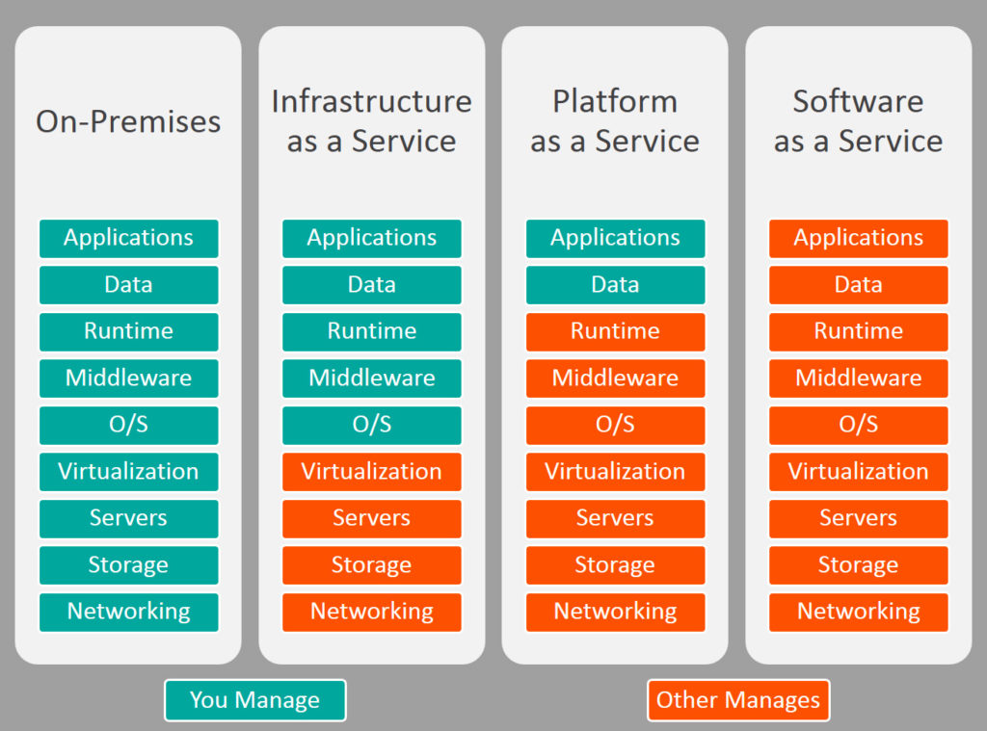
Figure 1. Cloud Models. This figure illustrates the responsibility of management for the cloud models.
Reprinted from “SaaS vs PaaS vs IaaS: What’s the difference and how to choose” by Watts, S., 2017, http://www.bmc.com/blogs/saas-vs-paas-vs-iaas-whats-the-difference-and-how-to-choose/
In this document, we will primarily focus on Infrastructure as a Service. The concept of moving one’s infrastructure to the cloud can be appealing, especially when faced with some number crunching provided by one of the cloud giants like Amazon Web Services (AWS). In the white paper “Introduction to AWS Economics,” AWS claims that moving to their cloud infrastructure will provide considerable cost savings both variable and upfront as compared to traditional data centers. (Amazon Web Services, 2015) See figure 2.
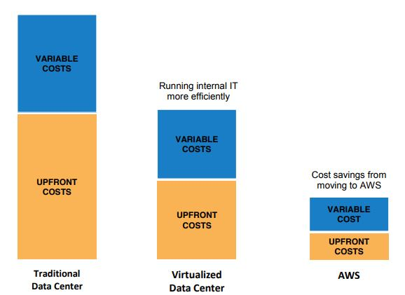
Figure 2. AWS Economics. This figure illustrates the estimated cost for data center models as explained by AWS.
Reprinted from “Introduction to AWS economics - Reducing costs and complexity” by Amazon Web Services, 2015, https://d0.awsstatic.com/whitepapers/introduction-to-aws-cloud-economics-final.pdf
With such promises, it comes as no surprise that companies are deciding to make the transition. Many articles are available that discuss the benefits of moving to the cloud. Many companies are being baited by the promises of less cost and less maintenance. Is it true that the cloud can save money? Possibly. Does the cloud reduce the effort to operate? It can, but you must also factor in additional hidden costs that the cloud providers don’t initially reveal.
On the other hand, there are articles written that caution folks from making the transition, claiming that cloud technology is evil and insecure and all of your data is at risk. After all, the cloud is just running your systems in someone else's network, right?
In reality, the cloud can actually be safe and secure, and may even offer some long-term cost savings. However, it's not all unicorns and rainbows, and especially not up front. Let’s take a look at some previous approaches and issues that have been experienced.

Previous Approaches
Traditional data centers, whether owned or leased, offer limited space, aging equipment at best, and limited scalability. Every few years some equipment must be replaced. Add to that the cost of power, cooling, maintenance and operations and you have a hefty price tag on your hands. It’s no secret that cloud technology reduces some of that overhead and offers some additional benefits.
Cloud providers, including some of the giants such as Amazon Web Services (AWS), Microsoft Azure, and Google Cloud Platform, advertise their many benefits, some of which can make any Chief Financial Officer (CFO) want to make the switch yesterday.
An example of one of these benefits is elastic computing which provides scalability. Elastic Computing as defined by Microsoft is “the ability to dynamically provision and de-provision computer processing, memory, and storage resources to meet changing demands without worrying about capacity planning and engineering for peak usage,” (Cloud computing terms, 2018, para. 10). This means that resources are provided as they are needed.
An example is during a holiday sale on a commercial website, perhaps the site gets 5 times as many customers visiting and placing orders than during a normal day of operations. This influx of traffic could have devastating effects on an IT system hosted in a traditional architecture. However, utilizing the elastic computing concept in the cloud can allow for more processors to be provisioned when needed, and then turned back off when the load decreases. The concept of elastic computing also saves money in the long run, as you only pay for the services as they are used.
However, the cloud has had its fair share of problems. Below are a few of the issues that have been experienced at the provider level and at the customer level.
- In Microsoft Office Suite Exchange Online, both standalone and Office 365, suffered a disruption in June of 2014 leaving many companies that relied on the service for email in the dark. (Endler, 2014)
- Again, this time in November 2014, Microsoft's Azure cloud service experienced an 11-hour outage due to improperly applied updates, which affected many customers that used the platform around the globe. (Okyle, 2014).
- Healthcare.gov experienced tremendous system issues when it tried to launch its cloud based website in 2013 resulting in error messages, latency, and downtime that caused many to not be able to enroll for health care coverage. This issue resulted in public embarrassment for the Department of Health and Human Services. (Hendricks, 2014)
David Linthicum, contributor to InfoWorld.com, discussed IT project failures in recent years, citing an Innotas survey that depicted a 32 percent failure in 2014, and a jump to 55 percent failure in 2015. However, in 2016 the failure rate decreased slightly to 50 percent. David attributed these failure rates to companies migrating to the cloud. He also said “In fact, I figure you have a one-in-three chance that your cloud project will be considered a failure, perhaps because you spent way more than you budgeted or more likely because you pick the wrong technology or cloud services,” (2017, para. 4).

According to a survey conducted by Sungard Availability Services in 2015, the 3 top reasons for cloud migration failures as illustrated by Fleece (2015):
Table 1.
Top 3 reasons for cloud migration failures
Reason | % of 276 total respondents
Lack of understanding of cloud security and compliance | 56%
Lack of clearly-identified business objectives for migrating to the cloud | 55%
Lack of planning | 42%
Note: Adapted from “Why cloud computing implementations typically fail” by Fleece, J., 2015, November 17, https://www.forbes.com/sites/sungardas/2015/11/17/why-cloud-computing-implementations-typically-fail/

New Findings
As Jeff Fleece of SungardAS wrote “What it all comes down to is this: businesses need to treat the cloud exactly the same as any technology enhancement. Cloud adoption may include a number of desirable benefits, but you have to think of it as just a new technology architecture: nothing more, nothing less,” (2015, para. 11).
Some considerations need to be made to effectively decide if moving to the cloud is feasible for your situation so your project doesn’t end in failure. Below you will find some questions that you can ask yourself to assist in making an effective decision:
Approach – Depending on your existing systems will determine the approach you would need to take should you pursue migrating to the cloud.
- Does your company have existing IT systems that you believe are good candidates to host in the cloud?
- If so, are those systems cloud-ready or do they need significant code changes?
New Technology – With the new cloud environment comes all new terminology and applications.
- Is your staff educated well enough on the new environment and technology to provide support?
- Do you need to hire contractors to help with setting up the environment?
Security – With new technology comes new sources of attack. Having an understanding of how security is implemented and managed in the cloud is a must.
- Does your staff have the knowledge to effectively secure the new environment?
- Have you considered the legal regulations that you must abide by in your business as it pertains to cloud technology?
Unexpected Costs – Quotes and invoices for cloud computing are usually dependent on the amount of data in transit and at rest. However, there are a few other factors that make that monthly invoice increase. In addition, training and licenses will add to the overall price tag as well.
- Do you know how much traffic your website will generate?
- Do you know how much storage you need?
- Do you have an idea of what licenses you will need to procure to complete the transition?

Approach
If you are looking to utilize IaaS-benefits and become a cloud based company, there are several approaches you can take depending on if the system you are looking to make cloud based is an existing system or not.
New Systems – If you are either a new start-up company or are an existing company that is looking to build a new system in the cloud, this approach is much easier than the rest. You can design the application from the beginning to interface with the cloud technology. However, being a new system does not make the system immune to configuration errors, security threats, or the hidden costs described further on.
Lift and shift – This approach refers to lifting an existing IT system that is not built for the advanced features of the cloud and shifting it to the new cloud environment without very many modifications.
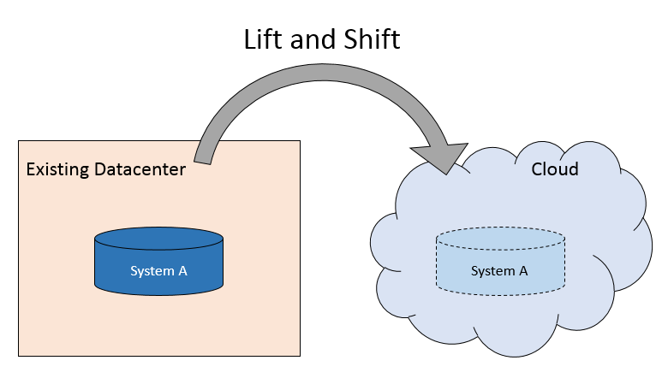
Figure 3. Lift and Shift – Moving a system from one location to another without many modifications.
Essentially, the existing IT system is running as if it were still in a traditional data center with all of the traditional limitations. In order to take advantage of the cloud capabilities of automation using application programming interfaces (APIs), load balancing, and auto-scaling, the application has to be designed for it. Margaret Rouse wrote an article for tech target describing the lift and shift approach and made a comparison to moving a houseplant (2017, para. 5):
Lifting and shifting can be compared to moving a houseplant from one environment to another; being in a different habitat can affect whether the plant will thrive. Likewise, an IT project that started in an on-premises or original legacy system might not work as well in a new location.
Modernize and release - For existing applications, this approach may have the best end result, but it also has the highest price tag. While you are designing the application and developing the new cloud environment, you must continue to support the existing system within the original data center. This means for a period of time, you will have two invoices each month, one for the current environment and one for the future environment. In addition to the double cost, another consideration with this type of approach is return on investment. The business unit within your organization that utilizes the system does not get to see any benefit to the rewrite of the application until there is something available to demo within the new cloud environment.

New Technology
The technology within the cloud environment has some of the underlying components shared with traditional data centers, like virtual servers, operating systems, IP addressing, etc. However, there are many new tools and additional terminology that system administrators must become accustomed to. As a cloud administrator, he or she must understand virtual machine and virtual network configuration, provisioning and automation, interconnectivity between instances, and much more.
Furthermore, some of the existing IT roles may no longer be necessary for administrators. In the white paper titled “The impact of cloud computing: Should the IT Department be organized as a cost center or a profit center,” it was stated that “As more services are procured from cloud vendors, the need for functions within the IT department that serve to administer, monitor, and maintain the IT infrastructure will be considerably diminished or even eliminated” (Choudhary, V., & Vithayathil, J., 2013, para. 66). Some considerations for the roles of your administrators need to be made prior to implementation.

Security
One security concern is for auditing of who has access to your data, both physically and logically. Many organizations can audit access control to their data center and see who entered the premises, or determine how secure the facility is. That’s not really a possibility in a cloud environment. In addition, who has access to your virtual servers? In an article discussing cloud adoption based on perceived risks, it was stated that “organizations cannot ignore the fact that once their corporate proprietary information is transferred over to a Cloud service provider, it can no longer be considered private and confidential” (Ho, Booth, & Ocasio-Velazquez, 2017, para. 504). This is a considerable issue and a sticking point for many organizations.
Another consideration for security is that cloud design is typically based on the idea that multiple tenants share the cloud resources, which can be an audit concern for many regulated organizations. Many auditors and security professionals feel that any shared technology can potentially expose your assets through vulnerabilities in the multi-tenant architecture. How strong are the mechanisms that provide isolation to your data? Two recent vulnerabilities in 2018, Meltdown and Spectre, are among some of those threats that pose a risk to application isolation requiring both firmware and operating system level patching (Donohue, 2018).

JP Morgenthal was quoted in a Forbes article as saying:
There are not as many trained professionals with skills on how to secure cloud applications and, thus, there is a greater likelihood of a mistake in the configuration of a cloud environment. These mistakes are a lot more difficult to make in a private data center. However, each is open to breach. (Poremba, 2018, para. 2).
The best bet for keeping security in any environment under control is to have educated staff that know your systems and environment, conduct regular routine patching, limit access for users, systems, and applications to least privilege, and be familiar with what's happening in your environment through monitoring, logging, and auditing.

Unexpected Costs
As mentioned previously, elastic computing allows for provisioning of servers automatically. However, if you are not aware of the amount of expected traffic and plan for the additional usage, you may incur additional costs that you didn’t plan for.
In addition, another type of unexpected cost can come in the form of cloud sprawl. Cloud sprawl is an over-abundance of virtual servers, instances of applications, or services running than are needed, and frequently without the knowledge from the company until the monthly invoice shows up. These virtual servers are frequently turned on by a developer or engineer to do some testing and then abandoned. It is usually very easy in the cloud environments to initiate new servers or services and not quite as easy to monitor and manage them. This of course benefits the cloud provider, who stands to make more money with more servers being utilized.
Additionally, unmanaged virtual machines pose a security risk. In an article from the International Journal of Emerging Engineering Research and Technology, it discussed virtual machine sprawl, stating “This dynamic nature and possible for VM sprawl makes it difficult to achieve and maintain consistent security,” (Ballada, 2017, para. 14).
Therefore, it is very important as a consumer to have a plan in place to monitor cloud storage and maintain the environment so those unexpected line items don’t show up on the monthly bill.

Conclusion
There are many reasons one may consider the cloud as a viable option for hosting one’s services. The benefits of potential lower cost, flexible scalability, and no aging equipment are worth considering. However, the transition must be successful in order to achieve any of these benefits. Many companies have attempted the transition and suffered for failed altogether. This is primarily due to lack of planning and education.
Know your applications and decide if they are good candidates for the new environment. Realize that new technology is hard to support if you do not have staff educated in that technology. Plan to incorporate security up front so you don’t build in vulnerabilities into the architecture. Finally, realize that there will be unexpected costs. Budget for failure. Allow enough time to build these concepts into your final plan and you may be a success story.

Sources
Ballada, L., (2017, February). My cloud data logger. International Journal of Emerging Engineering Research and Technology 5(2) 32-35 DOI: http://dx.doi.org/10.22259/ijeert.0502004
"Benjamin Franklin Quotes." (2018, February 17). Benjamin Franklin Quotes. Retrieved from https://www.quotes.net/quote/36948
Choudhary, V., & Vithayathil, J., (2013, October 1). The impact of cloud computing: Should the IT Department be organized as a cost center or a profit center? Journal of Management Information Systems (pg. 88, p 3) DOI:10.2753/MIS0742-1222300203
Cloud computing terms. (2018). Microsoft Azure. Retrieved from https://azure.microsoft.com/en-us/overview/cloud-computing-dictionary/
Donohue, B., (2018). Meltdown and spectre attacks exploit speculative execution in processor chips. MKA Cyber. Retrieved from https://mkacyber.io/news/meltdown-and-spectre-attacks/
Endler, M. (2014, June 24). Microsoft Exchange Online suffers service outage. Information Week. Retrieved from https://www.informationweek.com/cloud/software-as-a-service/microsoft-exchange-online-suffers-service-outage/d/d-id/1278829
Fleece, J. (2015, November 17). Why cloud computing implementations typically fail. Forbes. Data retrieved from https://www.forbes.com/sites/sungardas/2015/11/17/why-cloud-computing-implementations-typically-fail/
Hendricks, D. (2014, January 14). Why HealthCare.gov was desperate to switch hosting providers. Forbes. Retrieved from https://www.forbes.com/sites/drewhendricks/2014/01/14/why-healthcare-gov-was-desperate-to-switch-hosting-providers/
Ho, S.M., & Booth, C., & Ocasio-Velazquez, M., (2017). Trust or consequences? Causal effects of perceived risk and subjective norms on cloud technology adoption. Elsevier Ltd. DOI: 10.1016/j.cose.2017.08.004
Introduction to AWS economics - Reducing costs and complexity. (2015, May). Amazon Web Services. Image retrieved from https://d0.awsstatic.com/whitepapers/introduction-to-aws-cloud-economics-final.pdf
Linthicum, D. (2017, February 28). Cloud project? Prepare for failure. Infoworld. Retrieved from https://www.infoworld.com/article/3174482/cloud-computing/cloud-project-prepare-for-failure.html
Mell, P., Grance, T. (2011, September). The NIST definition of cloud computing. National Institute of Standards and Technology. Retrieved from https://csrc.nist.gov/publications/detail/sp/800-145/final
Okyle, C. (2014, November 20). Microsoft says 11-hour Azure outage was caused by system update. Entrepreneur. Retrieved from https://www.entrepreneur.com/article/240029

Poremba, S. (2018, February 17). 7 Common misconceptions about security threats in cloud computing. Forbes. Retrieved from https://www.forbes.com/sites/sungardas/2015/05/12/7-common-misconceptions-about-security-threats-in-cloud-computing/
Rouse, M. (2017, December 29). Lift and shift. Techtarget. Retrieved from http://whatis.techtarget.com/definition/lift-and-shift
Watts, S. (2017, September 22). SaaS vs PaaS vs IaaS: What’s the difference and how to choose. BMC. Image retrieved from http://www.bmc.com/blogs/saas-vs-paas-vs-iaas-whats-the-difference-and-how-to-choose/
What is cloud computing? A beginner’s guide. (2018). Microsoft Azure. Retrieved from https://azure.microsoft.com/en-us/overview/what-is-cloud-computing/

