1 | Match the formula to its correct description and/or usage:  Description 1: : Finding sample size for means  Description 2: Confidence interval - when σ is known and n ≥ 30  Description 3: Confidence interval - when σ is unknown and n< 30  Description 4 Test value | Descr  1,2,3,4
  Formula A | $\frac{\overline{x}-}{\frac{}{\sqrt{n}}}$
  Formula B | $\overline{ x }- t_{{∝/}_{2 }} \left(\frac{s}{\sqrt{n}}\right)$< μ $< \overline{x }+ t_{{∝/}_{2 }} \left(\frac{s}{\sqrt{n}}\right)$
  Formula C | $\overline{ x }- z_{{∝/}_{2 }} \left(\frac{σ}{\sqrt{n}}\right)$< μ $< \overline{x }+ z_{{∝/}_{2 }} \left(\frac{σ}{\sqrt{n}}\right)$
  Formula D | : $n = {\left(\frac{z*σ}{E}\right)}^{2}$
  A
  B
  C
  D
2 | 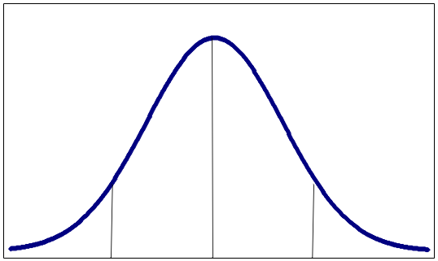  z = - 1.05 z =1.05  What is the closest confidence level indicated by the above figure ?  Round to 2 decimal places—answer must be a %
3 | As the percentage of confidence decreases, the confidence interval will become wider. True - False
4 | Total Area = 75.8%  What is the margin of error for the above figure ?  Express as a % with 2 decimal places
4A | WHICH STATEMENTS ARE TRUE REGARDING THE DECISION AND THE CONCLUSION?  - The decision is always “reject”  - The decision is made prior to stating the conclusion  - The conclusion DOES NOT depend on the decision  - The decision comes from analyzing the placment of the test value  - The conclusion is ALWAYS the opposite of the claim
4B | - REJECT H0  - DO NOT REJECT H0  - REJECT H1  - DO NOT REJECT H1  IF THE TEST VALUE IS  -2.35 AND THE CRITICAL VALUE IS -2, STATE THE DECISION

4C | IF H1 IS stated as----  H1 : MEAN> 34.5, AND WE REJECT H0  CHOOSE THE CORRECT ANSWER | - MEAN > 34.5  - MEAN = 34.5  - MEAN >= 34.5  - MEAN < 34.5  - NONE
4D | Which statements are TRUE regarding the MEANINGS of the test value and the critical value ?  LIST ALL TRUE ANSWERS | - The test value is found in a table while the critical value is found by a formula  - The test value is always positive, while the critical value is always negative  - Both are found in tables  - Both are found by formulas  - The critical value is found in a table while the test value is found by a formula  - The test value is always to the left of the critical value | ANSWER(S)

5a |  | The local Shop and Save store claims that they sell LESS than 300 half-gallons of almond milk per day in their local stores.  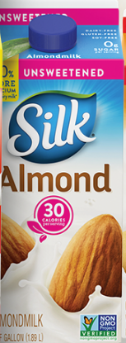  State the appropriate h1 hypothesis:  - H₀ : the mean > 300  - H₁ : the mean <= 300  - H₀ : the mean < 300  _{D.} H₁ : the mean < 300  E. H₀ : the mean <= 300  F. H₀ : the mean >= 300  G. H₁ : the mean > 300  H. none of these
5b |  | Now state the appropriate h0 hypothesis:  - H₀ : the mean < 300  - H₁ : the mean < 300  - H₀ : the mean < 300  _{c.} H₁ : the mean < 300  d. H₀ : the mean >= 300  e. H₀ : the mean <= 300  f. H₁ : the mean <= 300  g. none of these
During the Spring and Fall of the years, homeowners and
landscapers purchase record numbers of bags of mulch.
Mulch is a material that comes from the bark of various
types of trees and then colored to suit the needs of the
customer. It has been found that some mulch contains inferior
materials that cause the colors to fade. Landscaper Julius wants to test a truckload of
mulch to see if it does indeed contain inferior materials but he wants to test only the minimum number of bags at a 99% confidence level; he knows the stdev of the number of bad bags to be 12.36 and he wants to be within 3.98 bags. Find the minimum sample size and state your answer as an appropriately rounded number.

6
  A partial history of the growth of popcorn in some mid-western states indicates how many acres are dedicated to popcorn growing. For example, the state of Indiana planted 43,147 acres in 2013. The Della Gadova seed company wants to ensure that the states have enough seeds for the next planting year, therefore, they need a confidence interval to serve that purpose. They will use the 43,147 as their mean and a stdev of 6000 acres and want to use a 90% confidence level. The 8,500 acres varies due to weather, finances etc. State the 95% confidence interval---round to 2 decimal places. n= 100 bags
  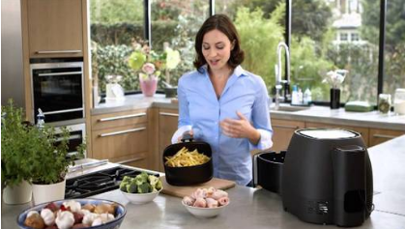
7 |  | 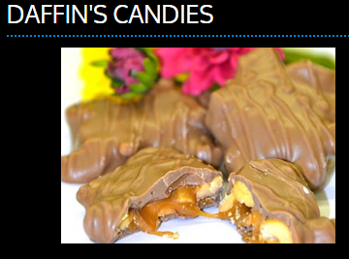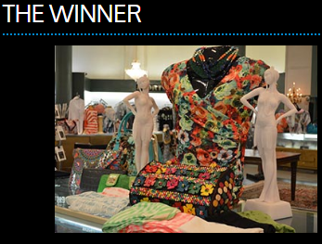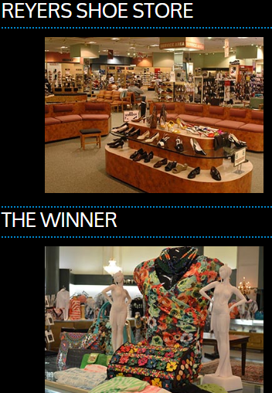  Sharon , a city in Northwestern Pennsylvania, is well-known for it’s world’s largest selection of stores—these include Reyer’s Shoes, The Winner ( clothing), Daffin’s Candy etc. During the heyday of Sharon’s history when steel mills were flourishing and people came to Sharon to shop, the city also flourished—especially the above mentioned stores. It has been estimated that the number of shoppers in the stores in those days was, on average, 6,250 per day with a stdev of 1,230 depending on weather, holidays etc. Sally, Sharon’s historian claims that that number should be HIGHER ( than 6250) and she has a sample mean of 7,000. Test Sally’s claim by answering the questions that follow---use a 90% confidence level and sample size of 16 days.
8A |  | Choose the appropriate H₁  A . H₁ : the mean ≠ 6,250 shoppers  B . H₁ : the mean < 6,250 shoppers  C . H₁ : the mean > 6,250 shoppers  D . H₁ : the mean = 6,250 shoppers  E . H₁ : the mean > 7,000 shoppers  F . H₁ : the mean = 7,000 shoppers  G. H₁ : the mean < 1,230 shoppers  H . NONE OF THESE
B. |  | Choose the appropriate H_{0 :}  A . H₀ : the mean ≠ 6,250 shoppers  B . H₀ : the mean < 6,250 shoppers  C . H₀ : the mean >= 6,250 shoppers  D . H₀ : the mean <= 6,250 shoppers  E . H₀ : the mean ≠ 7,000 shoppers  F . H₁ : the mean > = 6,250 shoppers  G. NONE OF THESE
C |  | Choose the appropriate claim:  - THE CLAIM IS H1  - THE CLAIM IS H0  - NONE OF THESE ANSWERS
D. |  | State the closest critical value(s):  - +/- 1.86  - -1.96  - +/- 1.96  - +2.58  - +/-2.58  - -2.58  - 1.65  - -1.65  - +/-1.65  - +1.28  - +1.96  - +/- 1.28  - NONE OF THESE ANSWERS - place your answer in the answer slot
E |  | State the test value(s) :
F |  | What is the decision ?  - REJECT H0  - REJECT H1  - DO NOT REJECT H0  - DO NOT REJECT H1  - REJECT BOTH H1 AND H0  - REJECT NEITHER H1 NOR H0  - NONE OF THESE ANSWERS
G |  | Choose the correct conclusion:  - Sally is correct---the number of shoppers is higher  - Sally is NOT correct—the number of shoppers is not higher  - Neither of these answers
BONUS  3 points
  BONUS QUESTION A survey found that 66% of all golfers use a golf cart to play. A random sample of 326 golfers showed that 105 of them use golf carts. if the critical value is -1.65, what is your decision ? NOTE: MATERIAL NOT REVIEWED BY INSTRUCTOR –NOT A SIMPLE PROBLEM

