Name:
Course:
Instructor:
Date of submission:
SCISSORS
General Description
Scissors are cutting apparatus that are manually operated. Scissors have two metal blades sharpened on the inner edges, hinged together and designed to slide against each other once the handles are moved in a closing direction for shearing to take place. The blades are blunt on the outer edges which ensures safety against injuring the user. There are various things that can be cut using scissors including paper, metal foil, wire as well as other thin materials. Scissors come in different sizes and designs depending on the special uses with the larger variety being referred to as shears. Scissors can easily be used while being held using one hand. There are both right-handed and left-handed varieties since their functionality is considered asymmetric. Those types designed for hair-cutting for example have specialized blade angles for their functionality and using any other type for the same purpose is likely to result in damaged hair. There are also those types used in the kitchen for purposes of cutting different types of food such as meat known as kitchen scissors. Scissors are designed in a way that supports human factors having a combination of either plastic and rubber handles that facilitates easy use of the apparatus. Main parts of the scissors include two metal blades, pivot point and handles that have finger holes.

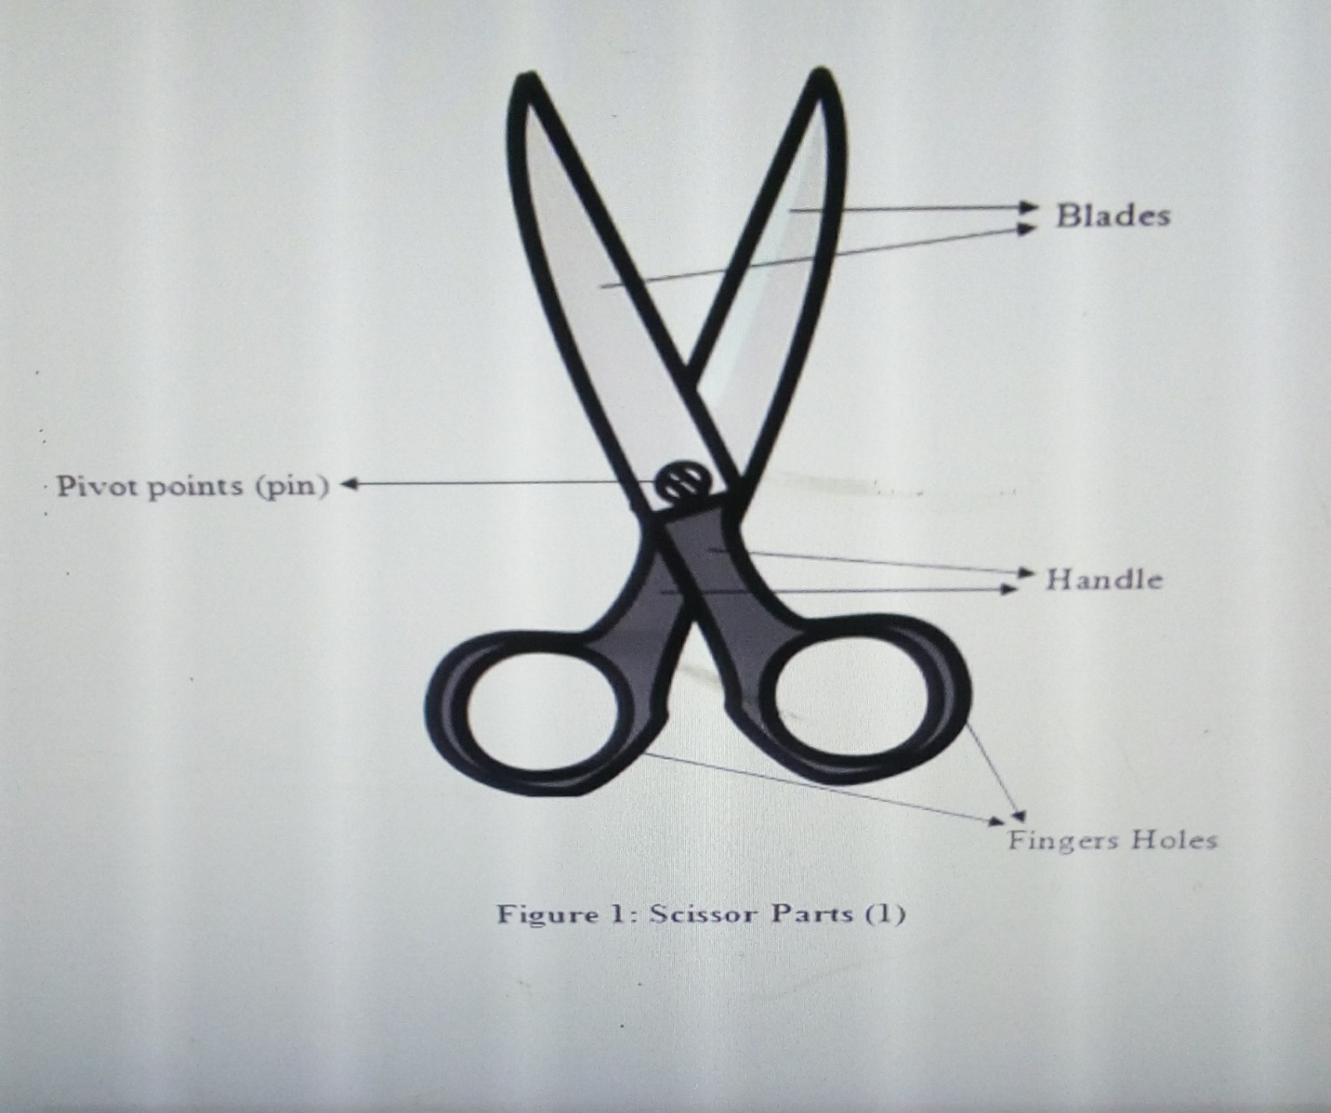
Figure 1. Main Parts of the Scissors
Blades
There are two pivoted blades on every pair of scissors. Blades overlap each other and regardless of any orientation, shape or size, the one at the top always forms a similar diagonal to the others. The inner edges of the scissors are sharp for cutting while the outer edges are blunt preventing cases of injury to the user. High quality scissors have exceedingly sharp edges compared to the low quality. Children scissors however have blunt blades for safety and are only meant to tear objects apart. The blades approach each other from opposite direction while handles are moved in a closing direction so that they overlap against each other to facilitate cutting.
Pivot Point
The pivot hinges the two blades together and acts as a fulcrum making the apparatus a top double-lever. Mechanically, when the material to be cut is placed close to the pivot, it results to easy cutting as the force applied to the handles is twice at the fulcrum. The pivot point consists of a pin that that provides stability for the parts of the scissors. It ensures the closing and opening of the scissors and is therefore closed in a manner that it leaves room for easy functioning resulted from minimum applied power. Its point of placement depends on the length of scissors.
Handles
The handles are generally made up of a combination of thermoplastic material and rubber. They are the means by which scissors are gripped. The hand movement on the handles results into cutting. Some quality scissors have a finger tang found just beneath the index finger hole that is placed to provide rest for the middle finger. This finger brace is beneficial in provision of improved control and accuracy cutting. A finger tang is a component most buyers look for while selecting the best scissors as the users claim it is convenient for finger rest during the cutting process. There are also specialized scissors in the market designed for people with special needs. For persons who may not have the ability to use their hands, there are foot- operated types while there are also motorized types for quadriplegics that can be operated by mouth. The length of the handles in a pair of scissors is measured from the middle of the scissors. The handles end with finger holes.
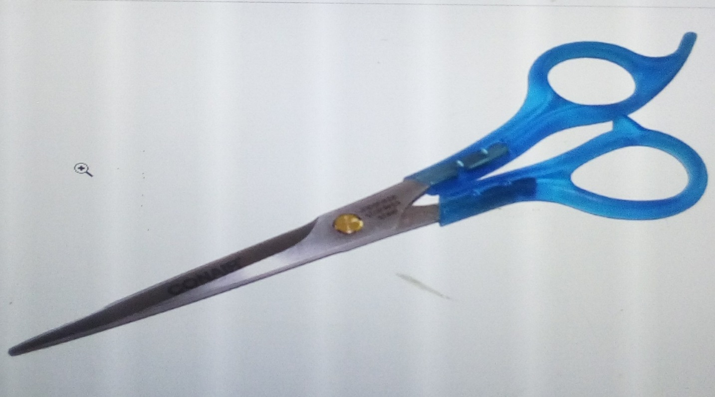
Figure 2. Hair-cutting shears with finger tangs.
Operation
The shearing of the two blades results into cutting of the material placed in between the blades. Where extremely sharp scissors are required, the user needs to ensure the blades are tension sprung at the point where they meet for maximum shearing tension and easy cutting. To add tension, the user needs to push the thumb while pulling the rest of the fingers which results into perfect cutting of materials such as silk. If the material to be cut is a bit thick or heavy, it is recommended that it should be placed closer to the point of contact of the two blades since the force applied at the handles is generally double at the pivot. For cutting to take place, shear pressure surpassing that of material’s shear power is required to be applied. High quality shears only require minimum energy for a clean cut and might also be a bit expensive compared to the lower quality types. There are many specialized types of scissors in the market that serve different needs. Scissors come in many designs and shapes depending on the special tasks they are used.
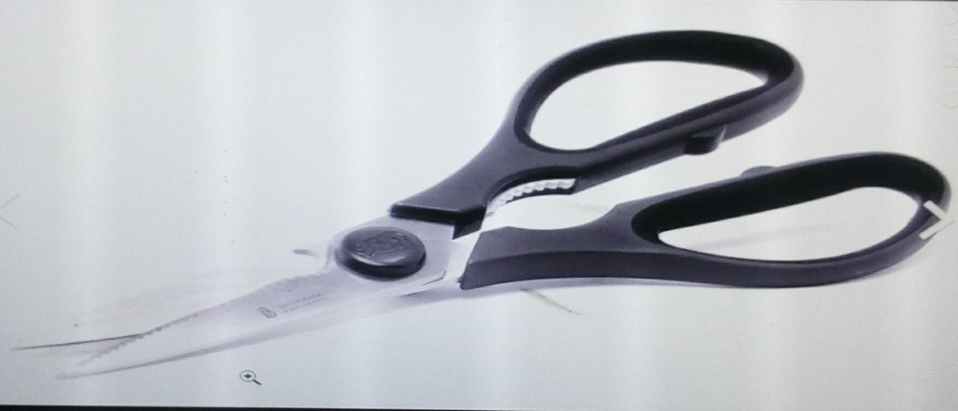
Figure 3. Kitchen Scissors made up of stainless steel that is oxidation free
Reference
Kozakai, T., & Yoshida, N. (2014). U.S. Patent Application No. 29/470,679.

