Procedure I ‐ Household Solutions
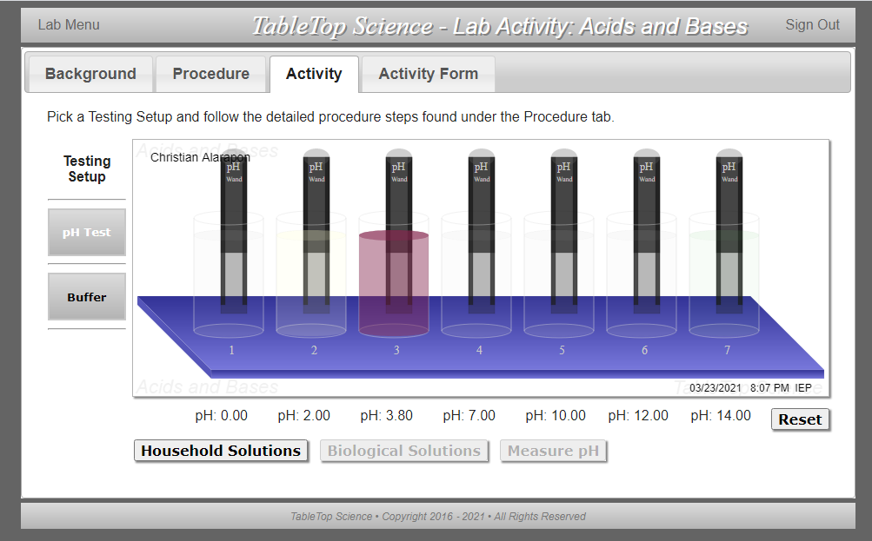

Procedure II - pH of Biological Solutions
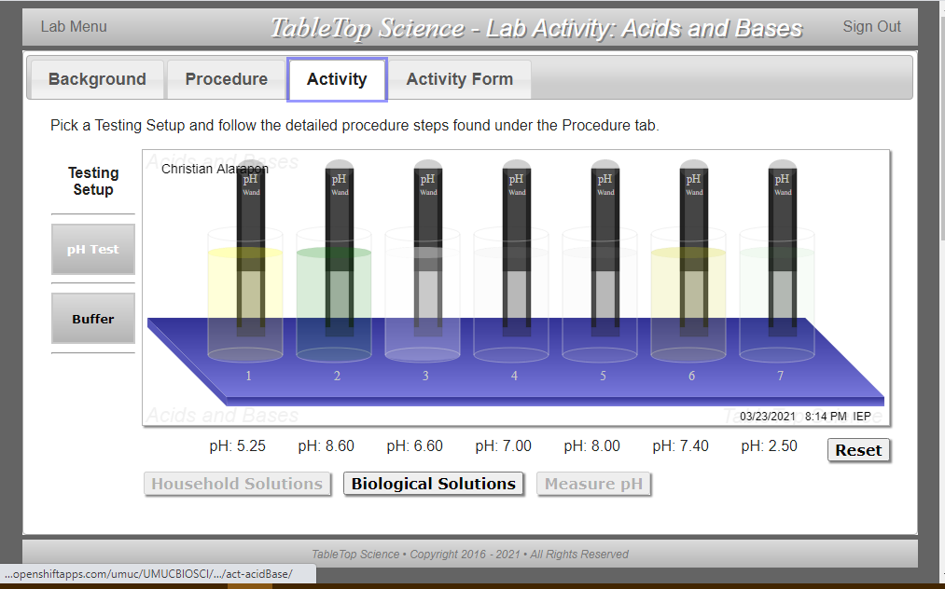

Procedure III ‐ Adding Acid Solution to the Buffer Solution
Procedure III: 1 drop
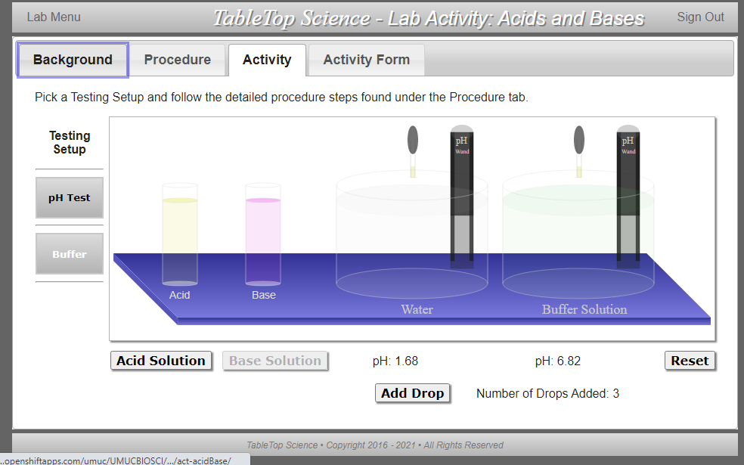
Procedure III: 2 drops
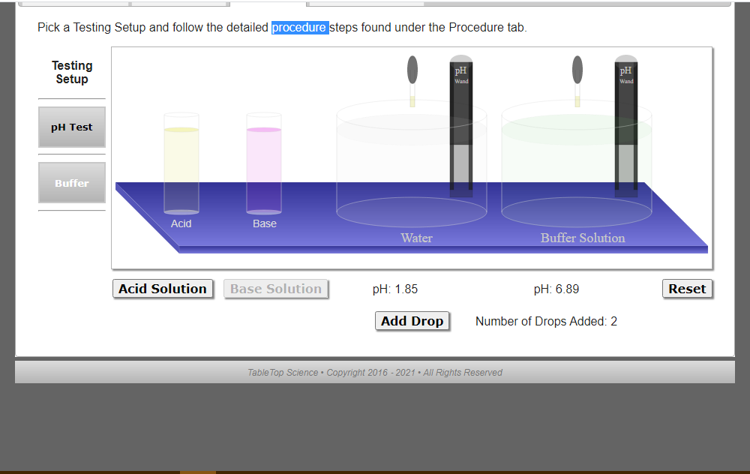

Procedure III: 3 drops
Procedure III: 4 drops
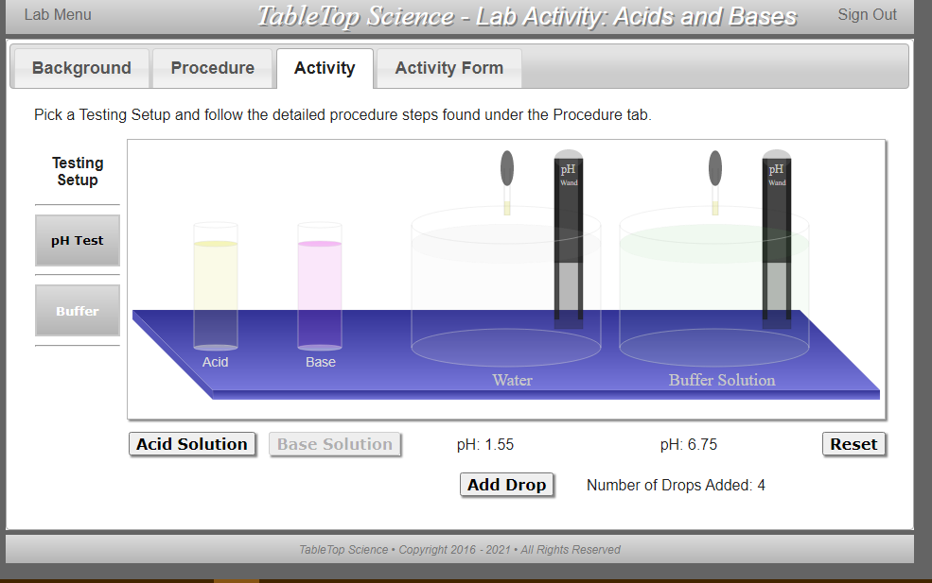

Procedure III: 5 drops
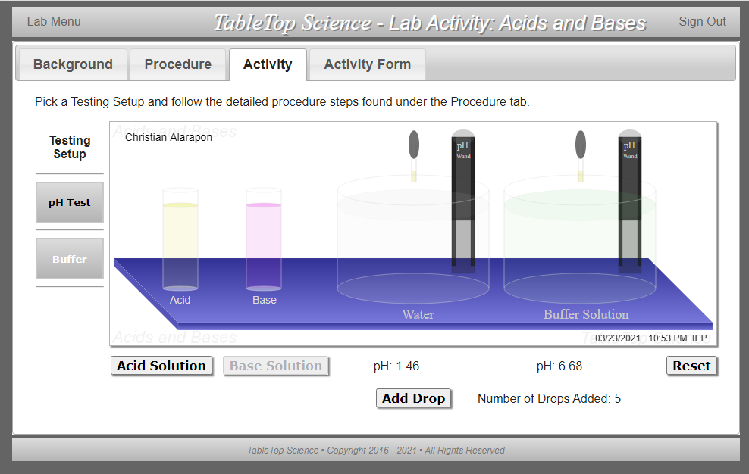

Procedure IV ‐ Adding Base Solution to the Buffer Solution

Procedure IV: 1 drop
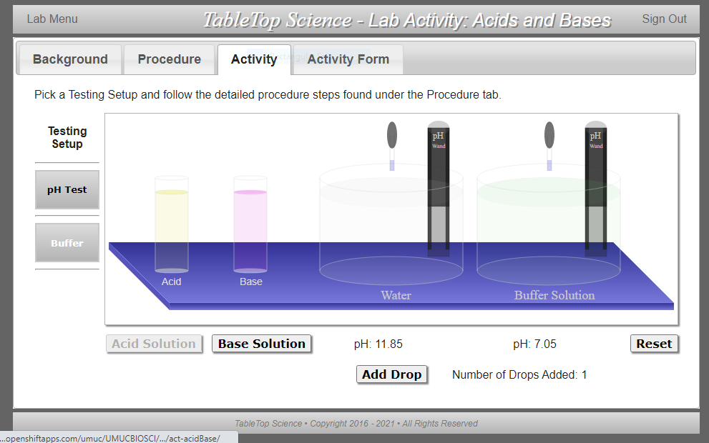

Procedure IV: 2 drop
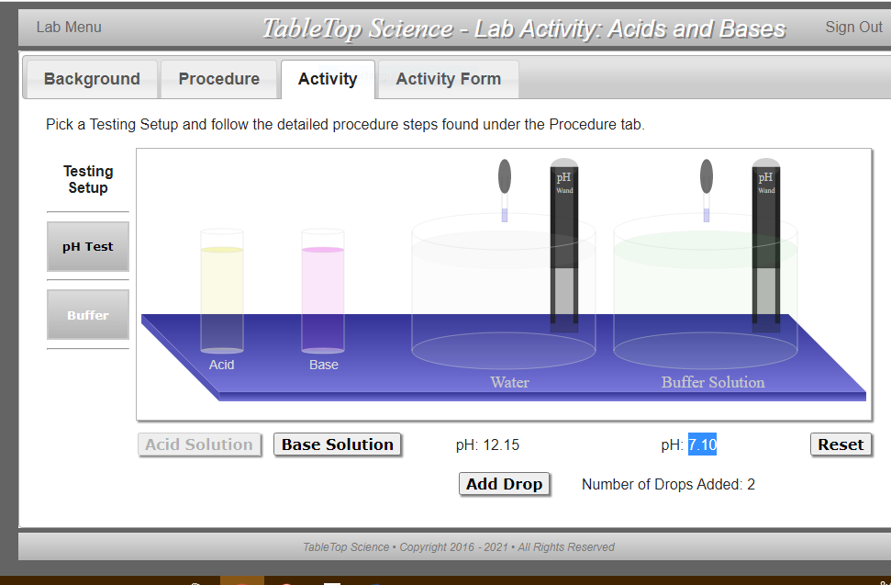

Procedure IV: 3 drop
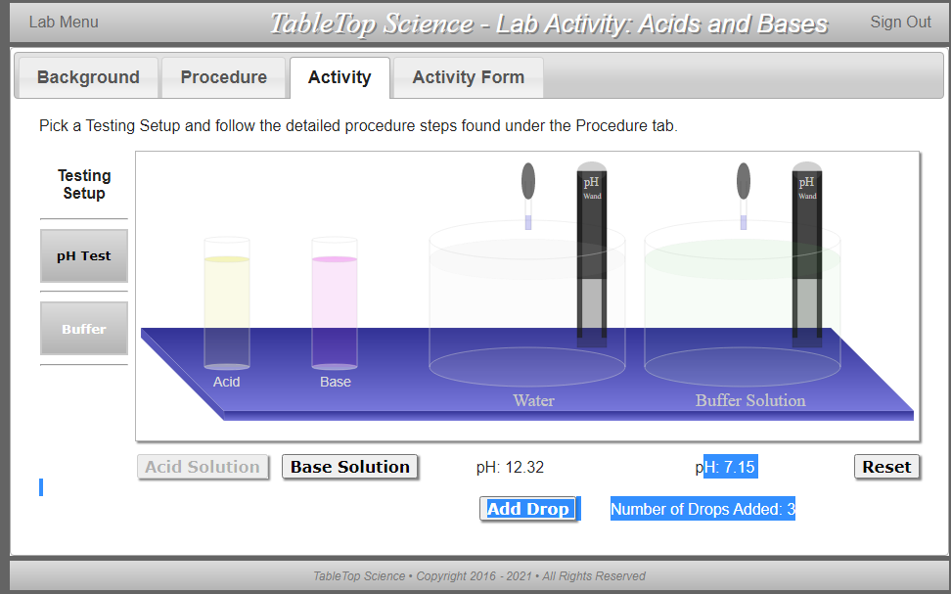

Procedure IV: 4 drop
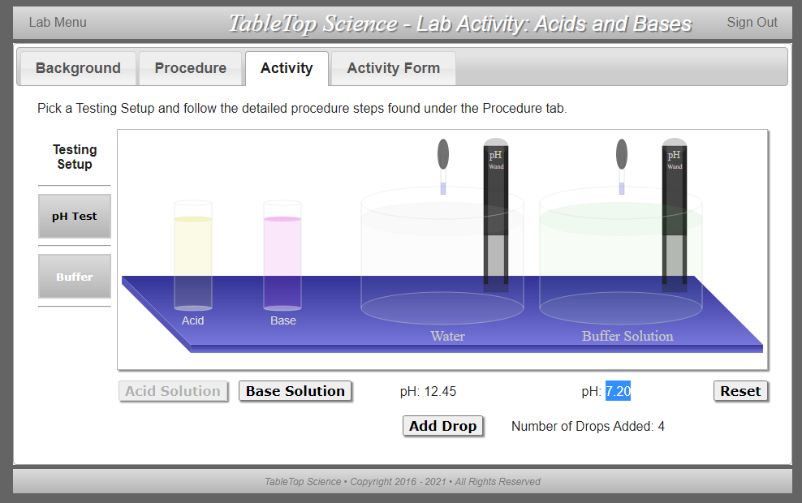

Procedure IV: 4 drop
