Lifespan Growth and Development of Mary
Student’s Name
Institutional Affiliation

Introduction
Mary is a child born in a humble background, raised by her mother, a single parent. She has grown up in the street with her mother struggling to ensure Mary attends school from early childhood till adulthood. Using Jean Piaget's cognitive theory of development, the paper describes how Mary has been working to ensure that she maintains the top position in class with high grades. Erickson's theory will focus on how the lady has been socially interacting and the conflict she has encountered during different life stages. To understand her personality and behavior development, we study Sigmund Freud's Psychosexual theory. The mentioned theory will be used to explore Mary’s development at different stages of her life. Starting from conception to adulthood, the struggles she has undergone and breakthrough. Development is a continuous lifelong process occurring rather than piece-meal.
By relating the idea of Jean Piaget in his theory of cognitive development, a child is believed to inherit a high percentage of intelligence quotient from the mother. The lady is gifted in the classroom as she has a good memory in processing information, especially academic ones. The theory has four main stages: the sensory-motor stage occurs between birth, which is followed by stimuli. This stage is followed by a pre-operational one between the age of 2-6 years, where she learned language starting with mother's language followed by secondary language. This stage is followed by the concrete operational stage between the age of 7-11, where she developed logical thinking and recognized the status and struggle her mother was making. The last stage in this theory is a formal operation which takes place between the age of 12-adulthood. During this level, a child can think logically, reason deductively, and construct thought logically. The other theory is Erickson's psychosexual theory which its main focus is exploring the development of a child socially. The theory has eight stages a child undergoes a lifetime. Each stage associated with different interaction and conflict that arises. The eighth stages include: trust versus mistrust between birth to 1 year, autonomy versus shame and doubt occurring between the age of 1-3 years, initiative versus guilt a stage occurring between the age of 3-6 years, industry versus inferiority which happens between the age of 6-12 years, followed by identity versus role confusion between the age of 12-20 years, those stages are referred to as teenage, the following stages are adulthood which includes, intimacy versus isolation which takes place at between the age of 20-40 years, the stage followed by generativity versus stagnation which takes place between the age of 40-65 years, the last stage is integrity versus despair which takes place between the age of 65 till death.
Sigmund Freud's Psychosexual theory. According to Freud, when a child is born, it comes into a world filled with sexual energy or libido. In different stages of development, different parts of the body are satisfied with this sexual energy (Arnett, J., et al 2018). The personality of a child is developed in the following stages. Between the age of 0-1 year the period associated with sucking reflexes, if a child will not be mothered and allowed to suck properly, in future a person may be expected to smoke or be sarcastic. Between the age of 2-3 years at this stage, toilet training is a major concern, if properly done, self-confidence is created to a child if not done a child properly in future becomes stingy. The followed stage is between 4-5 years, a boy develops feeling towards mother and a girl to the father. The boy should be trained to associate with a mother and a girl with a mother to identify their roles. The last stage, in theory, is between the age of 6-11. At this stage, child sex is dormant, and they spend most of their time with same-sex peers. The last stage of development is between 12-19, feeling toward the other gender is developed. The base for a good relationship is developed. In a nutshell, the stages discussed above occur in succession and continuous; one's success will determine the success of the other. If one stage fails, it means fixation will occur, and problems may arise by displaying bad behavior in society (Osher, D et al 2020).
Mary suffered malformation of limbs, and she could not walk well. The problem prohibited her from performing most exercise and passion for participating in athletics. The problem arose from her mother taking a very dangerous drug known as thalidomide. Community is working hand in hand with relevant authority if locating drug dealers and taking action by severe punishment. The best way to fight this problem is by thorough advice to pregnant women and the government offering financial assistance to them.
Chart showing thalidomide effect in the US

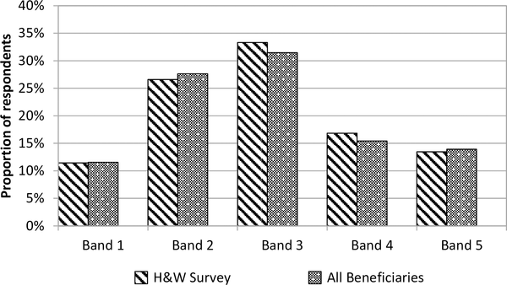
Mary has been having a problem being segregated by her fellow friend because of her ethnicity. Her mother migrated from her matrimonial home. Since Mary does not know to communicate in their language, they segregate her. She also suffers an economic crisis as she does not afford to pay school fees on time. Her mother also leads Mary to participate in female genital mutilation, which affects her. According to V# Arnett, J., et al (2018), children are suffering abandonment by their parents claiming to be busy; they also suffer stress. Mary was the victim of the two from an early age.
Mary's culture does not allow her to participate in any dance, but her school principal requested her to engage in music dance held at the music festival. She also suffers from race discrimination from her peers. They migrated and came to reside in this new area where most people are not associated with her race.
During Mary's adolescent age, she encountered many challenges, including not receiving her menstrual period. It took a long time, and this made Mary feel unworthy. She decided against committing suicide. Mary, from her mothers' influence and stress she was engaging herself in taking alcohol. The later influence was dropping out of school for a little while.
Conclusion
Development is a lifelong process that occurs in succession. It follows a sequence series of events. Mary, from conception she has undergone many challenges. Including those born with physical challenges also facing discrimination from her peers. Race discrimination forced her to take alcohol in the adolescence period.

Arnett, J., Chapin, L., & Brownlow, C. (2018). Human development: A cultural approach. Pearson Australia.

Osher, D., Cantor, P., Berg, J., Steyer, L., & Rose, T. (2020). Drivers of human development: How relationships and context shape learning and development1. Applied Developmental Science, 24(1), 6-36.

