(Solution)

1:
Solution:
Design procedure:
1.

x A B C D E F G

0 |  |  | 0 | 0 | 1
0 |  |  | 0 | 1 | 0
0 |  |  | 0 | 1 | 1
0 |  |  | 1 | 0 | 0
1 |  |  | 0 | 1 | 1
1 |  |  | 1 | 0 | 0
1 |  |  | 1 | 0 | 1
1 |  |  | 1 | 1 | 0
0 |  |  | 0 | 0 | 1
0 |  |  | 0 | 1 | 0
0 |  |  | 0 | 1 | 1
0 |  |  | 1 | 0 | 0
1 |  |  | 0 | 1 | 1
1 |  |  | 1 | 0 | 0
1 |  |  | 1 | 0 | 1
1 |  |  | 1 | 1 | 0

2. Obtain the simplified Boolean functions for each output as a function of the input variables.

Map for output A: yz y
The simplified expression from the map is:
A xz xy yz
x 00 01 11 10

Map for output B:
The simplified expression from the map is:
0 0 0 0

1 0
 | 1
1 |  | 1 |  | 1

z
yz y
B xyz xyz xyz xyz
x 00 01 11 10
0 0 1 0 1

1 1 0 1 0

Map for output C:
The simplified expression from the map is:
z
yz y
C z'
x 00 01 11 10
0 1 0 0 1

1 1 0 0 1

z
3. Draw the logic diagram.

A xy xz yz
B xyz xyz xyz xyz
C z'

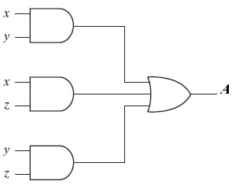

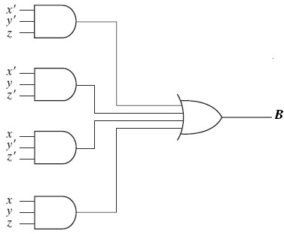

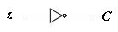

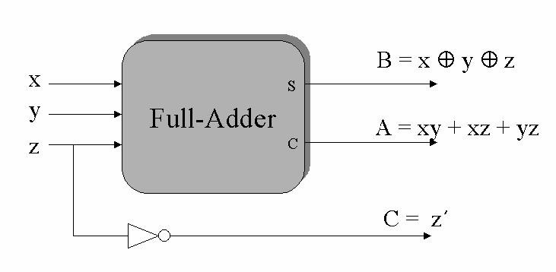

Solution:
Design procedure:

1. The truth table for the circuit.

E A B D0 D1 D2 D3

0 | X | X | 0 | 0 | 0 | 0
1 | 0 | 0 | 1 | 0 | 0 | 0
1 | 0 | 1 | 0 | 1 | 0 | 0
1 | 1 | 0 | 0 | 0 | 1 | 0
1 | 1 | 1 | 0 | 0 | 0 | 1

D0= EA’B’=(E’+A+B)’ D1= EA’B =(E’+A+B’)’ D2= EAB’ =(E’+A’+B)’ D3= EAB =(E’+A’+B’)’

2. The logic diagram

A
D0

B
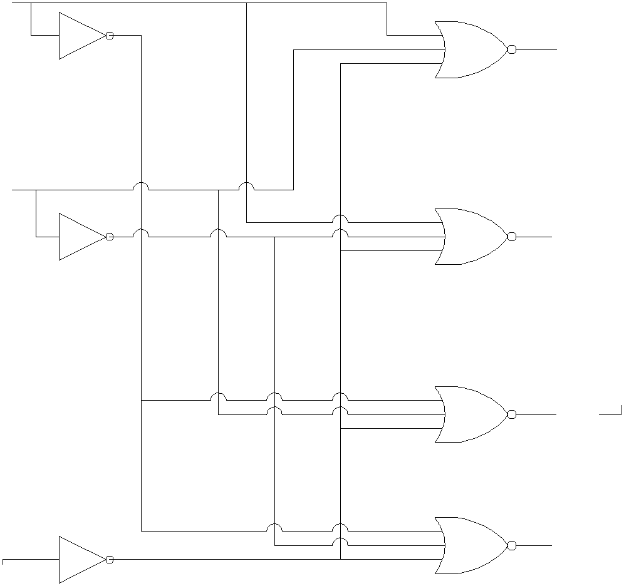D1

D2

E D3

Implement a full adder with two 4 x 1 multiplexers.

Solution:
Design procedure:
1. Derive the truth table that defines the required relationship between inputs and outputs.

X | Y |  | Z | C | C | S | S
0 | 0 |  | 0 | 0 | C=0 | 0 | S=Z
0 | 0 |  | 1 | 0 |  | 1
0 | 1 |  | 0 | 0 | C=Z | 1 | S=Z’
0 | 1 |  | 1 | 1 |  | 0
1 | 0 |  | 0 | 0 | C=Z | 1 | S=Z’
1 | 0 |  | 1 | 1 |  | 0
1 | 1 |  | 0 | 1 | C=1 | 0 | S=Z
1 | 1 |  | 1 | 1 |  | 1

2. We connect the first two variables of the functions to the selection inputs
of the multiplexer. The remaining single variable of the function is used for the data inputs.

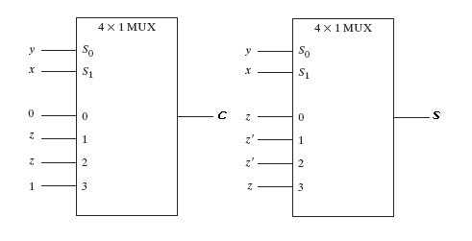

Implement the truth table given below using

input |  |  | output
a | b | c | f
0 | 0 | 0 | 1
0 | 0 | 1 | 0
0 | 1 | 0 | Don't care
0 | 1 | 1 | 0
1 | 0 | 0 | 1
1 | 0 | 1 | 1
1 | 1 | 0 | Don't care
1 | 1 | 1 | 1

a) A single 3-to-8 Decoder and any simple logic (e.g AND / OR / INV) .

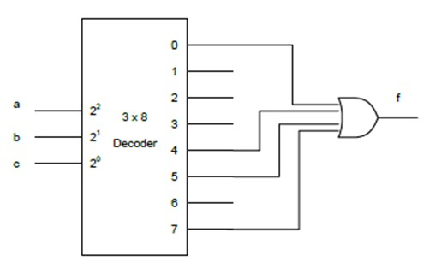
b) A single 8-to-1 Multiplexer and any simple logic (e.g AND / OR / INV) .

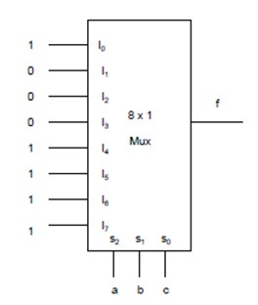

c) A single 4-to-1 Multiplexer and any simple logic (e.g AND / OR / INV) .

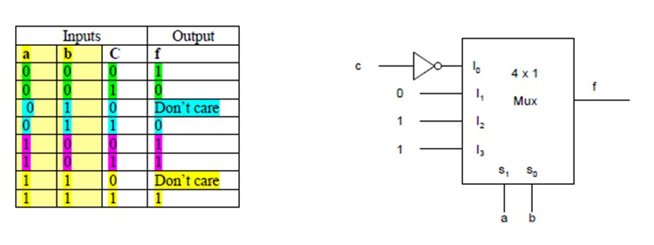
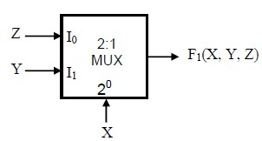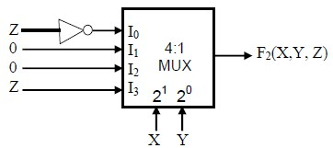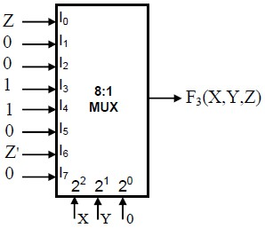
Given the Boolean functions (F1,F2,F3,F4) . determine the Boolean expression of each one.

F1(X, Y, Z) = …X'Z + XY…

F2(X, Y, Z) = X'Y'Z' + XYZ…

F3(X, Y, Z) = ∑(1,4,5,6) …

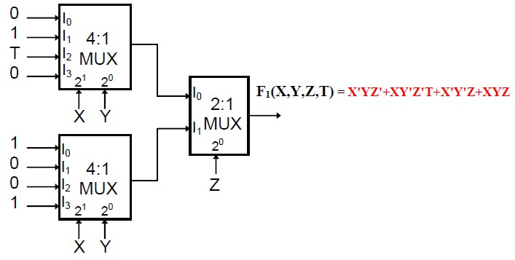

Given the four-variable Boolean function
F(A,B,C,D) = AB'C+A'B'CD+A'BCD'+ABC.
What are the multiplexer’s inputs (I0,…,I7) for the multiplexer ?

I0 = 0
I1 = D I2 = 0
I3 = D'
I4 = 0
I5= 1
I6 = 0
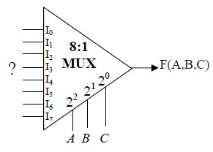I7 = 1

Problem 7:
A D flip-flop, and a JK flip-flop are connected as shown below .
Complete the timing diagram (note that QA and QB are initially low (0))

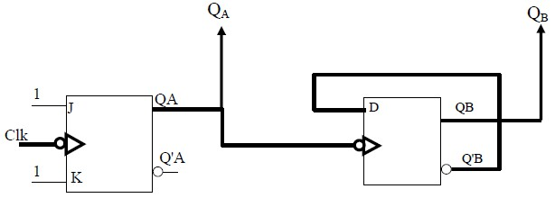

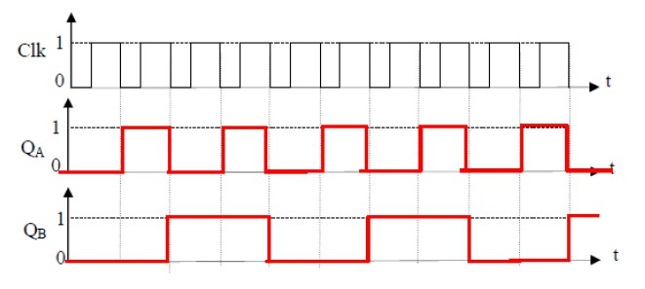

1) Convert a T-FF to a JK-FF.

2) Convert a T-FF to a D-FF.

3) Convert a JK-FF to a D-FF.

4) Convert a JK-FF to a T-FF.

Problem 9:
Design a four-input priority encoder , with input D 0 having the highest
priority and input D 3 the lowest priority.

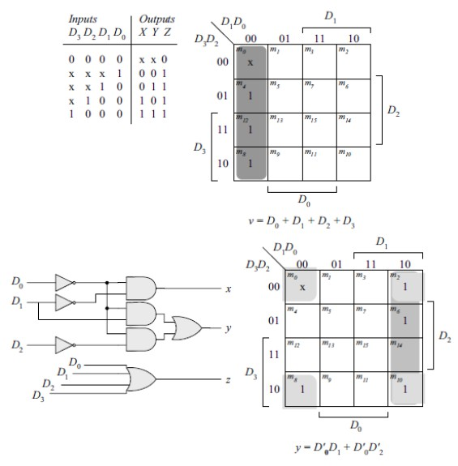

Problem 10:
Implement the function F= Σ(0,2,4,5,7,8,10,11,15) using MUX .

A | B | C | D | F
0 | 0 | 0 | 0 | 1 | F = D'
0 | 0 | 0 | 1 | 0 | F = D'
0 | 0 | 1 | 0 | 1 | F = D'
0 | 0 | 1 | 1 | 0 | F = D'
0 | 1 | 0 | 0 | 1 | F = 1
0 | 1 | 0 | 1 | 1 | F = 1
0 | 1 | 1 | 0 | 0 | F = D
0 | 1 | 1 | 1 | 1 | F = D
1 | 0 | 0 | 0 | 1 | F = D'
1 | 0 | 0 | 1 | 0 | F = D'
1 | 0 | 1 | 0 | 1 | F = 1
1 | 0 | 1 | 1 | 1 | F = 1
1 | 1 | 0 | 0 | 0 | F = 0
1 | 1 | 0 | 1 | 0 | F = 0
1 | 1 | 1 | 0 | 0 | F = D
1 | 1 | 1 | 1 | 1 | F = D

