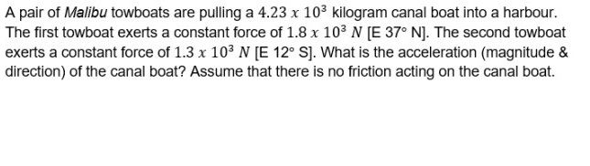
Consider the following FBD of the boat –
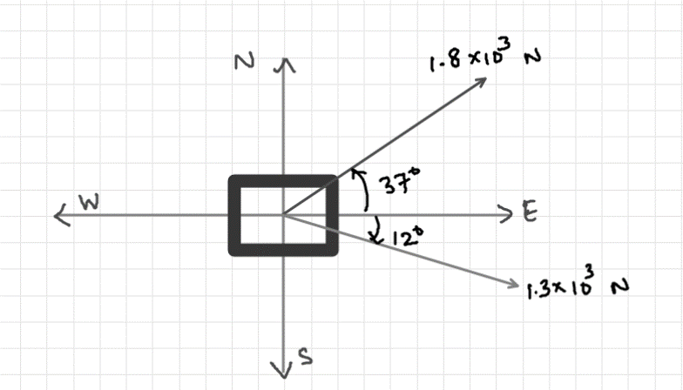
Suppose east axis is positive x axis and North axis is positive y axis.
Thus, we can find x and y component of the forces.
X component of $1.8×{10}^{3}N force$
$$F\cos{θ}=1.8×{10}^{3}\cos{{37}^{0}}=1437.5N$$
y component of $1.8×{10}^{3}N force$
$$F\sin{θ}=1.8×{10}^{3}\sin{{37}^{0}}=1083.3N$$
X component of $1.3×{10}^{3}N force$
$$F\cos{θ}=1.3×{10}^{3}\cos{{12}^{0}}=1271.6N$$
y component of $1.3×{10}^{3}N force$
$$-F\sin{θ}=-1.8×{10}^{3}\sin{{12}^{0}}=-270.3N$$
{Note this component is negative because it is along negative y axis}
Thus, net force acting on the boat =
Along x axis $: 1437.5 + 1271.6 N = 2709.1 N$
Along y axis = $1083.3 - 270.3 N = 813 N$
Now, to find acceleration along each axis, we will be using following formula –
$$a=\frac{F}{m}$$
In x direction
$$a_{x}=\frac{2709.1}{4.23×{10}^{3}}=0.64m/s^{2}$$
In y direction
$$a_{y}=\frac{813}{4.23×{10}^{3}}=0.19 m/s^{2}$$
Now, in order to find magnitude, we need to find the resultant of the two perpendicular vectors.
Magnitude
$$a=\sqrt{a_{x}^{2}+a_{y}^{2}}=\sqrt{{0.64}^{2}+{0.19}^{2}}=0.67 m/s^{2}$$
Direction (i.e. angle above x axis in counter-clockwise direction) =
$$→\tan^{-1}\left(\frac{a_{y}}{a_{x}}\right) =\tan^{-1}\left(\frac{0.19}{0.64}\right)={16.5}^{0}$$

