Q1 we need to import math and pomegranate library into the PyCharm integrated development environment in order to perform all the calculations
(a) we are needed to draw Bayesian graph. Bayesian falls under the category of probabilistic graphical modelling where a model is represented by a directed cyclic graph.
In our case, the Bayesian is represented as shown below.
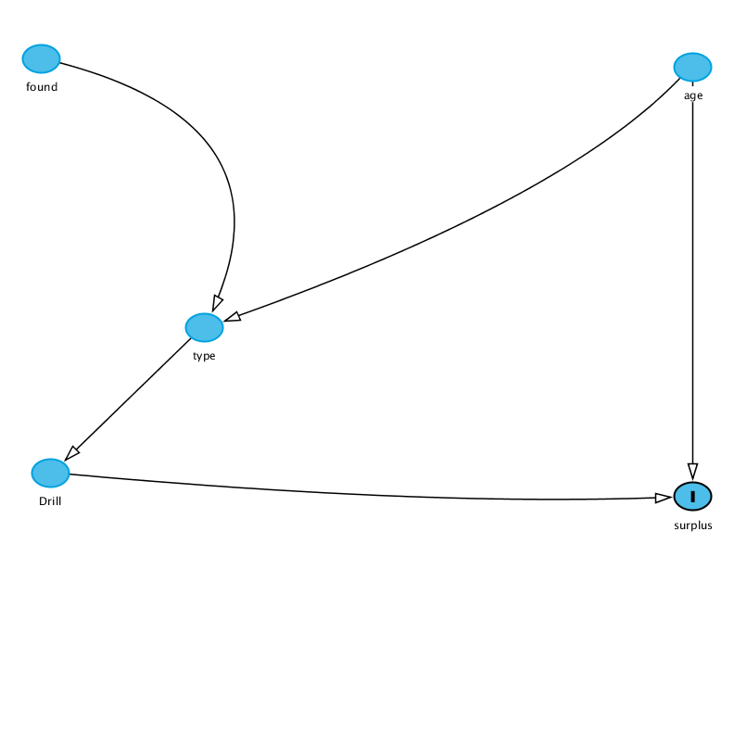
From the diagram above found and age nodes (variables) depends on the type and hence type node is a dependent variable.
Then Drill and surplus node are both dependent as type and age depend on them respectively.

(b)
Joint probability defines the measure of events happening at the same time.
For our case
probability of found =p ([ 'A''B','C','D','E')
probability of age =p ([ 'A''B','C','D','E')
probability of type =p([ 'A''B','C' ,'D','E')
probability of Drill =p ([ 'A''B','C','D','E')
Where A for found then B for age, C for type then D for drill then E for surplus respectively.

(c) A for found then B for age, C for type then D for drill then E for surplus.
#the found initial selection is completely random
FOUND=DiscreteDistribution([ 'A':1./5,'B':1./5 ,'C':1./5 ,'D':1./5 ,'E':1. /5])
#the Age initial is completely random
AGE=DiscreteDistribution([ 'A':1./5,'B':1./5 ,'C':1./5 ,'D':1./5 ,'E':1./5])
#the type selection is also completely random
TYPE=DiscreteDistribution([ 'A':1./5,'B':1./5 ,'C':1./5 ,'D':1./5 ,'E':1./5])
#the drill initial selection is also completely random
DRILL=DiscreteDistribution([ 'A':1./5,'B':1./5 ,'C':1./5 ,'D':1./5 ,'E':1./5])
#suplus is conditional probability and thus it is computed as shown
Surplus=conditional probability table (
[‘A’,’A’,’A’,’A’,’A’,0.0]
[‘A’,’A’,’A’,’A’,’B’,0.1]
[‘A’,’A’,’A’,’A’,’C’,0.2]
[‘A’,’A’,’A’,’A’,’D’,0.3]
[‘A’,’A’,’A’,’A’,’E’,1.0])

(d) the formula to evaluate drill
Probability of drill in respect to shale=p(D|C)
p ([ 'A''B','C','D','E') which is the probability of A or B or C or D or E which means we add A, B, C, D and E

Q2
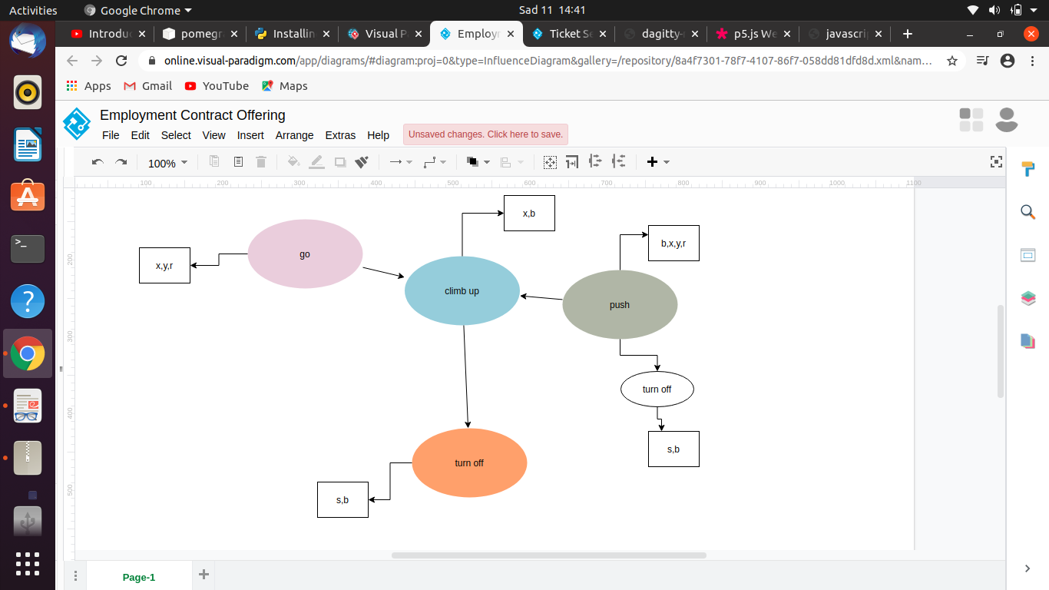

Probability of go=p(‘x’:1/3,’y’:1/3,’r’:1/3)
Probability of push= p (‘’b’: ¼, x’:1/4,’y’:1/4,’r’:1/4)
Probability of climb=p (x’:1/2,’b’: ½)
Probability of turn on=p (‘s’:1/2,’b’: ½)
Probability of turnoff=p (‘s’:1/2,’b’: ½)

Q3
(a) is the correct order logic
(b)the translation logic is not correct. Both peter and joe security number should have n since its joint probability where the two events are occurring at the same time.
(c )the correct order logic is correct

Q4
(a) probability of slippery
P(slippery)
P (0.13*0.065) or (0.2*0.1)
0.00845+0.02=0.02845

(b) probability of sandy in respect to slippery
1-(0.1*0.2)
1-0.02
=0.98
98/100
(c) not sandy and not slippery
1-p (0.04*0.11)
1-0.0044
=0.9956

